**Title**

**Create a login form with database verification.**

**Objective  
To learn to verify a user login from the existing records in the database.**

**Program Code:**import javax.swing.*;

import java.awt.event.ActionEvent;

import java.awt.event.ActionListener;

import java.sql.Connection;

import java.sql.DriverManager;

import java.sql.PreparedStatement;

import java.sql.ResultSet;

public class DBLogin extends JFrame {

private JTextField usernameField;

private JPasswordField passwordField;

private JButton loginButton;

private JPanel mainPanel;

public DBLogin() {

setTitle("Login Form");

setSize(350, 250);

setDefaultCloseOperation(JFrame.EXIT_ON_CLOSE);

setLocationRelativeTo(null);

mainPanel = new JPanel();

mainPanel.setLayout(null);

JLabel userLabel = new JLabel("Username:");

userLabel.setBounds(30, 30, 80, 25);

mainPanel.add(userLabel);

usernameField = new JTextField(20);

usernameField.setBounds(120, 30, 185, 25);

mainPanel.add(usernameField);

JLabel passwordLabel = new JLabel("Password:");

passwordLabel.setBounds(30, 70, 80, 25);

mainPanel.add(passwordLabel);

passwordField = new JPasswordField(20);

passwordField.setBounds(120, 70, 185, 25);

mainPanel.add(passwordField);

loginButton = new JButton("Login");

loginButton.setBounds(30, 110, 275, 30);

mainPanel.add(loginButton);

add(mainPanel);

loginButton.addActionListener(new ActionListener() {

@Override

public void actionPerformed(ActionEvent e) {

try {

Connection connection = DriverManager.getConnection("jdbc:mysql://localhost:3306/userdetails", "root", "");

String query = "SELECT * FROM userdata WHERE username=? AND password=?";

PreparedStatement preparedStatement = connection.prepareStatement(query);

preparedStatement.setString(1, usernameField.getText());

preparedStatement.setString(2, new String(passwordField.getPassword()));

ResultSet resultSet = preparedStatement.executeQuery();

if (resultSet.next()) {

JOptionPane.showMessageDialog(null, "Login successful!");

} else {

JOptionPane.showMessageDialog(null, "Invalid username or password.");

}

connection.close();

} catch (Exception ex) {

System.out.println("Error");;

}

}

});

}

public static void main(String[] args) {

SwingUtilities.invokeLater(new Runnable() {

@Override

public void run() {

new DBLogin().setVisible(true);

}

});

}

}

**OUTPUT:**

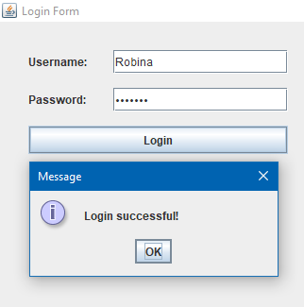

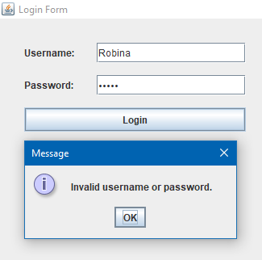

**Discussion  
The practice for validating an user login from the existing records in the database which was accessed through the SQLConnector library imported in the program was understood and performed successfully.**

**Conclusion:**

**By completing this program, I learnt to validate an user login with the existing records in the database.**

**Title**

**Create a registration form containing text fields, passwords, radio button, checkbox, label, button with confirm password field which should be validated.**

**Objective  
To learn to confirm the two user input passwords and register the user only if the two passwords match each other in the form along with other details.**

**Program Code:**

import javax.swing.*;

import java.awt.event.ActionEvent;

import java.awt.event.ActionListener;

public class RegistrationForm extends JFrame {

private JTextField usernameField;

private JPasswordField passwordField;

private JPasswordField confirmPasswordField;

private JRadioButton maleRadioButton;

private JRadioButton femaleRadioButton;

private JCheckBox agreeCheckBox;

private JButton registerButton;

private JPanel mainPanel;

public RegistrationForm() {

setTitle("RegistrationForm");

setSize(400, 350);

setDefaultCloseOperation(JFrame.EXIT_ON_CLOSE);

setLocationRelativeTo(null);

mainPanel = new JPanel();

mainPanel.setLayout(null);

JLabel userLabel = new JLabel("Username:");

userLabel.setBounds(30, 30, 80, 25);

mainPanel.add(userLabel);

usernameField = new JTextField(20);

usernameField.setBounds(150, 30, 200, 25);

mainPanel.add(usernameField);

JLabel passwordLabel = new JLabel("Password:");

passwordLabel.setBounds(30, 70, 80, 25);

mainPanel.add(passwordLabel);

passwordField = new JPasswordField(20);

passwordField.setBounds(150, 70, 200, 25);

mainPanel.add(passwordField);

JLabel confirmPasswordLabel = new JLabel("Confirm Password:");

confirmPasswordLabel.setBounds(30, 110, 120, 25);

mainPanel.add(confirmPasswordLabel);

confirmPasswordField = new JPasswordField(20);

confirmPasswordField.setBounds(150, 110, 200, 25);

mainPanel.add(confirmPasswordField);

JLabel genderLabel = new JLabel("Gender:");

genderLabel.setBounds(30, 150, 80, 25);

mainPanel.add(genderLabel);

maleRadioButton = new JRadioButton("Male");

maleRadioButton.setBounds(150, 150, 80, 25);

mainPanel.add(maleRadioButton);

femaleRadioButton = new JRadioButton("Female");

femaleRadioButton.setBounds(230, 150, 80, 25);

mainPanel.add(femaleRadioButton);

ButtonGroup genderGroup = new ButtonGroup();

genderGroup.add(maleRadioButton);

genderGroup.add(femaleRadioButton);

agreeCheckBox = new JCheckBox("I agree to the terms and conditions.");

agreeCheckBox.setBounds(30, 190, 320, 25);

mainPanel.add(agreeCheckBox);

registerButton = new JButton("Register");

registerButton.setBounds(150, 230, 100, 30);

mainPanel.add(registerButton);

add(mainPanel);

registerButton.addActionListener(new ActionListener() {

@Override

public void actionPerformed(ActionEvent e) {

String password = new String(passwordField.getPassword());

String confirmPassword = new String(confirmPasswordField.getPassword());

if (!password.equals(confirmPassword)) {

JOptionPane.showMessageDialog(null, "Passwords do not match!");

} else if (!agreeCheckBox.isSelected()) {

JOptionPane.showMessageDialog(null, "You must agree to the terms and conditions.");

} else {

JOptionPane.showMessageDialog(null, "Registration successful!");

}

}

});

}

public static void main(String[] args) {

SwingUtilities.invokeLater(new Runnable() {

@Override

public void run() {

new RegistrationForm().setVisible(true);

}

});

}

}

**OUTPUT:**

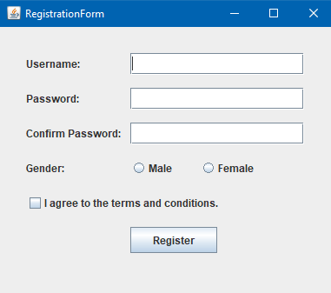

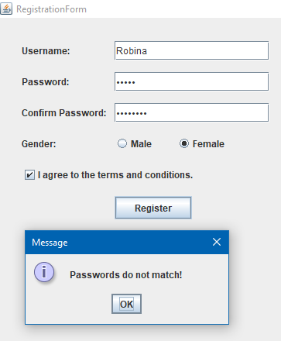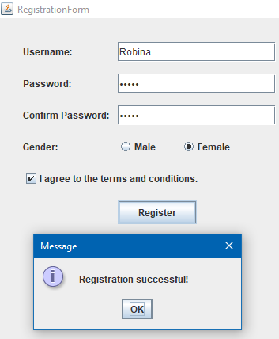

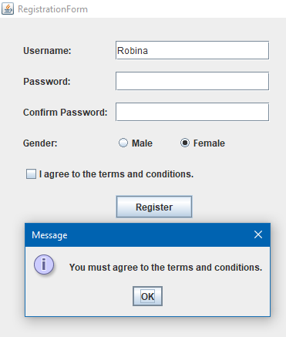

**Discussion  
The practice for registering an user only and only if the two passwords input in the password field and confirm password field match each other and if they don’t match return the error message was understood and performed successfully.**

**Conclusion:**

**By completing this program, I learnt to validate the user password inputs and confirm passwords input comparing them to each other and only registering in the case of successful password inputs.**

**Title  
 Create a GUI that displays record from database.**

**Objective  
To learn to access the database and view the database existing records.**

**Program Code:**import javax.swing.*;

import javax.swing.table.DefaultTableModel;

import java.awt.*;

import java.sql.Connection;

import java.sql.DriverManager;

import java.sql.ResultSet;

import java.sql.Statement;

public class DisplayRecordProgram extends JFrame {

public JTable table;

public DefaultTableModel tableModel;

public DisplayRecordProgram() {

setTitle("Display Records");

setSize(600, 400);

setDefaultCloseOperation(JFrame.EXIT_ON_CLOSE);

setLocationRelativeTo(null);

String[] columnNames = {"Username", "Password"};

tableModel = new DefaultTableModel(columnNames, 0);

table = new JTable(tableModel);

JScrollPane scrollPane = new JScrollPane(table);

scrollPane.setBounds(20, 20, 550, 300);

JPanel mainPanel = new JPanel();

mainPanel.setLayout(null);

mainPanel.add(scrollPane);

add(mainPanel);

loadDataFromDatabase();

}

private void loadDataFromDatabase() {

String url = "jdbc:mysql://localhost:3306/userdetails?zeroDateTimeBehavior=convertToNull";

String user = "root";

String password = "";

try {

Connection connection = DriverManager.getConnection(url, user, password);

Statement statement = connection.createStatement();

String query = "SELECT * FROM userdata";

ResultSet resultSet = statement.executeQuery(query);

while (resultSet.next()) {

String username = resultSet.getString("username");

String passwords = resultSet.getString("password");

tableModel.addRow(new Object[]{username, passwords});

}

connection.close();

} catch (Exception ex) {

System.out.println(ex.getMessage());;

}

}

public static void main(String[] args) {

SwingUtilities.invokeLater(new Runnable() {

@Override

public void run() {

new DisplayRecordProgram().setVisible(true);

}

});

}

}

**OUTPUT:**

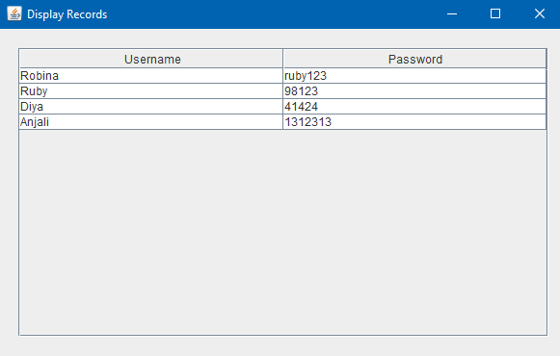

**Discussion  
The practice for accessing the database with the help of SQL connector imported in the library and making the view for the existing database records in a tabular form was understood and performed successfully.**

**Conclusion:  
By completing this program, I learnt to retrieve the data existing in the database with the help of required libraries and present it in a tabular form.**

**Title  
Create a GUI that will receive password of an existing user and change it in database when button is clicked.**

**Objective  
To learn to retrieve the password of an existing user in the database and change the existing password to a new password in the database through the input textfield.**

**Program Code:**import javax.swing.*;

import java.awt.event.ActionEvent;

import java.awt.event.ActionListener;

import java.sql.Connection;

import java.sql.DriverManager;

import java.sql.PreparedStatement;

import java.sql.ResultSet;

public class ChangePasswordProgram extends JFrame {

private JTextField usernameField;

private JPasswordField newPasswordField;

private JButton changePasswordButton;

private JPanel mainPanel;

public ChangePasswordProgram() {

setTitle("Reset Password");

setSize(400, 250);

setDefaultCloseOperation(JFrame.EXIT_ON_CLOSE);

setLocationRelativeTo(null);

mainPanel = new JPanel();

mainPanel.setLayout(null);

JLabel usernameLabel = new JLabel("Username:");

usernameLabel.setBounds(30, 30, 100, 25);

mainPanel.add(usernameLabel);

usernameField = new JTextField(20);

usernameField.setBounds(150, 30, 200, 25);

mainPanel.add(usernameField);

JLabel newPasswordLabel = new JLabel("New Password:");

newPasswordLabel.setBounds(30, 70, 100, 25);

mainPanel.add(newPasswordLabel);

newPasswordField = new JPasswordField(20);

newPasswordField.setBounds(150, 70, 200, 25);

mainPanel.add(newPasswordField);

changePasswordButton = new JButton("Change Password");

changePasswordButton.setBounds(100, 120, 200, 30);

mainPanel.add(changePasswordButton);

add(mainPanel);

changePasswordButton.addActionListener(new ActionListener() {

@Override

public void actionPerformed(ActionEvent e) {

String username = usernameField.getText();

String newPassword = new String(newPasswordField.getPassword());

String url = "jdbc:mysql://localhost:3306/userdetails?zeroDateTimeBehavior=convertToNull";

String user = "root";

String password = "";

try {

Connection connection = DriverManager.getConnection(url, user, password);

String fetchQuery = "SELECT password FROM userdata WHERE username=?";

PreparedStatement fetchStmt = connection.prepareStatement(fetchQuery);

fetchStmt.setString(1, username);

ResultSet resultSet = fetchStmt.executeQuery();

if (resultSet.next()) {

String oldPassword = resultSet.getString("password");

String updateQuery = "UPDATE userdata SET password=? WHERE username=?";

PreparedStatement updateStmt = connection.prepareStatement(updateQuery);

updateStmt.setString(1, newPassword);

updateStmt.setString(2, username);

int rowsUpdated = updateStmt.executeUpdate();

if (rowsUpdated > 0) {

JOptionPane.showMessageDialog(null, "Password for user: " + username + " has been changed from \"" + oldPassword + "\" to \"" + newPassword + "\".");

} else {

JOptionPane.showMessageDialog(null, "Failed to update password. User not found.");

}

} else {

JOptionPane.showMessageDialog(null, "User not found.");

}

connection.close();

} catch (Exception ex) {

ex.printStackTrace();

}

}

});

}

public static void main(String[] args) {

SwingUtilities.invokeLater(new Runnable() {

@Override

public void run() {

new ChangePasswordProgram().setVisible(true);

}

});

}

}

**OUTPUT:**

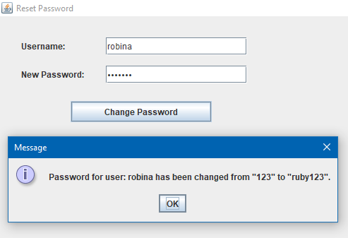

**Discussion  
The practice for accessing the database with the help of SQLConnector imported in the library retrieving the password of existing user and changing it to a new password was understood and performed successfully.**

**Conclusion:  
By completing this program, I learnt to retrieve the password of an existing user in the database and make desired changes to it.**

**Title  
 Create a GUI to ask username and delete that user from the database.**

**Objective  
 To delete an existing user in the database with the help of username.**

**Program Code:**import javax.swing.*;

import java.awt.event.ActionEvent;

import java.awt.event.ActionListener;

import java.sql.Connection;

import java.sql.DriverManager;

import java.sql.PreparedStatement;

public class DeleteUser extends JFrame {

private JTextField usernameField;

private JButton deleteButton;

private JPanel mainPanel;

public DeleteUser() {

setTitle("Delete a user");

setSize(400, 200);

setDefaultCloseOperation(JFrame.EXIT_ON_CLOSE);

setLocationRelativeTo(null);

mainPanel = new JPanel();

mainPanel.setLayout(null);

JLabel usernameLabel = new JLabel("username:");

usernameLabel.setBounds(30, 30, 100, 25);

mainPanel.add(usernameLabel);

usernameField = new JTextField(20);

usernameField.setBounds(150, 30, 200, 25);

mainPanel.add(usernameField);

deleteButton = new JButton("Delete User");

deleteButton.setBounds(100, 70, 200, 30);

mainPanel.add(deleteButton);

add(mainPanel);

deleteButton.addActionListener(new ActionListener() {

@Override

public void actionPerformed(ActionEvent e) {

String username = usernameField.getText();

String url = "jdbc:mysql://localhost:3306/userdetails?zeroDateTimeBehavior=convertToNull";

String user = "root";

String password = "";

try {

Connection connection = DriverManager.getConnection(url, user, password);

String deleteQuery = "DELETE FROM userdata WHERE username=?";

PreparedStatement deleteStmt = connection.prepareStatement(deleteQuery);

deleteStmt.setString(1, username);

int rowsDeleted = deleteStmt.executeUpdate();

if (rowsDeleted > 0) {

JOptionPane.showMessageDialog(null, "User " + username + " has been deleted.");

} else {

JOptionPane.showMessageDialog(null, "User not found.");

}

connection.close();

} catch (Exception ex) {

ex.printStackTrace();

JOptionPane.showMessageDialog(null, "Error occurred while deleting user.");

}

}

});

}

public static void main(String[] args) {

SwingUtilities.invokeLater(new Runnable() {

@Override

public void run() {

new DeleteUser().setVisible(true);

}

});

}

}

**OUTPUT:**

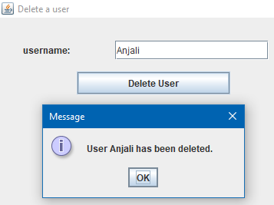 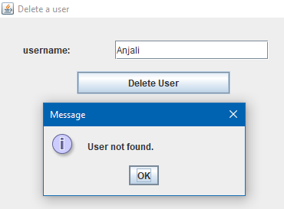

**Discussion  
The practice for accessing the database with the help of SQLConnector imported in the library and delete the existing user from the database with the help of username to that corresponding user was understood and performed successfully.**

**Conclusion:  
By completing this program, I learnt to delete an existing user in the database with the help of username corresponding to that user.**