**Title**

**Create a GUI to show “Welcome to Java World” pop up message when GUI is launched.**

**Objective  
To learn how to create a GUI that displays Welcome to Java World.**

**Program code:**

import javax.swing.*;

public class Main {

public static void main(String[] args) {

JFrame frame = new JFrame("POP-UP Message");

frame.setSize(500,500);

frame.setVisible(true);

frame.setLayout(null);

frame.setDefaultCloseOperation(JFrame.EXIT_ON_CLOSE);

JOptionPane.showMessageDialog(frame,"Welcome to Java World");

}

}

**OUTPUT:**

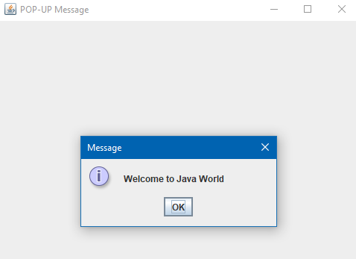

**Discussion**

**The practice for making a GUI that displays the message as passed in the program was understood and performed successfully.**

**Conclusion:**

**By completing this program, I learnt to create a GUI and display a pop up message.**

**Title**

**Create a GUI having two textbox that adds both values when button is clicked.**

**Objective  
To learn how to create a GUI with two textbox and a button which performs addition when button is clicked.**

**Program Code:**import javax.swing.*;

import java.awt.event.ActionEvent;

import java.awt.event.ActionListener;

public class Main {

public static void main(String[] args) {

JFrame f1 = new JFrame("Simple Addition");

f1.setSize(300, 250);

f1.setDefaultCloseOperation(JFrame.EXIT_ON_CLOSE);

f1.setLayout(null);

f1.setVisible(true);

JLabel labelnum1 = new JLabel("Value 1:");

labelnum1.setBounds(30, 30, 80, 30);

f1.add(labelnum1);

JTextField num1 = new JTextField();

num1.setBounds(110, 30, 100, 30);

f1.add(num1);

JLabel labelnum2 = new JLabel("Value 2:");

labelnum2.setBounds(30, 70, 80, 30);

f1.add(labelnum2);

JTextField num2 = new JTextField();

num2.setBounds(110, 70, 100, 30);

f1.add(num2);

JButton add = new JButton("Add");

add.setBounds(110, 110, 100, 30);

f1.add(add);

JLabel result = new JLabel("Result:");

result.setBounds(30, 150, 200, 30);

f1.add(result);

add.addActionListener(new ActionListener() {

@Override

public void actionPerformed(ActionEvent e) {

try {

int val1 = Integer.parseInt(num1.getText());

int val2 = Integer.parseInt(num1.getText());

int sum = val1 + val2;

result.setText("Result: " + sum);

} catch (NumberFormatException ex) {

result.setText("Please enter valid integers.");

}

}

});

}

}

**OUTPUT:**

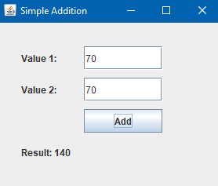

**Discussion**

**The practice for making a GUI consisting two textbox which took inputs & performed addition on button click in the program was understood and performed successfully.**

**Conclusion:**

**By completing this program, I learnt to create a GUI with textbox and events and performing desired actions on click.**

**Title**

**Create a GUI having two buttons and swap the text when button is clicked.**

**Objective  
To learn how to create a GUI with two buttons and button click swaps the value among the buttons on click.**

**Program Code:**

import javax.swing.*;

import java.awt.event.*;

public class Main {

public static void main(String[] args) {

JFrame f1=new JFrame("Swap");

f1.setLayout(null);

f1.setSize(500,500);

f1.setVisible(true);

f1.setDefaultCloseOperation(JFrame.EXIT_ON_CLOSE);

JButton b1=new JButton("Ayush");

b1.setBounds(100,150,100,25);

JButton b2=new JButton("Pakhrin");

b2.setBounds(250,150,100,25);

JButton swap=new JButton("Swap");

swap.setBounds(175,200,100,25);

f1.add(b1);

f1.add(b2);

f1.add(swap);

swap.addActionListener(new ActionListener() {

@Override

public void actionPerformed(ActionEvent e) {

String data1= b1.getText();

String data2= b2.getText();

String temp="";

temp=data1;

data1=data2;

data2=temp;

b1.setText(data1);

b2.setText(data2);

}

});

}

}

**OUTPUT:**

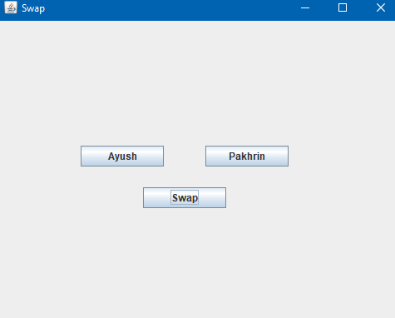  
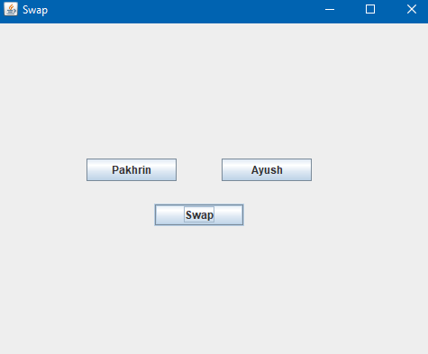

**Discussion**

**The practice for making a GUI having two buttons which swapped each other values onclick was understood and performed successfully.**

**Conclusion:**

**By completing this program, I learnt to create a GUI consisting buttons which swapped values onclick.**

**Title**  
**Create a GUI of a calculator having four button(+,-,*,/) and perform related arithmetic operation on values when button is clicked.**

**Objective  
To learn how to create a GUI of a calculator having all arithmetic operations performed on values when button is clicked.**

**Program Code:**

**Main.java**

public class Main {

public static void main(String[] args) {

Calculator calc=new Calculator();

}

}

**Calculator.java**

import javax.swing.*;

import java.awt.event.ActionEvent;

import java.awt.event.ActionListener;

class Calculator implements ActionListener {

public JFrame frame;

public JLabel l1,l2,result;

public JTextField val1,val2;

public JButton add,sub,mul,div;

public Calculator(){

frame=new JFrame("Calculator");

frame.setSize(500,500);

frame.setVisible(true);

frame.setDefaultCloseOperation(JFrame.EXIT_ON_CLOSE);

frame.setLayout(null);

l1=new JLabel("Value 1:");

l1.setBounds(100,100,75,25);

val1=new JTextField();

val1.setBounds(160,100,100,25);

l2=new JLabel("Value 2:");

l2.setBounds(100,150,75,25);

val2=new JTextField();

val2.setBounds(160,150,100,25);

result=new JLabel("Result:");

result.setBounds(100,200,100,25);

add=new JButton("+");

add.setBounds(100,225,50,25);

sub=new JButton("-");

sub.setBounds(160,225,50,25);

mul=new JButton("*");

mul.setBounds(220,225,50,25);

div=new JButton("/");

div.setBounds(280,225,50,25);

frame.add(l1);

frame.add(l2);

frame.add(val1);

frame.add(val2);

frame.add(result);

frame.add(add);

frame.add(sub);

frame.add(mul);

frame.add(div);

add.addActionListener(this);

sub.addActionListener(this);

mul.addActionListener(this);

div.addActionListener(this);

}

@Override

public void actionPerformed(ActionEvent e) {

try {

Double firstVal = Double.parseDouble(val1.getText());

Double secondVal = Double.parseDouble(val2.getText());

Double res=0.0;

switch (e.getActionCommand()){

case "+":

res = firstVal + secondVal;

break;

case "-":

res = firstVal - secondVal;

break;

case "*":

res = firstVal * secondVal;

break;

case "/":

if (secondVal != 0) {

res = firstVal / secondVal;

} else {

JOptionPane.showMessageDialog(null, "Cannot divide by zero");

return;

}

break;

}

result.setText("Result: " + res);

}

catch (Exception ex){

System.out.println("Enter Valid Number!");

}

}

}

**OUTPUT:**

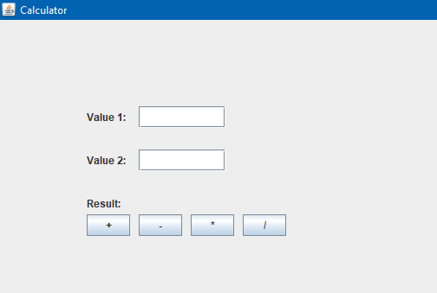 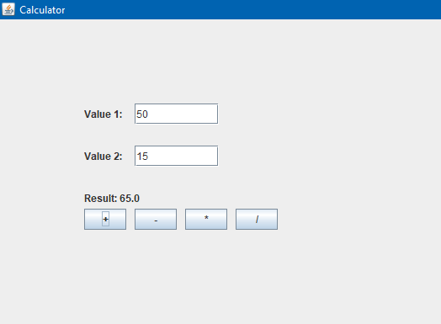

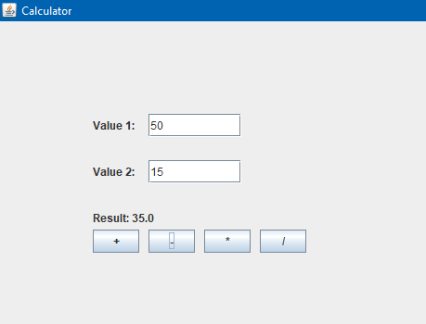 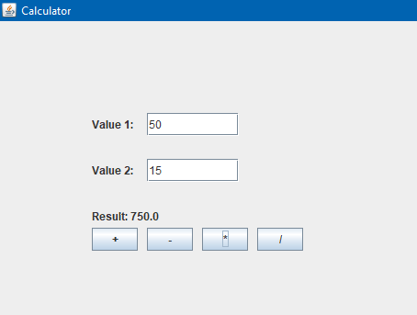

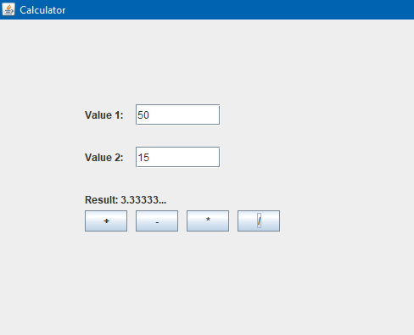

**Discussion  
The practice for making a GUI of a calculator which performed arithmetic operations on values when button clicked was understood and performed successfully.**

**Conclusion:**

**By completing this program, I learnt to create a GUI of a calculator and performed desired arithmetic operations.**

**Title**

**Create a simple calculation that takes input in a box and display results in same box.**

**Objective  
To learn how to create a GUI of a calculator having all input values in a box which is passed on click of input value buttons and arithmetic operations is performed on the button clicks and result displayed.**

**Program Code:**

**Main.java**

public class Main {

public static void main(String[] args) {

CalculatorGUI calc=new CalculatorGUI();

}

}

**CalculatorGUI.java**

import javax.swing.*;

import java.awt.event.ActionEvent;

import java.awt.event.ActionListener;

public class CalculatorGUI implements ActionListener {

JFrame f1;

JTextField display;

JButton b1,b2,b3,b4,b5,b6,b7,b8,b9,plus,minus,mul,div,zero,clear,res;

double num1 = 0, num2 = 0, result = 0;

char operator;

public CalculatorGUI(){

f1=new JFrame("Calculator");

f1.setVisible(true);

f1.setSize(600,800);

f1.setLayout(null);

f1.setDefaultCloseOperation(JFrame.EXIT_ON_CLOSE);

display=new JTextField();

display.setBounds(50,20,250,50);

b1=new JButton("1");

b2=new JButton("2");

b3=new JButton("3");

b4=new JButton("4");

b5=new JButton("5");

b6=new JButton("6");

b7=new JButton("7");

b8=new JButton("8");

b9=new JButton("9");

plus=new JButton("+");

minus=new JButton("-");

mul=new JButton("*");

div=new JButton("/");

clear=new JButton("C");

zero=new JButton("0");

res=new JButton("=");

b1.setBounds(180,175,50,40);

b2.setBounds(115,175,50,40);

b3.setBounds(50,175,50,40);

b4.setBounds(180,130,50,40);

b5.setBounds(115,130,50,40);

b6.setBounds(50,130,50,40);

b7.setBounds(180,85,50,40);

b8.setBounds(115,85,50,40);

b9.setBounds(50,85,50,40);

plus.setBounds(245,85,50,40);

minus.setBounds(245,130,50,40);

mul.setBounds(245,175,50,40);

div.setBounds(245,225,50,40);

res.setBounds(180,225,50,40);

zero.setBounds(115,225,50,40);

clear.setBounds(50,225,50,40);

b1.addActionListener(this);

b2.addActionListener(this);

b3.addActionListener(this);

b4.addActionListener(this);

b5.addActionListener(this);

b6.addActionListener(this);

b7.addActionListener(this);

b8.addActionListener(this);

b9.addActionListener(this);

plus.addActionListener(this);

minus.addActionListener(this);

mul.addActionListener(this);

div.addActionListener(this);

clear.addActionListener(this);

res.addActionListener(this);

zero.addActionListener(this);

f1.add(b1);

f1.add(b1);

f1.add(b2);

f1.add(b3);

f1.add(b4);

f1.add(b5);

f1.add(b6);

f1.add(b7);

f1.add(b8);

f1.add(b9);

f1.add(plus);

f1.add(minus);

f1.add(mul);

f1.add(div);

f1.add(clear);

f1.add(res);

f1.add(zero);

f1.add(display);

}

@Override

public void actionPerformed(ActionEvent e) {

String command = e.getActionCommand();

if ((command.charAt(0) >= '0' && command.charAt(0) <= '9') || command.charAt(0) == '.') {

display.setText(display.getText() + command);

} else if (command.charAt(0) == 'C') {

display.setText("");

num1 = num2 = result = 0;

operator = '\0';

} else if (command.charAt(0) == '=') {

num2 = Double.parseDouble(display.getText());

switch (operator) {

case '+':

result = num1 + num2;

break;

case '-':

result = num1 - num2;

break;

case '*':

result = num1 * num2;

break;

case '/':

result = num1 / num2;

break;

}

display.setText(String.valueOf(result));

} else {

if (!display.getText().isEmpty()) {

num1 = Double.parseDouble(display.getText());

operator = command.charAt(0);

display.setText("");

}

}

}}

**OUTPUT:**

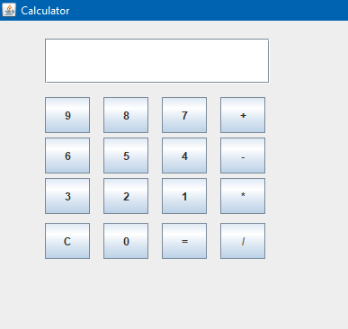 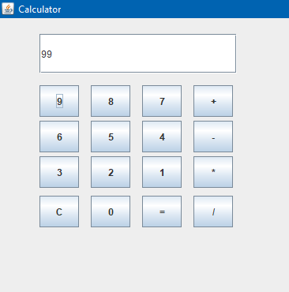 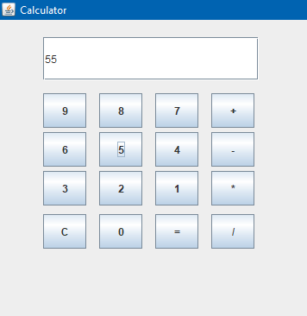 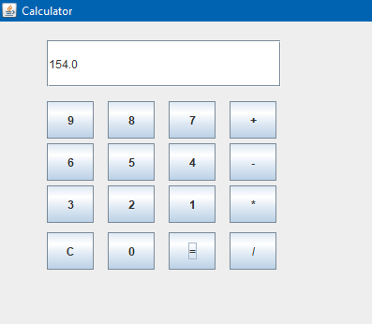

**Discussion  
The practice for making a GUI of a calculator which performed arithmetic operations on values which are passed through input value buttons button clicked was understood and performed successfully.**

**Conclusion:**

**By completing this program, I learnt to create a GUI of a calculator which had all input values as button inputs and performed desired arithmetic operations.**

**Title  
Create a gallery having some thumbnails with action listener and show full screen image when clicked.**

**Objective  
To learn how to create a gallery of desired images thumbnails and on click the desired images to be displayed on full screen.**

**Program Code:**

import javax.swing.*;

import java.awt.event.ActionEvent;

import java.awt.event.ActionListener;

public class Main {

public static void main(String[] args) {

JFrame f1 = new JFrame("Thumbnails");

f1.setLayout(null);

f1.setSize(1000, 1000);

f1.setVisible(true);

f1.setDefaultCloseOperation(JFrame.EXIT_ON_CLOSE);

ImageIcon img1 = new ImageIcon("C:\\Users\\pakhr\\Desktop\\6th sem\\AdvancedJava\\Lab reports\\lab6\\Images\\img1.jpg");

ImageIcon img2 = new ImageIcon("C:\\Users\\pakhr\\Desktop\\6th sem\\AdvancedJava\\Lab reports\\lab6\\Images\\img2.jpg");

ImageIcon img3 = new ImageIcon("C:\\Users\\pakhr\\Desktop\\6th sem\\AdvancedJava\\Lab reports\\lab6\\Images\\img3.jpg");

ImageIcon img4 = new ImageIcon("C:\\Users\\pakhr\\Desktop\\6th sem\\AdvancedJava\\Lab reports\\lab6\\Images\\img4.jpg");

JButton b1 = new JButton(img1);

JButton b2 = new JButton(img2);

JButton b3 = new JButton(img3);

JButton b4 = new JButton(img4);

b1.setBounds(0, 0, 400, 400);

b2.setBounds(400, 0, 400, 400);

b3.setBounds(0, 400, 400, 400);

b4.setBounds(400, 400, 400, 400);

b1.addActionListener(new ActionListener() {

public void actionPerformed(ActionEvent e) {

displayZoomedImage(img1);

}

});

b2.addActionListener(new ActionListener() {

public void actionPerformed(ActionEvent e) {

displayZoomedImage(img2);

}

});

b3.addActionListener(new ActionListener() {

public void actionPerformed(ActionEvent e) {

displayZoomedImage(img3);

}

});

b4.addActionListener(new ActionListener() {

public void actionPerformed(ActionEvent e) {

displayZoomedImage(img4);

}

});

f1.add(b1);

f1.add(b2);

f1.add(b3);

f1.add(b4);

}

public static void displayZoomedImage(ImageIcon icon) {

JFrame f2 = new JFrame("Zoomed Image");

f2.setSize(800, 800);

JLabel l2 = new JLabel(icon);

f2.add(l2);

f2.setVisible(true);

}

}

**OUTPUT:**

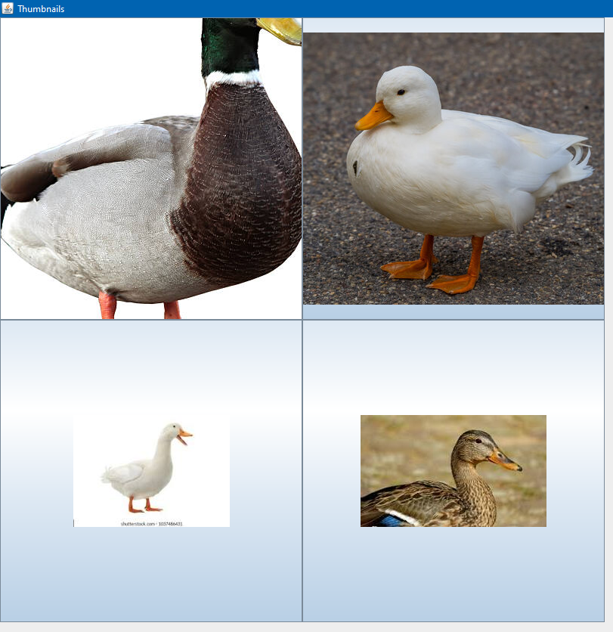

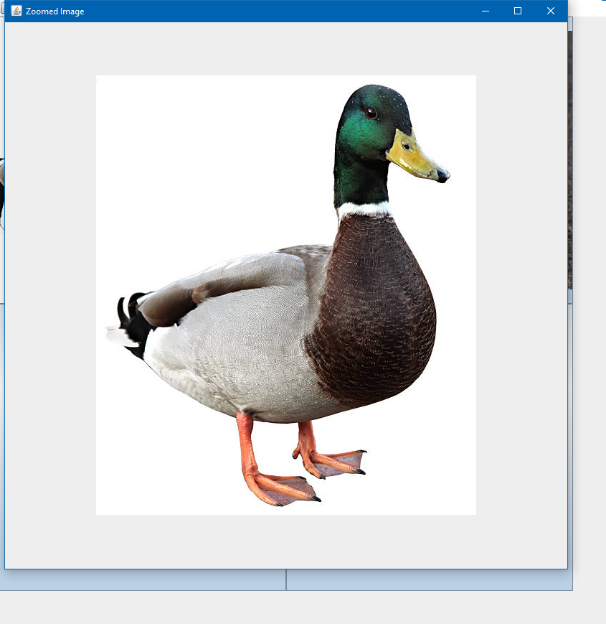

**Discussion  
The practice for making a GUI of a gallery of desired images thumbnails and on click the desired images to be displayed on full screen with the help of action listener was understood and performed successfully.**

**Conclusion:**

**By completing this program, I learnt to create a gallery of images and display desire image on full screen via the help of action listener.**