* 1. **Write the program to Demonstrate Which Protocol the virtual machine support?**

**Program:**

import java.net.*;

public class ProtocolChecker {

public static void main(String[] args) {

testProtocol("http://www.Whatsapp.com");

testProtocol("https://www.DrDuck.com");

testProtocol("ftp://ImageUploader.to");

testProtocol("mailto:Pakhrinayush56@gmail.com");

testProtocol("telnet://ARStore.to");

testProtocol("file:///BlahBlah/UserData");

testProtocol("gopher://gopher.anc.org.za/");

testProtocol("ldap://TU.com");

testProtocol("jar:http://LavieGarden.com");

testProtocol("nfs://utopia.poly.edu/usr/tmp/");

testProtocol("jdbc:mysql://Amazon.com:5000/Products");

testProtocol("rmi://ibiblio.org/RenderEngine");

testProtocol("doc:/UsersGuide/release.html");

testProtocol("netdoc:/UsersGuide/release.html");

testProtocol("systemresource://www.youtube.com/index.html");

testProtocol("verbatim:http://www.Facebook.com/");

}

private static void testProtocol(String url) {

try {

URL u = new URL(url);

System.out.println(u.getProtocol() + " is supported");

} catch (MalformedURLException ex) {

String protocol = url.substring(0, url.indexOf(':')); System.out.println(protocol + " is not supported");

}

}

}

**Output:**

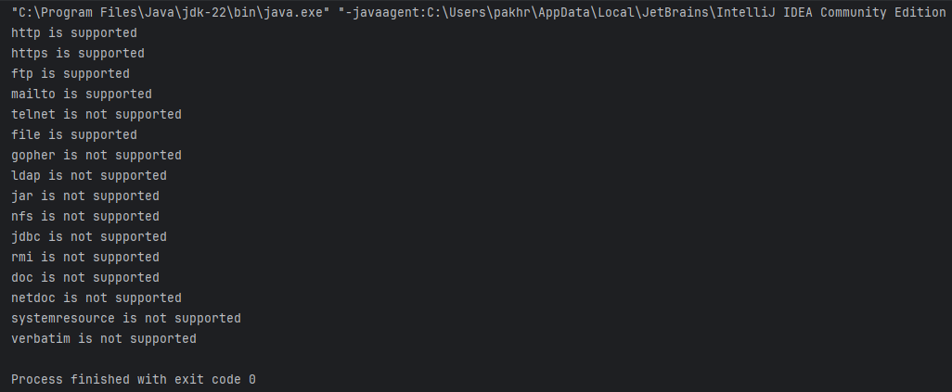

* 1. **Write a program to download the WebPage.**

**Program:**

import java.io.*;

import java.net.*;

public class WebPageDownloadProgram {

public static void main(String[] args) {

if (args.length > 0) {

InputStream in = null;

try {

URL u = new URL(args[0]);

in = u.openStream();

in = new BufferedInputStream(in);

Reader r = new InputStreamReader(in);

int c;

while ((c = r.read()) != -1)

{

System.out.print((char) c);

}

}

catch (MalformedURLException ex) {

System.err.println(args[0] + " is not a parseable URL");

}

catch (IOException ex) {

System.err.println(ex);

} finally {

if (in != null) {

try {

in.close();

}

catch (IOException e) {

System.out.println(e.getMessage());

}

}

}

}

}

}

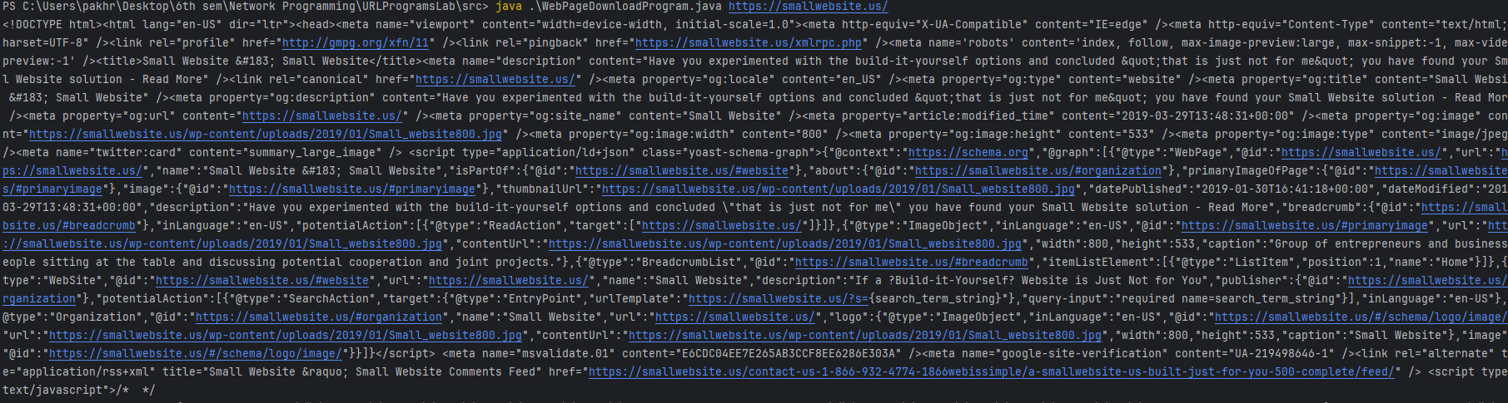**Output**:

* 1. **Write a program to download an Object.**

**Program:**

import java.io.*;

import java.net.*;

public class ObjectDownloadProgram {

public static void main(String[] args) {

if (args.length > 0) {

try {

URL u = new URL(args[0]);

Object o = u.getContent();

System.out.println("Object: " + o.getClass().getName());

} catch (MalformedURLException ex) {

System.err.println(args[0] + " is not a parseable URL");

} catch (IOException ex) {

System.err.println(ex.getMessage());

}

}

}

}

**Output:**



* 1. **Write a program to split the parts of a URL.**

**Program:**

import java.net.*;  
public class MyAddressProgram {  
 public static void main(String[] args){  
 try {  
 InetAddress me = InetAddress.getLocalHost();  
 String dottedQuad = me.getHostAddress();  
 System.out.println("My address: " + dottedQuad);  
 } catch (UnknownHostException ex) {  
 System.out.println("Myan! I got no address");  
 }  
 }  
}

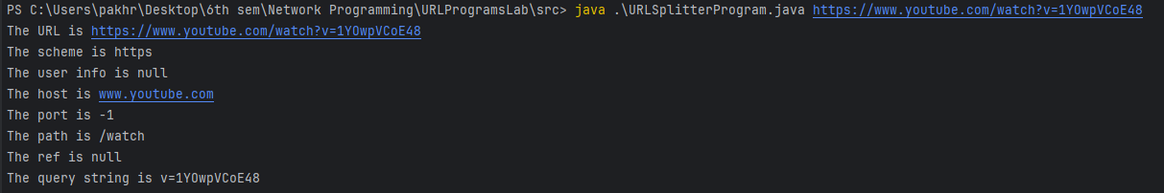**Output:**

* 1. **Write a program to compare two URLs.**

**Program:**

import java.net.*;

public class URLsCompareProgram {

public static void main(String[] args) {

try

{

URL first = new URL("https://www.animension.to/");

URL second = new URL("https://www.animension.com/");

if (second.equals(first)) {

System.out.println(second + " is the same as " + first);

} else {

System.out.println(second + " is not the same as " + first);

}

}

catch (MalformedURLException e)

{

System.err.println(e.getMessage());

}

}

}

**Output:**

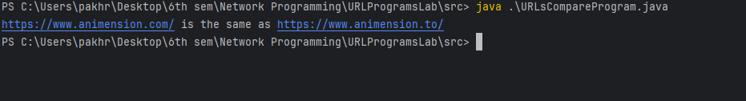

* 1. **Write a program to split the parts of URI .**

**Program:**

import java.net.*;

public class URISplitterProgram {

public static void main(String[] args) {

for (int i = 0; i < args.length; i++) {

try {

URI u = new URI(args[i]);

System.out.println("The URI is " + u);

if (u.isOpaque()) {

System.out.println("This is an opaque URI.");

System.out.println("The scheme is " + u.getScheme());

System.out.println("The scheme specific part is "

+ u.getSchemeSpecificPart());

System.out.println("The fragment ID is " + u.getFragment());

} else {

System.out.println("This is a hierarchical URI.");

System.out.println("The scheme is " + u.getScheme());

try {

u = u.parseServerAuthority();

System.out.println("The host is " + u.getHost());

System.out.println("The user info is " + u.getUserInfo());

System.out.println("The port is " + u.getPort());

} catch (URISyntaxException ex) {

System.out.println("The authority is " + u.getAuthority());

}

System.out.println("The path is " + u.getPath());

System.out.println("The query string is " + u.getQuery());

System.out.println("The fragment ID is " + u.getFragment());

}

}

catch(URISyntaxException ex){

System.err.println(args[i] + " does not seem to be a URI.");

}

System.out.println();

}

}

}

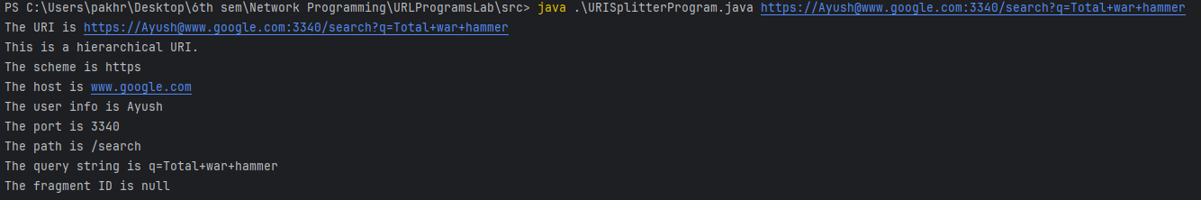**Output:**

* 1. **Write a Program to print various encoded strings.**

**Program:**

import java.io.*;

import java.net.*;

public class URLEncodeProgram {

public static void main(String[] args)

{

try

{

System.out.println(URLEncoder.encode("Yo string ma spaces xa","UTF-8"));

System.out.println(URLEncoder.encode("Yo*string*ma*asterisks*xa","UTF-8"));

System.out.println(URLEncoder.encode("Yo%string%ma%percent%signs%xa","UTF-8"));

System.out.println(URLEncoder.encode("Yo+string+ma+pluses%xa","UTF-8"));

System.out.println(URLEncoder.encode("Yo/string/ma/slashes/xa","UTF-8"));

System.out.println(URLEncoder.encode("Yo\"string\"ma\"quote\"marks\"xa","UTF-8"));

System.out.println(URLEncoder.encode("Yo:string:ma:colons:xa","UTF-8"));

System.out.println(URLEncoder.encode("Yo~string~ma~tildes~xa","UTF-8"));

System.out.println(URLEncoder.encode("Yo(string)ma(parentheses)xa","UTF-8"));

System.out.println(URLEncoder.encode("Yo.string.ma.periods.xa","UTF-8"));

System.out.println(URLEncoder.encode("Yo=string=ma=equals=signs=xa","UTF-8"));

System.out.println(URLEncoder.encode("Yo&string&ma&ampersands&xa","UTF-8"));

System.out.println(URLEncoder.encode("Yoéstringémaé non-ASCII characters xa","UTF-8"));

}

catch (UnsupportedEncodingException ex)

{

System.out.println("Broken VM does not support UTF-8");

}

}

}

**Output:** 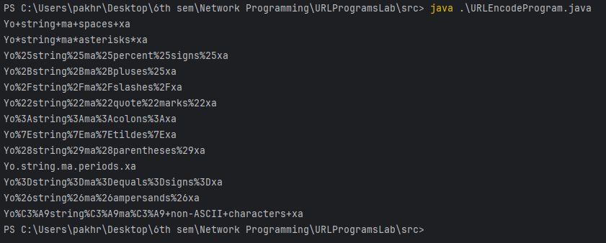

* 1. **Write a program that decode the provided URL.**

**Program:**

import java.io.UnsupportedEncodingException;

import java.net.URLDecoder;

public class URLDecodeProgram {

public static void main(String[] args) {

try {

String input = "https://www.google.com/search?q=Total+war+hammer&oq=Total+war+hamme";

String query = input.substring(input.indexOf('?') + 1);

String decodedQuery = URLDecoder.decode(query, "UTF-8");

String output = input.substring(0, input.indexOf('?') + 1) + decodedQuery;

System.out.println("Original URL: " + input);

System.out.println("Decoded URL: " + output);

}

catch (UnsupportedEncodingException e)

{

System.out.println(e.getMessage());

}

}

}

**Output:**

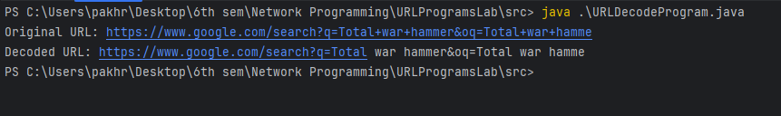

* 1. **Write a program to demonstrate a ProxySelector that remembers what it can connect to.**

**Program:**

**ProxyProgram.java**

import java.io.IOException;

import java.net.HttpURLConnection;

import java.net.*;

public class ProxyPrograms {

public static void main(String[] args){

java.net.ProxySelector.setDefault(new LocalProxySelector());

try {

URL url=new URL("https://www.youtube.com");

HttpURLConnection connection=(HttpURLConnection) url.openConnection();

connection.connect();

System.out.println("HTTP Request Succeeded: "+connection.getResponseCode());

}catch(IOException e){

System.out.println("HTTP Request Failed!");

}

try {

URL url=new URL("https://www.facebook.com");

HttpURLConnection connection=(HttpURLConnection) url.openConnection();

connection.connect();

System.out.println("HTTP Request Succeeded: "+connection.getResponseCode());

}catch(IOException e){

System.out.println("HTTP Request Failed!");

}

try {

URL url=new URL("https://www.instagram.com");

HttpURLConnection connection=(HttpURLConnection) url.openConnection();

connection.connect();

System.out.println("HTTP Request Succeeded: "+connection.getResponseCode());

}catch(IOException e){

System.out.println("HTTP Request Failed!");

}

try {

URL url=new URL("https://www.asdasd.com");

HttpURLConnection connection=(HttpURLConnection) url.openConnection();

connection.connect();

System.out.println("HTTP Request Succeeded: "+connection.getResponseCode());

}catch(IOException e){

System.out.println("HTTP Request Failed!");

}

}

}

**LocalProxySelector.java**

import java.io.*;

import java.net.*;

import java.util.*;

public class LocalProxySelector extends ProxySelector {

private List<URI> failed = Collections.synchronizedList(new ArrayList<URI>());

public List<Proxy> select(URI uri) {

List<Proxy> result = new ArrayList<Proxy>();

if (failed.contains(uri) || !"http".equalsIgnoreCase(uri.getScheme())) {

result.add(Proxy.NO_PROXY);

} else {

SocketAddress proxyAddress = new InetSocketAddress("proxy.example.com", 8000);

Proxy proxy = new Proxy(Proxy.Type.HTTP, proxyAddress);

result.add(proxy);

}

return result;

}

public void connectFailed(URI uri, SocketAddress address, IOException ex) {

System.err.println("Connection to " + uri + " failed: " + ex.getMessage());

failed.add(uri);

}

public static void main(String[] args) {

java.net.ProxySelector.setDefault(new LocalProxySelector());

}

}

**Output:**

