The FOLLOWER algorithm measures the distance between two points as one or both move through a metric space. It was conceived during the development of the measure of distance between two different crystallographic unit cells (lattices). (See the publications of Andrews and Bernstein for explanations of various such measures.)

The current (2021) implementation is PointDistanceFollower (PDF). PDF implements several modes of operation. They are named POINT, LINE, CHORD, CHORD3, and TRIANGLE (see the publication of Andrews and Bernstein 2021).
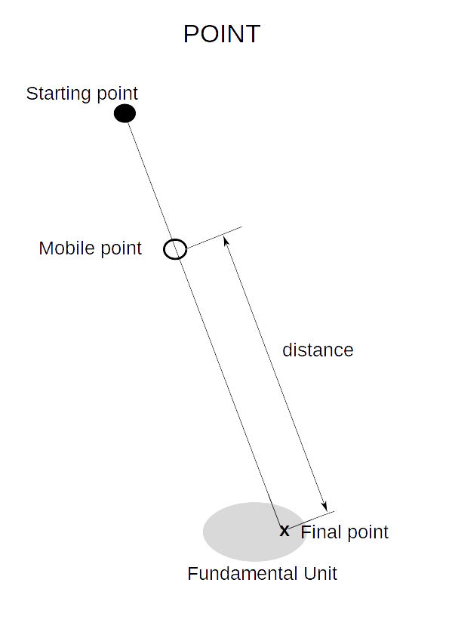
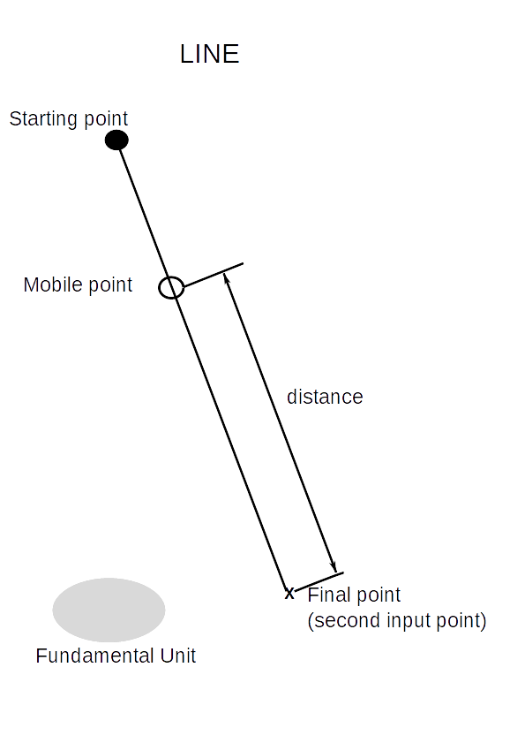
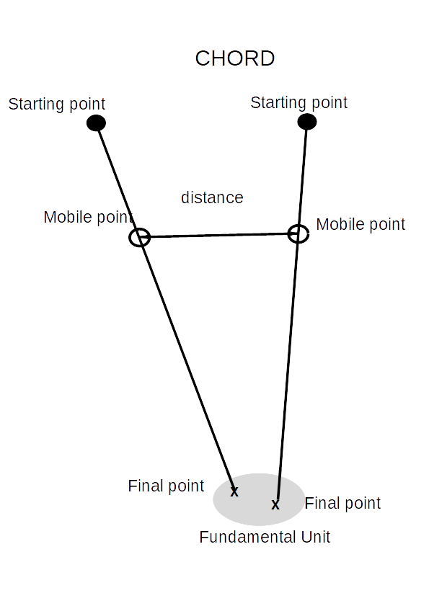
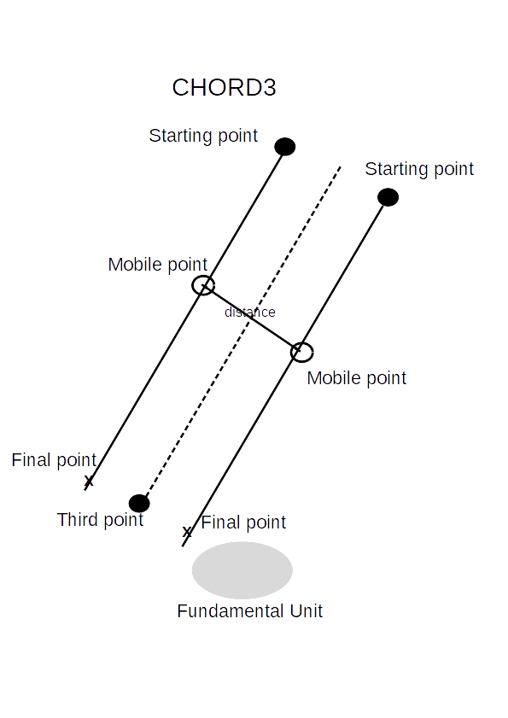
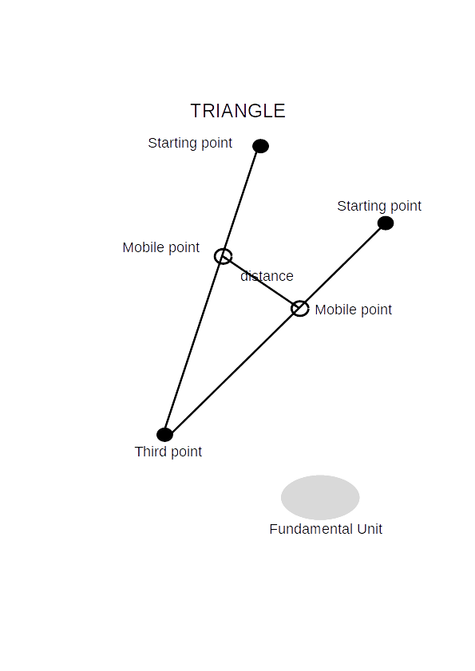

From the figures we see that POINT, LINE, CHORD, CHORD3, and TRIANGLE consume one, two, two, three, and three unit cells respectively for each plot generated. Input unit cells have various forms that they can enter in: Input is case insensitive.

Type of cell input | Label | Example
unit cell parameters | Any of P,A,B,C,I,F,R,H | P 10 10 10 66 66 66
S⁶ | S or S6 | S 0 0 0 -100 -100 -100
G⁶ | G or G6 or V | G 100 100 200 0 0 0
D⁷ | D7
C³ | C3 | C3 followed by the real parts, then imaginary
Random | random | random

For R and H: If R is input and the angles are all equal, it is assumed that the input is a primitive rhombohedral cell; if the angles are 90, 90, 120, then it is assumed that the input is a triply-primitive rhombohedral cell. If the input is H, it is assumed to be a primitive cell, rhombohedral if the angles are equal, and hexagonal if the angles are 90, 90, 120. The choice and use of R or H in the literature is quite inconsistent (including in the Protein Data Bank).

INPUT
PDF input consists of two sections: setup and unit cell data. Each section must be completed with a text line “end”. All input is case insensitive. In setup section, each line has a specifier followed by a datum. The specifier is spelling-insensitive; if there is not an exact match to the input, then the “closest” match will be used. For example, “StepsPerFrame” and “steps” will both be recognized as StepsPerFrame. The datum value must be spelled exactly, or it will be ignored.

SETUP
The most useful setup commands are listed in the table below. The order does not matter, and if a command is input more than once, the last value will be used.
trials (default = 30, trials per input data)
FilePrefix (default = “Fol”)
stepsPerFrame (default = 100)
GlitchesOnly (default = false)
GlitchLevel (default = 3%)
RandomSeed (default = 19191)
PerturbBy (default = 0.05, multiplied times a random direction and added to the probe)
TimeStamp (default = true; false will produce output with no timestamp in the file names)
ENABLE/DISABLE (default is enable “S6” and “CS”) allows to turn on distance plotting and calculation for S6, G6, D7, DC, and CS (CS6Dist).
FOLLOWERMODE (default = “point”) for modes POINT, LINE, CHORD, CHORD3, and TRIANGLE

UNIT CELL DATA
The forms of input data are in the table above. They can be used mix-and-match. Invalid cells (including misspelling of the type) will be rejected with a console message. Data following the numeric specification is ignored.

BUILDING AND RUNNING POINTDISTANCEFOLLOWER

The zip file contains the folder /Follower. The source is in the folder /Follower/Follower (sic). Not other files are needed for the source.

To build in Linux, gcc version 9.3.0 has been used. From the folder /Follower/Follower, the following command suffices to build:
g++ *.cpp -o follow
to create the executable file “follow”.

Visual Studio 2019 can be used to build also. The .sln file is in the folder /Follower. (The project files are in the folder /Follower/Follower /Follower/Follower. VS 2022 (initial Preview) also compiled the source correctly.

The input is described above, and examples are given below.

EXAMPLE OF INPUT

trials 3
steps 17
end
random
end
---will generate three output files with 17 calculated points plotted. The starting points will be some randomly chosen cell, perturbed by 5% in S6. The points used will go from the start to the reduced cell. The 5% perturbation will be in a different direction in each plot.

Trials 1
perturbby 0
FollowerMode LINE
end
p 10 10 10 75 75 75
p 10 10 10 105 105 105
end
---will generate one output file with 100 (default) points plotted). The line will go from the all acute rhombohedral cell to the all acute one (exact cells because PerturbBy is zero).

Trials 20
followermode point
end
s -100 -20 -40 -200 -50 -37
random
random
random
random
end

This will generate 100 output files. There will be 20 starting from the same (perturbed) lattice.

OUTPUT:
For each plot generated, there will be two output files. One will have the extension “svg” and the other “txt”. The text file contains information about steps in the plot. The svg file can be viewed in any browser (and in some graphics programs; inkscape can read these files). The svg file also contains the input for the run and the actual first and last steps for the graph.

The file names begin with the current prefix, “FOL_” unless the setup has changed the prefix. The prefeix is followed by a timestamp of the date and time of the run. The timestamp will be the same for each of the “trials”. For example in the “trials 20” example above, there will be five timestamps used in the 100 runs. Finally, the sequence number of the input cell is appended, followed by the ordinal of the trial.

This input:
trials 3
end
random
random
end
results in:
# Fol_2021-06-17.10_13_26.0_0 first cell, first trial
# Fol_2021-06-17.10_13_26.0_1 first cell, second trial
# Fol_2021-06-17.10_13_26.0_2 first cell, third trial
# Fol_2021-06-17.10_13_26.1_0 second cell, first trial
# Fol_2021-06-17.10_13_26.1_1 second cell, second trial
# Fol_2021-06-17.10_13_26.1_2 second cell, third trial
The date is 2021-06-17. The time is 10_13_26.

