POINTDISTANCEFOLLOWER

Global Inputs:
(Input keywords are case-insensitive and rather spelling insensitive. The data is case-insensitive.)

trials (default = 30, trials per input data)
FilePrefix (default = “Fol”)
steps (default = 100)
GlitchesOnly (default = false)
GlitchLevel (default = 3%)
RandomSeed (default = 19191)
PerturbBy (default = 0.05, multiplied times a random direction and added to the probe)
TimeStamp (default = true; false will produce output with no timestamp in the file names)
ENABLE/DISABLE (default = “S6” and “CS”) allows to turn on distance plotting and calculation for S6, G6, D7, and CS6Dist.
FOLLOWERMODE (default = “POINT”) for modes point, line and line3
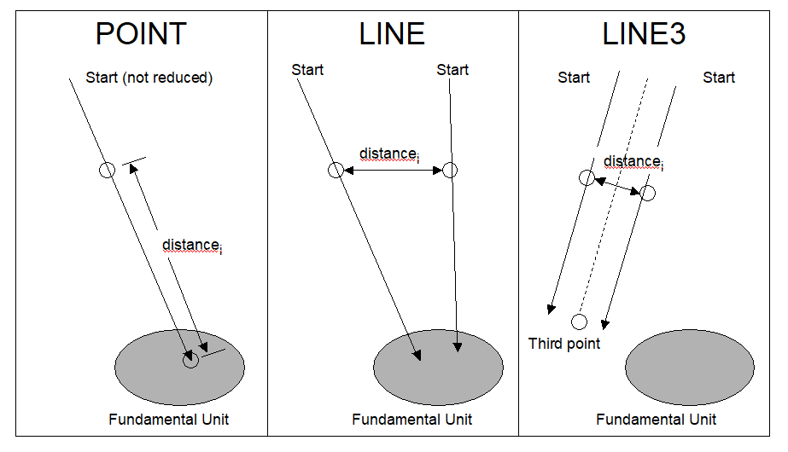
END (ends the global input section)

Data Inputs:
Input starting points for the scan. If the input is Selling-reduced, then it will be ignored. These are case-insensitive.

RANDOM (PointDistanceFollower chooses the starting point)

Vector Input:
v (or g or g6) for G6 vectors
d (or d7) for D7 vectors
s (or s6) for Delone/Selling scalars
C3 for C3 input (without parentheses or commas, “C” would be interpreted as a C-centered unit cell)

Crystal Lattice Input:
"A ", "B ", "C ", "P ", "R ", "F ", "I " followed by three axis lengths and three angles (in degrees)

END (ends the data input section)

Usage:
PointDistanceFollower starts from an unreduced point (Selling reduction). The reduced point is generated, and the distances calculated from points along the line between the two. The output is two files. Distances are calculated in any of 4 systems, but currently only S6Dist and CS6Dist are used. A one-line code change will enable the others.

The probe points and the distances are listed in the .txt file. Glitches in any of the distances are marked with the word “glitch”.

The SVG file contains a graph of the distances for each of the distance-calculation-systems. Glitches are marked, but the detection may incorrectly mark other places.

Examples:

Output file names:
Fol_2018-05-15.09_27_13.7_6.svg and Fol_2018-05-15.09_27_13.7_6.txt

Input:

---- output 7 files
trials 1
stepsperframe 100
randomseed 21
end
random
random
random
random
random
random
random
end

---- output 40 files
trials 20
stepsperframe 100
randomseed 21
end
c3 -90.714 -134.359 -175.439 -143.205 -0.866 -0.213
c3 -173.877 -90.668 -133.484 -142.412 -0.627 -0.013
end

---- output one file
Trials 1
end
random
end

