CS 373 - Fall 2003 – NMG ******* Solution ****************
September 19, 2003
Homework Assignment 3, P11 fixed, P7, P8 fixed
Due 9/26/03 (Friday) at the end of class

Problems related to chapter 3.
Notation: let RE stand for regular expression.
In the problems below regular expressions may be simplified using the identities given in the Supplementary Notes for chapter 3 (posted along with the lecture notes). If you do simplify an RE, then you must stated which of the identities you used.
P1. Consider the regular languages denoted by the following pairs of regular expressions. For each pair, determine whether the two languages are equal. If so give a proof using the algebraic identities (or “laws”) included in the Supplementary Notes for chapter 3 (posted along with the lecture notes); if not give a counterexample of a string in one that is not in the other.
(a) (0 + 1)* 0* + 1*
(b) 0(120)*12 01(201)*2
(c) ∅* λ*
(d) (0*1*)* (0*1)*
(e) (01 +0)*0 0(10 +0)*
P2. Sketch a DFA accepting the set of strings matching the regular expression (01 + 10).

P3. Find an NFA that accepts the language given by the regular expression:
(a+b)* + aba(aba)*.
a. (5 points) Use the formal method given in the text for Theorem 3.1.
b. (5 points) Now solve this problem in one state!

P4. If r, s, and t are regular expressions, prove that r = s*t implies that r = sr +t . You may assume that RE’s are commutative under “+”, λr = rλ = r, and r(s+t) = rs + rt.

P5. For the regular expression r = (0 + 1(01*0)*1)*, sketch an NFA which accepts the language generated by r. Use the formal method given in the text for Theorem 3.1.

P6. Construct a DFA for the regular language given by c*(a+bc*)*.

P7. Part a: Sketch a graph for a DFA on ∑ = {0,1} which accepts any bit string whose decimal value is a multiple of 4 plus 2. For example the binary representations for the decimal integers: 2, 6, 10, 14, 18, 22, … are accepted and all others are rejected. Decimal 0 counts as a multiple of 4 and leading zeros are allowed.

Part b: Using the algorithm given in the Supplementary Notes for chapter 3 (posted along with the lecture notes) , reduce this graph to two states: an initial state and a final state with no more that four links each labeled with a regular expression (this is what the text calls a “Generalized Transition Graph”). Note that the algorithm cited above must be used and demonstrated. There is no credit for a “seat of the pants” solution. Demonstrate the algorithm by starting with the original graph, and then make separate “partial solution” graphs for each node that you eliminate, finally ending up with the two state solution.

Part c: Finally read the overall regular expression from the Generalized Transition Graph in Part b. Your result should fit formula 3.1 in Linz’s text.

P8. Find regular grammars for the following languages on ∑ = {a, b}:
a. L is all strings with exactly one a ∈ ∑.
b. L is all strings with at least one a ∈ ∑.
P9. Find a regular grammar that generates the language L(aa*(ab + a)* ). Verify your solution by deriving the string: aaaababa .

P10. Find a regular grammar that generates the lanuage on {a,b} consisting of all strings with no more than two a’s.

P11. Find a DFA that accepts the complement of the language: L(ab*aa + bba*ab)
Hint: use the result of part a.

P12. Review and understand problem 3.2.8 in Linz – answer in back of book: no credit on this one, but the concepts are fair game for quizzes or exams.
Answers:

P1. Consider the regular languages denoted by the following pairs of regular expressions. For each pair, determine whether the two languages are equal. If so give a proof using the algebraic identities (or “laws”) included in the Supplementary Notes for chapter 3 (posted along with the lecture notes); if not give a counterexample of a string in one that is not in the other.
(a) (0 + 1)* 0* + 1*
(b) 0(120)*12 01(201)*2
(c) ∅* λ*
(d) (0*1*)* (0*1)*
(e) (01 +0)*0 0(10 +0)*
(a) Not equal. The string 01 matches the left expression but not the right one.
(b) Equal. The proof is a one-step application of the sliding rule 14.
(c) Equal. By rules 10, 3 and 9, ∅* = λ + ∅∅*. We show that λ = λ* also.
(d) Not equal. The string 0 matches the left expression but not the right one.
(e) Equal. Both expressions match the set of strings not containing the substring 11.
(01 + 0)*0 = (0(1 + λ))*0 rules 6 and 7
= 0((1 + λ)0)* rule 14
= 0(10 + 0)* rules 6 and 8

P2. Sketch a DFA accepting the set of strings matching the regular expression (01 + 10).

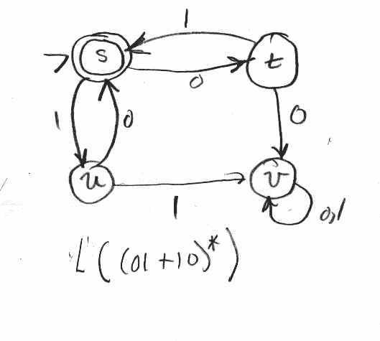
P3. Find an NFA that accepts the language given by the regular expression:
(a+b)* + aba(aba)*.
a. (5 points) Use the formal method given in the text for Theorem 3.1.
b. (5 points) Now solve this problem in one state!

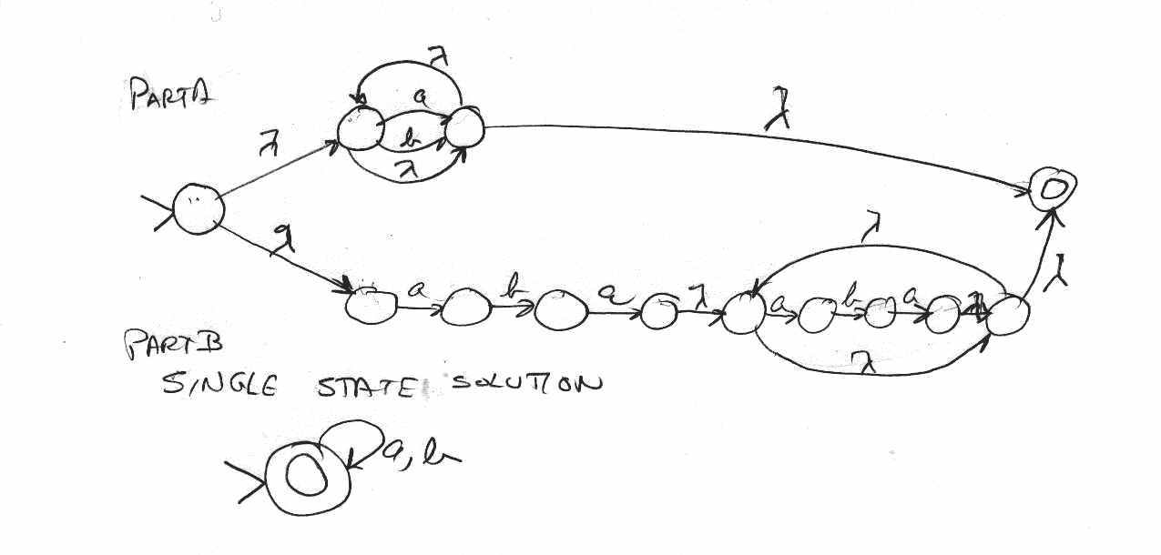

P4. If r, s, and t are regular expressions, prove that r = s*t implies that r = sr +t . You may assume that RE’s are commutative under “+”, λr = rλ = r, and r(s+t) = rs + rt.

r = s*t = (λ + s⁺)t since by definition, s⁺ = λ + s*, using a set interpretation of the RE s
= (λ + ss* )t since sλ= s and thus ss* = s⁺
= λt + ss*t associative law
= t + sr since λt = t and s*t = r (a given)
= sr + t commutative law

P5. For the regular expression r = (0 + 1(01*0)*1)*, sketch an NFA which accepts the language generated by r. Use the formal method given in the text for Theorem 3.1.
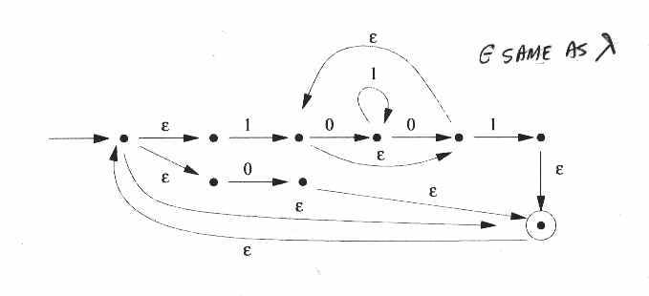

P6. Construct a DFA for the regular language given by c*(a+bc*)*.
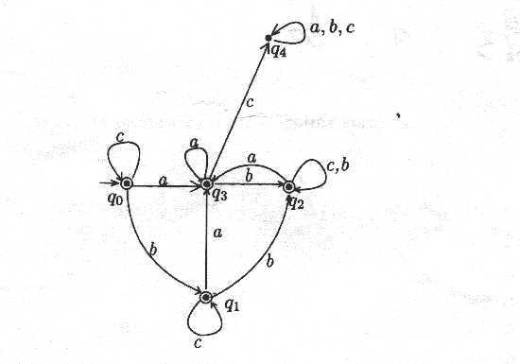

P7. Part a: Sketch a graph for a DFA on ∑ = {0,1} which accepts any bit string whose decimal value is a multiple of 4 plus 2. For example the binary representations for the decimal integers: 2, 6, 10, 14, 18, 22, … are accepted and all others are rejected. Decimal 0 counts as a multiple of 4 and leading zeros are allowed.

Part b: Using the algorithm given in the Supplementary Notes for chapter 3 (posted along with the lecture notes) , reduce this graph to two states: an initial state and a final state with no more that four links each labeled with a regular expression (this is what the text calls a “Generalized Transition Graph”). Note that the algorithm cited above must be used and demonstrated. There is no credit for a “seat of the pants” solution. Demonstrate the algorithm by starting with the original graph, and then make separate “partial solution” graphs for each node that you eliminate, finally ending up with the two state solution.

Part c: Finally read the overall regular expression from the Generalized Transition Graph in Part b. Your result should fit formula 3.1 in Linz’s text.

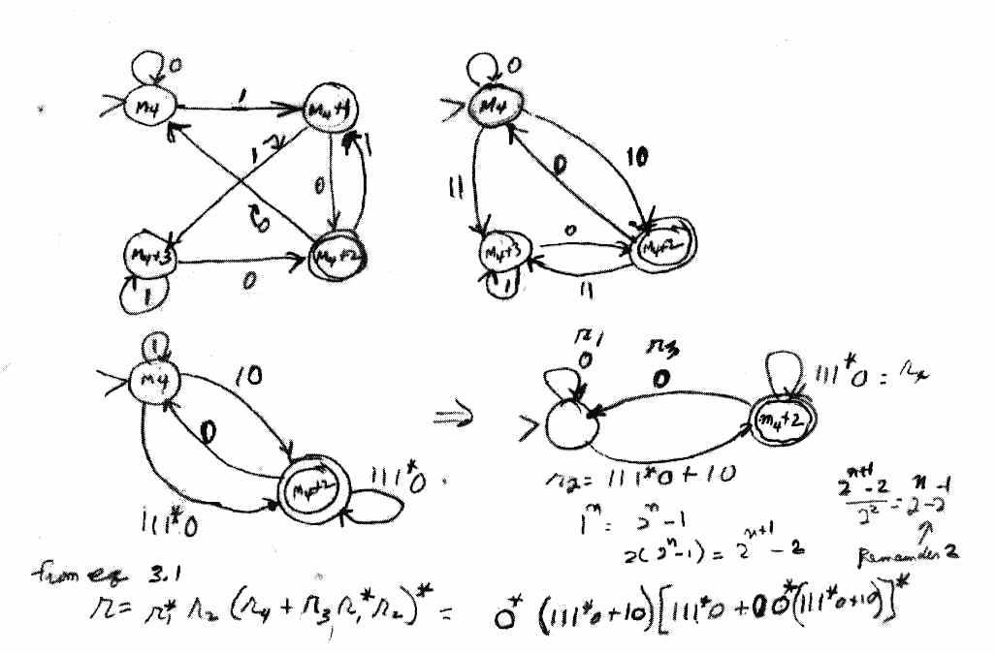

P8. Find regular grammars for the following languages on ∑ = {a, b}:
a. L is all strings with exactly one a ∈ ∑.
$Answer: S -> bS | A
A -> aB
B -> bB | λ
b. L is all strings with at least one a ∈ ∑.
$Answer: S -> aS | bS | A
A -> aB
B -> aB | bB | λ

P9. Find a regular grammar that generates the language L(aa*(ab + a)* ). Verify your solution by deriving the string: aaaababa .
Solution:
G = (V; T, S, P), where
V = {S, A, B}
T = {a, b}
P:
S -> aA
A -> aA | B
B -> abB | aB | λ
S ➔ aA ➔aaA ➔ aaaA ➔ aaaB ➔ aaaabB ➔ aaaababB ➔ aaaababaB ➔ aaaababa

Alternate solution:
S -> aA
A -> aA | aB | λ
B -> bA
The derivation of a string aaaababa:
S ➔ aA ➔ aaA ➔ aaaA ➔ aaaaB ➔ aaaabA ➔ aaaabaB
➔ aaaababA ➔ aaaababaA ➔ aaaababa
P10. Find a regular grammar that generates the language on {a,b} consisting of all strings with no more than two a’s.
Answer:
L₀: has no a’s:
S₀ -> bS₀ | λ

L₁: has only one a:
S₁ -> bS1 | aA₁
A₁ -> b A₁ | λ

L₂: hs only two a’s
S₂ -> bS₂ | aA₂
A₂ -> bA₂ | aB₂
B₂ -> bB₂ | λ

L -> L₀ | L₁ | L₂ ie., L = L₀ ∪ L₁ ∪ L₂ is regular because L₀ , L₁ , and L₂ are regular

P11. Find a DFA that accepts the complement of the language: L(ab*aa + bba*ab)

Solution:
