CREATE TABLE emp(

ID INT PRIMARY KEY AUTO_INCREMENT,

FIRST_NAME VARCHAR(50) NOT NULL,

LAST_NAME VARCHAR(50) NOT NULL,

EMAIL VARCHAR(50) NOT NULL UNIQUE,

DEPARTMENT VARCHAR(50),

SALARY INTEGER,

DATE_OF_JOINING DATE);

Task -1

Write an SQL query to fetch “FIRST_NAME” from the Worker table using the alias name as <WORKER_NAME>.

Select FIRST_NAME as WORKER_NAME from emp;

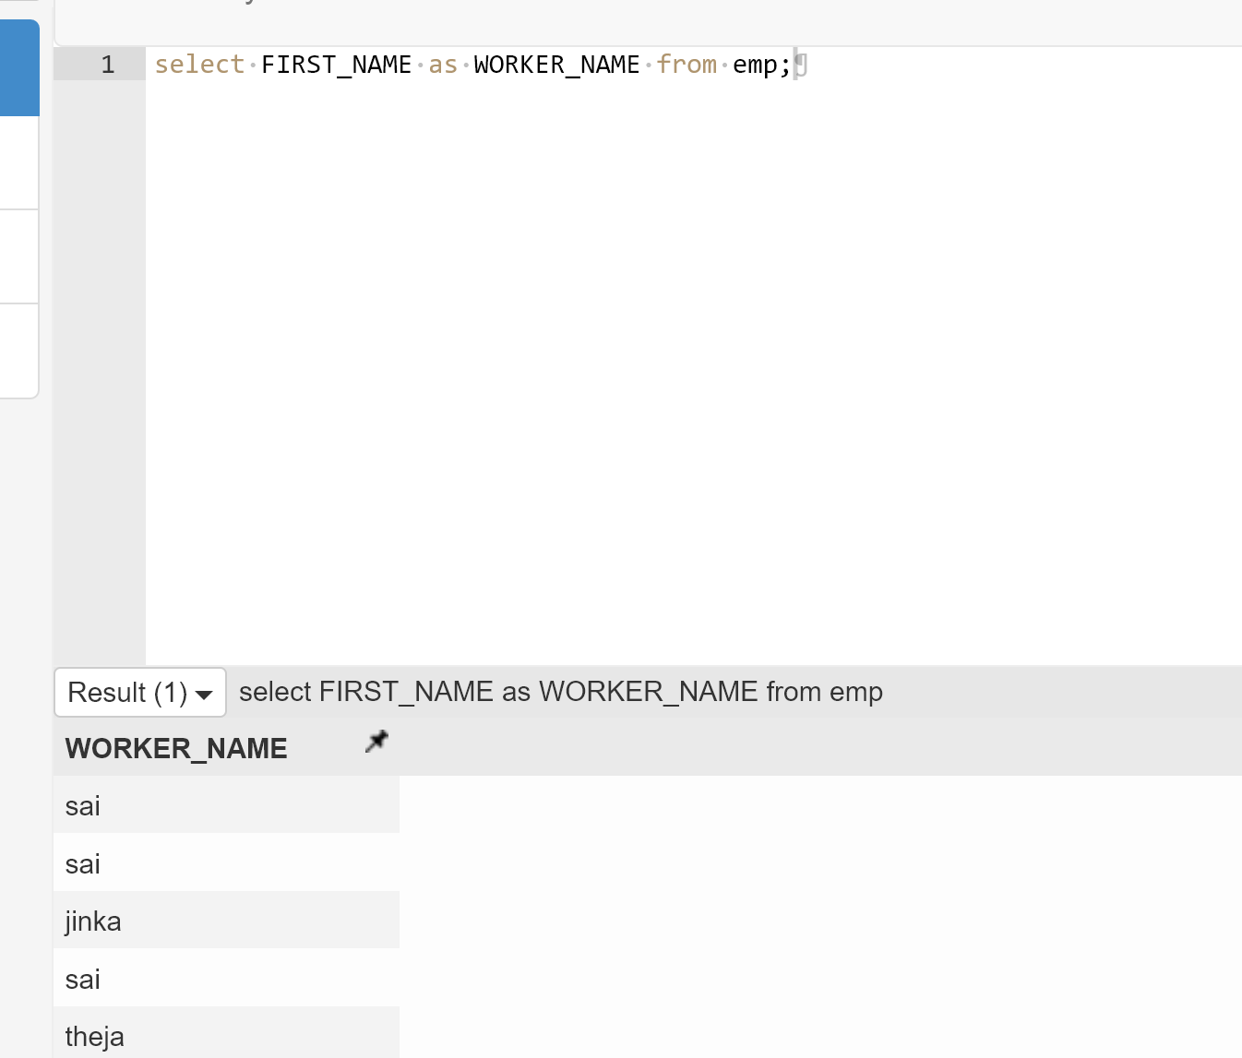

Write an SQL query to fetch unique values of DEPARTMENT from the Worker table.

Select distinct department from emp;

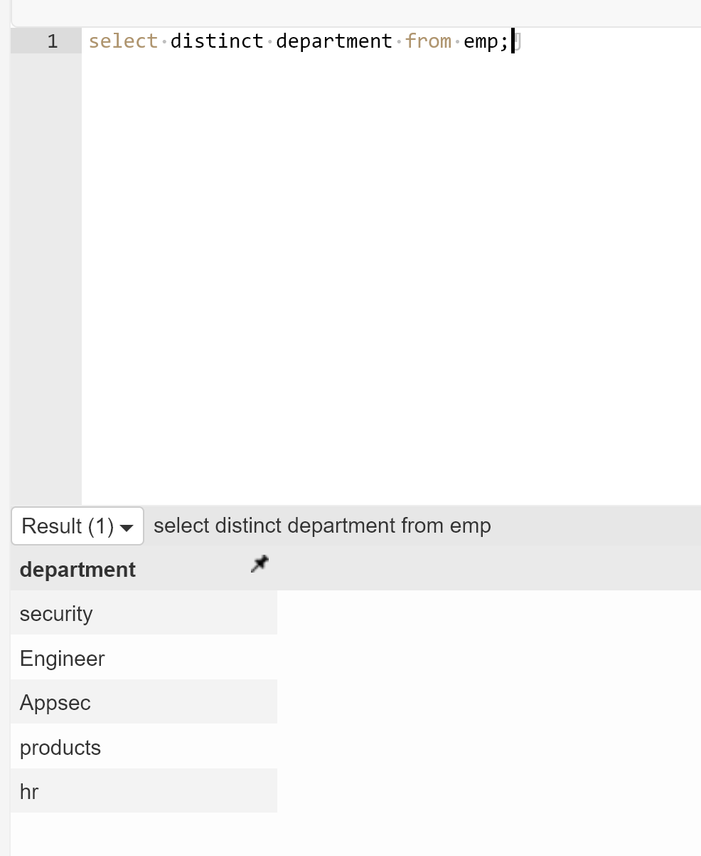

Write an SQL query to show the last 5 records from a table.

Select * from emp order by id desc limit 5

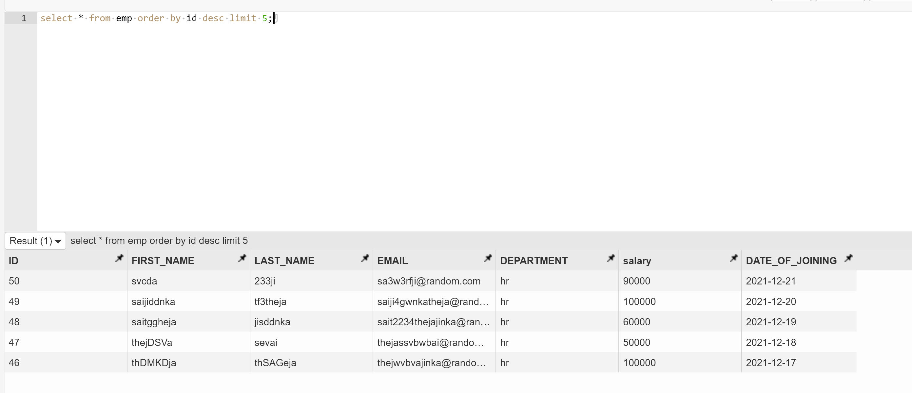

Task – 2

Write an SQL query to print the first three characters of FIRST_NAME from Worker

Select substring(FIRST_NAME,1,3) from emp;

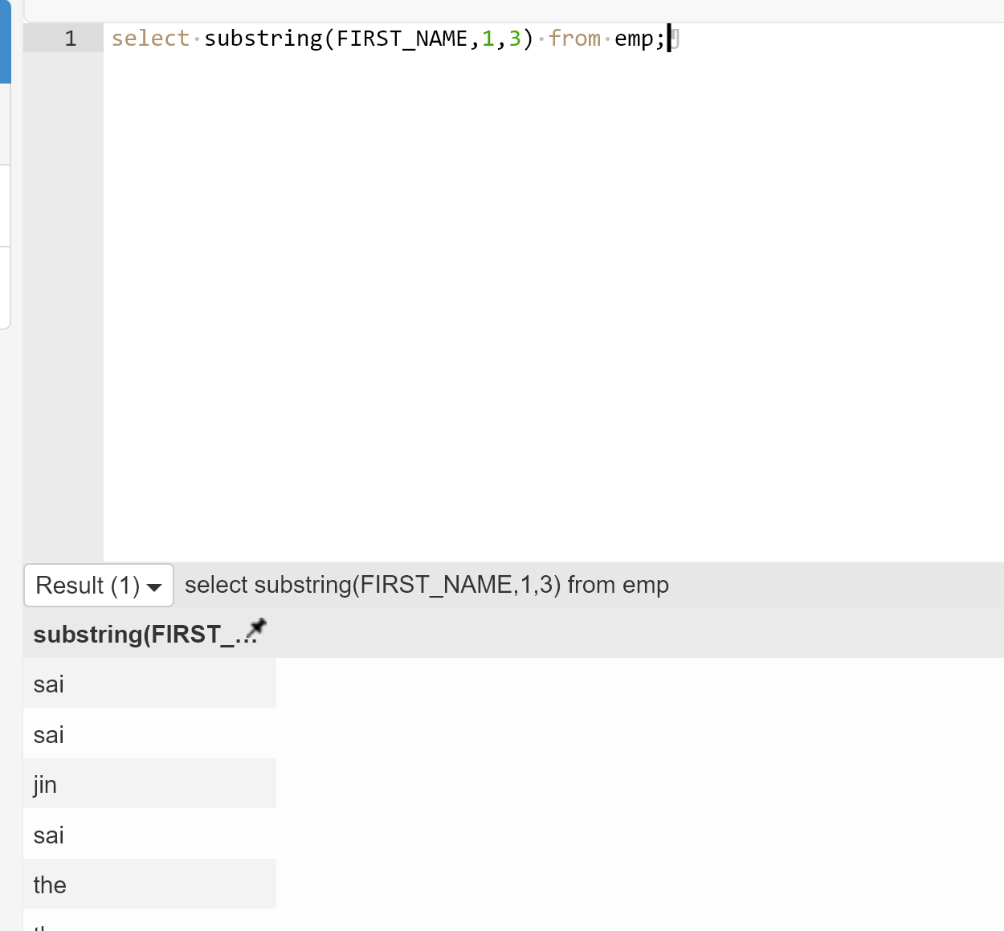

Write an SQL query to find the position of the alphabet (‘a’) in the first name

Select instr(FIRST_NAME,’a’) from emp

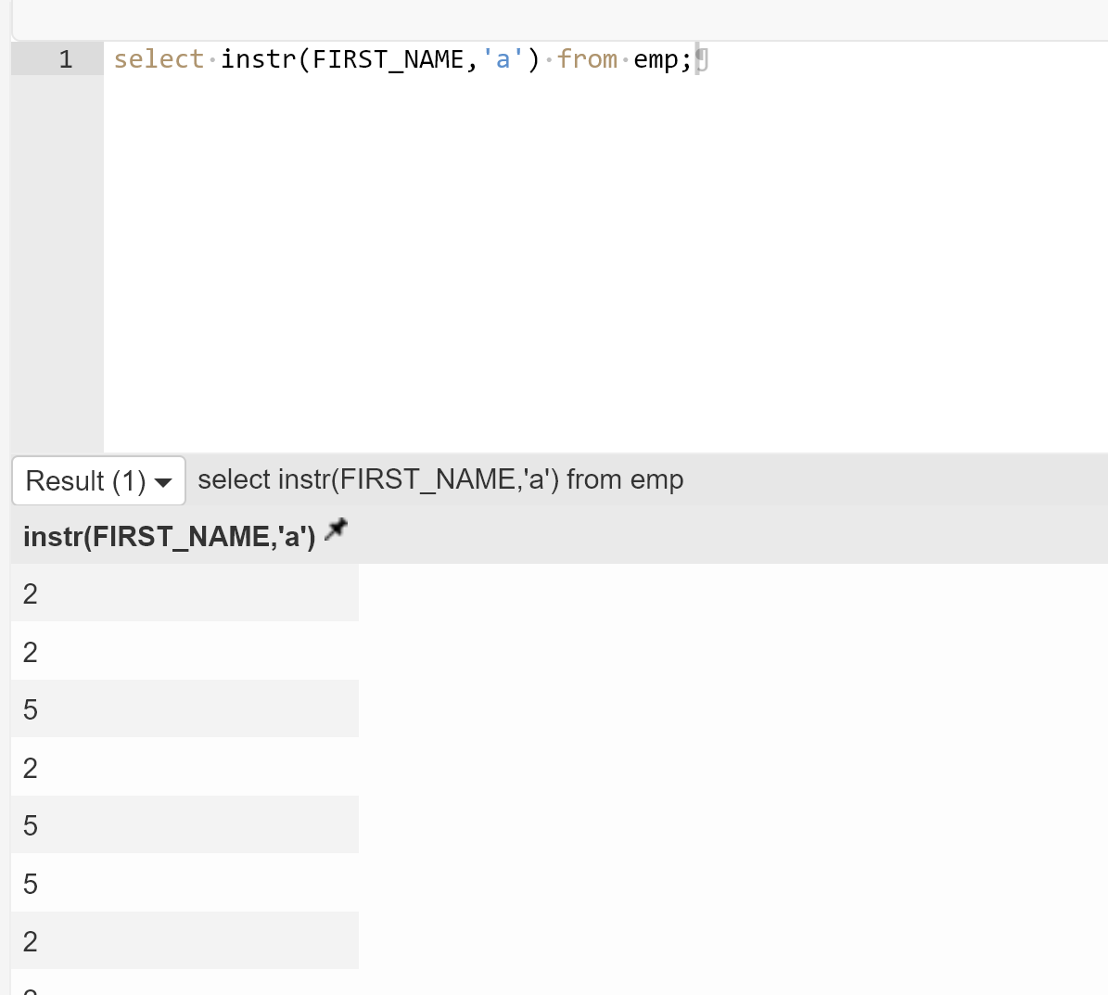

Write an SQL query to print the name of employees who have the highest salary in each department.

Select max(salary) from emp group by department

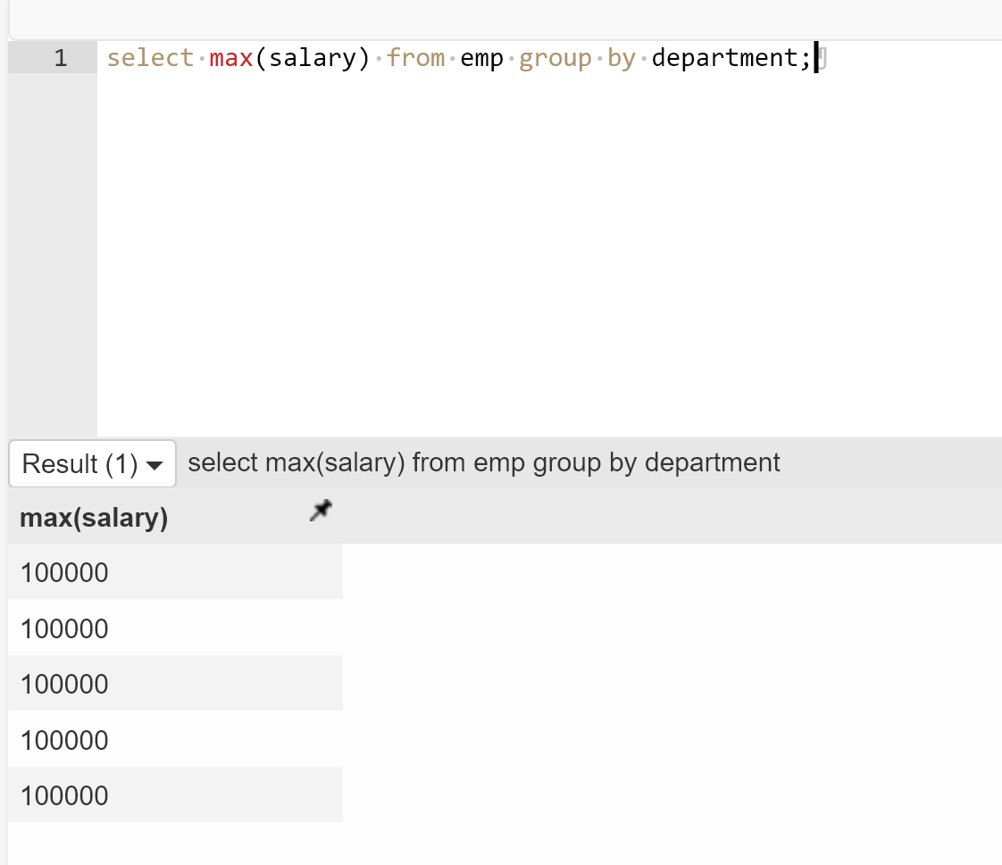

Task – 3

Write an SQL query to print the FIRST_NAME from the Worker table after removing white spaces from the right side.

Select rtrim(FIRST_NAME) from emp

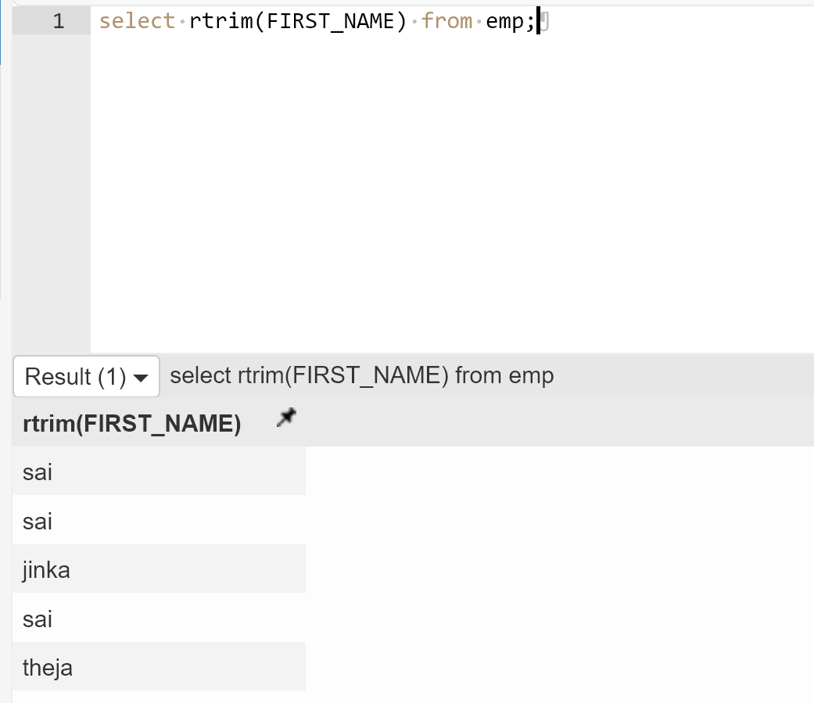

Write an SQL query that fetches the unique values of DEPARTMENT from the Worker table and prints its length.

Select DISTINCT department, length(department) from emp

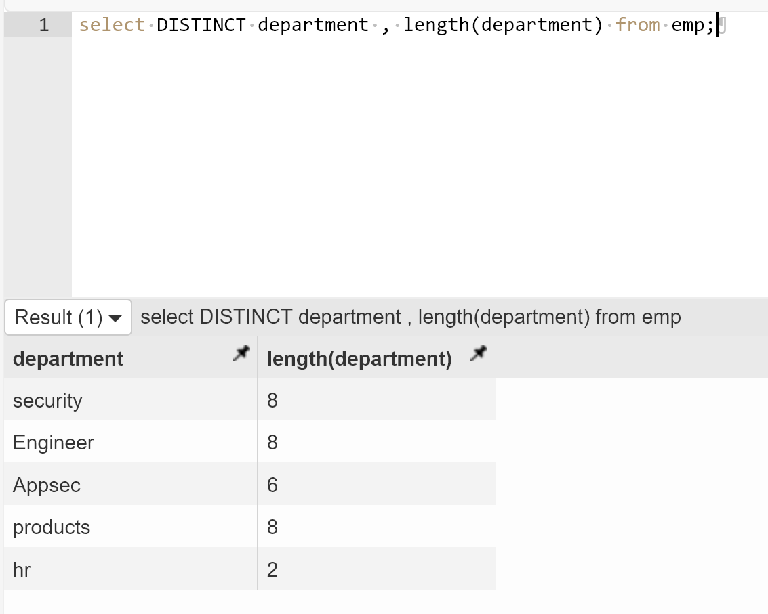

Write an SQL query to fetch nth max salaries from a table.

Select min(salary) from (select distinct salary from emp order by salalry desc limit 3) as sal

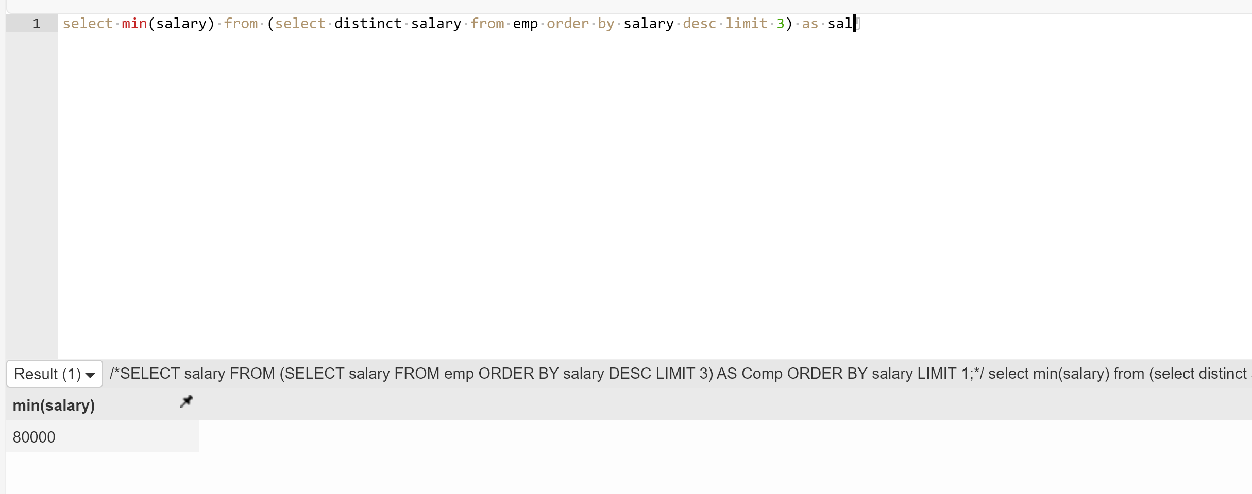

Task – 4

Write an SQL query to print the FIRST_NAME from the Worker table after replacing ‘a’ with ‘A’.

Select REPLACE(FIRST_NAME,’a’,’A’) from emp

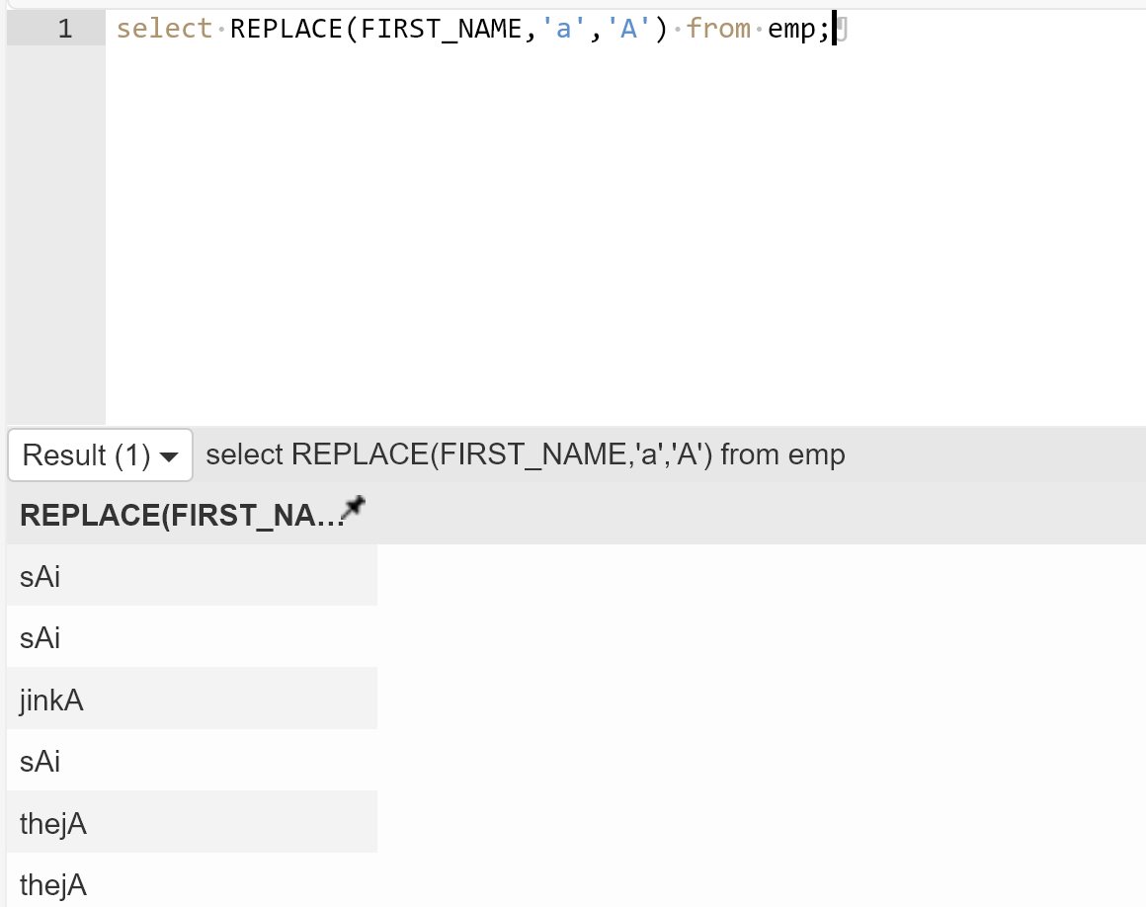

Write an SQL query to print all Worker details from the Worker table order FIRST_NAME Ascending and DEPARTMENT Descending.

Select * from emo order by FIRST_NAME asc, DEPARTMENT desc;

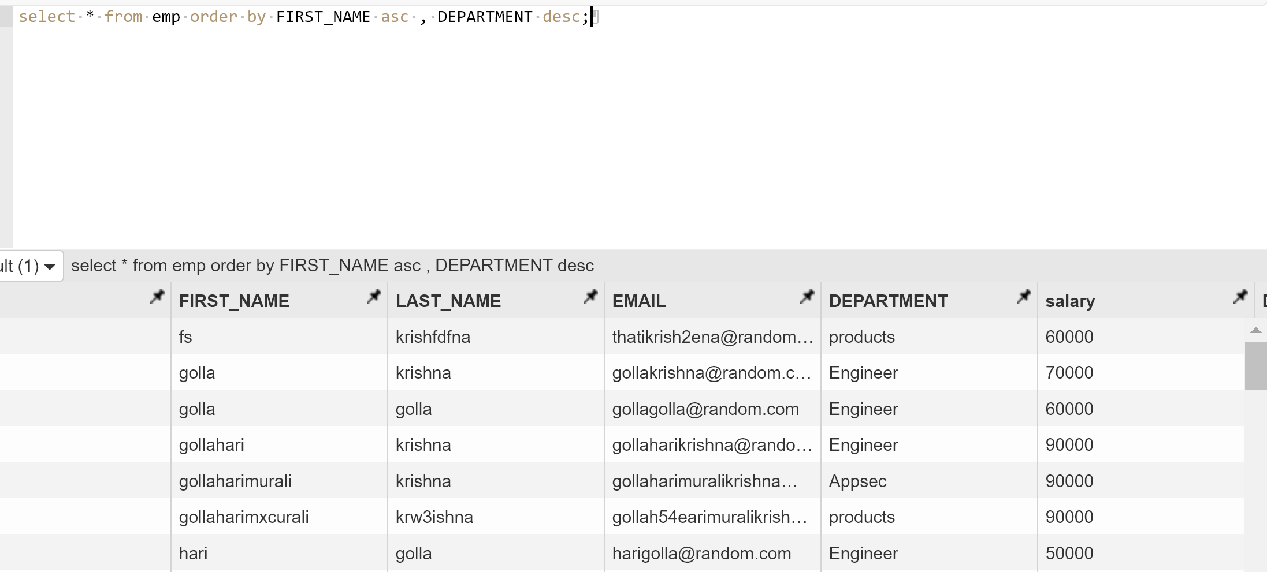

Write an SQL query to fetch the names of workers who earn the highest salary

Select FIRST_NAME from emp where salary = (select max(salary) from emp);

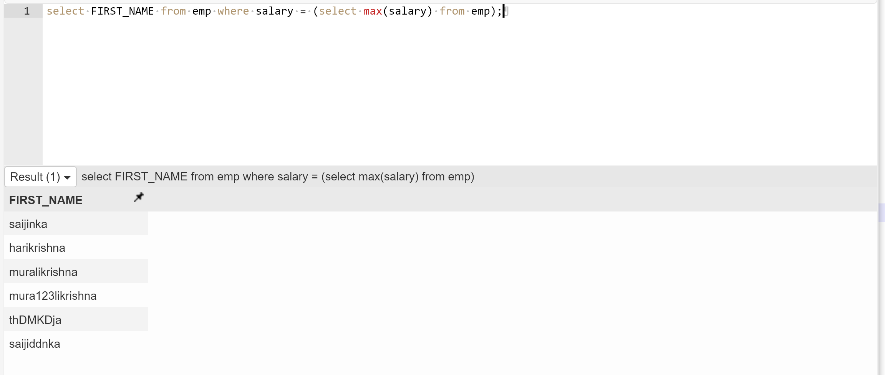

Task – 5

Write an SQL query to print details of workers excluding first names, “Ramesh” and “Santhosh” from the Worker table.

In the below query instead of the name given, I choose other names as those names are not in my table

Select * from emp where FIRST_NAME not int (‘Ramesh’,’Santhosh’);

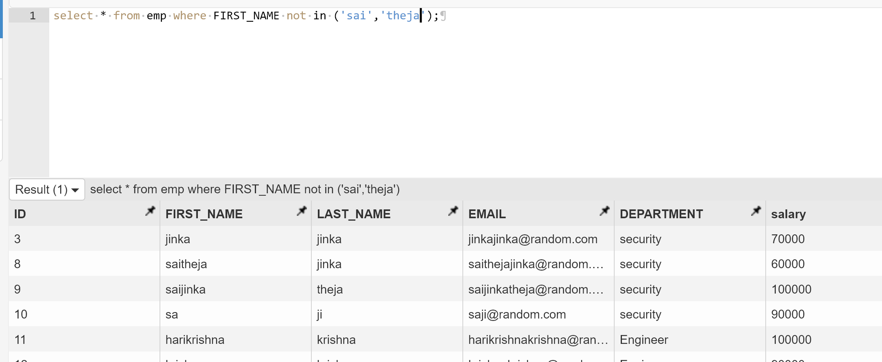

Write an SQL query to print details of the Workers whose FIRST_NAME ends with ‘h’ and contains six alphabets.

I have changed the below query where you asked for h where as I don’t have names with h init so I used ‘i’ instead

Select * from emp where FIRST_NAME like ‘______h’;

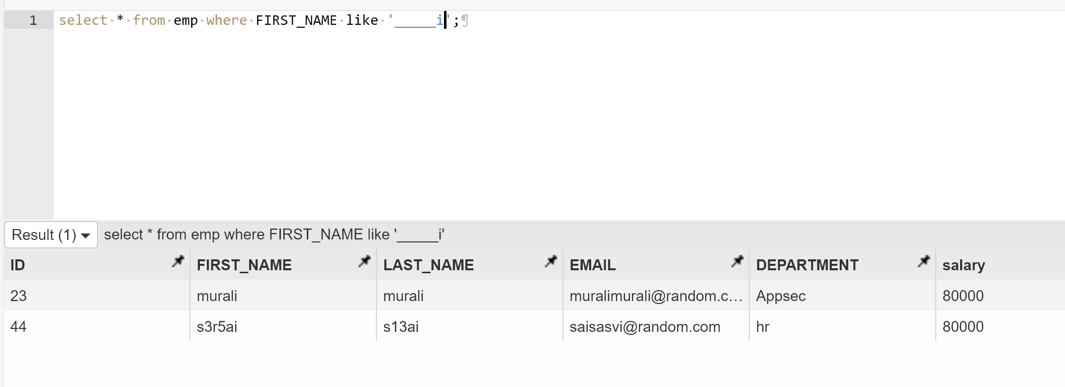

Write a query to validate Email of Employee (email should have first name last name and guvi.com example (first name=Kamal last name= raja and the mail id should be [kamalraja@guvi.com](mailto:kamalraja@guvi.com)).

In the below query 0 is as match and 1 is not

Select concat(FIRST_NAME,LASR_NAME,’@guvi.com’), strcmp((concat(FIRST_NAME,LASR_NAME,’@guvi.com’),email) from emp;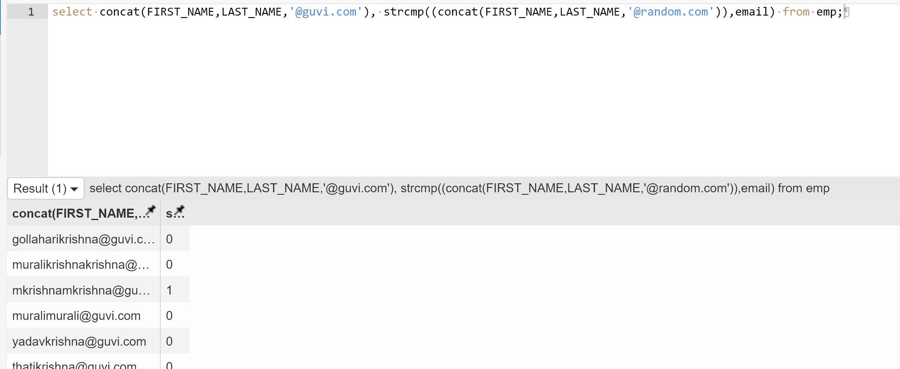

Task – 6

Write an SQL query to print details of the Workers who have joined in March ’2021.

The below query is modified as there are not employees joined in 3rd month in my table

Select * from emp where year(DATE_OF_JOINING) = 2021 and month(DATE_OF_JOINING) = 3;

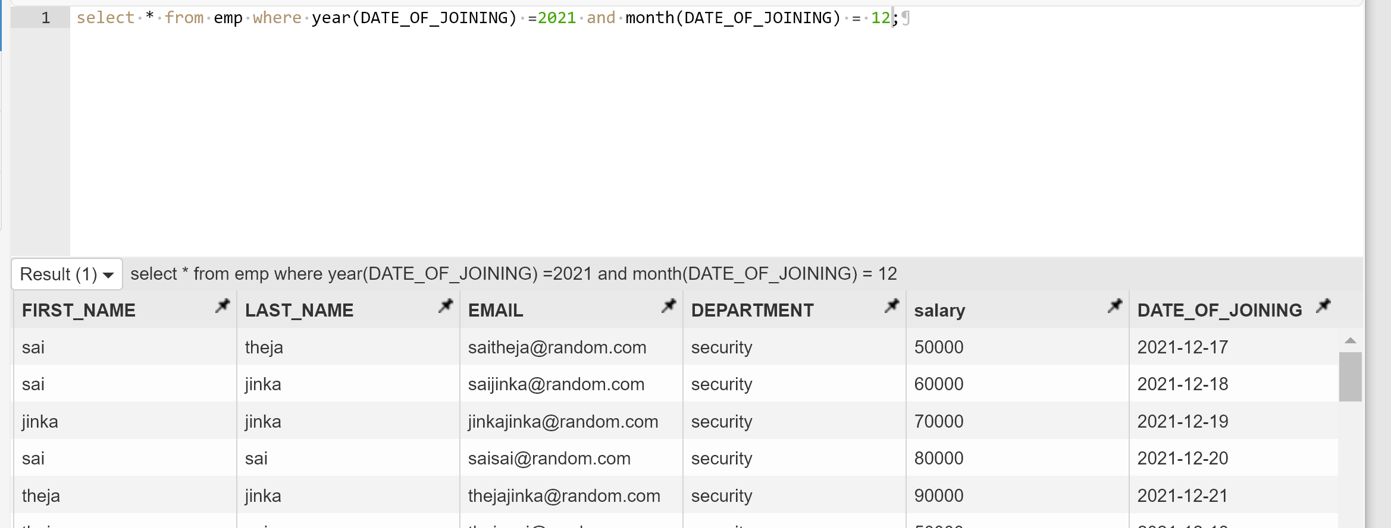

Write an SQL query to fetch duplicates that have matching data in some fields of a table.

Select * from emp e1, emp e2 where e1.last_name = e2.last_name and e1.date_of_joining = e2.date_of_joining and e1.id > e2.id

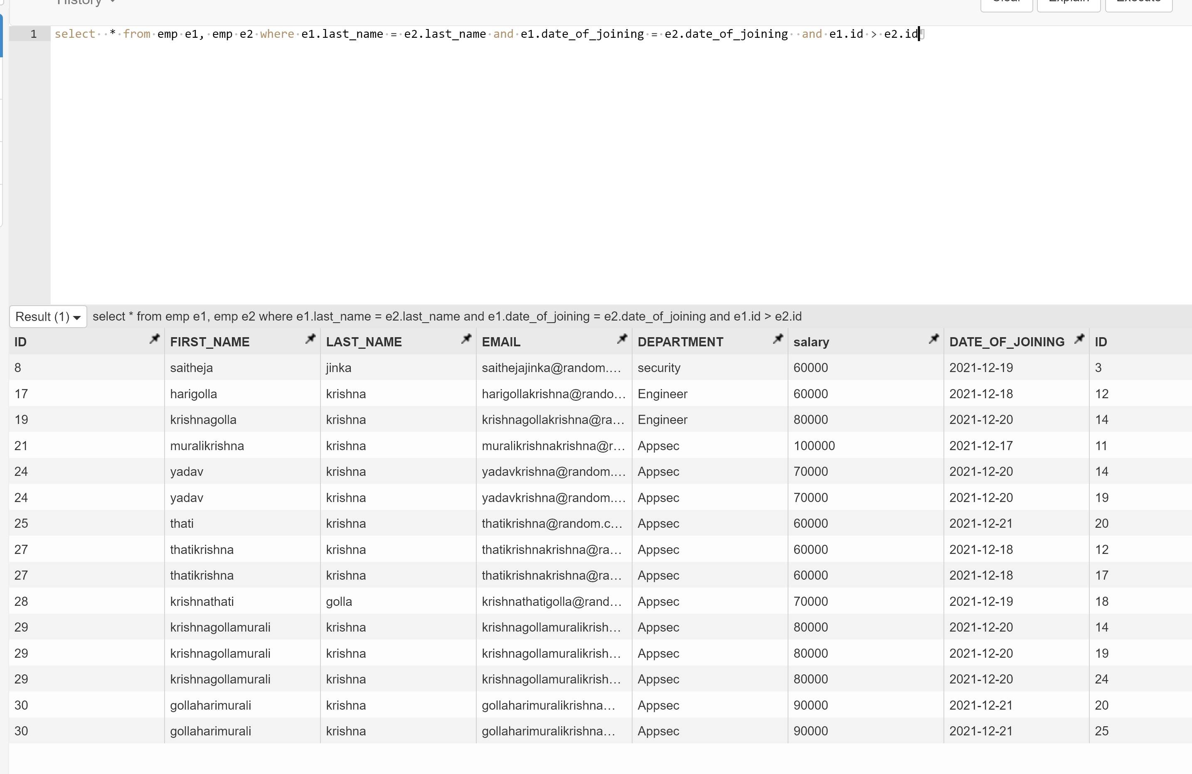

How to remove duplicate rows from the Employees table.

Delete from emp

Where id IN (select e1.id from emp e1, emp e2 where e1.last_name = e2.last_name and e1.date_of_joining = e2.date_of_joining and e1.id > e2.id)

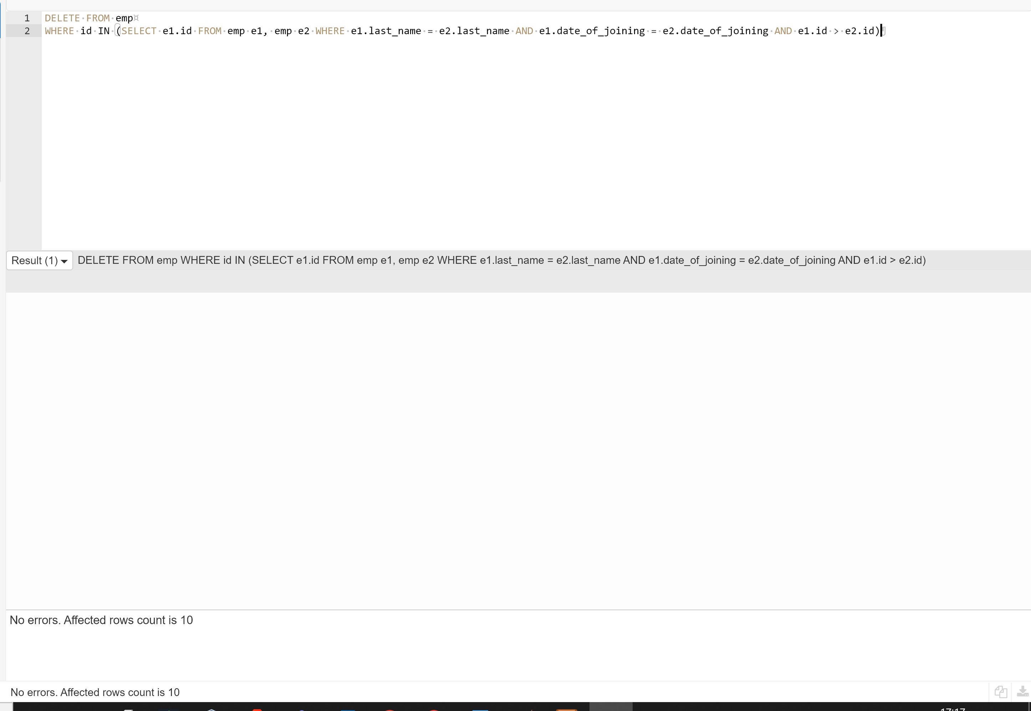

Task – 7

Write an SQL query to show only odd rows from a table.

Select * from emp where (id%2)n= 1

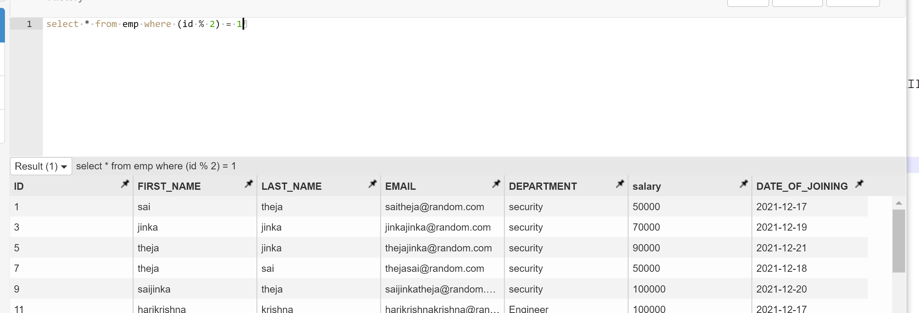

Write an SQL query to clone a new table from another table.

Create table emp_dups as select * from emp

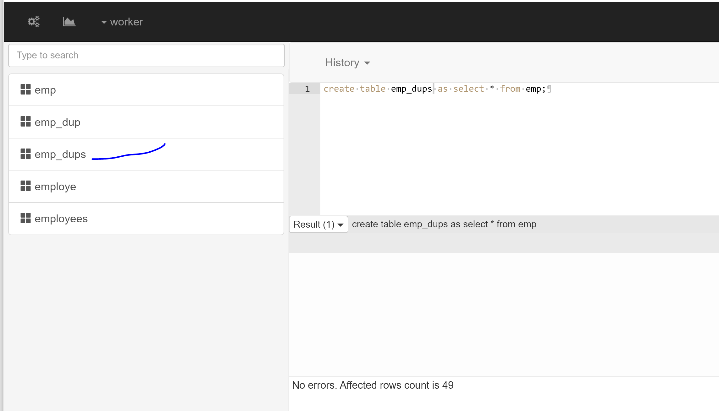

Task -8

Write an SQL query to fetch intersecting records of two tables.

I don’t have keys for emp table so I used other tables for same question

Select students.*, marks.* from students inner join marks on students.id = marks.id

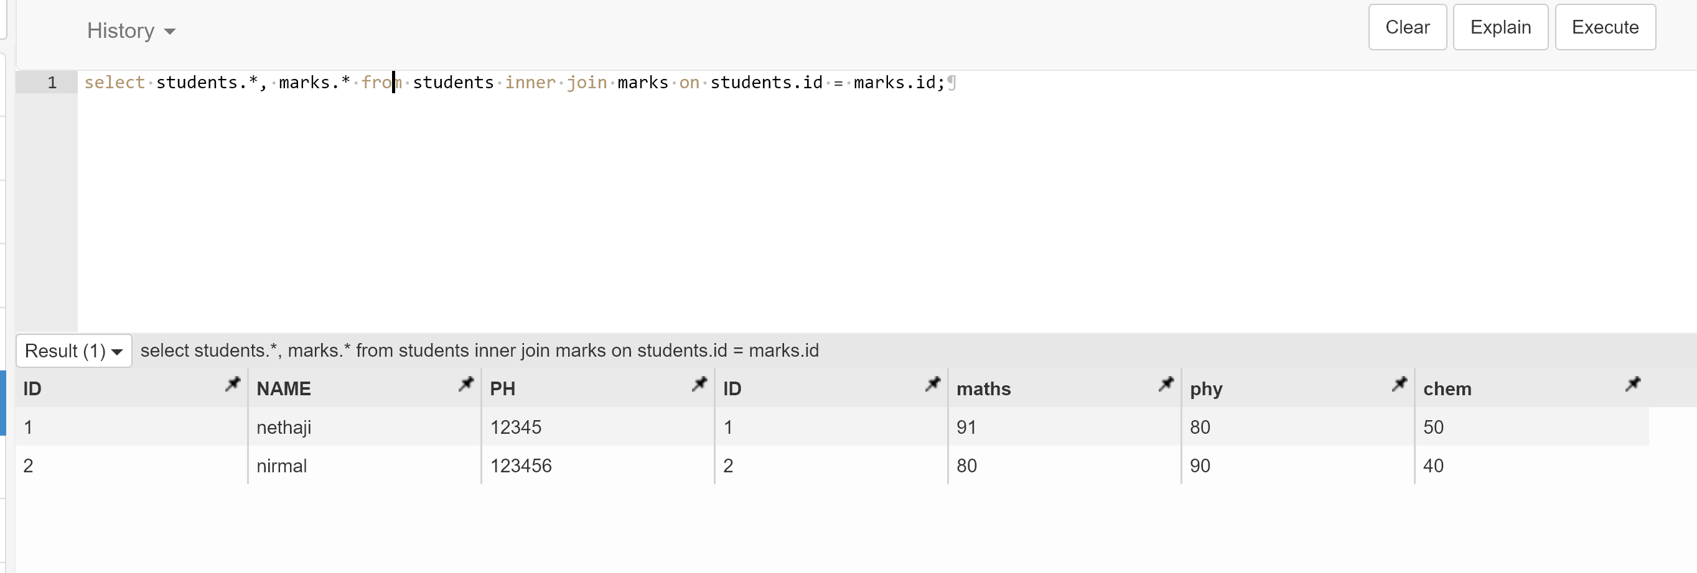

Write an SQL query to show records from one table that another table does not have.

SELECT students.* FROM students

LEFT JOIN marks ON marks.id = students.is

WHERE marks.id IS NULL

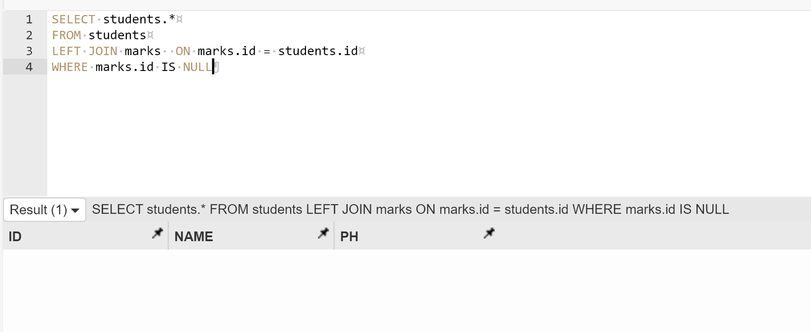

Task – 9

Write an SQL query to show the top n (say 15) records of a table.

SELECT * FROM emp LIMIT 15

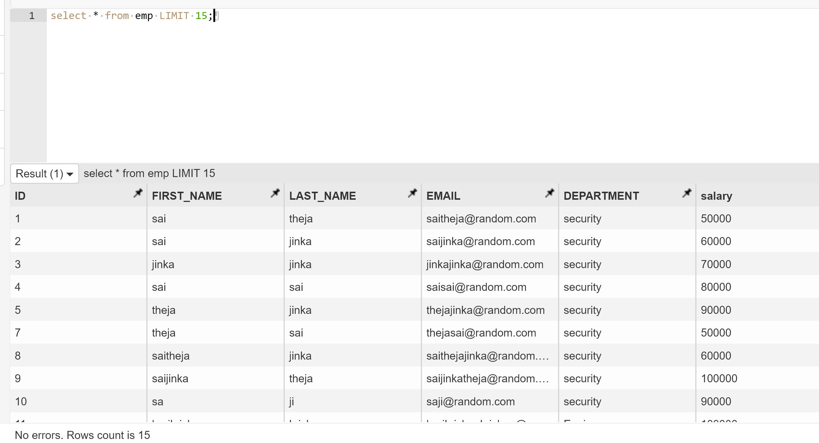

Write an SQL query to determine the nth (say n=10) highest salary from a table.

Select min(salary) from (select distinct salary from emp order by salary desc limit 3) as sal;

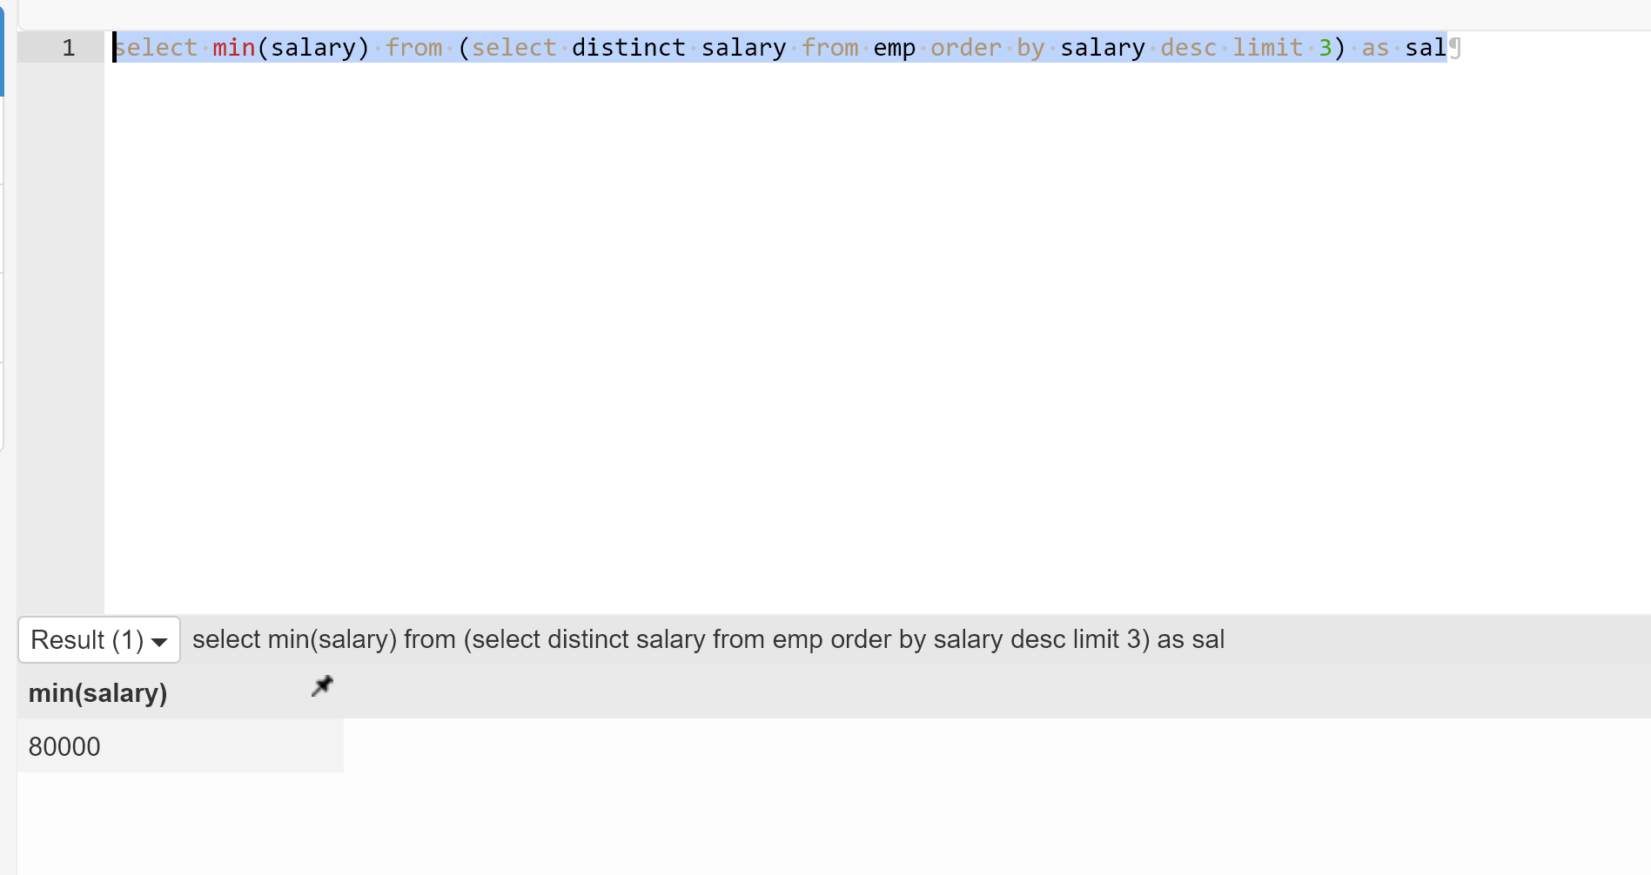

Task – 10

Write an SQL query to determine the 8th highest salary without using TOP or LIMIT methods.

Select * from ( select *, ROW_NUMBER() over (order by salary desc)s from e) as emp where s = 3

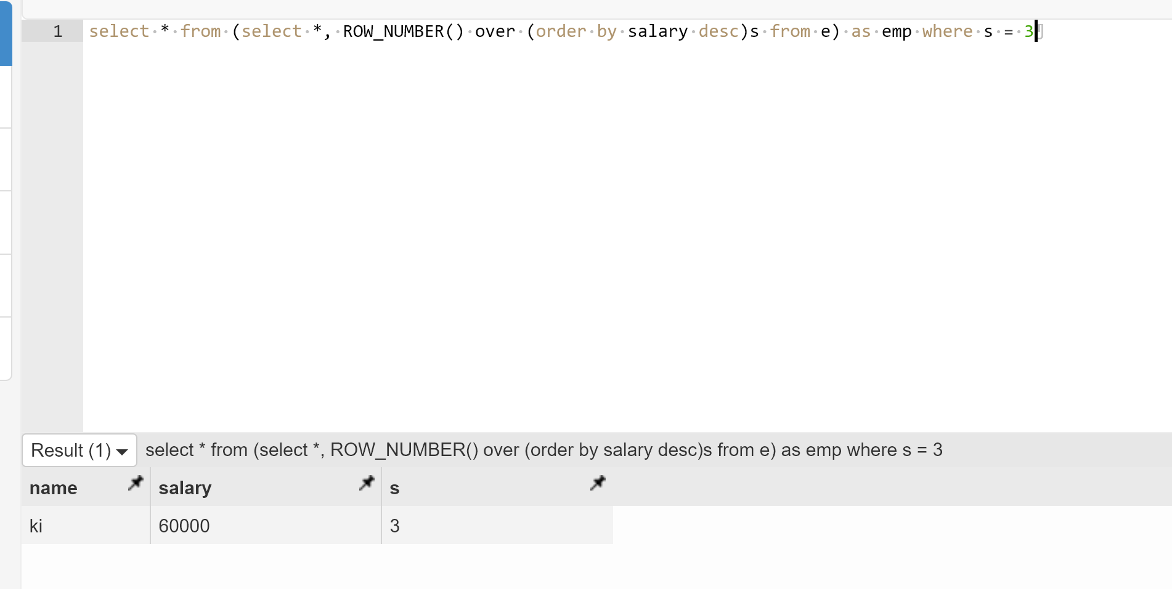

Write an SQL query to fetch the list of employees with the same salary.

Select name,salary from emp where salary in (select salary from emp group by salary having count(*) > 1

