**CHAPTER 2: SOFTWARE PROJECT MANAGEMENT PLAN (SPMP)**

## **2.1 Purpose**

* Help readers understand the organization and activities of the project and help readers easily visualize how the project is going.
* Set out the principles that the team members must adhere to and strictly follow the rules throughout the project.
* Each team member must be conscious of the team project, so all team members must use this document to clarify their responsibilities.

**2.1.1 Software process model**

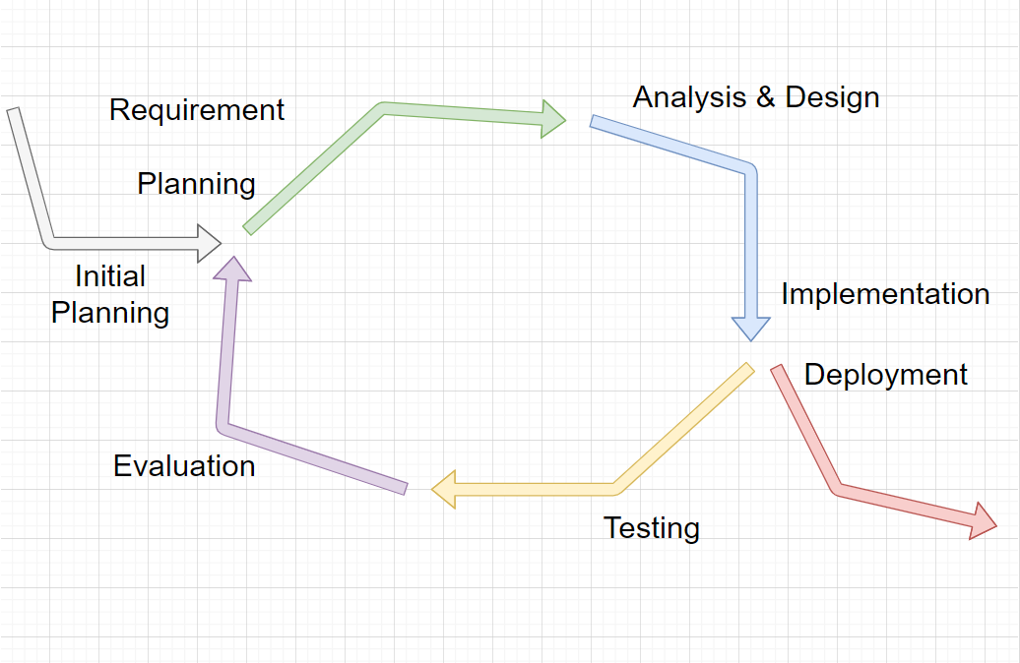

*Figure: .Iterative development model*

Project uses the Iterative Process Model

The Iterative Process Model is mostly used when the scope of the project is big, the major requirements are defined clearly, some more details will be added later in software development. By using this software process model, we break down the developing system task into series of smaller tasks which will be completed separately, allowing us to take advantage of what was learned during development of earlier parts of the system. In addition, the iterative model is easier than other models when the issues are discovered. They are fed back to the team, and solutions will be found while the project is still in development.

### **2.1.2 Roles and Responsibilities**

#### **2.1.2.1 Organization Structure**

|  |  |
| --- | --- |
| **Role** | **Responsibility** |
| Project Manager | Planning,divide work among team members,developing schedules,support team members,coordinating communication with team members to feel comfortable and easy to work , always keep the team focused on working for the main goal |
| Technical Leader | Choosing and deciding what technologies should be used, instruct and support team members in using a technology they may not be familiar with, overseeing the work being done by other developers |
| Test Leader | Test execution, including test set-up and test run, evaluation of test run and error recovery, defect logging and test results recording. |
| Developer | Code the product,discuss, exchange and review code of other developers. |
| Designer | Design product’s user interface |
| Tester | Test the product |

*Table 2-1 : Project Structure*

#### 

#### **2.1.2.2 Project Team Member**

|  |  |
| --- | --- |
| **Team Member** | **Role** |
| DucDD | Project Manager,Technical Leader,Developer,Designer |
| KienBT | Test Leader,Developer,Designer,Tester |
| KhanhNN | Developer,Designer,Tester |
| LongND | Developer,Designer,Tester |
| KhangNM | Developer,Designer,Tester |

*Table: Project Team Member*

### **2.1.2.3 Tool and Techniques**

|  |  |  |
| --- | --- | --- |
| **Software Tool** | **Version** | **Description** |
| Microsoft project | 2013 | Management tools |
| Project | Online | Management tools |
| Github | Online | Source code control |
| Source Tree | 3.1.3 | Source code control |
| Eclipse | 2020 | IDE for coding |
| Microsoft Words | 2019 | Document tools |
| Microsoft Excel | 2019 | Document tools |
| Microsoft SQL Server 2019 | 2019 | SQL server |
| Facebook | Online | Communication tool |
| Skype | Online | Communication tool |
| Process Model |  | Iterative Model |
| Draw.io | Online | Diagram, UML tool, chart |
| Spring Boot | 2.3.3 | IDE for coding |
| Spring Data JPA | 2.0.3 | IDE for coding |
| Hibernate |  | IDE for coding |
| Visual Studio Code | 1.34.0 | IDE for coding |
| HTML |  | IDE for coding |
| CSS |  | IDE for coding |
| Bootstrap |  | IDE for coding |

*Table: Tool and Techniques*