# Logo 2D.jpg

# 

**DuckietownHS 1.0**

**An MIT project for High Schools**



# 

# 

# **Index**

Sommario

**Index** 2

**Revisions** 4

**License** 5

**Abbreviations** 5

**The DuckietownHS project** 6

**Introduction** 6

**Purpose** 6

**Perlatecnica’s role** 7

**The details of the project** 7

**Where to start** 7

**Give life to the Duckietown Engineering Company** 8

**Roles and managerial responsibilities** 8

**CEO - Chief Executive Officer** 8

**CTO - Chief Technology Officer** 8

**CSO - Chief Strategy Officer (CSO) or Chief Strategist** 8

**Supply chain manager** 9

**HR- Human resources manager** 9

**Roles and operational responsibilities** 9

**Build DuckiebotHS** 10

**What to buy** 10

**Build the "DuckietownHS" city** 11

**What to buy** 11

**The carriageway** 12

**The traffic light** 14

**The road signs** 14

The road signs are static and represented by barcodes printed on adhesive paper that have to be laid horizontally along the roadway. The contained information should be encoded in two bits and in accordance with what is stated below. 14

**The first mission of the Duckiebot** 17

# **Revisions**

|  |  |
| --- | --- |
| **Rev** | **Description** |
| Rev-0 | First Release |

# 

# 

# **License**

DuckietownHS is a reproducible and open-source project.All material (the hardware, the software, and teaching materials) is released as "open source".

The source code is released under GNU-GPL *the* [*free software*](http://www.gnu.org/philosophy/free-sw.en.html) *license* <http://www.gnu.org/licenses/licenses.en.html>



The teaching materials and guides are licensed under Creative Commons license

**CC BY-SA 4.0**<https://creativecommons.org/licenses/by-sa/4.0/>



# **Abbreviations**

**DTHS** Duckietown High School

**DBHS** High School DuckieBot

**DTE** Duckietown Engineering

# 

# **The DuckietownHS project**

## **Introduction**

Duckietown is an open source project of the MIT[(http://duckietown.org/),](http://duckietown.org/) and an advanced course focusing on autonomous vehicles. Duckietown is also an exercise based on the principles of a role-playing game where teachers and students take on the typical roles existing within an engineering company, which in this case is called Duckietown Engineering (DTE). However Duckietown is also a research project, an open source project used by other organizations or by "unconventional students" and a means to raise awareness on the subject and a learning experience for everyone involved.

The technical objectives of DuckietownHS are simplified compared to those of the Duckietown project intended for universities so it is perfectly suited to the technical knowledge of the classes involved. The purpose is to create self-driving DuckiebotHS vehicles which can make choices and move autonomously on the streets of Duckietown, using sensors installed on the vehicles and special road signs positioned within Duckietown.

Once DuckiebotHS have been assembled and programmed to meet the specifications contained in this document and issued by the "customer" Perlatecnica, special missions and games will be offered for DuckiebotHS. The participants can also submit their own missions and games.

Just like the university project, DuckietownHS is an open source project, a role-playing game, a means to raise awareness on the subject and a learning experience for everyone involved.

## **Purpose**

The project has two main purposes.

1. It is a course where students and teachers take part in a role play and they take the typical professional roles of an engineering company. They must design and implement a Duckietown responding to the specifications of the project, assemble DuckiebotHS (DBHS), and develop the software that will run on them. The deliverables of the project will be tutorials, how-to, source code, documentation, binaries and images and them will be designed and manufactured according to the procedures of the DTE.
2. In respect of that mentioned above, special missions and games for DBHS will be introduced by the "customer" Perlatecnica.

## **Perlatecnica’s role**

Perlatecnica assumes the role of the customer and commissions the Duckietown Engineering company to design and construct the Duckietown and DuckiebotHS. It will provide all necessary product requirements and will assume the responsibility to validate the compliancy of all deliverables to the required specifications.

## **The details of the project**

The project consists in the design and realization of **DuckiebotHS** and **DuckietownHS.** They must have the same characteristics as the city of the University project as far as the size and color of the delimiting roadway bands is concerned but with a different type of management of the traffic lights system that regulates the passage of DuckiebotHS at intersections. The DuckietownHS (DTHS) and DuckiebotHS (DBHS) are defined in the documentation and there is little room for the DTE to make its own choices in terms of design. The reason for this is that the DBHS produced by the different DTE’s need to be identical from a hardware point of view so that the software development makes the difference.

## **Where to start**

The purchase of the necessary materials is the first step to take. For both DTHS and DBHS a list of these materials is provided with links to possible sellers. Even though Amazon™ is typically indicated as a seller this is nothing more than an indication to facilitate the purchase for those less experienced. It is left to the individual DTE to choose where to buy the required parts. It is allowed to buy and use parts that are not on the list but this is not recommended as they will make the Duckiebot unfit to enter in official competitions. When necessary an assembly tutorial will be provided together with the list of materials. Once the DTHS city and the DBHS robots have been assembled, the next step will be the development of the software for the running of both the city and the DuckiebotHS. The city and the Duckiebot run on a board based on a microcontroller STM32 from [STMicroelectronics](http://www.st.com/) the [Nucleo F401RE](https://developer.mbed.org/platforms/ST-Nucleo-F401RE/) that will be programmed via the online development environment [mbed.](https://developer.mbed.org/) Perlatecnica will not release any of the official codes necessary for the navigation of the DuckiebotHS as these are owned by the DTE who developed them.

Each DTE may release the source code under a license Creative Commons **CC BY-SA 4.0**[**.**](https://creativecommons.org/licenses/by-sa/4.0/)

# 

# **Give life to the Duckietown Engineering Company**

DuckietownHS Engineering is the Company responsible for realizing the project, assembling all the necessary parts and developing the code that runs the city (DTHS) and the autonomous vehicles (DBHS). As every other company it has a name, logo and personnel with specific duties and responsibilities. So the first step is to give a name to your DTE and design a logo.

Listed below are some essential roles within every company. This is an indicative list and you can adapt the organizational structure to your needs and add other roles if necessary.

## **Roles and managerial responsibilities**

For each of the following roles you should identify one or more people. The roles can be filled by either teachers or students. The role of the CEO should be played by the school principal or by a delegated teacher. Filling the different roles will also allow the proper definition of each of these roles and thus ensure the best support to the project.

### **CEO - Chief Executive Officer**

He is in charge of the general management of the company. In the DuckietownHS project, he is the one who has the power of attorney and the final decision-making. Typically, this role is played by the school principal.

### **CTO - Chief Technology Officer**

He provides strategic advice to the CEO and the company's board of directors. In the DuckietownHS project, he is one who keeps the overview of the project. Typically, this role is played by a teacher.

### **CSO - Chief Strategy Officer (CSO) or Chief Strategist**

This is the executive responsible for assisting the Chief Executive Officer (CEO) with the development, communication, implementation and support of all strategic business initiatives. In DuckietownHS he is the one who assumes the responsibility for the organization of the project in terms of the resources within the school. Typically, this role is played by a teacher.

### **Supply chain manager**

He is the manager responsible for purchasing and managing all material resources.

### **HR- Human resources manager**

This is the executive in charge of human resources. In DuckietownHS, he assumes the responsibility for the proper division of the roles among the students. Typically, this role is played by a teacher.

## **Roles and operational responsibilities**

The roles mentioned above are supposed to coordinate the project, ensure its success and integrate the project within the school’s organizational structure. These are therefore roles played by managers and teaching staff.

The roles listed below are roles closely linked to the operational development of DTHS and DBHS products and therefore mainly played by students.

The goal of those who occupy an operational role is to gather all the parts of the project and their assembly.

The following is required for the realization of the city:

* installation of the panels that form the base of the streets
* marking of the roads
* installation of LED strips that form the traffic lights
* installation of road signs
* wiring
* developing the code and programming the board for the running of the traffic lights

For the realization of the DuckiebotHS the following is needed:

* assembly of mechanical parts
* assembly of the electronical parts
* developing the code and programming the board for the required mission.

# 

# **Build DuckiebotHS**

## **What to buy**

The parts that make up a DuckiebotHS (DBHS) model are summarized in the following table.

|  |  |  |  |
| --- | --- | --- | --- |
| **ID Part Number** | **Description** | **Qty** | **Where to buy** |
| 1 | Magician Chassis | 1 | [Chassis](http://www.robot-domestici.it/joomla/home/magician-chassis)  [Chassis](http://www.campustore.it/kit-robot-mobile-magician-chassis-1.html) |
| 2 | DC motor drive | 1 | [X-NUCLEO-IHM12A1](http://www.digikey.com/product-search/en?WT.z_cid=sp_497_0928_buynow&Enterprise=44&lang=en&Vendor=497&mpart=X-NUCLEO-IHM12A1) |
| 3 | MEMS | 1 | [X-NUCLEO-IKS01A2](http://www.digikey.com/product-search/en?WT.z_cid=sp_497_0928_buynow&Enterprise=44&lang=en&Vendor=497&mpart=X-NUCLEO-IKS01A2) |
| 4 | Proximity Sensors | 1 | [X-NUCLEO-53L0A1](http://www.digikey.com/product-search/en?WT.z_cid=sp_497_0928_buynow&Enterprise=44&lang=en&Vendor=497&mpart=X-NUCLEO-53L0A1) |
| 5 | Infrared sensors | 2 | [Infrared sensor](https://www.amazon.it/ostacolo-evitare-infrarosso-riflessione-fotoelettrico/dp/B00XXEJD58/ref=sr_1_1?s=electronics&ie=UTF8&qid=1478591162&sr=1-1&keywords=sensori+infrarossi+arduino) |
| 6 | Microcontroller board STMicroelectronics NucleoF401RE | 1 | [STM32-NUCLEOF401RE](http://it.rs-online.com/web/p/kit-di-sviluppo-per-processori-e-microcontrollori/8029425/) |
| [7](http://it.rs-online.com/web/p/kit-di-sviluppo-per-processori-e-microcontrollori/8029425/) | [Rechargeable Battery](http://it.rs-online.com/web/p/kit-di-sviluppo-per-processori-e-microcontrollori/8029425/) | [1](http://it.rs-online.com/web/p/kit-di-sviluppo-per-processori-e-microcontrollori/8029425/) | [Battery](https://www.amazon.it/AmazonBasics-Caricabatterie-esterno-portatile-5600/dp/B00LRK8IV0/ref=sr_1_14?s=electronics&ie=UTF8&qid=1478614068&sr=1-14&keywords=batteria+cellulare) |
| 8 | Color Sensor TCS3200 | 1 | [Color sensor](https://www.amazon.it/Sensore-Riconoscimento-TCS3200-Raspberry-TE172/dp/B00XXEIWUK/ref=pd_sbs_107_3?_encoding=UTF8&psc=1&refRID=67ZS6J9QRBWB1RM4N8Y3) |
| 9 | Encoder LM393 for odometer feature | 2 | [Encoder LM393](https://www.amazon.it/motore-comparazione-Sensore-velocit%C3%A0-modulo/dp/B01AV0WJVQ/ref=sr_1_1?ie=UTF8&qid=1503398333&sr=8-1&keywords=lm393) |

# 

# 

# **Build the "DuckietownHS" city**

There is no binding layout of the city during the study and implementation phase of the project. It will, however, be defined and the same for everyone during the competition phase.

Since there is no binding layout for the city there are no quantities indicated in the material list as this depends on the choices made.

## **What to buy**

|  |  |  |  |
| --- | --- | --- | --- |
| **ID Part Number** | **Description** | **Qty** | **Where to buy** |
| 1 | rugs in foam |  | [mats](https://www.amazon.it/66Fit-BP-LT-6613-Tappetini-Incastro-pezzi/dp/B004OW24CM/ref=pd_sim_sbs_201_5?ie=UTF8&psc=1&refRID=M72VAGDBXBD9D1N7AM39) |
| 2 | adhesive white tape |  |  |
| 3 | adhesive yellow tape |  |  |
| 4 | adhesive red tape |  |  |
| 5 | card microcontroller STMicroelectronicsNucleoF401RE |  | [STM32-NUCLEOF401RE](http://it.rs-online.com/web/p/kit-di-sviluppo-per-processori-e-microcontrollori/8029425/) |
| 6 | Relay Board minimum 4 relay | 1 |  |

Links to online stores are purely indicative. The material can be bought in any store.

## 

## 

## **The carriageway**

The figure below shows the measurements and other indications for how a curve should be designed. The dimensions shown are also relevant for the straight roads.

**The lines on the road in the curves should be solid and not broken as shown in the figure below!**

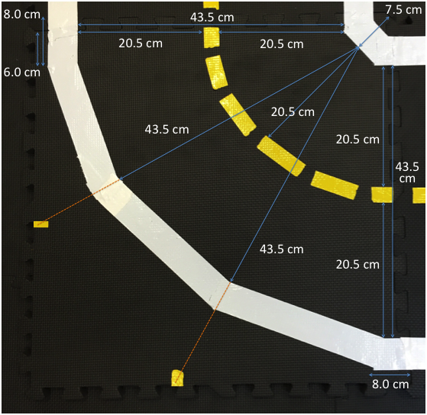

Straight roads can be either a two-way or a one-way road.

The figures below show the two possible ways in which the colored ribbons can be placed on the road.

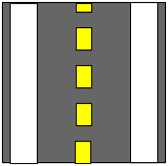 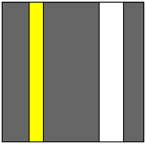

There are two possible types of intersections, type T and X. Both are shown in the figures below.

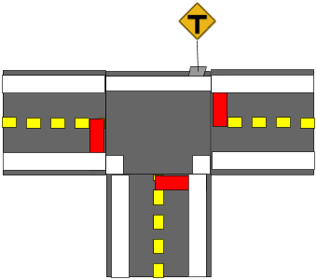

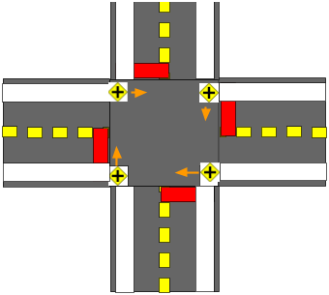

## **The traffic light**

The traffic light is made up of a RGB LED strip across the entire lane just before the intersection. Red indicates that the Duckiebot needs to stop within 3 cm of the LED strip. The Duckiebot must remain stationary until the traffic light turns green. The possible directions allowed are shown on the road signs. The decision which direction to take depends on the specific mission.

## 

## **The road signs**

## The road signs are static and represented by barcodes printed on adhesive paper that have to be laid horizontally along the roadway. The contained information should be encoded in two bits and in accordance with what is stated below.

When the Duckiebot passes a blue strip it receives a signal that it is in close proximity of a road sign and that it has to use its infrared sensors to read the information content. The black strip allows the Duckiebot to align itself to the signal and to read it. Immediately after this it will find some black and white lines and the passage from white to black will trigger the Duckiebot to read the bit on the left.

There are four possible combinations that have the following meanings:

**00 - All directions**



**01 Straight and to the right**



**10 Straight and to the left**



**11 Left and Right**



# **The first mission of the Duckiebot**

Once you have completed the assembly of all the parts that make up the Duckietown and DuckiebotHS you should start programming the microcontroller so that the Duckiebot can move independently.

***The basic mission of the DuckiebotHS is to move autonomously on the roads respecting the road signs and traffic lights, choosing a random journey and without crashing into other DuckiebotHS.***

For the development of the code, there are no architectural constraints, but we recommend proceeding with order and to focus primarily on its major functions and not on a specific mission.

The main functions are those of perception and movement.

Moving around in DuckietownHS, the DuckiebotHS will have to drive on straight roads, make 90 degree curves while crossing an intersection but also make other unexpected curves. While doing all this the Duckiebot can be supported by a gyroscope that provides guidance to the orientation of the vehicle.