|  |  |
| --- | --- |
|  | Diagrams |
|  |  |
| Generated 5/7/2015 | THG_USECASE |
|  |  |

THG_USECASE_Context (THG_USECASE_Context.ndx)

From THG_USECASE Package

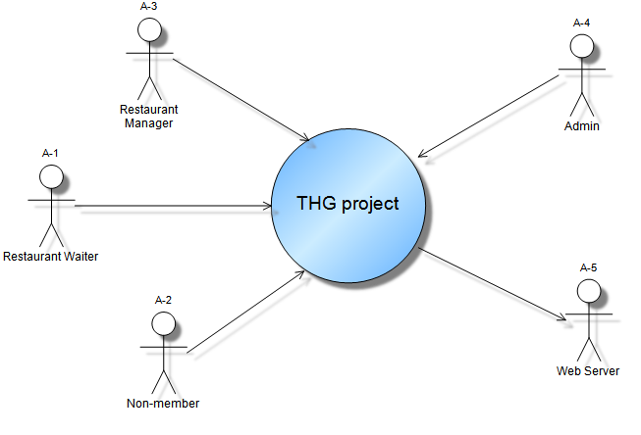

Connecting (Connecting.ndx)

From THG_USECASE Package

