**HTML Interview Questions**

1. **What do the letters HTML stand for?**

HTML stands for Hypertext Markup Language

1. **What is the current or latest version of HTML?**

The latest version of HTML is HTML5

1. **What authority publishes the official HTML5 specification?**

W3C publishes HTML5 specification

1. **What are some of the new elements or tags in HTML5 and what are their purpose?**

<caption>I didn’t copy and paste, I typed everything</caption>

|  |  |
| --- | --- |
| **Structural elements** | **Purpose** |
| <article> | Defines an article in the document |
| <aside> | Defines content aside from the page content |
| <bdi> | Defines a part of text that might be formatted in a different direction from other text |
| <details> | Defines additional details that the user can view or hide |
| <dialog> | Defines a dialog box or window |
| <figcaption> | Defines a caption for a <figure> element |
| <figure> | Defines self-contained content (i.e. illustrations, diagrams) |
| <footer> | Defines a footer for the document or a section |
| <header> | Defines a header for the document or a section |
| <main> | Defines the main content of a document |
| <mark> | Defines marked or highlighted text |
| <menuitem> | Defines a command/menu item that the user can invoke from a popup menu |
| <meter> | Defines a scalar measurement within a known range (a gauge) |
| <nav> | Defines navigation links in the document |
| <progress> | Defines the progress of a task |
| <rp> | Defines what to show in browsers that do not support ruby annotations |
| <rt> | Defines an explanation/pronunciation of characters (East Asian typography) |
| <ruby> | Defines a ruby annotation (East Asian typography) |
| <section> | Defines a section in the document |
| <summary> | Defines a visible heading for a <details> element |
| <time> | Defines a date/time |
| <wbr> | Defines a possible line-break |
| **Form elements** | **Purpose** |
| <datalist> | Defines pre-defined options for input controls |
| <keygen> | Defines a key-pair generator fields (for forms) |
| <output> | Defines the result of a calculation |
|  |  |
| **Graphics elements** | **Purpose** |
| <canvas> | Draw graphics, on the fly, via scripting |
| <svg> | Draw scalable vector graphics |
|  |  |
| **Media elements** | **Purpose** |
| <audio> | Defines sound content |
| <embed> | Defines containers for external applications |
| <source> | Defines sources for <video> and <audio> |
| <track> | Defines track for <video> and <audio> |
| <video> | Defines video or movie content |
|  |  |

1. **What are some of the old elements or tags from previous versions of HTML that have been eliminated and should no longer be used?**

|  |  |
| --- | --- |
| **Removed elements** | **Description** |
| <acronym> | Defines an acronym |
| <applet> | Defines an applet |
| <basefont> | Defines an base font for the page |
| <big> | Defines big text |
| <center> | Defines centered text |
| <dir> | Defines a directory list |
| <font> | Defines text font, size, and color |
| <frame> | Defines a frame |
| <frameset> | Defines a set of frames |
| <isindex> | Defines a single-line input field |
| <noframes> | Defines a noframe section |
| <s> | Defines a strikethrough text |
| <strike> | Defines a strikethrough text |
| <tt> | Defines teletype text |
| <u> | Defines underlined text |

1. **What is the doctype for the current version of HTML?**

The current version uses <!DOCTYPE>, the first thing that every HTML document must have.

1. **What does the doctype do?**

It instructs the browser about what version of HTML the page is written in

1. **Provide the minimum skeleton for an HTML5 document.**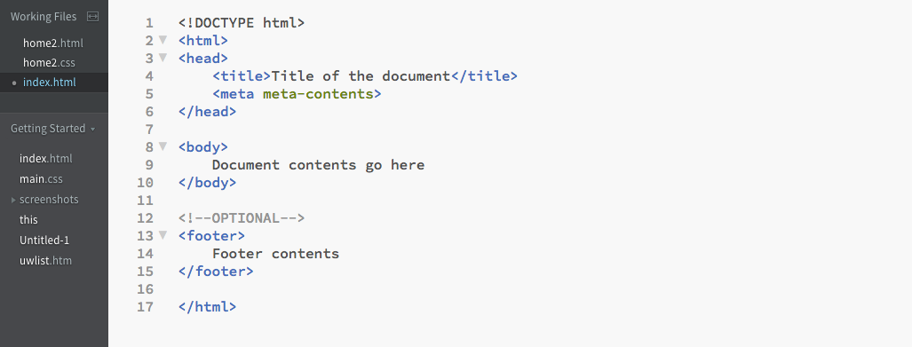
2. **What is the difference between an element and a tag?**

There are two kinds of tags:

* Opening tags <>
* Closing tags </>

Tags are not elements, tags surround an element, indicating the start and end of an HTML element. i.e. <table></table>, where table is the element name.

1. **What are attributes and values?**

An attribute is used to define the characteristics of an element and is placed inside the element's opening tag. Attributes are made up of two parts: a name and a value.

Value < Attributes.

1. **What are self-closing (or empty) tags? Can you provide a few examples?**

Empty elements are elements with no content. For example:

* <br>
* <hr>
* <link>
* <meta>

1. **What are the differences between linking to an image and linking to another web page?**

* Linking to an image: use <img> tags, with image being specified in quotes using source attribute. <img src=”duck.jpg”> </img>
* Linking to web page: use <a> tags, and the link is specified in the href attribute. <a href=”www.duck.com”>Quack Quack</a>

1. **How do you write comments in HTML?**

By using comment tags: <!-- Comment goes here --> anything within these tags are considered a comment and

1. **What is semantic markup? (In other words, what is the difference between using <b> and <i> for bold and italic text in earlier versions of HTML and using <strong> and <em> instead in modern HTML markup?)**

Semantic markup is HTML that introduces meaning to the web page rather than just presentation.

1. **How do you know if your HTML5 document is correct and valid?**

Usually errors are pretty good indicators to me, also [W3C Markup Validation Service](https://validator.w3.org/#validate_by_uri+with_options) works as well.

1. **What do you use as reference material when you need to look up information about HTML5 elements and rule?**

My main source for referencing is usually online:

* [W3schools](http://www.w3schools.com/) or [TutorialsPoint](https://www.tutorialspoint.com/html/) for detailed information, and trying out codes.
* [Stackoverflow](http://stackoverflow.com/) for specific problems that I cant figure out
* [Caniuse](http://caniuse.com/) to check for web compatibility for all kind of elements
* [htmlcolorcodes](http://htmlcolorcodes.com/) to look for colors
* Textbook is also another option if Google does not work.