**Chapter 4**

­­­

1. **What is the difference between a tag and an element?**

There are two kinds of tags:

* Opening tags <>
* Closing tags </>

Tags are not elements, tags surround an element, indicating the start and end of an HTML element. i.e. <table></table>, where table is the element name.

1. **Write out the recommended minimal structural f an HTML5 document:**

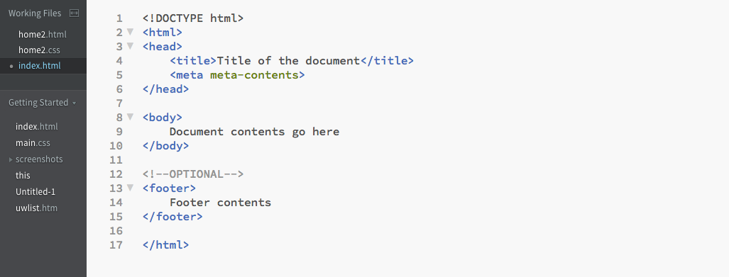

1. **Indicate whether each of these filenames is acceptable for a web document by answering “yes” or “no”.** 
   1. Yes
   2. No, the file ends with .doc instead of .html or .htm
   3. No, there shouldn’t be spaces in the name
   4. Yes
   5. No, because there’s a slash in the name
   6. No, because of the use of symbol (percentage)
2. **Identify errors:** 
   1. <img> tag needs src attribute to reference the picture: <img src=”birthday.jpg”>
   2. Closing tag does not have a slash: <i></i>
   3. There should not be a 2nd href attribute inside the closing tag: <a href=”file.html”> Linked text </a>
   4. The slash in the closing tag should be front slash not a backslash:

<p>This is a new paragraph </p>

1. **Comment markup:**

Inclosing the text within the comment tag will not display it in the browser window

<!--product list begins here-->

**Chapter 5**

1. **Thematic break between paragraphs:**

By inserting <hr> in between the paragraphs

1. **Difference between blockquote and q element:**
   1. Blockquote: represents a section that is quoted from another source
   2. Q element: represents some phrasing content quoted from another source
2. **Display whitespace exactly as it is typed into the source doc:**

Using pre

1. **Difference between a ul and an ol:**
   1. Ul: unordered list, usually being represented as bullet points, where the order of the list’s items is not significant
   2. Ol: ordered list, usually being represented as numbers, where the order of the list’s items is important
2. **Remove bullets from an unordered list:**

* Using CSS, for i.e.:

ul {

list-style-type: none;

}

* Using HTML, for i.e.:

<ul style=”list-style-type:none”></ul>

1. **W3C full name in doc:**

<abbr title =”World Wide Web Consortium”>W3C</abbr>

1. **Difference between a dl and a dt:**
   1. Dl: a description list with terms and descriptions
   2. Dt: only defines a term/name within a description list (dl)
2. **Difference between id and class:**
   1. Id: IDs are unique; because each element have only one ID, and each page can only have one element with that unique ID
   2. Class: classes are not unique; the same class can be used on multiple elements or multiple classes can be used on the same element
3. **Difference between article and section:**
   1. Article: specifies independent, self-contained content (forum, blog, news, comment, etc.)
   2. Section: defines sections in a document, such as chapters, headers, footers, or any other sections of the document (in a way, <section> is smaller than <article>).
4. **Characters generated by these character entities:**
   1. &mdash; dash
   2. &nbsp; ampersand
   3. &bull; non breaking space
   4. &amp; copyright
   5. &copy; bullet
   6. &trade; trademark

**Chapter 6**

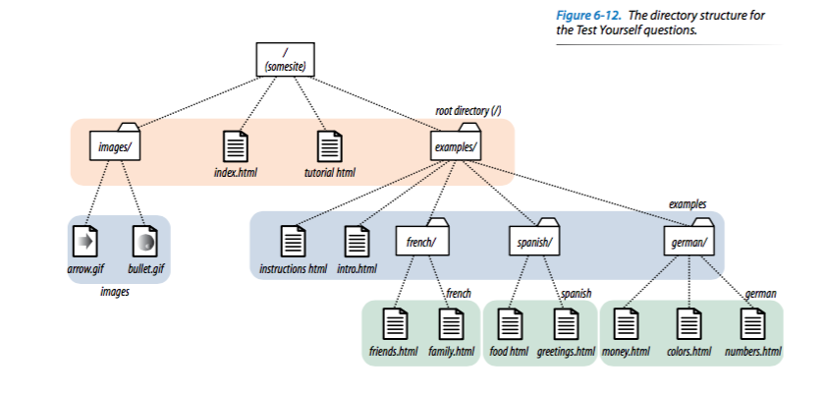

1. <a href=”tutorial.html”> Tutorial </a>
2. <a href=”examples/instructions.html”> Instructions </a>
3. <a href="examples/french/family.html">French Family</a>
4. <a href="/examples/german/numbers.html">German Numbers</a>
5. <a href="../index.html">Index</a>
6. <a href="http://www.learningwebdesign.com">Some Website LOL</a>
7. <a href="../instructions.html">Instructions</a>
8. <a href="../../index.html">Index</a>
9. <img src="images/arrow.gif" alt="Arrows" >
10. <img src="../images/arrow.gif" alt="More Arrows" >
11. <img src="../../images/bullet.gif" alt="Bullet! Scary" >

**Chapter 7**

1. **Attributes must be included in every img element are:**

<img> has src attribute and alt attribute, src must be included because if theirs is no source for image, the image will not be displayed; alt can be left empty.

1. <img src="furry.jpg" alt="Nick Furry">
2. Why is alternative text necessary:

* it provides a description of the image if it is not available or not viewable
* The value of the attribute can be read by screen readers.

1. What is the advantage of including **width** and **height** attributes for every graphic on the page? When should you leave them out?

* It allows the browser to render the rest of the content while the image is being retrieved from the server, which can speed up the display of the page.
* Leave width and height attributes out if you are doing a responsive site design where image sizes need to stay flexible.

1. The three likely causes for a missing image are:

* Misspelling image’s name or file extension (.jpg, .png, .jpeg)
* Wrong URL name
* Image file is in wrong format

**Chapter 8**

1. **Elements of a basic HTML table:**

* <table></table>
* <caption></caption>
* <tr></tr>
* <th></th>
* <td></td>

1. **Professional web designers don’t use tables for layout:**

Complex table are harder to manage, harder to read, and harder to be compatible with every devices.

1. **Col element usage:**

The <col> tag is useful for applying styles to entire columns, instead of repeating the styles for each cell, for each row.

1. **Five errors in the table:**

* <caption></caption> must be inside the table
* Thursday night immediately after <table>
* <tr></tr> then 3 <th></th> are listed without being nested within any <tr>
* <colspan> is not an element, there’s a colspan attribute
* The 2nd <tr><tr> does not have a closing tag

If you want to add additional information about the structure of a table, to specify widths to speed up display,  or to add certain style properties to a column of cells.

**Chapter 9**

1. **GET or POST:**
   1. POST
   2. GET
   3. POST
   4. POST
2. **Form control element:**
3. Pull-down menu: <select>
4. Radio buttons: <input type=”radio”>
5. <textarea>
6. Eight checkboxes: <input type=”checkbox”>
7. Scrolling menu: <select multiple=”multiple”>
8. **Each of these markup examples contains an error. Can you spot what it is?**
9. Missing type attribute
10. <checkbox> is not an element
11. The <option> is not empty, it should contain the value for each option
12. Missing required name attribute
13. Width and height of a text area are specified with the cols and rows attributes

**Chapter 10**

1. **Difference between HTML and XHTML:**

The main difference between HTML and XHTML is syntax governing the two languages. XHTML has stricter syntax than HTML

**2. HTML in XHTML syntax:**

1. <h1> ... </h1>
2. <img src="image.png" />
3. <input type="radio" checked="checked"> d. <hr /> e. <title>Sifl &amp; Olly</title>
4. <ul>
5. <li>popcorn</li> <li>butter</li> <li>salt</li>
6. </ul>