**Chapter 11**

1. **Identify the various parts of this style rule:**

Blockquote { line-height: 1,5;}

* selector: blockquote
* property: line-height
* value: 1,5
* declaration: line-height: 1,5;

1. Paragraphs will have gray color, because the same element <p>, but different color rules, meaning the last rule being listed will be the rule being applied.
2. **Rewrite the css examples**

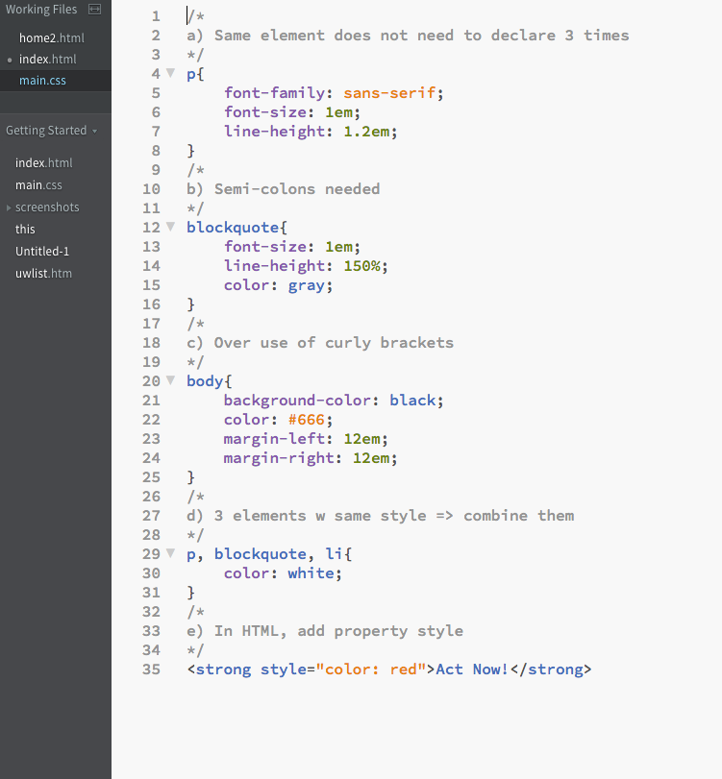

1. **Color the elements red according to style rule**

*Blue is red is this case

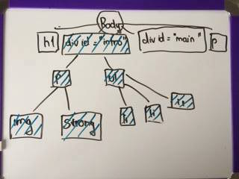

**Chapter 12**

1. **Using diagram, write style for each elements as described:**

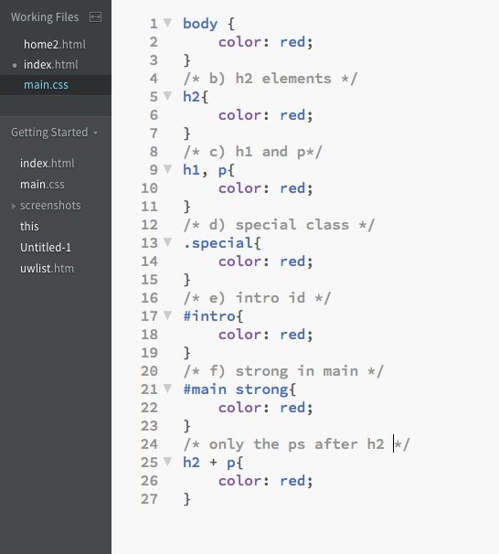

1. **Match style property with text samples:**
   1. 4
   2. 1
   3. 7
   4. 3
   5. 2
   6. 9
   7. 8
   8. 5
   9. 6

**Chapter 13**

1. **Which of these areas get filled with a background color:**

g.

1. **Which is not a way to specify the color white in CSS:**

d. rgb(FF, FF, FF)

1. **Match the pseudo-class with elements it targets:**
   1. 5
   2. 1
   3. 4
   4. 6
   5. 2
   6. 3
2. **Match rules with their respective samples:** 
   1. 1
   2. 3
   3. 2
   4. 6
   5. 5
   6. 4

**Chapter 14**

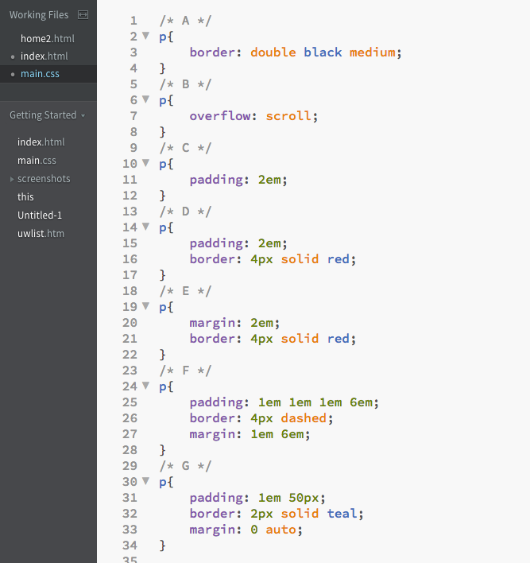

**Chapter 15**

1. **Which of the following is not true of floated elements?**

B – because floats are positioned against content edge not the padding edge

1. **Which of the style rules is incorrect?**

C – because float does not have “right” property (right: 30px;)

1. **Make sure footer div starts below a floated sidebar by:**

(in CSS) div#footer{

Clear: both;

}

1. **The name of the positioning method:**
   1. Absolute
   2. Absolute, fixed
   3. Fixed
   4. Relative, absolute, fixed
   5. Static
   6. Relative
   7. Absolute, fixed
   8. Relative, absolute, fixed
   9. Relative

**Chapter 16**

1. **Match layout type with the factor that determines the final size of the page area:**
   1. Fluid
   2. Elastic
   3. Fixed
2. **Match layout type with the unit of measurements:**
   1. Elastic
   2. Fixed
   3. Fluid
3. **Match layout type with its primary potential advantage:**
   1. Elastic
   2. Fluid
   3. Fixed
4. **Match layout type with its potential disadvantage:**
   1. Fluid
   2. Elastic
   3. Fixed