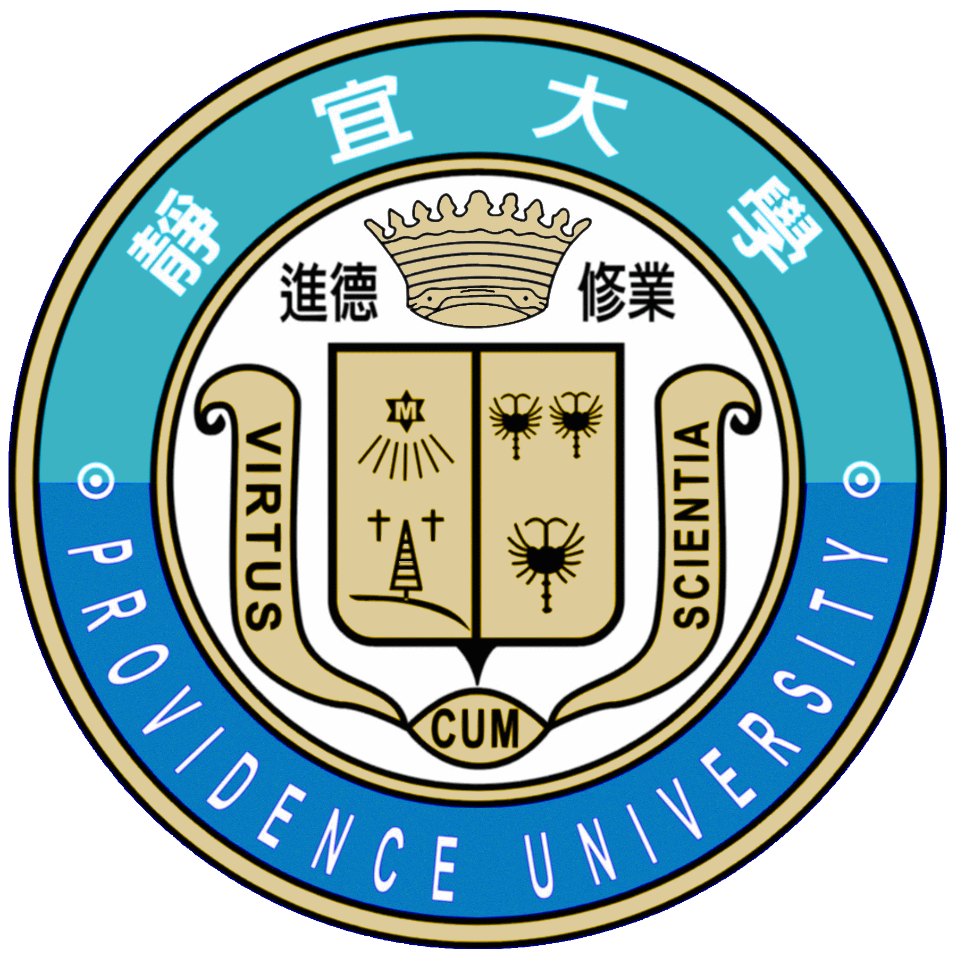

2018 Cultural Immersion Program
Providence University

Vietnam

About Providence University
In answering to the recent national south bound policy of Taiwan, we're reaching out to the institution in Vietnam and intensify the collaboration. It is our sincere hope that Providence University could host the short-term study in Taiwan program for students from Vietnam.
Providence University is a Catholic co-educational institution that was founded in 1956 by an American congregation: the Sisters of Providence of Saint Mary-of-the-Woods, Indiana, USA. It is currently sponsored by the Catholic Diocese of Taichung. Providence University is one of the prominent educational institutions in Taiwan, with 22 departments, 19 graduate programs, two Ph.D. programs, 5 EMBA programs, and one Chinese Language Education Center. We have 12,000 undergraduate students, 1,200 graduate students and 400 full-time faculties (all approximate figures). PU offers fully taught English program in International Business Administration (BBA) and also Graduate International Program (MBA). Furthermore, many programs and courses are taught in English in the field of Science and information Science.

Goals of the Program
Theme: The Advanced mandarin course is planned by the Chinese Language Education Center and the College of Information Science and Informatics. It’s an intermediate Chinese language course together with the information management course for the students in Vietnam. Three goals are set here to make to acquire the linguistic knowledge of language teaching and the skills in Chinese language, information management and culture in Taiwan.

Date | Morning section |  | Afternoon section
Day 1 | Arrival
Day 2 | Campus Tour |  | Chinese Language course
Day 3 | Information Management |  | AI course
Day 4 | Trip to Nantou: Sun Moon Lake
Day 5 | Culture Course | Tour to the City
Day 6 | Departure

Location of the Program
Dates of the program: 19 -24 March 2018
Place: Providence University, Taichung, Taiwan

Registration
This is a 6-day Short-term Study in Taiwan Program designed for students from Vietnam. We are aiming to receive 25 students. Please have the participants fill out the application form as below and send it to Ms. Evangeline Chang at ywchang1@gm.pu.edu.tw.

Financial support
Providence University will support the full program fees for students, including tuition, housing and trips during the 6 days program in Taiwan. The participants are expected to be pay for their own meals (about 50 USD) during the program. Furthermore, the participants also need to be responsible for their airfare, visa and insurance for the program.

Registration Form
Family Name |  | Frist Name |  | Recent Color Photo  （2 Inches）
*Nationality |  | Gender |  | Recent Color Photo  （2 Inches）
Date of Birth |  | *Passport No. |  | Recent Color Photo  （2 Inches）
School/ Department |  |  |  | Recent Color Photo  （2 Inches）
*Tel: | School office/Lab: *Mobile Phone:  *Home: Others:
*E-mail | (1)  (2)
*Permanent Address | □□□-□□
*Emergency Contact at School | Name: ____________________ Tel:________________________  Position: __________________ Mobile Phone:_________________  Institution: _________________________________________________  Email:_____________________________________________________  Address: _____________________________________________________
*Declaration | I declare that the information on this form is true correct, and complete. Providence University has my permission to verify the information reported as needed.  Applicant's Signature:_______________________ Date:______________
Notify | → Please mail this registration form to ywchang1@gm.pu.edu.tw before application deadline.   Be sure your traveling insurance covers all the days in Taiwan.
A copy of Participant’s passport

