**Description of Chilean access to the SPECULOOS Southern Observatory**

**Description of the SPECULOOS Southern Observatory**

The SPECULOOS Southern Observatory (SSO) is composed of four identical 1m robotic telescopes located at ESO Paranal Observatory (Fig. 1). It is operated by a consortium composed of the Universities of Liege (PI), Cambridge, and Birmingham. This facility is essentially devoted and optimized to conduct exoplanet transit search and observations, and in particular to carry out the project SPECULOOS (Search for habitable Planets EClipsing ULtra-cOOl Stars) (Delrez et al. 2018 <http://arxiv.org/pdf/1806.11205>).

The whole facility is operating in robotic mode. Each SSO telescope is a F/8 Ritchey-Chretien with a German equatorial mount operated with direct drive torque motors (Fig. 1). The primary and secondary mirrors are coated with raw aluminum. The combined reflectance curve is shown in Fig. 2. Each telescope is equipped with a 2Kx2K deeply depleted CCD camera with quantum efficiency (QE) above 85% from 400 to 850nm (Fig. 2). Camera’s pixel size is 13.5 microns, translating into a pixel scale of 0.35”/pixel and a total field of view of 12’ x 12’. Each camera is operated at a temperature of -60°C. Measured dark current is about 0.1 el/s/pixel. Cryostat window is optimized for the visible/near-IR and blocks all wavelengths below ~400nm (Fig. 2). CCD gain is about 1el/ADU, and it is linear over its whole dynamical range. The read-out + overhead time is about 10s. The camera is available with a filter wheel equipped with the Sloan g’, r’, i’, and z’ filters, and special filters “I + z” (transmittance >90% from 750 nm to beyond 1000 nm) and “blue-blocking” (transmittance >90% from 500 nm to CCD IR cut-off). The transmission curves of these filters are shown in Fig. 3. The global efficiency curve of the telescope, without filter and accounting also for atmospheric extinction at Paranal for an airmass of 1.5, is shown in Fig. 2.

All four telescopes are controlled by the ACP Expert Observatory Control Software based on instruction scripts (<http://acp.dc3.com/>) dispatched to the telescopes before dusk, based on a 24h scheduling pattern. Before dusk, telescope start-up is done remotely by a member of the consortium. Night operations are carried out automatically under the software supervision of ACP and under the watch of a weather alert triggering system. Any alert triggered during the night (wind, cloud or humidity) or earthquake strong enough to affect the system terminates the night observation. No restart is possible.

At the end of the night the data are automatically transferred to ESO archive and may be retrieve by using PI ID credential.

**Chilean community access**

Following ESO agreement, 10% access of the SSO facility’s observing time is offered to the Chilean community:

1. After subtracting time for technical and maintenance operations, *each semester* there are 330x4/2=660 nights available for observation on the SSO facility. This means that with 4 operational telescopes, each semester, there will be 66 nights available to the Chilean community. These nights are offered in series of 3 consecutive nights, about once every 8-9 days, on one SSO telescope. Available night scheduling will be announced at the time of each call. Observations requests using more than one telescope during the same night are not possible. Note that in order to optimize the robotic sequences, a specific telescope cannot be requested.
2. When Chilean community will be invited to apply for time on SSO, target list of SPECULOOS core (GTO) program will be made available for the purpose of preventing these targets from being proposed for observations. It is the responsibility of the Chilean TAC to ensure that the SPECULOOS core (GTO) program is protected. The consortium will check that the approved programs comply with this restriction, and will not execute those for which it is not the case.
3. After selection and on due time, the Chilean TAC will provide the SSO consortium with the ESO program ID, title, and PI name for each night slot offered in the call. Detailed instructions describing how to prepare the observations will be sent to Chilean PIs.
4. When applying for time, the following observation constraints should be considered:
   1. Shutter limitation restricts exposure time to a minimum of 10 sec;
   2. No telescope out of focus observation is available;
   3. To avoid mechanical failure, for long series (30 minutes or more) the filter wheel cannot be moved at a frequency higher than 1/240 Hz (1 motion every 4 minutes).
5. To prepare their observations, we will provide to the Chilean PIs access to an online Exposure Time Calculator. For information, the best seeing measured on SSO is 0.7”. Careful planning to accommodate with the robotic operation mode of the telescope to avoid saturation.
6. The PIs of Chilean programs will have the responsibility to prepare their sequences of observations, and to recover their data on the ESO archive.
7. Chilean PIs have the responsibility to check their programs using a verification tool provided by the SSO consortium and to submit their sequences to SSO for implementation at least **1 month** before the date planned for observations.
8. Any slot for which no verified program has been submitted by the deadline will be released and available to the consortium.
9. The consortium will not review the Chilean observation sequences but reserves the right to abort at any time any sequence that would be considered unsafe for the facility.
10. The consortium will not compensate for observing time lost due to technical or meteorological reasons.
11. At the end of the night, all images recorded during the night (including calibrations) are automatically transferred to the ESO archive where they can be retrieved by Chilean PI using their ESO credentials.

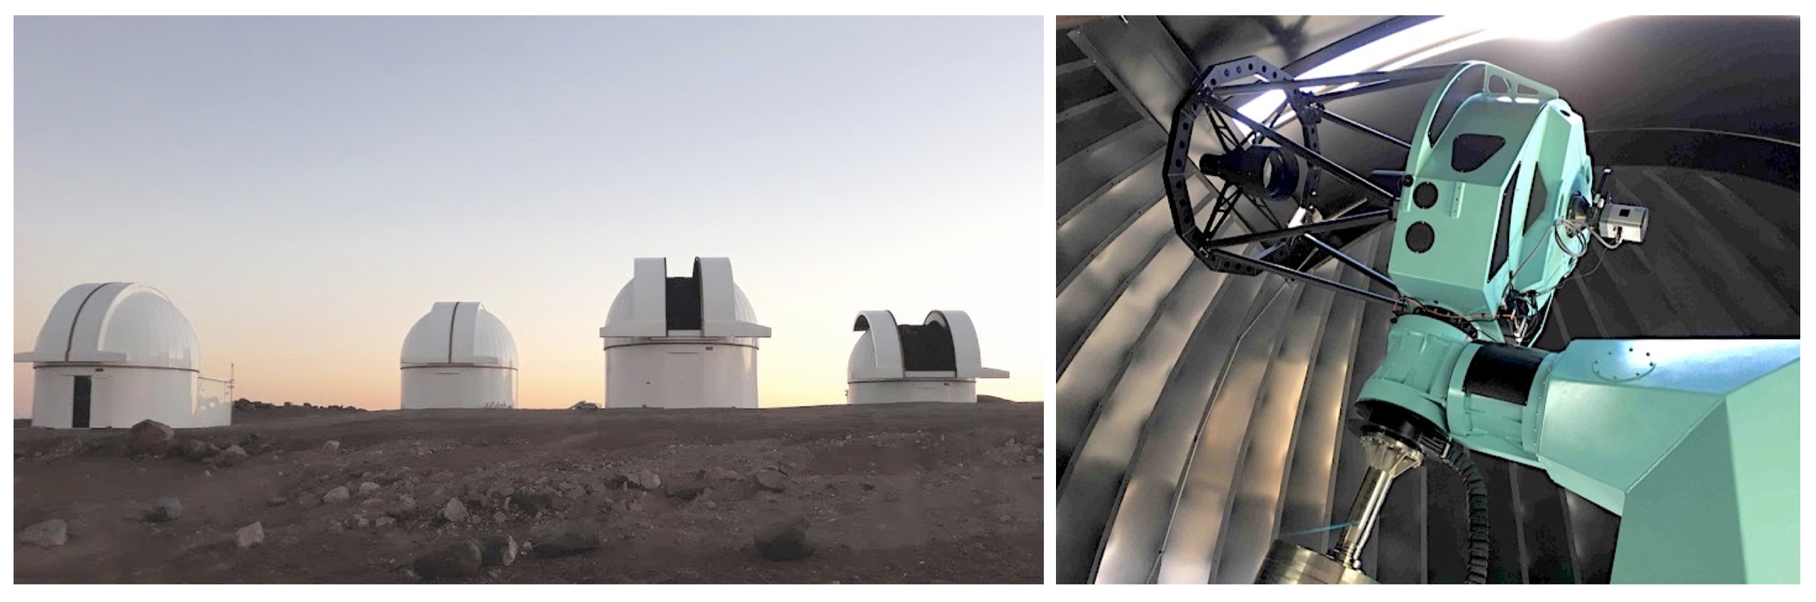Fig. 1. *Left:* The four domes of SSO. *Right*: Callisto, the third telescope of the facility, which is in the leftmost dome on the left picture.

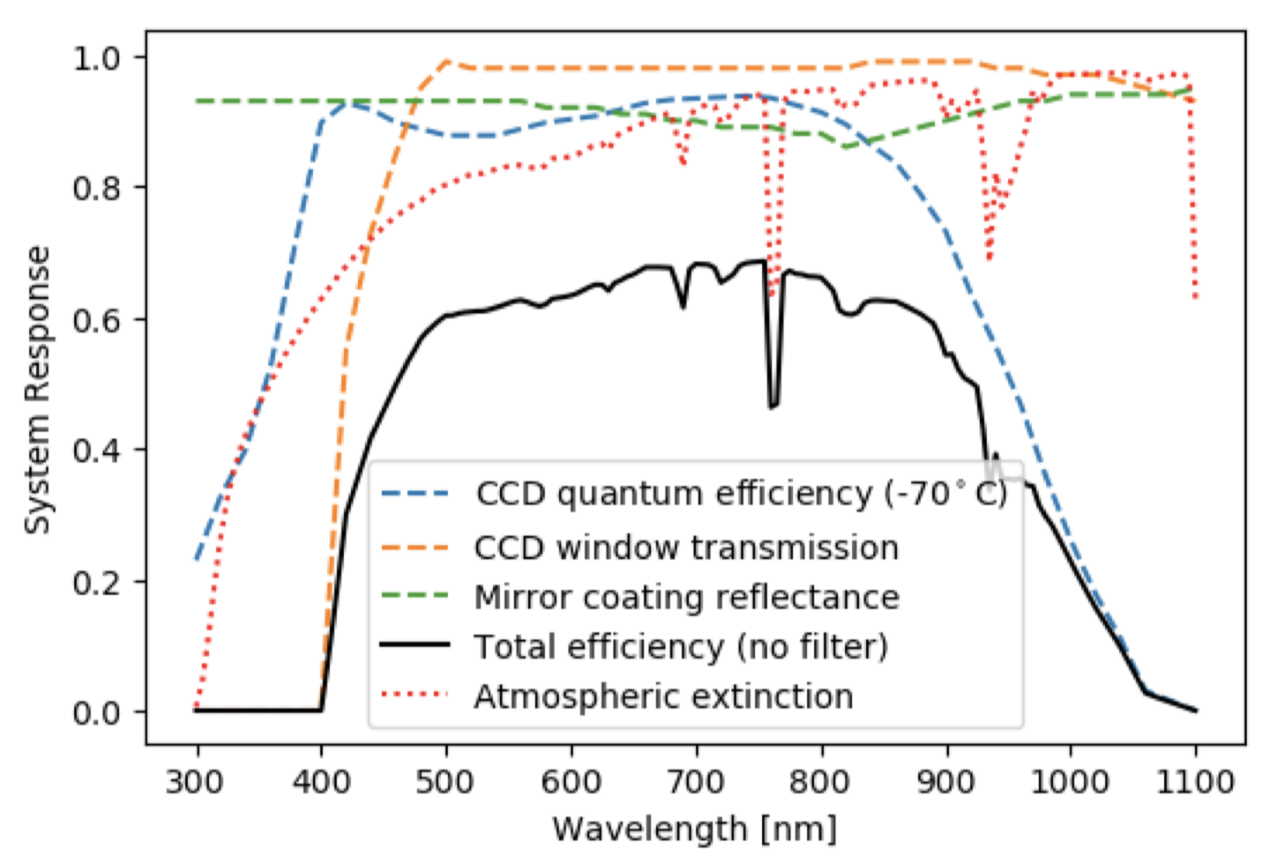

Fig. 2. Overall system efficiency (black curve) taking into account the CCD quantum efficiency (blue dashed line), the CCD window transmission (orange dashed line), the combined reflectance curve of the primary + secondary mirrors (shown here for one mirror, green dashed line), and atmospheric extinction (for an airmass of 1.5, red dotted line), but assuming that the filter wheel is in “clear” position (no filter).

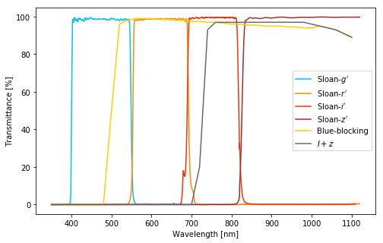Fig. 3. Transmission curves of the different broad-band filters available on the telescopes of SSO.