**Sprint 3**

**Online Document Generator**

**IT Clan Consulting Services**

|  |  |
| --- | --- |
| **Industry Partner** | Vimal |
| **Primary Instructor** | Anjana Shah |
| **Team Member** | Minh Duc Cung |
| **Team Member** | Dilan Piyasenage Don |
| **Team Member** | Kunga Lhosel |
| **Team Member** | Dominic Gopalakrishnan |

Document Revision History

|  |  |
| --- | --- |
| Revision # | Date |
| **1.0** | 11-10-2021 |

# 1.0 Introduction

## Purpose

To increase end user’s workflow and correctability using the program. Ideally the application will perform and provide all outcomes ultimately, increasing efficiency in the end user’s environment.

## Scope

The web application must have a feature that allows users to select a document type and fill out the necessary information. The application would then auto-generate the entire document correctly and sent to the user for manual verification. This document is then sent to selected clients with minimal effort and low error rate.

# System Overview

## Project Perspective

To develop a smart application that integrates with end users to provide automatic generation of documents, use of templates and validation.

Team will work together to create the design and layout of the application as well as the functionality. Users of the program will be those who want to increase efficiency of workflow through document generation and validation. Stakeholder, Vimal, and his training department would also be considered a user of the application. Customers of this program are the individuals that will be receiving the documents which are generated, customized, and sent to them after validation.

## System Context

The software of our choice will be JavaScript with the addition of React to help code and complete this project. Additionally, we will use HTML and CSS because it will be a Web Application. Currently, we see no strategic issues for the future, but that might change and will alter how we approach this project.

## General Constraints

These are the General Constraints that we believe may impact the way we complete our final application:

* Communication delays between the team and stakeholder.
* The design and functionality could completely change depending on database dependency.
* Wrong output format displayed
* Non-effective quality control could lead to unexpected errors to occur.

## Assumptions

* Project team members will help each other to complete their tasks on time.
* The in-scope of the project will not change throughout the life cycle.
* Out of scope product will be work on and improve after in scope has been finished.
* Project will follow team governance guidelines and requirements.

## Dependencies

* The following are the internal and external dependencies that will have to be acknowledged and addressed.
* Client go-ahead is an external dependency, the project cannot be started until the stakeholder gives the go-ahead.
* Testing the application is an internal dependency, the application must be created and finalized before we can test it and its functionality.
* Templates that are pre-uploaded to the application are an internal dependency that it depends on as without it the application would not be able to function.

# Functional Requirements

## System Environment

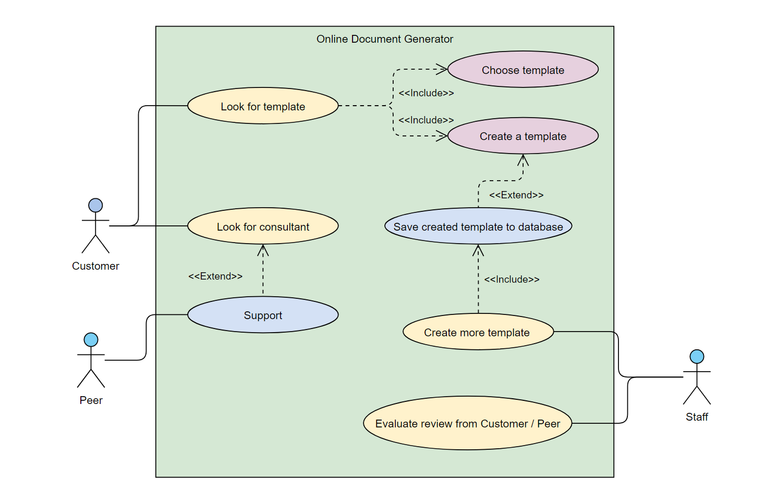  
The Online Document Generator has three active actors and one cooperating system. The Customer, Peer, or Staff accesses The Online Document Generator through the Internet. Customer will able to login and register on our website to have access to our services, the user can ask for assistance from our trained Peer team to help or improve the document. Both the Customer and Peer can communicate directly through our web login or personal email.  
Staff accesses the entire system directly through admin login and are able to create / add new template base on Customer needs. Staff can evaluate reviews from Customer and Peer after each appointment to see what to improve on or change in the future.

## Use Cases

### Customer Use Case

**Use Case:** Customer create document

**Diagram:**

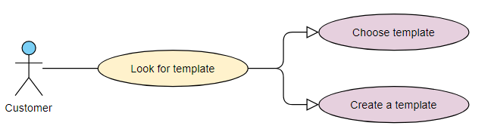

**Brief Description:** The Customer accesses the Online Document Generator Website, searches for a template it edits or create (if there is no template available)

**Step-By-Step Description:**Before this use case can be initiated, the Customer has already accessed the Online Document Generator Website.

1. The Customer choose to search by type or document, category or keyword.
2. The system displays the choices to the Customer.
3. The Customer selects the template desired.
4. The Customer edits the context of the template.
5. The Customer chooses to save to work on later or download the document.
6. The System ask for review/rate.

### Peer Use Case

**Use Case:** Peer service

**Diagram:**

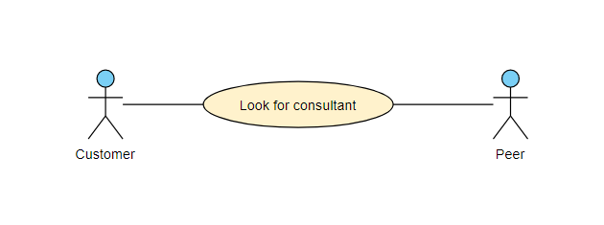

**Brief Description:** The Customer accesses the Online Document Generator Website, look for specialize peer to help / improve the document

**Step-By-Step Description:**Before this use case can be initiated, the Customer has already accessed the Online Document Generator Website.

1. The Customer choose the type of document that needs improve or the services that they need.
2. The System show all peer that matches Customer options.
3. The Customer can read review about that peer then select one that they want.
4. The System will send the request to the Peer that is selected
5. If the Peer is online, they can chat live, if not the Peer will set up the time.
6. After the service, System will ask for review from Customer and Peer.

### Staff Use Case

**Use Case:** Staff create template

**Diagram:**

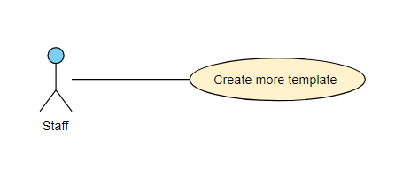

**Brief Description:** The Staff accesses the Online Document Generator Website, able to create template for the user.

**Step-By-Step Description:**Before this use case can be initiated, the Staff has already accessed the Online Document Generator Website.

1. The Staff open the recent template database
2. The Staff looks for new template that customer created or asked
3. The Staff learn and study the new template
4. The Staff create and upload the new template to the System for confirmation
5. All the Staff checks and fix the new template if it passed the new template will be available on the System for Customer to use.

**Use Case:** Staff evaluate review

**Diagram:**

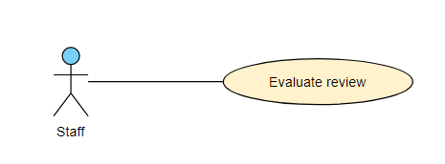

**Brief Description:** The Staff accesses the Online Document Generator Website, able to read Customer and Peer review. **Step-By-Step Description:**Before this use case can be initiated, the Staff has already accessed the Online Document Generator Website.

1. The Staff open the review and report database.
2. The Staff looks for new / un-check reports.
3. The Staff analyse and revaluate the report.
4. The Staff check for confirmation from both Customer and Peer.
5. The Staff make evaluation.
6. The Staff upload data and review on Customer and Peer profile.

## Data Modelling and Analysis

*Not everything is set in stone due to Vimal not confirming on what we have asked yet*

* Normalized Data Model Diagram (Next Page)

* 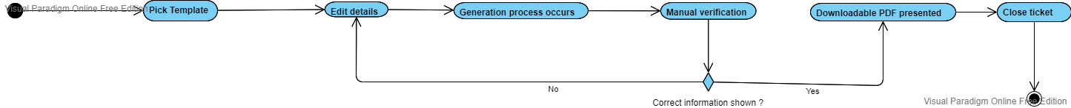Activity Diagrams
* Sequence Diagrams

* Diagram

  Description automatically generatedUML Class Diagram

## Process Modelling

* Data Flow Diagram

# Non-Functional Requirements

Performance: System should generate filled documents in 10 seconds or less.

Reliability: System should remain operating when all users are using its functionality and have an 85% percent reliability each month.

Availability: System downtime should not exceed 5 minute per day

Security: Users will require authorization and authentication when using the system.

Maintainability: System should be able to rollback when software updates fail

Portability: System should be available to all users regardless of operating system.

## Logical Database Requirements

A database will be used to store templates for document generation. Each template would hold different data fields, depending on their requirements. These data formats will vary depending on the input fields required. This database will be used frequently as a template is required for document generation. Data retention is temporary, as those templates used to generate required documents will revert to their previous template self. Generated documents will not be saved, as a pdf will be made available to be downloaded once approved through manual verification.

# 7.0 Approval

The signatures below indicate their approval of the contents of this document.

|  |  |  |  |
| --- | --- | --- | --- |
| Project Role | Name | Signature | Date |
| Member | Minh Duc Cung | M.C | 11-10-2021 |
| Member | R. Dilan Piyasenage Don | D.P | 11-10-2021 |
| Member | Kunga Lhosel | K.L | 11-10-2021 |
| Member | Dominic Gopalakrishnan | D.G | 11-10-2021 |