Project Identification

Project: | Online Document Generator
Prepared By: | K. Lhosel, D. Gopalakrishnan, D. Piyasenage Don, M. D. Cung
Document Version: | 2.0
Published Date: | October, 4th, 2021

Contributors
The following individuals contributed to this document.
Name | Title
Kunga Lhosel | Contributor / Student
Dominic Gopalakrishnan | Contributor / Student
Dilan Piyasenage Don | Contributor / Student
Minh Duc Cung | Contributor / Student

Distribution
This document is distributed to all the following people.
Name | Title
Dominic Gopalakrishnan | Contributor / Student
Kunga Lhosel | Contributor / Student
Dilan Piyasenage Don | Contributor / Student
Minh Duc Cung | Contributor / Student
Anjana Shah | Project overseer / Professor
Vimal | Stakeholder

Referenced Documents
This document refers to the following materials
Version number | Title | Author | Date | Source / Location
1 | COMP3059 Delivering_Business Requrements_Summary | Anjana Shah | 10-03-2021 | Blackboard/Course Content/Lecture Review/Delivering Business Requirements Summary

Revision History

Version Number | Revision Date | Summary of Changes | Modified by
1.2 | 10-01-2021 | Business Context Diagram changes | Minh Duc Cung
1.1 | 10-03-2021 | Grammar Checking and Formatting | Dominic Gopalakrishnan,  Dilan Piyasenage Don
1.1 | 10-03-2021 | Formatting | Kunga Lhosel
2.0 | 10-04-2021 | Final Revision | Minh Duc Cung,  Dominic Gopalakrishnan,  Dilan Piyasenage Don,  Kunga Lhosel

TABLE OF CONTENTS
1. Business Context Diagram 3
2. REquirements Scope Statements 4
3. High Level Business Requirements (HLR) Traceability 4
4. High Level Business Requirements Sign-Off 5

- Business Context Diagram
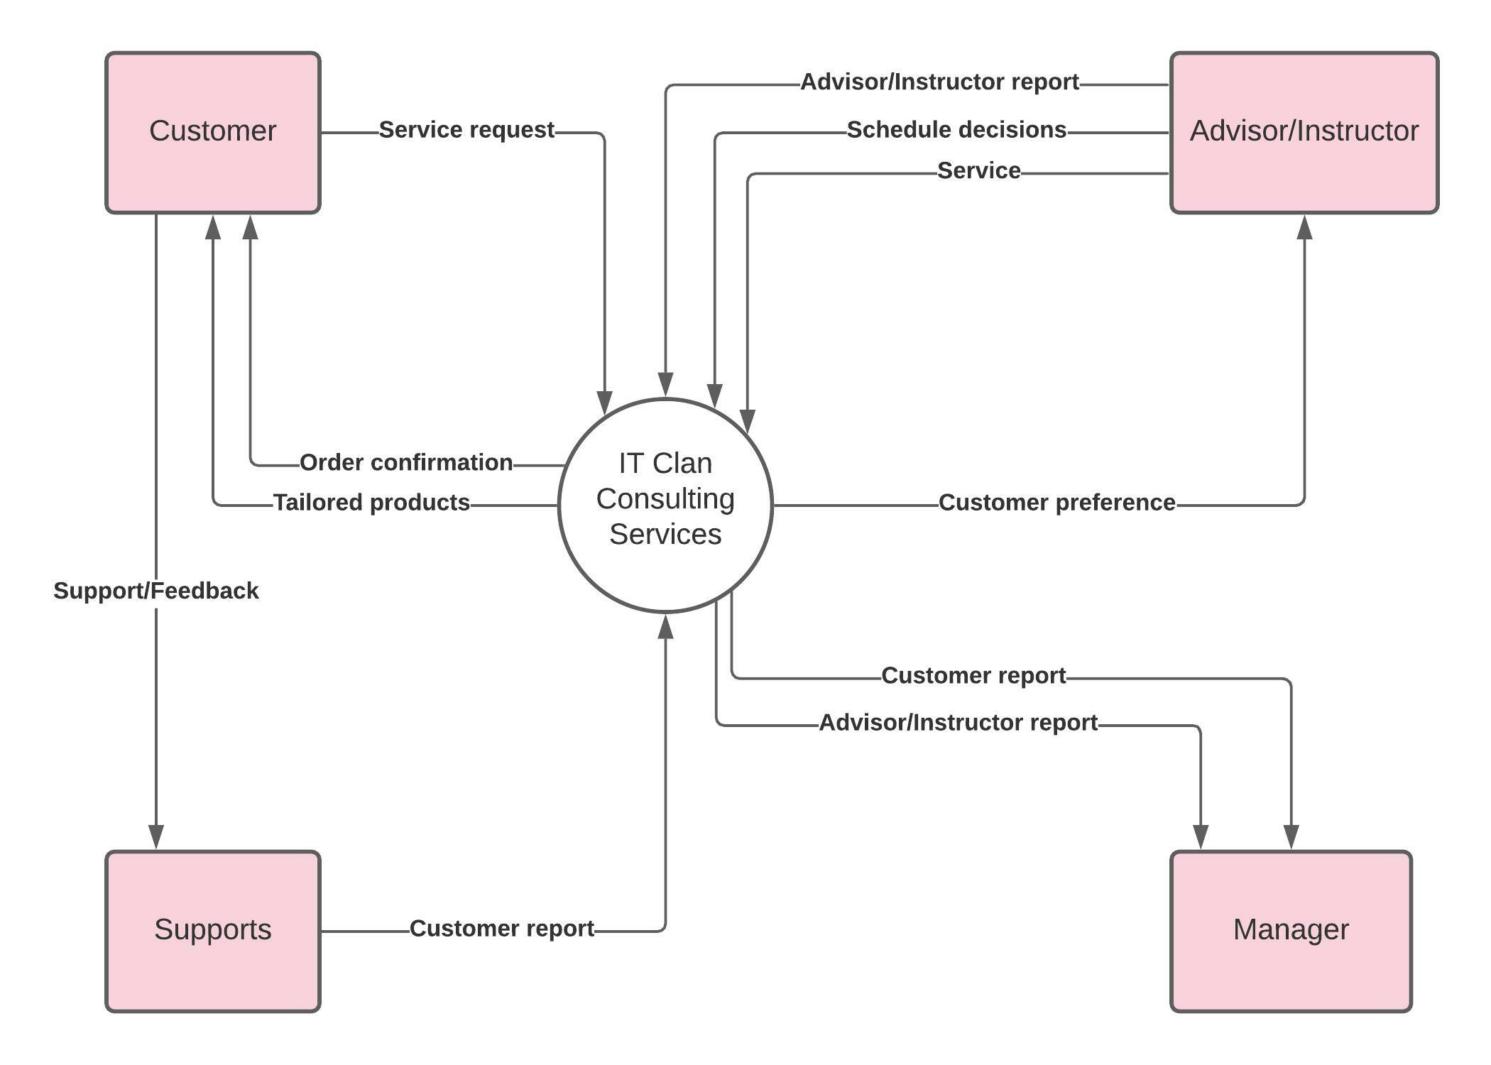

Requirement Scope Area | Description
IT Clan Consulting Services | Area responsible for providing services deals in IT consulting, services, and training

External Entity | Description
Customer | Customer who requests for our services
Advisor/Instructor | Employee taking care of the customer
Supports | Department in which takes customer’s feedback in the end
Manager | Department in which analyses all the results and feedback

Information Flows | Description
Service request | Customer requesting for our service and consultant
Order confirmation | Sending to confirmation to talk with the Advisor/Instructor
Tailored products | End-product or improvement made by the help of Advisor/Instructor
Schedule decisions | Advisor/Instructor setting up schedule to meet up with the Customer
Service | Our service to the Customer
Customer preference | To know what the Customer is looking help for
Support/Feedback | Taking feedback from Customer
Customer Report | Send feedback from the Customer to Manager to be analyzed
Advisor/Instructor Report | Send feedback from the Advisor to Manager to be analyzed
- Requirements Scope Statements
HLR# | Description | Priority  (H, M, L)
 | IT Clan Consulting Services must integrate the program correctly for end users so they can achieve the application’s functionality. | H
 | The application must allow templates to be uploaded and then customized to the users liking. | L
 | The application must send documents for validation to end users to receive the finished product | M

- High Level Business Requirements Sign-Off
The undersigned acknowledge their agreement with the contents of Version 2.0 of the High-Level Requirements document for Online Document Generator.

Following approval of this document, requirements changes will be governed by the project’s change management process, including impact analysis and appropriate reviews and approvals, under the general control of the Project Plan and according to company policy. Approved Change Request Documents, if present, will be attached to this Requirements Document as updates.

Name | Project Role and  Functional Area | Date Signed
Dominic Gopalakrishnan | Team Member, Production | 10-04-2021
Dilan Piyasenage Don | Team Member, Production | 10-04-2021
Kunga Lhosel | Team Member, Production | 10-04-2021
Minh Duc Cung | Team Member, Production | 10-04-2021
Vimal | Stakeholder

* Note: physical signatures are not required. Email approvals are acceptable and should be appended to project documents.

