TaskForge Submission Report -COS214 Practical 4
  - 1. event name, event description, team member names and student numbers;
  - Team member:
- Lethabo Molobi – u25090209
- Lillian Muller -u25253990
- Francois Venter- u25555202

  - Domain:
  - TaskForge models coordination of an emergency response effort. A single Incident is the root of a nested body of work: it contains one or more Divisions (e.g. Fire Division, Medical Division), each Division contains one or more Crews/Squads (e.g. Engine 12 Crew, Triage Unit B), and each Crew contains individual ResponseTasks — the actionable units of work (e.g. “Search Building 3”, “Treat casualty #4”). This gives a genuine recursive part-whole hierarchy at least three levels deep below the root, mixing both nested groups and individual leaf tasks at multiple points.
  - Problem the system solves:
During a live incident, command staff need to: (1) see the whole operation at a glance regardless of how deeply nested it is, (2) get a filtered, prioritised list of only the most urgent outstanding work, (3) track each task through a real lifecycle so that invalid actions (e.g. marking a task on-scene before it has even started travelling) are caught rather than silently corrupting state, (4) attach extra, combinable responsibilities to a task or crew on the fly when circumstances change (a hazmat leak is discovered, a casualty needs both medical support and media handling), and (5) restructure the operation while it is running (reassigning a task to a different crew, escalating it) without breaking a report that is already in progress elsewhere.

completed UML class diagram
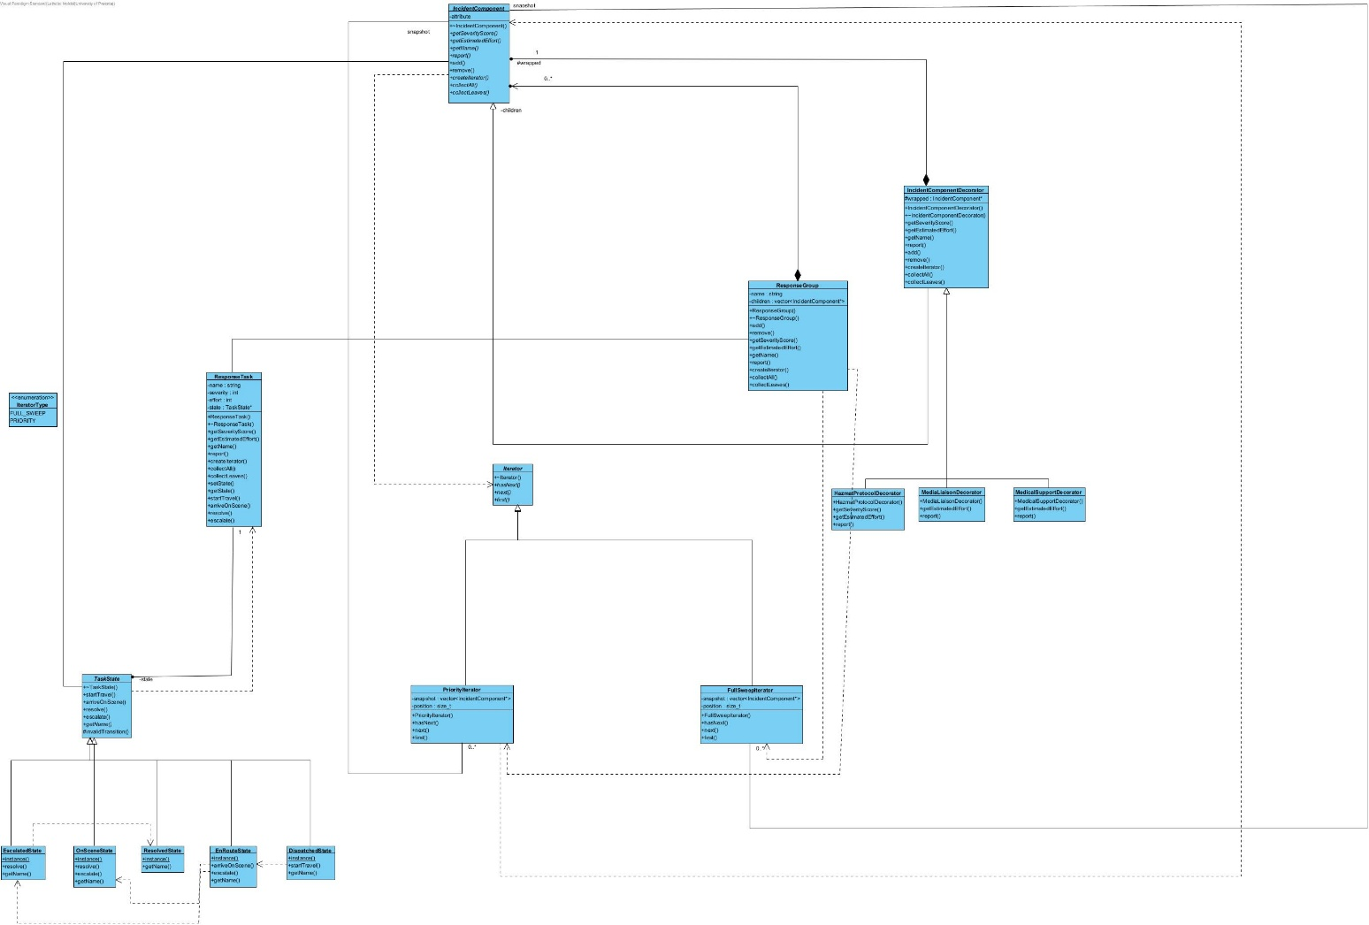
GoF participant mapping
2.2 GoF participant mapping
Pattern | Role | Class(es)
Composite | Component | IncidentComponent
Composite | Leaf | ResponseTask
Composite | Composite | ResponseGroup
Composite | Client | main.cpp
Iterator | Iterator | Iterator
Iterator | ConcreteIterator | FullSweepIterator, PriorityIterator
Iterator | Aggregate | IncidentComponent::createIterator(...)
Iterator | ConcreteAggregate | ResponseGroup, ResponseTask
State | Context | ResponseTask
State | State | TaskState
State | ConcreteState | DispatchedState, EnRouteState, OnSceneState, EscalatedState, ResolvedState
Decorator | Component | IncidentComponent
Decorator | ConcreteComponent | ResponseTask, ResponseGroup
Decorator | Decorator | IncidentComponentDecorator
Decorator | ConcreteDecorator | HazmatProtocolDecorator, MedicalSupportDecorator, MediaLiaisonDecorator

  - Design and Ownership Rationale:
Why one ResponseGroup class for both Division and Crew
Divisions and crews behave identically as containers — both aggregate severity as the worst-case among children and effort as the sum of children's effort, and both need add/remove/traversal. Introducing separate ResponseTeam and Squad subclasses with no behavioural difference would add classes without adding design value, which the brief explicitly discourages. If a genuine behavioural difference between the two levels emerges, ResponseGroup is the natural place to split from.
Ownership policy
●A ResponseGroup owns every child added to it and deletes the whole subtree recursively in its destructor.
●ResponseGroup::remove() detaches without deleting. This is what makes moving a task between groups safe: remove from the old parent, add to the new one, and the object is destroyed exactly once, by whichever group still owns it when the tree is torn down.
●An IncidentComponentDecorator owns whatever it wraps and deletes it in its own destructor, so decorating a task doesn't change who is ultimately responsible for freeing it — the decorator chain is simply inserted into the same ownership chain the tree already uses.
●TaskState concrete states are stateless singletons (function-local static), never heap-allocated and never owned by ResponseTask, so there is nothing to leak and no lifetime to manage for objects that live for the whole program and hold no per-task data.
Why traversal hooks (collectAll / collectLeaves) instead of exposing the container
ResponseGroup deliberately has no getChildren(). Client code (and even the iterators themselves) never obtains the raw std::vector used internally — collectAll/collectLeaves are called polymorphically so each node contributes itself (or not, for collectLeaves on a group) without any caller needing to know whether it is looking at a ResponseTask, a ResponseGroup, or a decorated component.

object diagram
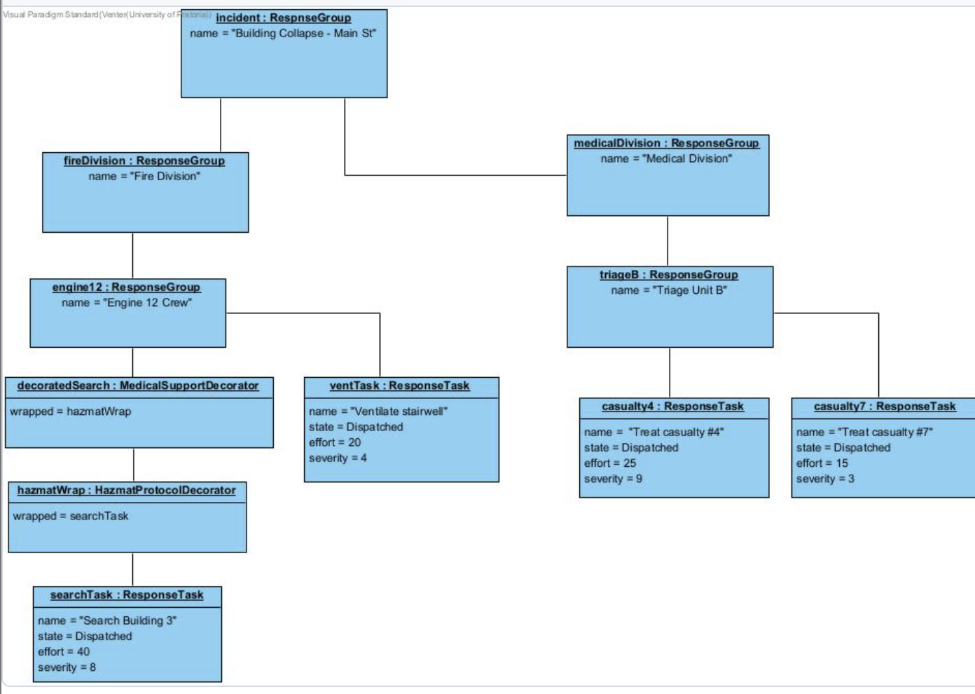
State:
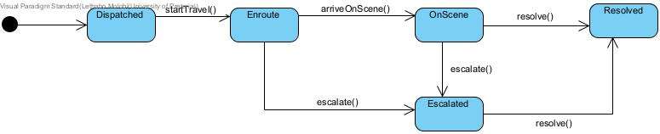

Activity diagram 1: Full incident report (traversal made visible)

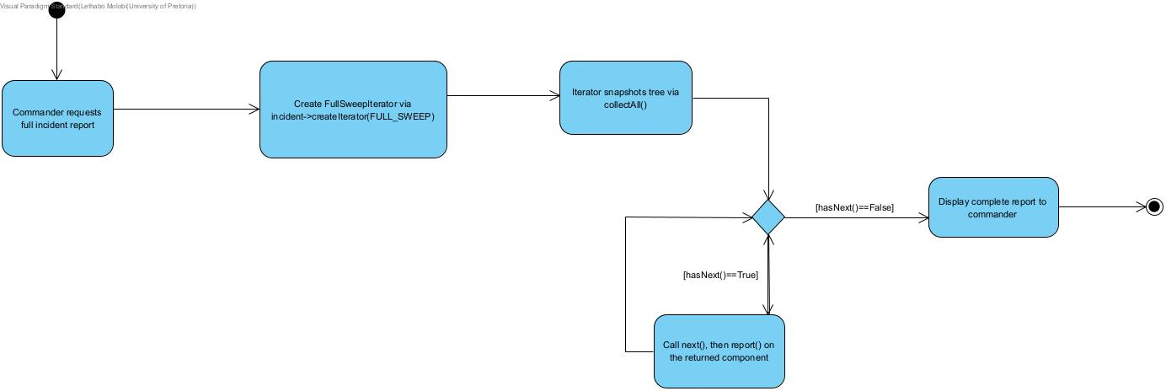

Activity diagram 2: Task escalation and reassignment
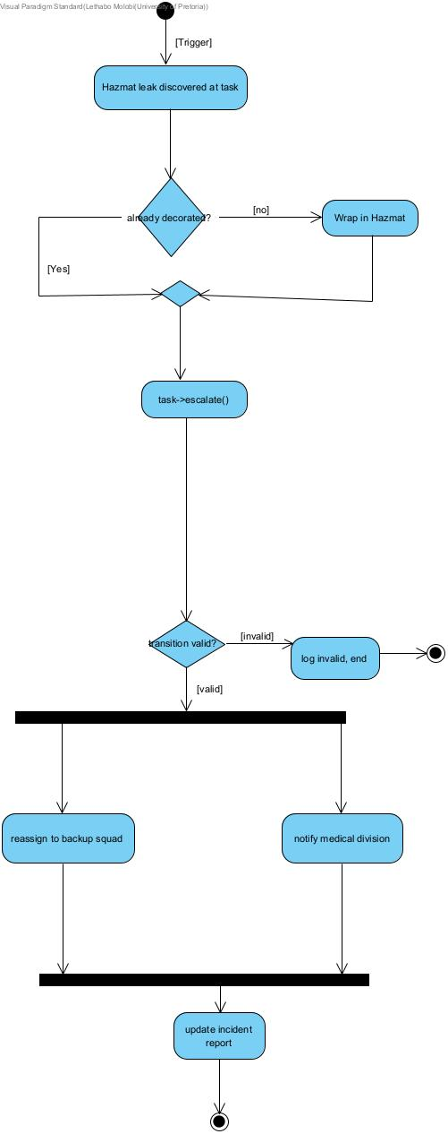

Activity diagram 3:
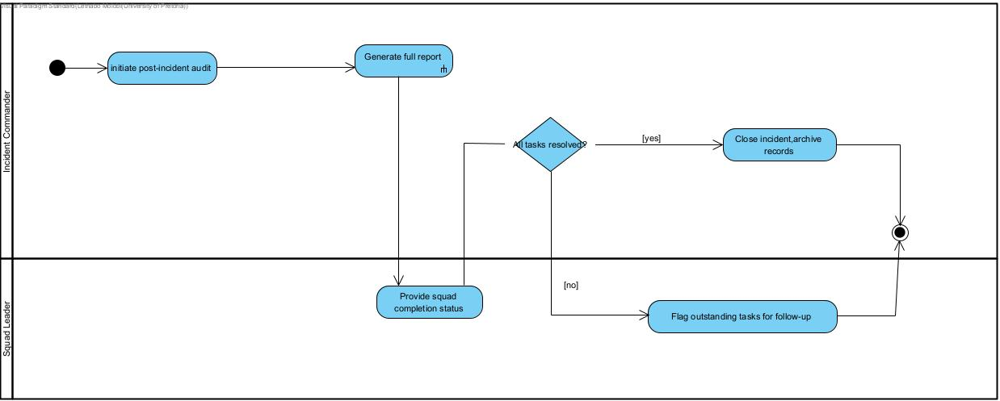

Traversal-Modification Policy and Other Design Decisions
Traversal-Modification Policy
Both FullSweepIterator and PriorityIterator take a snapshot of the structure at construction time (via collectAll/collectLeaves). An iterator created before a structural change (a task moved, added, decorated, escalated, or removed) keeps walking the structure exactly as it looked when it was created — it will not observe the change and cannot dangle, because it holds pointers into a subtree whose ownership has not changed, only its position in the tree. To observe a change, the caller creates a new iterator afterwards. This is deliberately the simpler, safer policy: a report in progress cannot be corrupted or produce inconsistent output just because command reassigned a task mid-sweep.
This is demonstrated directly in main.cpp: an iterator created immediately before casualty #4 is escalated and moved from Triage Unit B to Engine 12 Crew still reports the old structure, while a second iterator created immediately after the move reports the new one.

Other significant decisions
- Decorators are applied by detaching the plain component from its parent, wrapping it, and re-adding the wrapped result — the parent never needs to know or care whether what it holds is decorated.
- Invalid state transitions print a clear message rather than throwing, so they are visible during the demo without crashing the program; add() / remove() on a leaf or decorator instead throw, since attempting them is a programming error rather than an expected runtime path

Debugging and Memory Investigation
GDB Session:
A genuine bug encountered during development:
Symptom
main() ran to completion and printed all expected output, then crashed at the very end with Segmentation fault (core dumped) during final cleanup (delete incident;).
Cause
In the reassignment of casualty #7 from Triage Unit B to Engine 12 Crew, the call to triageB->remove(casualty7) was omitted before engine12->add(casualty7)
This left the same ResponseTask* stored in two ResponseGroups at once. Both groups' destructors run during the recursive teardown of the tree, so the first group to be destroyed frees casualty7, and the second group's destructor then calls delete on an already-freed pointer — a double free.
Debugging evidence
Valgrind pinpointed an invalid read at the delete child; line inside ResponseGroup's destructor, identified the freed block as having been released by an earlier ResponseTask destructor call from the same line (i.e. the first group's teardown), and traced the block's original allocation back to the exact new ResponseTask(...) call for casualty #7 in main.cpp. The LEAK SUMMARY still reported definitely lost: 0 bytes, confirming this was a double-free / invalid access rather than a leak — a distinct and, in some ways, more serious category of memory bug. GDB's backtrace on the automatically caught SIGSEGV showed the recursive ~ResponseGroup() chain unwinding through Incident → Fire Division → Engine 12 Crew, crashing the second time that chain reached casualty #7 — i.e. exactly the “two groups both think they own this task” mechanism.

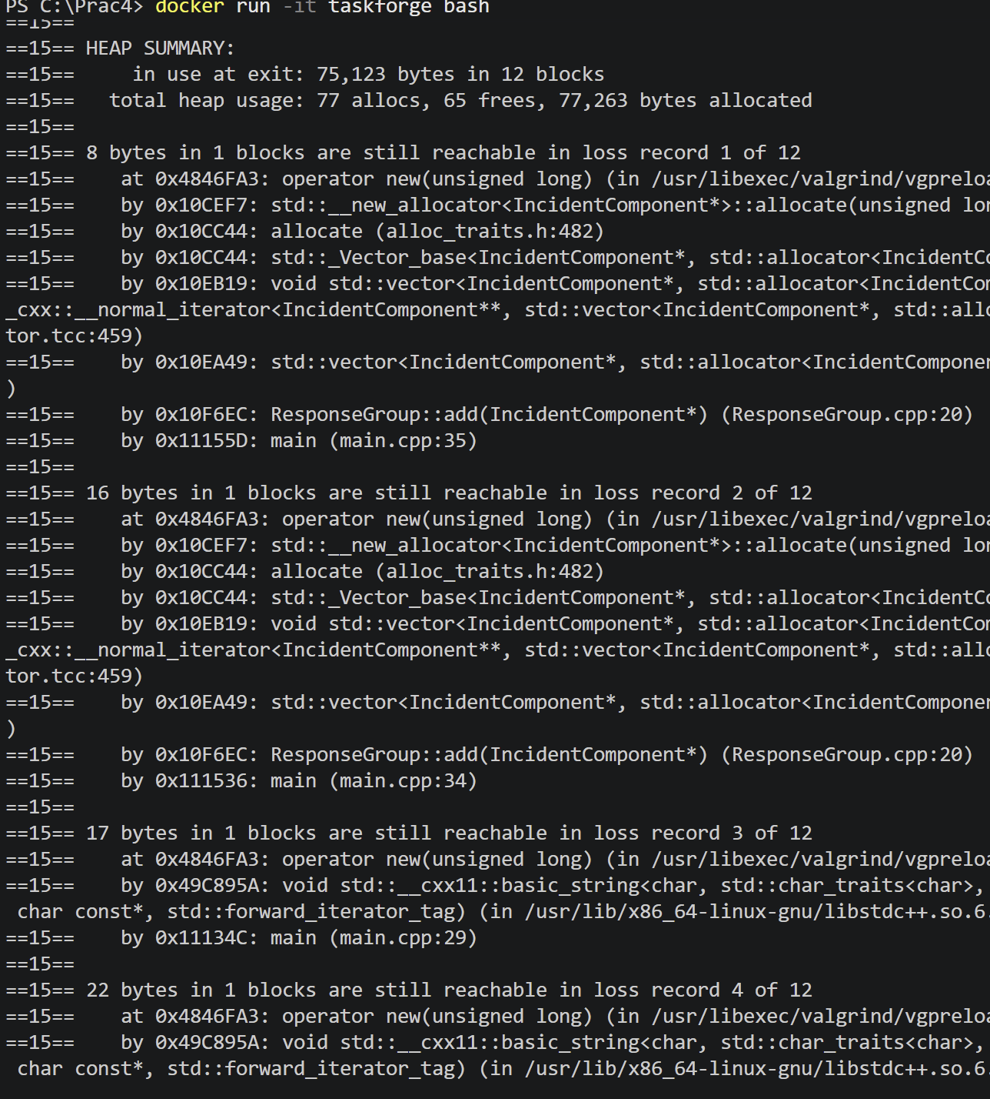

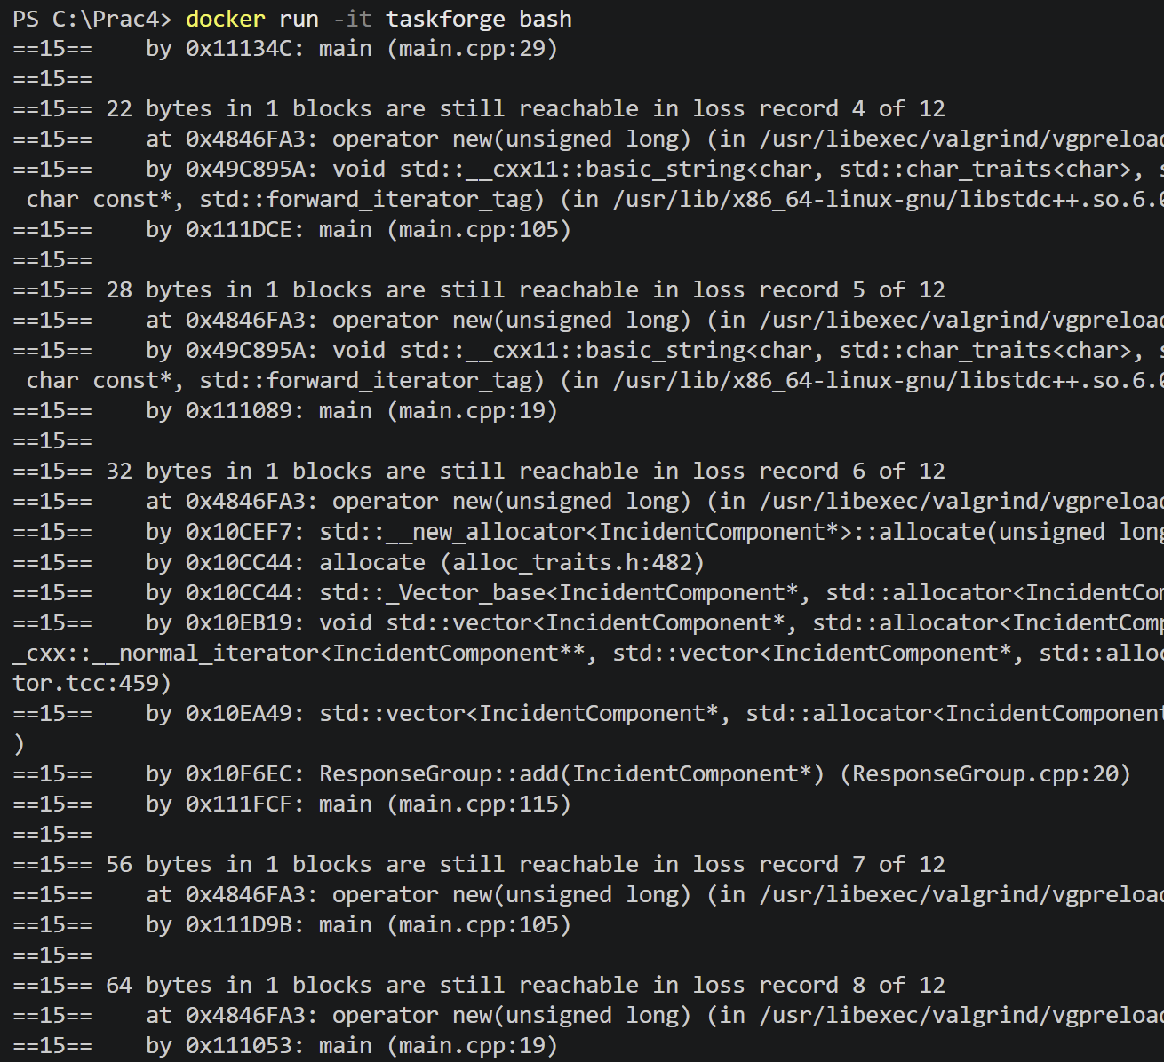

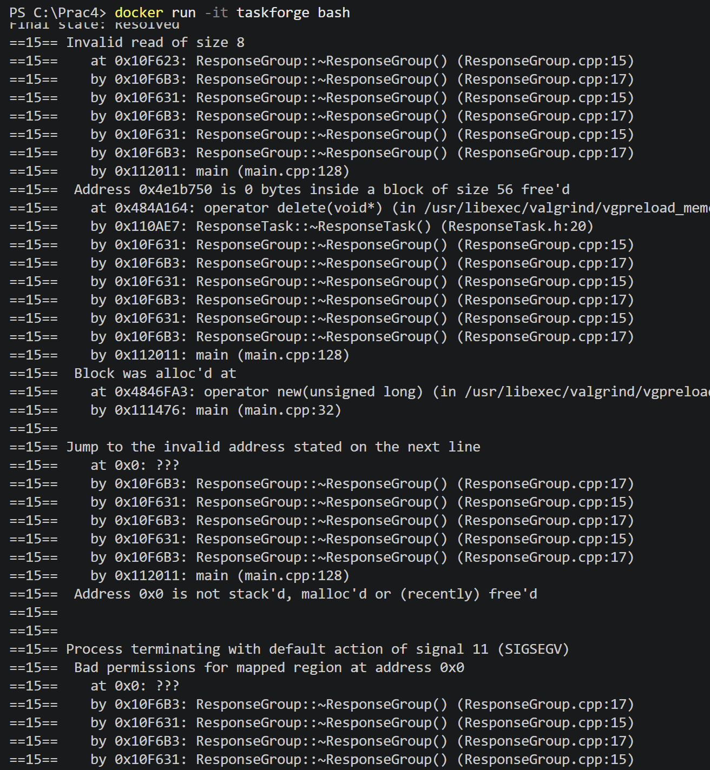

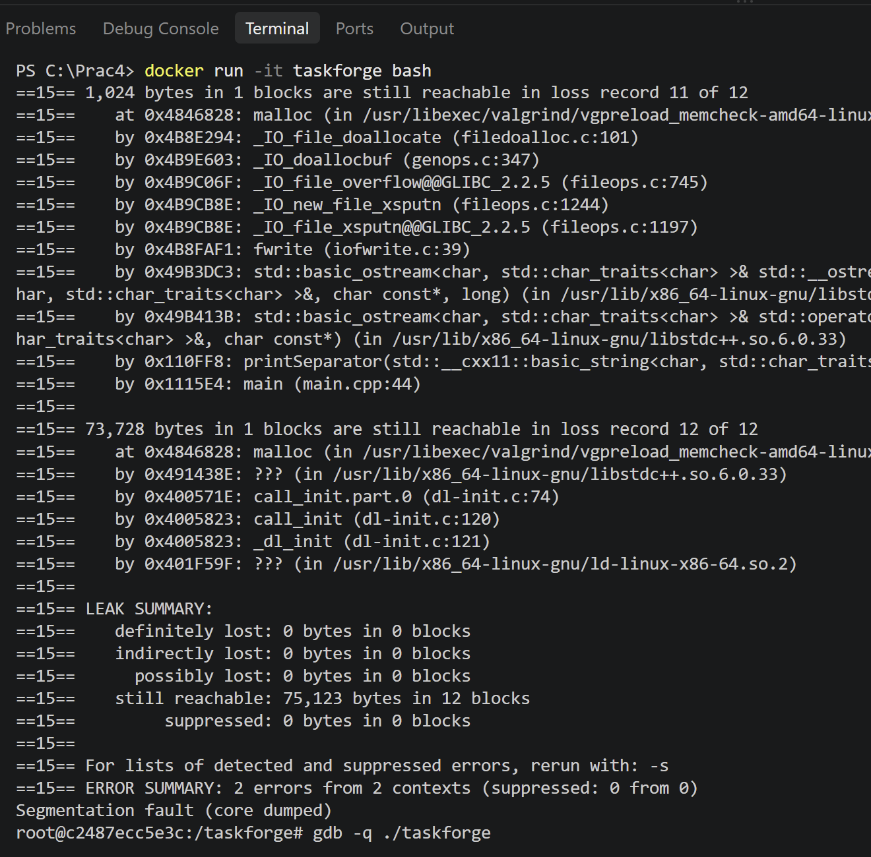

Reading symbols from ./taskforge...
(gdb) run
Starting program: /taskforge/taskforge
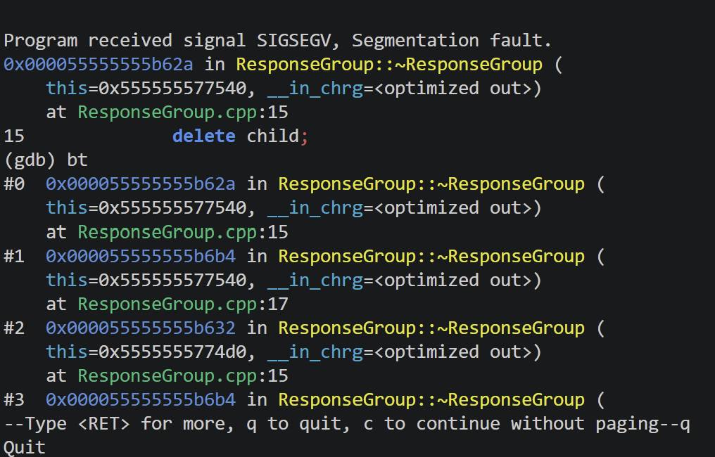

Correction
The missing detach was added back before the re-add, restoring the single-owner invariant:
triageB->remove(casualty7); // detach before transferring ownership
engine12->add(casualty7);
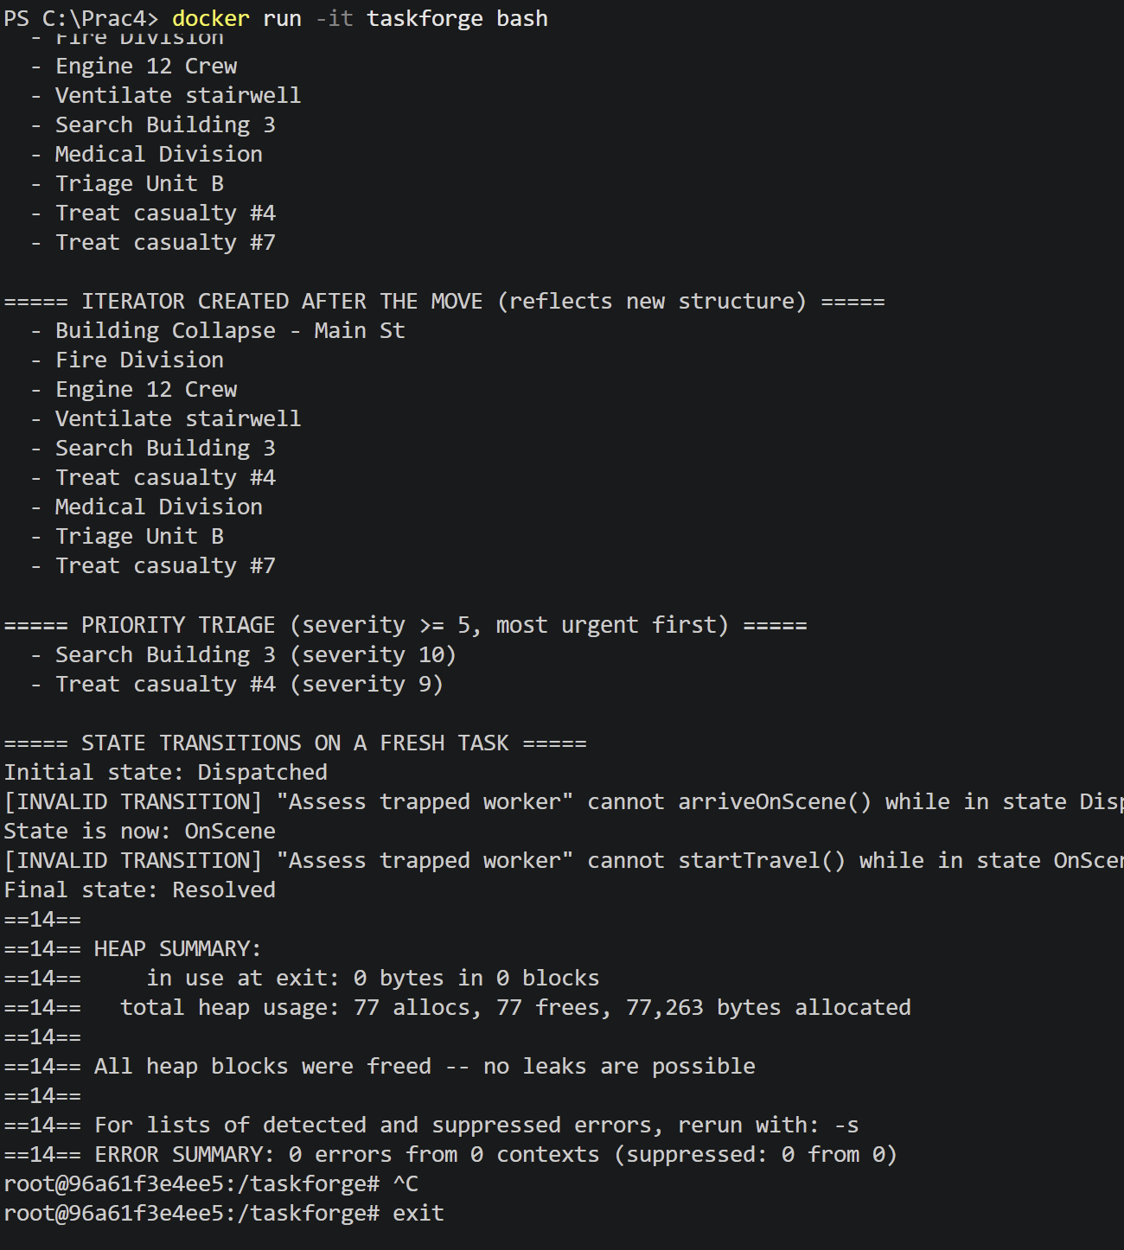
This resolves the symptom because casualty7 is now only ever present in one group's child list at a time, so exactly one destructor call frees it, however deep the recursive teardown goes.
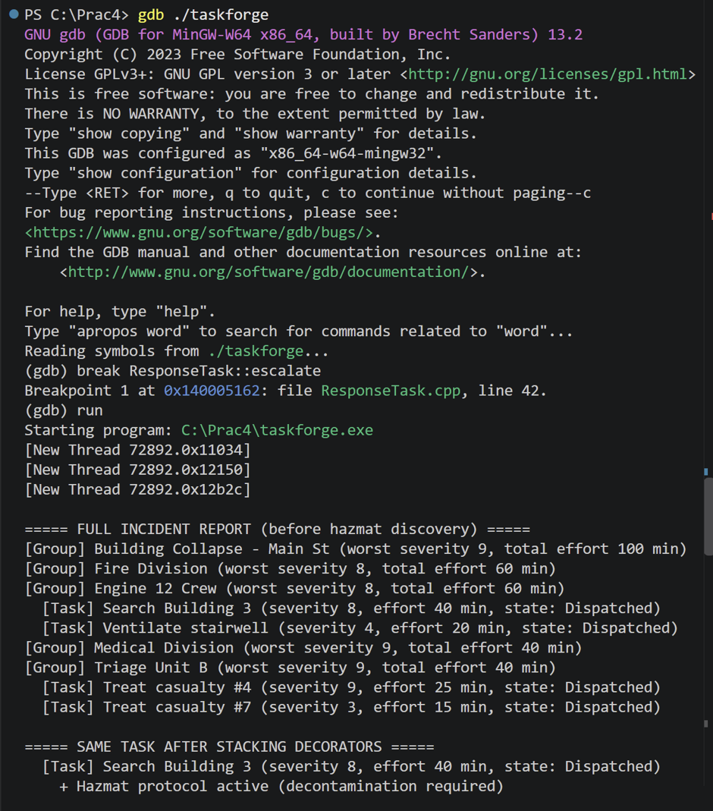

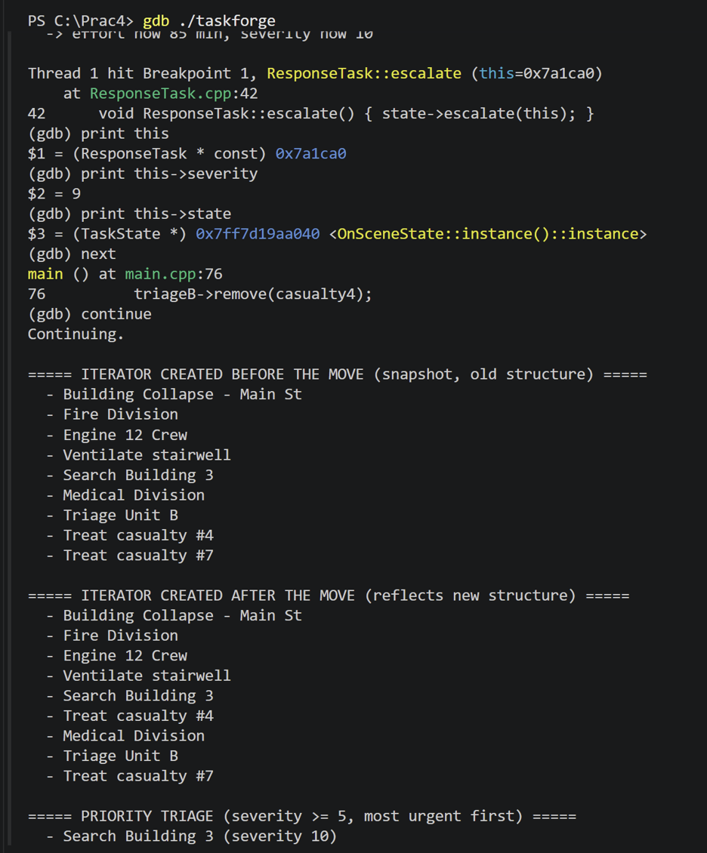
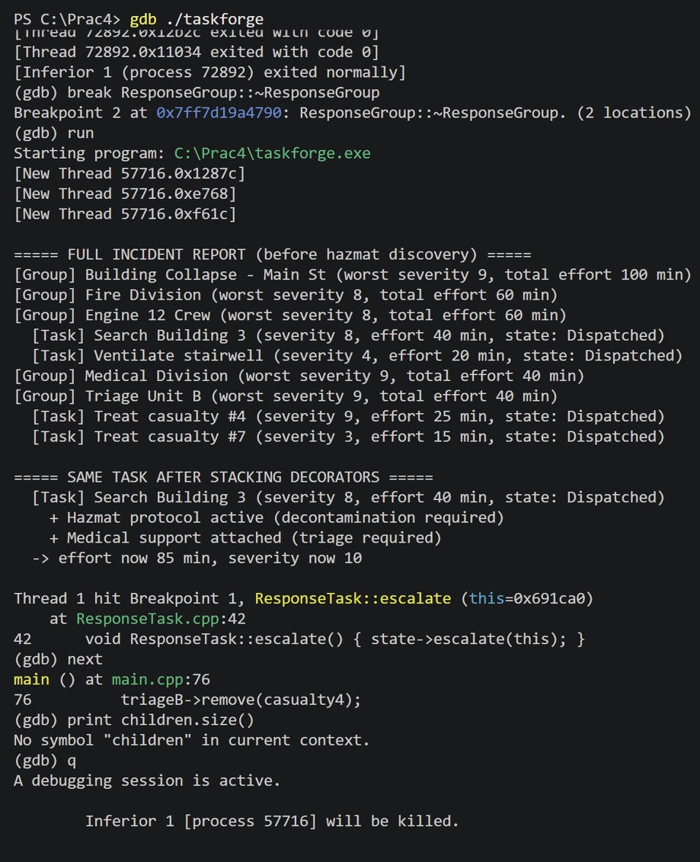

Valgrind evidence for the final application:
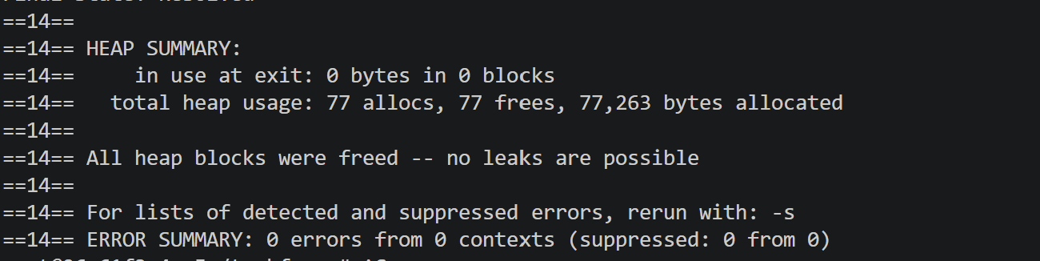
GitHub Repository and Workflow Reflection
Repository link: https://github.com/duckyducky2850/Prac4_214
Workflow reflection:
Our team followed a collaborative development process based on the initial TaskForge design. At the beginning of the project, all three members worked together to agree on the emergency-response domain, the Incident → ResponseGroup → ResponseTask hierarchy, the shared `IncidentComponent` abstraction, the ownership policy, and the approach to structural changes during traversal.
After the initial design was established, the implementation was divided between the three team members. Member A was responsible for the Composite and Iterator components, Member B was responsible for the State component, and Member C was responsible for the Decorator component as well as supporting project infrastructure and documentation. This allowed the main components to be developed in parallel while maintaining the common design agreed upon by the team.
The GitHub repository was used throughout development rather than being populated only at the end. The initial project structure was committed first, followed by commits implementing the Composite and Iterator functionality, the State implementation, and the Decorator implementation. Further commits were made during integration, testing and debugging. This allowed the repository history to reflect the development of the project over time and the contributions of all three team members.
Member A's work focused on the recursive hierarchy and traversal behaviour, including `IncidentComponent`, `ResponseTask`, `ResponseGroup`, `FullSweepIterator` and `PriorityIterator`. Member B's work focused on `TaskState`, the concrete task states and their integration with `ResponseTask`. Member C's work focused on the Decorator hierarchy, including `HazmatProtocolDecorator`, `MedicalSupportDecorator` and `MediaLiaisonDecorator`, as well as the Dockerfile, Makefile and supporting documentation.
Once the individual components were developed, the team integrated them into the complete TaskForge system. Integration was particularly important because the practical requires the Iterator, Composite, State and Decorator patterns to operate as one coherent system rather than as four isolated examples. The team tested the implementation using the two planned runtime scenarios: a building-collapse response and a mass-casualty triage response. These scenarios demonstrated traversal of the hierarchy, lifecycle changes, runtime decoration and structural changes.

Debugging and development tools were also incorporated into the workflow. GDB was used to investigate meaningful program behaviour such as task escalation and state changes, while Valgrind was used during development and for the final application to investigate memory management. The Docker environment, Makefile and README were developed alongside the implementation so that the complete project could be built and investigated consistently.
The final stage focused on integration, debugging, diagrams, documentation and preparation for the demonstration. All three members participated in final integration and testing so that every member could understand and explain the complete submission, including the design patterns, ownership decisions, traversal behaviour, runtime changes, debugging evidence and Docker workflow.
Overall, the GitHub workflow progressed from a shared initial design, through parallel implementation of the different components, to integration, testing and finalisation. The resulting repository history demonstrates ongoing development and meaningful contributions from all three members rather than a repository being created or populated only at the end.
Team Contribution Statement:
Member 1 — Lethabo Molobi u25090209
Member 1 was primarily responsible for the Composite and Iterator portions of the TaskForge system. Their implementation included IncidentComponent, ResponseTask, ResponseGroup, FullSweepIterator and PriorityIterator. They also contributed to the shared hierarchy, system integration and GDB investigation.
Member 2 — Lillian Muller u25253990
Member 2 was primarily responsible for the State portion of the TaskForge system. Their implementation included TaskState and the concrete states used to represent the lifecycle of a response task. They integrated the State pattern with ResponseTask and contributed to debugging, Valgrind investigation and the UML state diagram.
Member 3 — Francois Venter u25555202
Member 3 was primarily responsible for the Decorator portion of the TaskForge system. Their implementation included the decorator base and the HazmatProtocolDecorator, MedicalSupportDecorator and MediaLiaisonDecorator classes. They also contributed to the Dockerfile, Makefile, README, UML Activity Diagrams and supporting project documentation.
Team Contribution
All three members contributed to the initial system design and agreed on the domain, hierarchy, ownership policy, traversal-modification policy and shared IncidentComponent interface. The team also worked together during integration, runtime scenario development, debugging, documentation and final testing. This ensured that the four required design patterns were integrated into one coherent emergency-response system and that all members understood the complete submission.

