H-infinity HW4

108061578 高振晏

This is a nonlinear guidance control problem, we adopt fuzzy modeling technique to model the nonlinear system with error dynamic and external disturbance. Here the external disturbance can be consider as the flying behavior of target missile.

Here we control the Vr , Vɵ and Vɸ , and we can get the following figures.

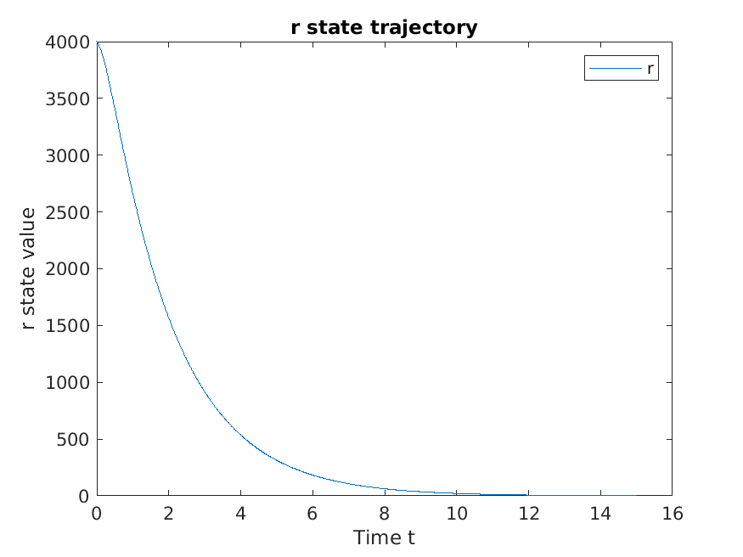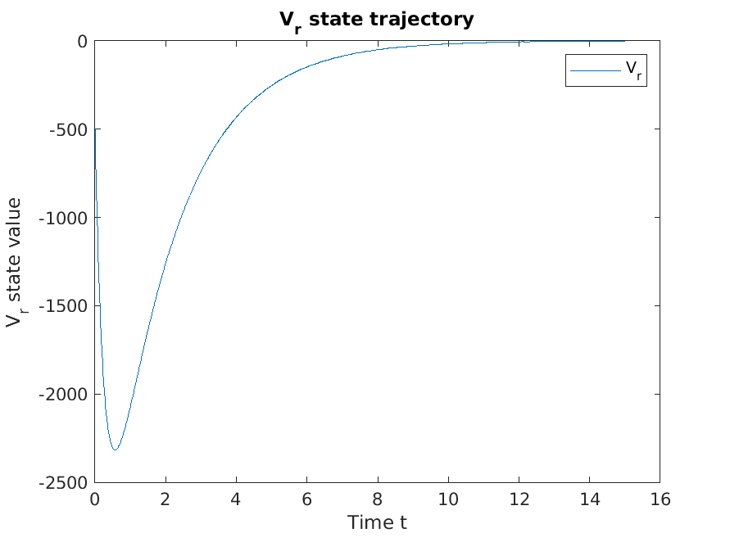

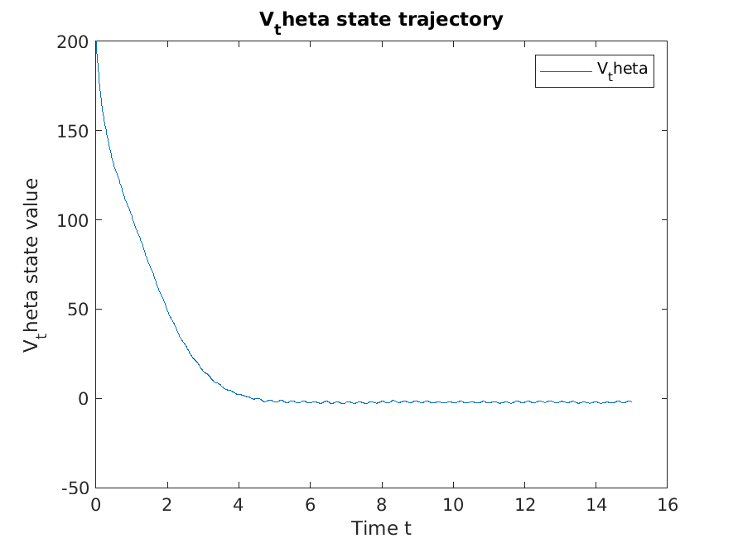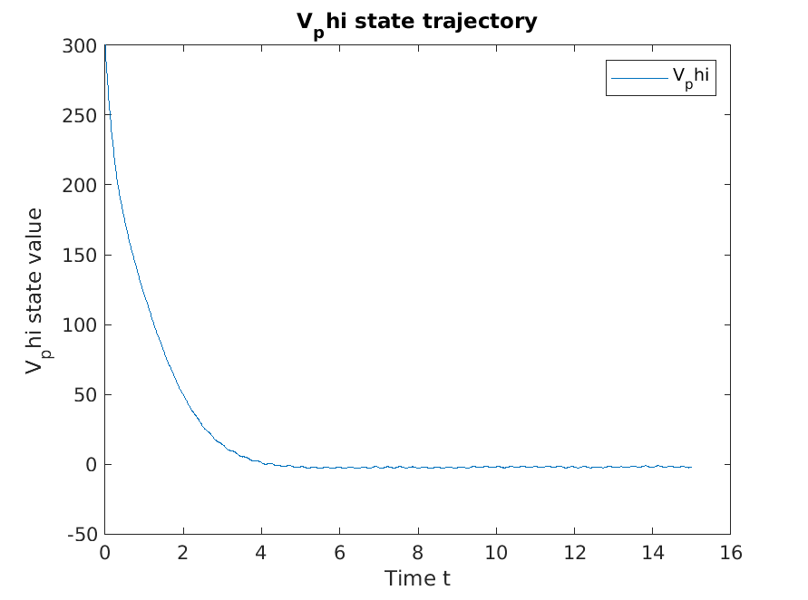

Fig 1. We can see that the r state trajectory is not a line but a curve, and it hits the target quite fast, here is because when we can control the relative velocity of the missile, it is like we can speed up or down velocity of our missile to alleviate the external disturbance. With this kind of benefit, our Vɵ and Vɸ can also converge to 0 quite fast.

However, we cannot really control the relative velocity between the missiles. So we can set ur = 0. Then we get the following figures.

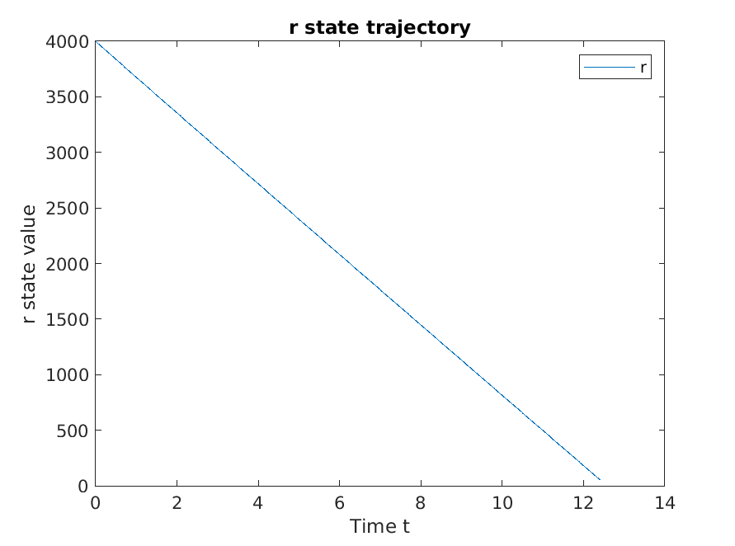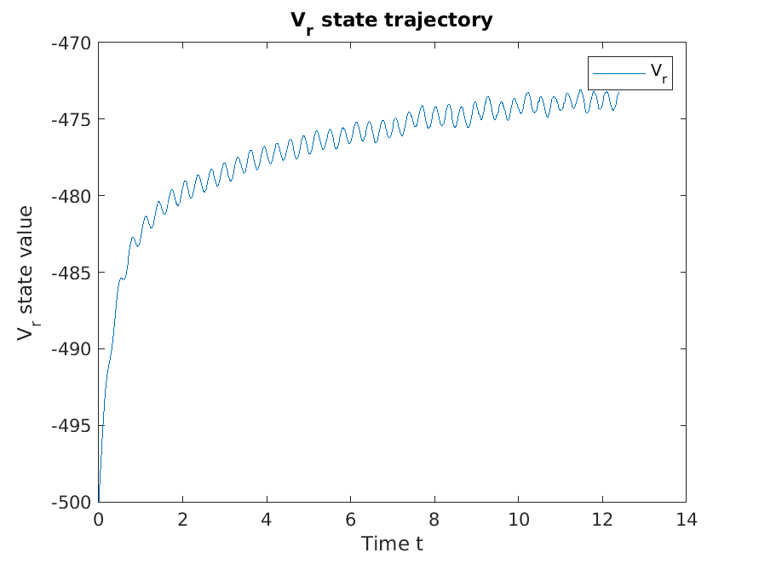

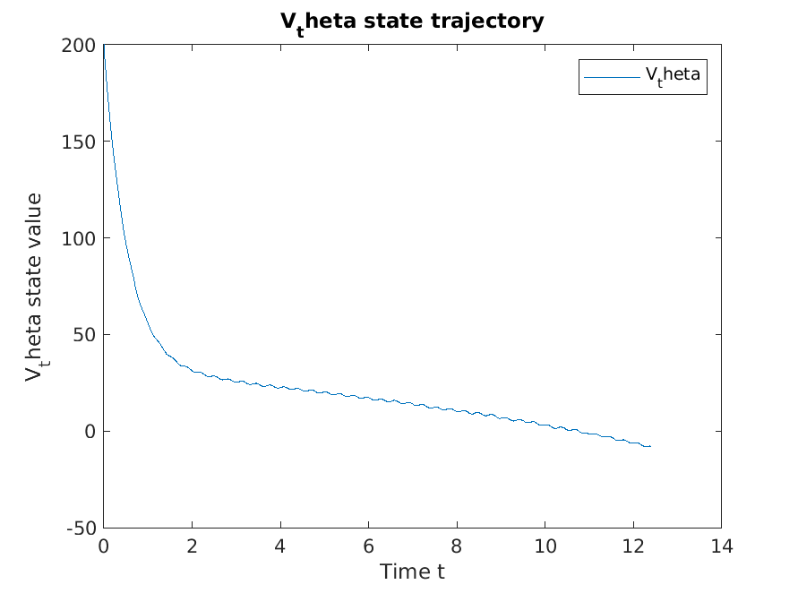 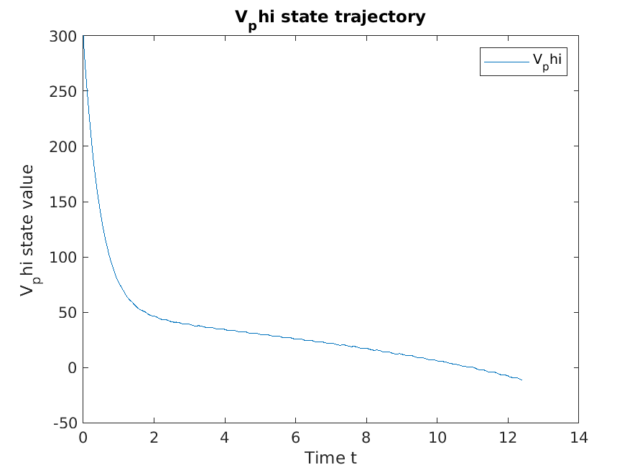

Fig 2. Here when we disable the control of ur we can see the relative distance is decrease like a straight line, however, it is still a little bit zigzag when we look closer. Also we can see that the relative velocity do suffer the external disturbance and perform some sinusoidal behavior, also the Vɵ and Vɸ does not converge to 0 that fast.