Part 1: Data Analysis & Design
- Main entities and key attributes
- User: UserId, UserName, Password, FullName, Email
- Course: CourseId, Title, Description, CoachId
- Coach: CoachId, CoachName, Specialization, Bio
- WorkoutSession: WorkoutSessionId, UserId, CoachId, CourseId, StartTime, EndTime, Duration
- Conceptual ERD
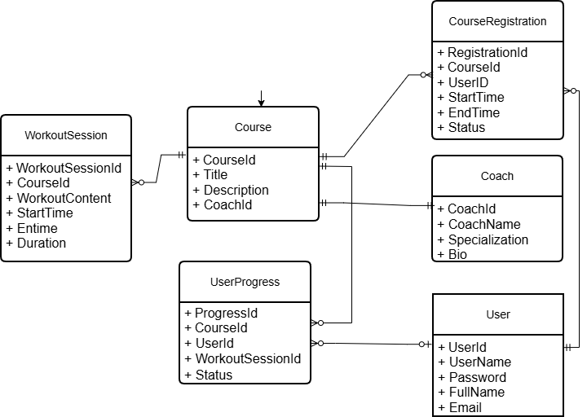
- Logical ERD
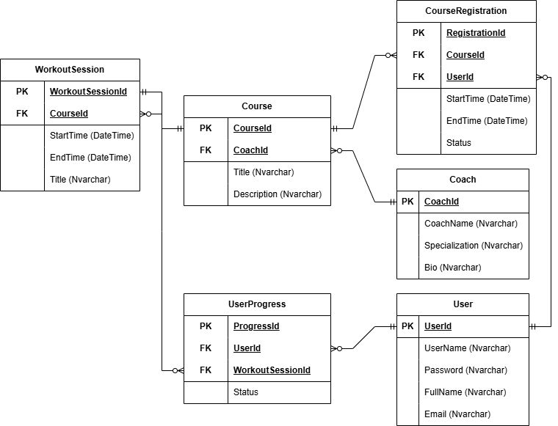
- State Diagram

Course Registration status:
- Pending
- Active
- Completed
- Cancelled
WorkoutSession State Diagram:
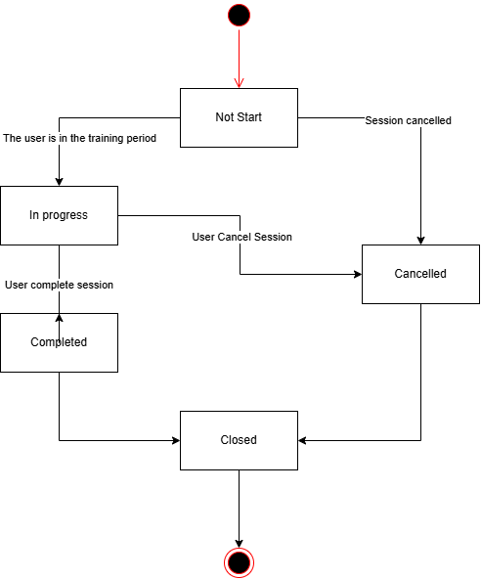
Part 2: Data Analysis & Design
- Client side, server side and database for the “register course” function.
- Client (React):
- Component: CourseDetailComponent (The course detail page) has a "Register" button.
- Service: ApiService.js (or RegistrationService.js) contains a registerCourse(courseId) function. This function will call an HTTP POST to the API server, sending the courseId in the body and the JSON Web Token (JWT) in the Authorization header.
- Server (MVC - e.g., Spring Boot):
- Controller (CourseRegistrationController):
  - Receives the POST /api/registrations request.
  - Method: createRegistration(courseId, userId) (It gets userId from the authenticated token).
  - Calls CourseRegistrationService to handle the business logic.
- Service (CourseRegistrationService):
  - Contains the main business logic.
  - Checks if the user is already registered for this course (queries via the Repository).
  - If not, creates a new CourseRegistration object.
  - Sets the initial state (e.g., Status = 'Pending') and assigns UserId, CourseId.
  - Handles payment logic (if any).
  - Calls CourseRegistrationRepository to save.
- Repository (CourseRegistrationRepository):
  - Interface (e.g., JpaRepository) responsible for database interaction.
  - Provides methods like save(registration) (corresponding to INSERT) or findByUserIdAndCourseId(...) (corresponding to SELECT).
- Database (MySQL/PostgreSQL):
- Table: CourseRegistration
- Action: A new row is **INSERT**ed into this table with the UserId, CourseId, Status, and other relevant information.
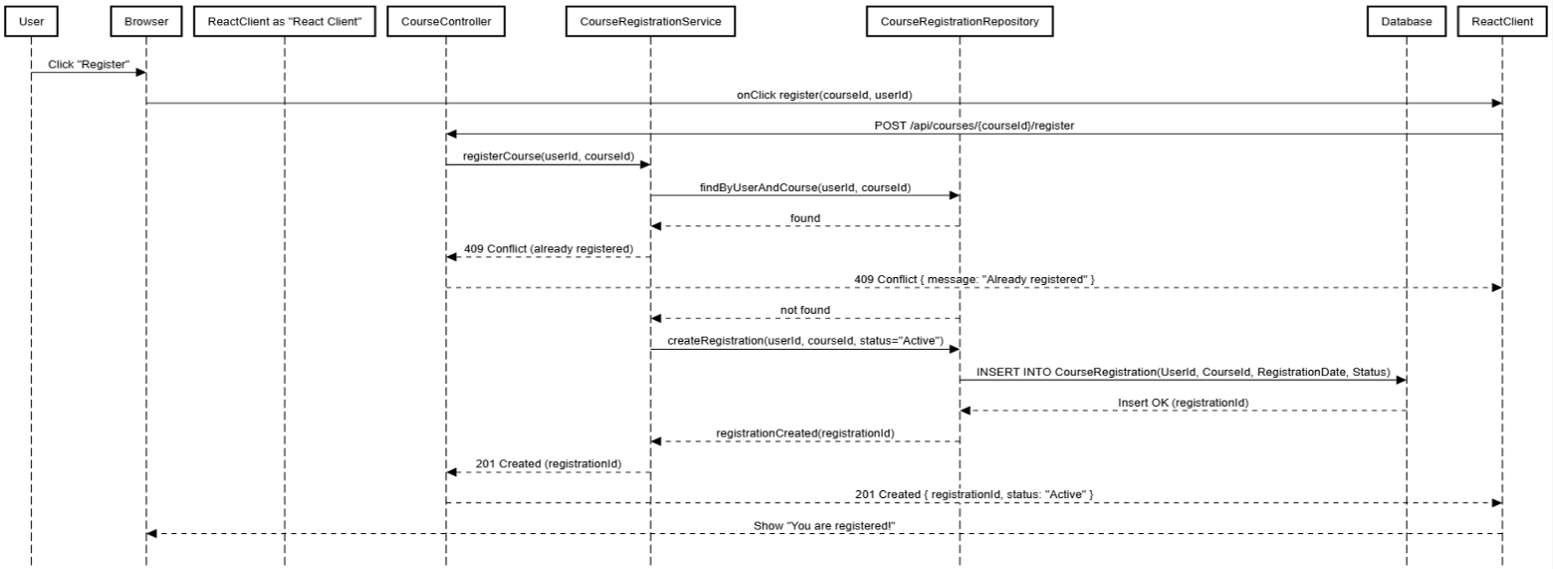
- Sequence Diagram
Part 3: Data Analysis & Design
- DESIGN PATTERN
- Decorator Pattern — belongs to Structural (structural pattern).
- Purpose: Assign additional behavior/responsibilities to an object at runtime without changing the original class.
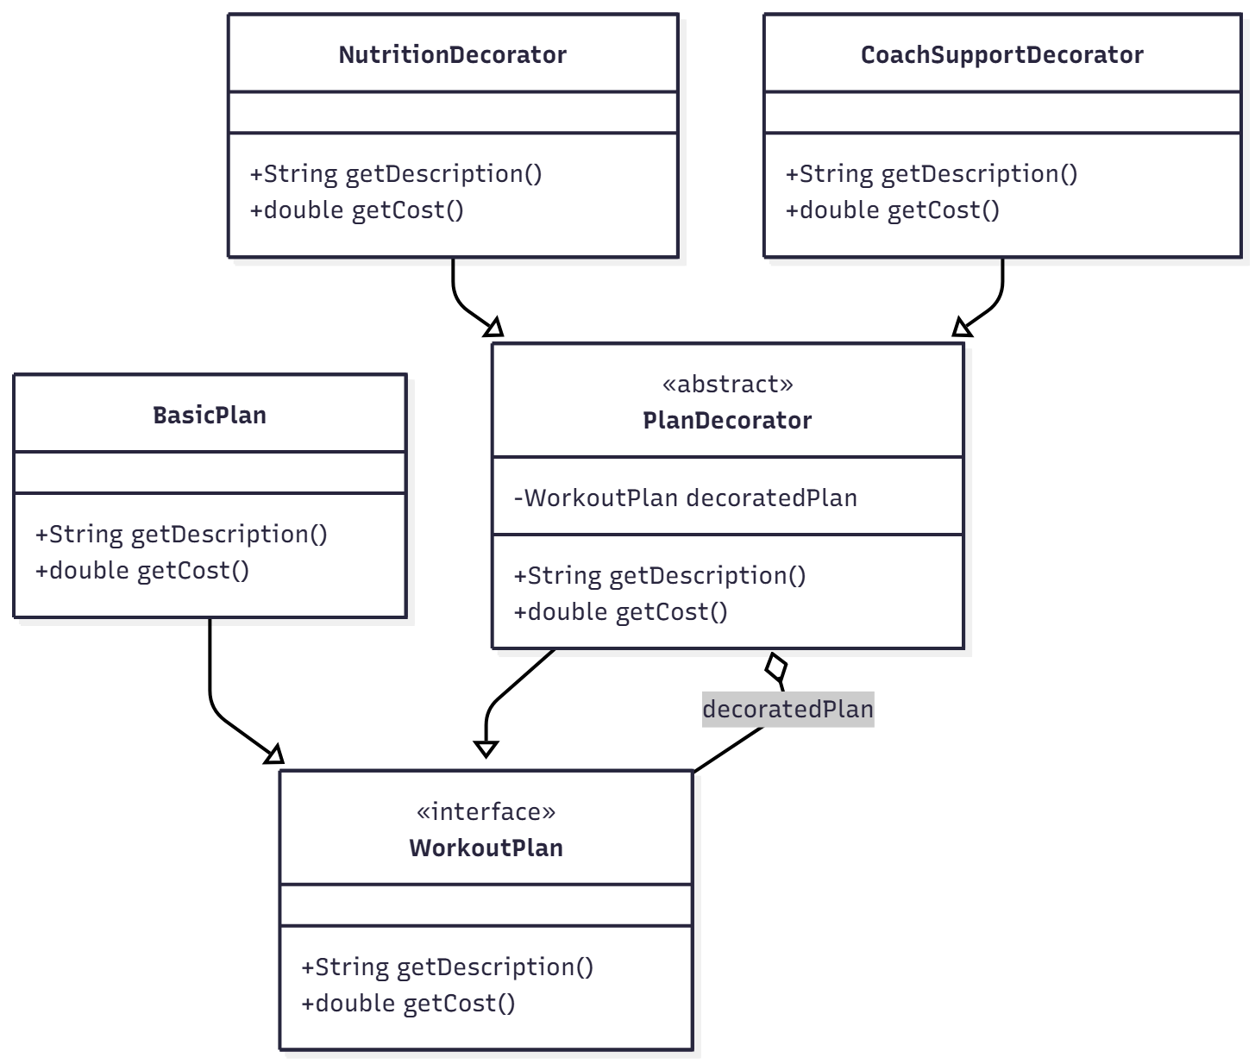
- Class diagram
- practical situation
For example, in a fitness/subscription app: having BasicPlan as the base package, users can add options like Nutrition Guide, Trainer Support, Additional Videos... by decorating the WorkoutPlan instance with the respective decorators.

