Câu 1:
1. Actors and Roles
* Primary Actors:
- User: The customer who rents an e-bike. Their primary role is to locate, rent, use, and pay for e-bikes via the mobile application.
- Control Center: The system administrators or staff responsible for monitoring the fleet's battery status, managing maintenance schedules, and overseeing the entire system's operations.
*Supporting Actors:
- Online Payment Gateway: A third-party system that securely processes financial transactions (e.g., balance recharges, rental fee deductions).
- Map Service: A third-party service (e.g., Google Maps) that provides map data and geolocation to display e-bike locations.
- IoT Tracking System: IoT devices installed on the e-bikes, responsible for sending real-time data about location, time, distance, and battery status to the server.
2. Key Use Cases
Manage Account: Includes essential user functions such as registering a new account and recharging the account balance.
Rent E-Bike: This is the core use case, allowing a user to locate a nearby bike, scan a QR code to unlock it, and start a ride.
Monitor System: Allows the Control Center to track the battery status of e-bikes and manage their maintenance schedules.
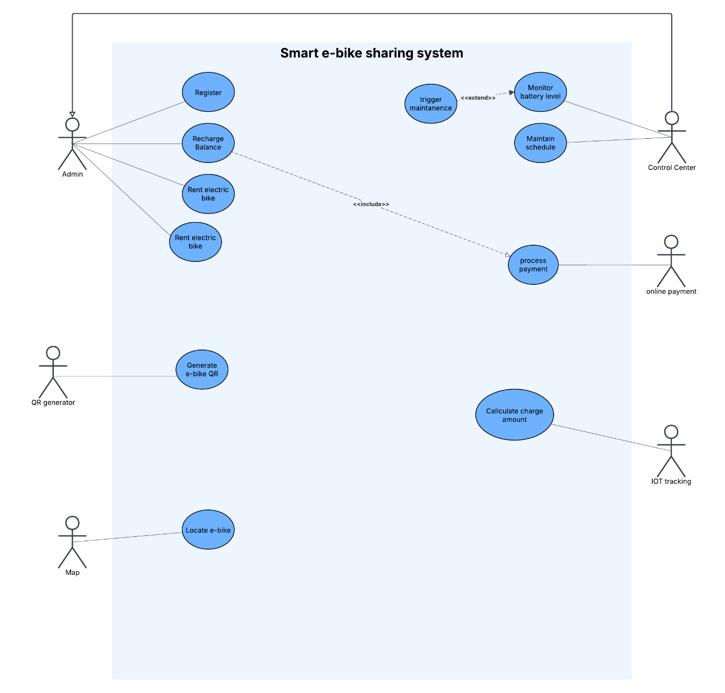
3. Use Case Diagram

The User is the primary actor for the Manage Account and Rent E-Bike use cases.
Recharge Balance is a specific function within account management that always <<includes>> the Process Payment use case.
The Rent E-Bike process involves locating and unlocking the bike.
The Control Center is the primary actor for the Monitor System use case, which includes monitoring battery levels and managing schedules.

Câu 2:
1. Class Classification (COMET)
*Entity Classes: Responsible for data persistence.
- User: Stores user information (ID, name, credentials, wallet balance).
- EBike: Stores the state of an e-bike (ID, location, energy level, status: Available/In Use).
- Payment: Records the history of transactions.
- DrivingTracking: Records ride details (user ID, bike ID, start/end times, distance).
- Schedule: Stores maintenance schedule information.
* Boundary Classes: Act as the interface to external actors.
- MobileAppUI: The mobile application interface for the User.
- ControlCenterDashboard: The web-based interface for the Control Center.
* Control Classes: Encapsulate business logic and control flows.
- RentalController: Manages the core logic for renting and returning an e-bike.
- PaymentController: Coordinates transactions with the external Payment Gateway.
- MonitoringController: Handles the logic for monitoring and maintenance tasks.
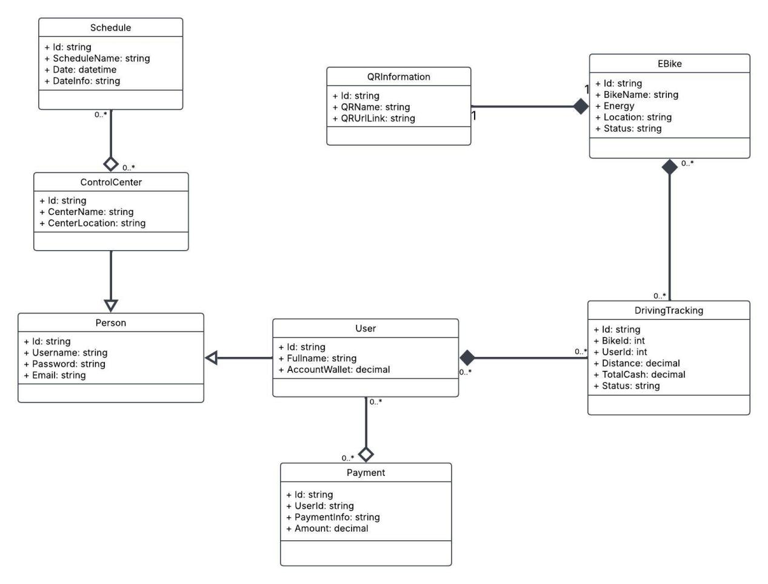
2. Class Diagram

The diagram illustrates the static structure according to the COMET methodology, using stereotypes (Entity, Boundary, Control) to define class roles.
The MobileAppUI (Boundary) class serves as the entry point for user interactions. It does not contain business logic but instead captures user input and delegates requests to a controller.
The RentalController (Control) class acts as the central orchestrator for the bike rental process. It coordinates interactions between the boundary and entity classes. For example, upon receiving a rental request from MobileAppUI, it invokes methods on the User entity to check the balance and on the EBike entity to verify its status.
The Entity classes (User, EBike, DrivingTracking, etc.) are responsible for holding and managing the application's data. They are manipulated by the control classes.
A Generalization relationship is used to show that User and ControlCenterStaff are specialized types of a more general Person class, inheriting its common attributes like name and email.
Câu 3:
1. Sequence Diagram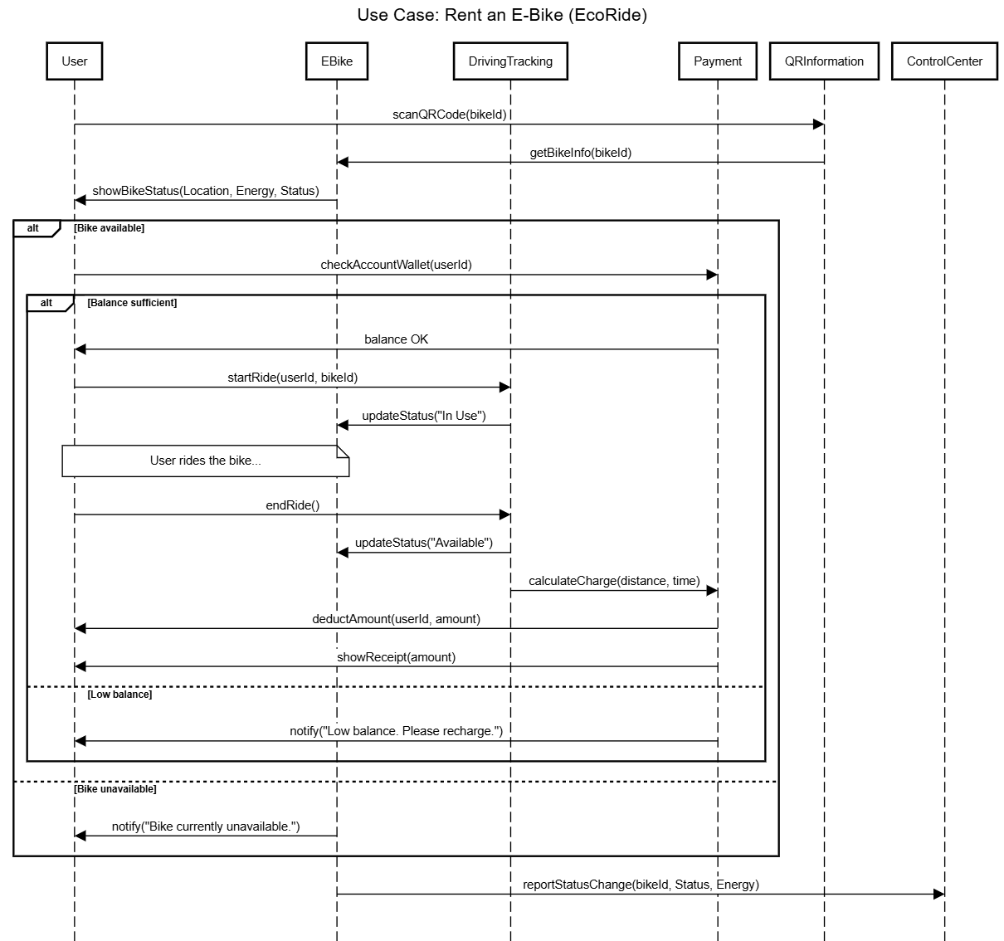

2. Flow Descriptions
Main Flow (Successful Rental):
The User interacts with the MobileAppUI to scan a QR code.
The MobileAppUI sends a single requestRent(userId, bikeId) message to the RentalController lifeline.
The RentalController receives the request and begins coordinating the process. It first sends a checkAccountWallet() message to the User object.
The User object returns that the balance is sufficient.
The RentalController then sends a checkStatus() message to the EBike object.
The EBike object returns its status as "Available".
With all conditions met, the RentalController creates a new DrivingTracking record, sends an updateStatus("In Use") message to the EBike, and unlocks the bike.
Finally, the RentalController returns a success message to the MobileAppUI, which notifies the User that the ride has started.
Alternative Flow (Insufficient Balance):
Steps 1-3 are the same as the main flow.
The User object returns a "Balance insufficient" response to the RentalController.
The RentalController immediately halts the process. It does not proceed to check the bike's status.
It returns a lowBalanceError message directly to the MobileAppUI.
The MobileAppUI displays an error message to the User, prompting them to recharge their account. The use case terminates.

Câu 4:
For the EcoRide system, I propose a modern, decoupled architectural approach: Feature-Sliced Design (FSD) for the frontend mobile application and Clean Architecture for the backend server. This combination is designed for long-term maintainability, team scalability, and technical flexibility.
1. Why This Architectural Style Was Chosen
- This hybrid architectural style was chosen to address the anticipated challenges of a growing startup: evolving requirements, a growing development team, and the need for a reliable, long-lasting system.
- Team Scalability & Parallel Development: FSD organizes the frontend codebase by business features ("slices") rather than technical types (e.g., components, services). This allows multiple developers or teams to work on different features simultaneously with minimal code conflicts, dramatically improving productivity.
- Extreme Maintainability & Modifiability: Clean Architecture's core principle is the Dependency Rule, where dependencies only point inwards. This isolates the core business logic (Entities and Use Cases) from external concerns like databases, frameworks, or UI. This means we can change the database, update the web framework, or even switch cloud providers without touching the critical business rules that define the EcoRide system.
- High Testability: Both architectures promote testability. The core logic in Clean Architecture is completely independent of external factors, making it perfect for isolated unit testing. FSD's feature isolation on the frontend allows for more focused and reliable component and feature testing.
- Technology Independence: The design is not tied to a specific technology. The business logic is written in plain code, making the system resilient to rapid changes in the tech landscape and protecting the long-term investment in the codebase.
2. The Major Subsystems/Components and How They Communicate
The system is logically divided into two main applications: the Frontend Client and the Backend Server, which communicate via a well-defined API.
a. Frontend Subsystem (Feature-Sliced Design)
The mobile app's code is structured in layers, where higher layers can use lower layers, but not the other way around.
- app/: The entry point. Initializes the app, routing, and global providers.
- pages/: Composes widgets and features into complete pages (e.g., HomePage, RideHistoryPage).
- widgets/: Combines multiple features and entities into larger UI blocks (e.g., a BikeMapWidget that includes bike entities and a booking feature).
- features/: Contains the logic for a specific piece of user functionality (e.g., feature-rent-bike, feature-recharge-wallet). This is where user interactions are handled.
- entities/: Represents core business entities (e.g., User, EBike). Contains components and state related to these entities.
- shared/: The lowest level. Contains reusable UI components (buttons, inputs), API configurations, and utility helpers. It knows nothing about the business logic.
b. Backend Subsystem (Clean Architecture)
The backend is structured in concentric circles, with the most important logic at the center.
- Entities (Core): Contains the enterprise-wide business objects and rules (e.g., an EBike class with logic like canBeRented()). This layer has zero external dependencies.
- Use Cases (Application Logic): Orchestrates the flow of data to and from the entities to achieve specific application goals (e.g., RentBikeUseCase, CalculateRideCostUseCase). This layer is independent of any UI or database.
- Interface Adapters: This layer acts as a converter.
- Controllers: Expose the Use Cases to the outside world via a REST API. They handle HTTP requests and responses.
- Gateways/Repositories: Implements interfaces defined by the Use Cases to communicate with the database, abstracting the data source away from the application logic.
- Frameworks & Drivers (Outermost Layer): Contains the specific implementations and external details, such as the Web Framework (e.g., NestJS, Express), the Database (e.g., PostgreSQL), and Third-Party Services (Payment Gateway, Map Service).
c. Communication Flow
A User interacts with a feature component in the Frontend (FSD).
The frontend makes an HTTP request via its shared/api layer to the Backend.
The request is received by a Controller in the Backend's Interface Adapters layer.
The Controller parses the request and calls the appropriate Use Case.
The Use Case executes the core business logic, using Entities and fetching/saving data via Repository interfaces.
The result is passed back out through the layers, eventually becoming a JSON response sent back to the client.
3. The Software Quality Attributes Your Design Supports
- This architectural choice provides strong support for key quality attributes:
- Maintainability: Excellent. This is the primary benefit. With FSD, finding and changing code related to a feature is straightforward. With Clean Architecture, business logic is protected from changes in technology, making long-term maintenance significantly less costly.
- Scalability: Excellent. The backend is inherently scalable; because the core logic is decoupled, it can be deployed in various ways (monolith, serverless functions, microservices) as needs evolve. The frontend's FSD structure allows the development team to scale without being slowed down by code complexity.
- Testability: Excellent. Core business rules (Use Cases, Entities) can be unit-tested without a database or web server. Frontend features can be tested in isolation, leading to a more robust and reliable application.
- Flexibility & Modifiability: Excellent. Need to switch from PostgreSQL to MongoDB? Only the repository implementation in the outermost backend layer needs to change. Want to add a web app alongside the mobile app? It can consume the same backend API. This design embraces change rather than resisting it.

