HANOI UNIVERSITY OF SCIENCE AND TECHNOLOGY

**SCHOOL OF INFORMATION AND COMMUNICATION AND TECHNOLOGY**

**---□**&**□---**



**Final Report**

**COMPUTER ARCHITECTURE LAB**

**Lecturer: Lê Bá Vui**

**Student: Lê Minh Đức – Hoàng Văn Phương**

**Group: 3**

**Class:135411**

***School year 2022-2023 ……***

Contents

## Group members

|  |  |  |
| --- | --- | --- |
| **Name** | **ID** | **Topic** |
| Lê Minh Đức | 20200270 | 10. Máy tính bỏ túi |
| Hoàng Văn Phương | 20200585 | 09. Vẽ hình bằng kí tự ASCII |

## Topic 10: Máy tính bỏ túi

**Logic:**

* Check not pressing. If all rows return `$a0 == 0`, update `code = 0`.
* If `code == 0`, run `back_to_polling`.
* Check pressing. If `pressed && $a0 != $s0`, run `update_code`.
* Run `handle_code` to get key's value and switch mode.
* There are 3 modes. Pressing a key will trigger its corresponding suitable mode.
* Mode 1: This mode is triggered after pressing 0 - 9
  + If old `operator` is `=`, remove old info before updating.
    - Press number after `=` will clear everything.
  + Update `operand`, output new `operand`.
* Mode 2: This mode is triggered after pressing `+ - * / %`
  + If old `operator` doesn't change, do nothing.
  + Else, update `operator`, store old operand in answer.
    - `answer = operand`.
  + Output old `operand` before removing old `operand`.
* Mode 3: This mode is triggerd after pressing `=`
  + Update {answer} = {answer} {operator} {operand}.
    - Doing calculation with 2 operands: {answer} {operand}
    - The method of calculation is specified with: {operator}
  + Update `operator`.
  + Update `operand = answer`.
  + Output new `answer`.
* Use `display(a0: int)` function to quickly draw last 2 digits of `a0`.

**Results:**

* **Press 1, 2, 3**

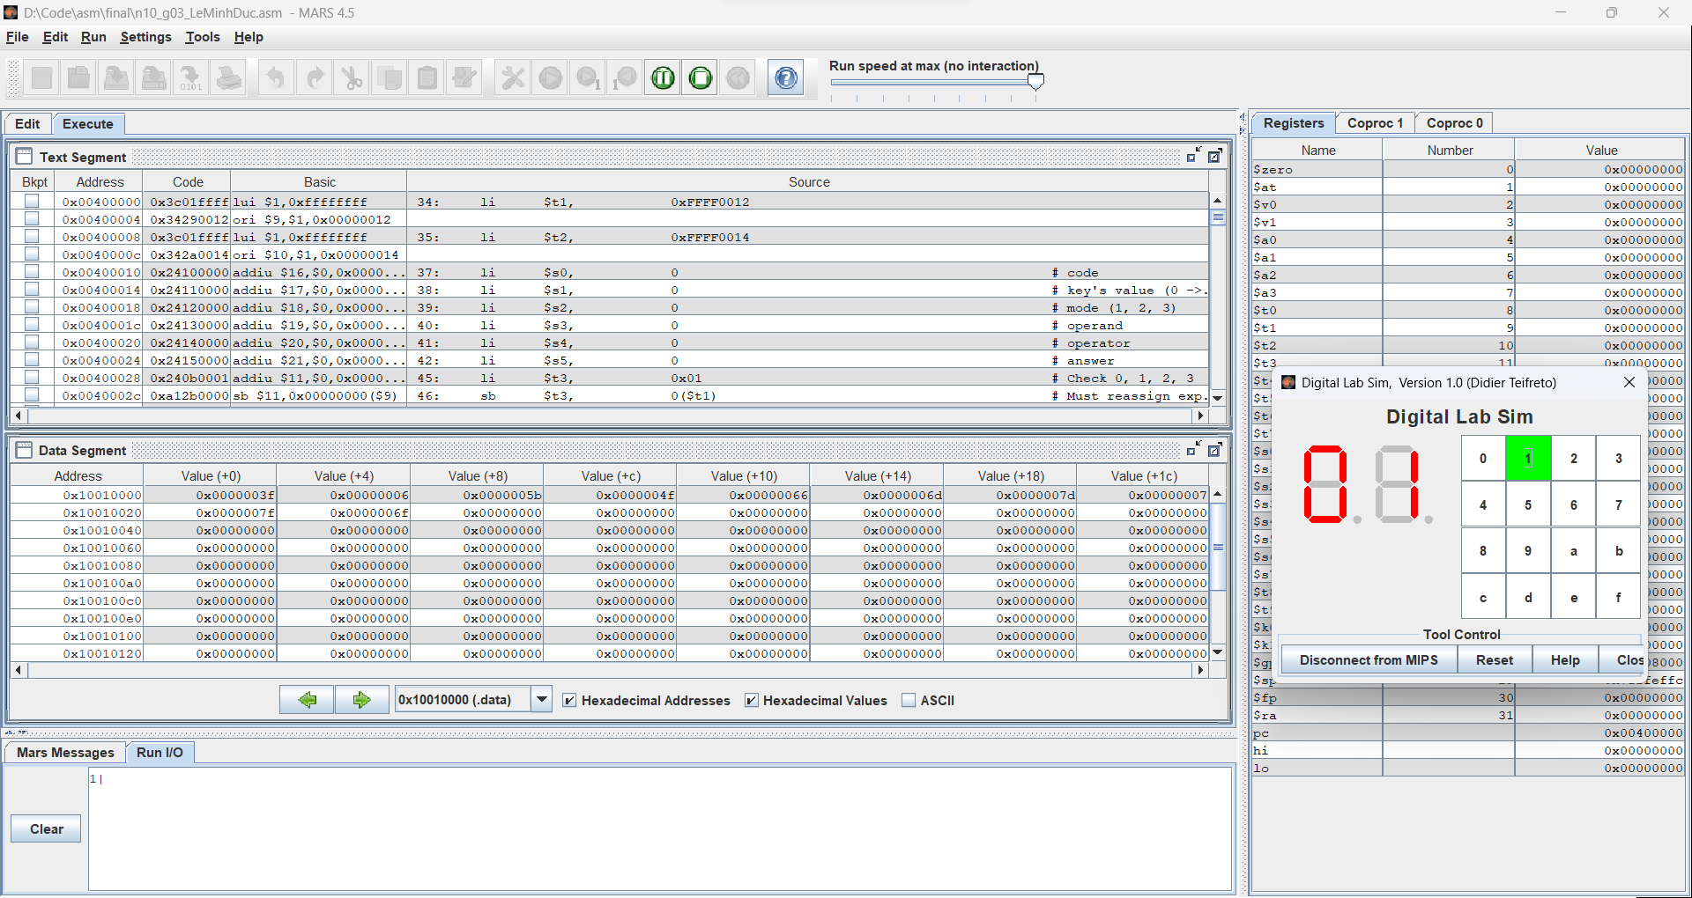

* **Press ‘a’ to add. Press 56.**

* **Press f to calculate. Here, 123 + 56 = 179.A screenshot of a computer

  Description automatically generated with medium confidence**
* **Keep calculating using previous answer. Press d to divide. Press 2. Press f to calculate. Here, 179 / 2 = 89 (mod 1). So the answer is 89.**

## Topic 09: Vẽ hình bằng kí tự ASCII

**Logic:**

**Results:**