Lab Report 05

## Assignment 1

**Code:**

.data

test: .asciiz "Hello World"

.text

li $v0, 4

la $a0, test

syscall

**Comments:**

* The beggning address of the string is 0x10010000, which also corresponds to letter “H”.
* The content of the first 4 bytes: H e l l
* The content of the next 4 bytes: o W o
* The content of the last 4 bytes: r l d \0

## Assignment 2

**Code:**

.data

string1: .asciiz "The sum of "

string2: .asciiz " and "

string3: .asciiz " is "

.text

input:

li $v0, 5

syscall

add $s0, $zero, $v0 # Store $s0

li $v0, 5

syscall

add $s1, $zero, $v0 # Store $s1

sum:

add $s2, $s0, $s1 # $s2 = $s0 + $s1

output:

li $v0, 4

la $a0, string1

syscall # Print "The sum of "

li $v0, 1

add $a0, $zero, $s0 # $a0 = $s0

syscall # Print (s0)

li $v0, 4

la $a0, string2

syscall # Print " and "

li $v0, 1

add $a0, $zero, $s1 # $a0 = $s1

syscall # Print (s1)

li $v0, 4

la $a0, string3

syscall # Print " is "

li $v0, 1

add $a0, $zero, $s2 # $a0 = sum

syscall # Print (sum)

**Result:**

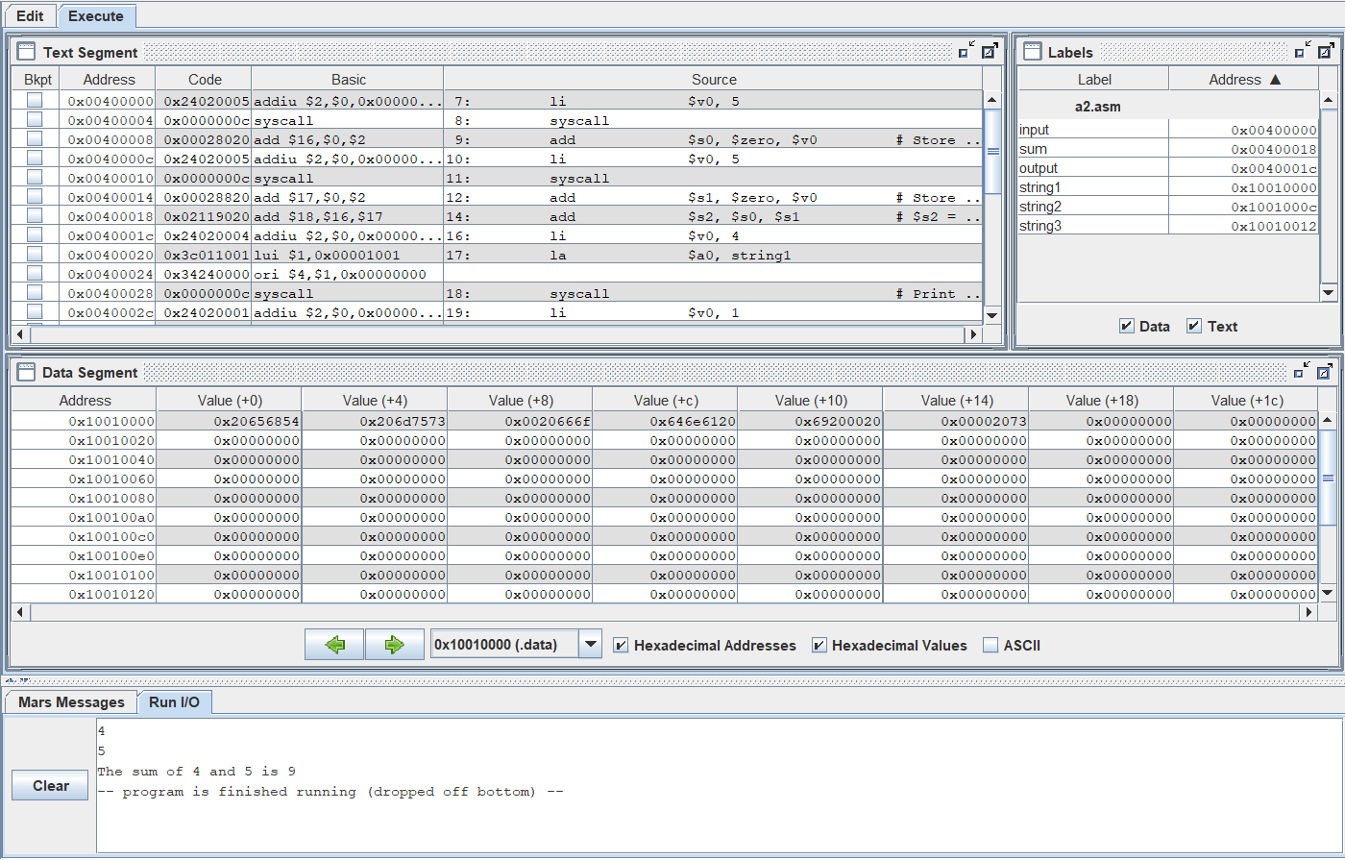

## Assignment 3

**Code:**

.data

x: .space 32 # destination string x, empty

y: .asciiz "Hello" # source string y

.text

init:

la $a0, x

la $a1, y

strcpy:

add $s0, $zero, $zero # $s0 = i = 0

L1:

add $t1, $s0, $a1 # $t1 = $s0 + $a1 = i + y[0]

# = address of y[i]

lb $t2, 0($t1) # $t2 = value at $t1 = y[i]

add $t3, $s0, $a0 # $t3 = $s0 + $a0 = i + x[0]

# = address of x[i]

sb $t2, 0($t3) # x[i]= $t2 = y[i]

beq $t2, $zero, end_of_strcpy # if y[i] == 0, exit

nop

addi $s0, $s0, 1 # $s0 = $s0 + 1 <-> i = i + 1

j L1 # next character

nop

end_of_strcpy:

**Comments:**

* The red code is where to load the address of x & y into the corresponding registers $a0, $a1.

**Result:**

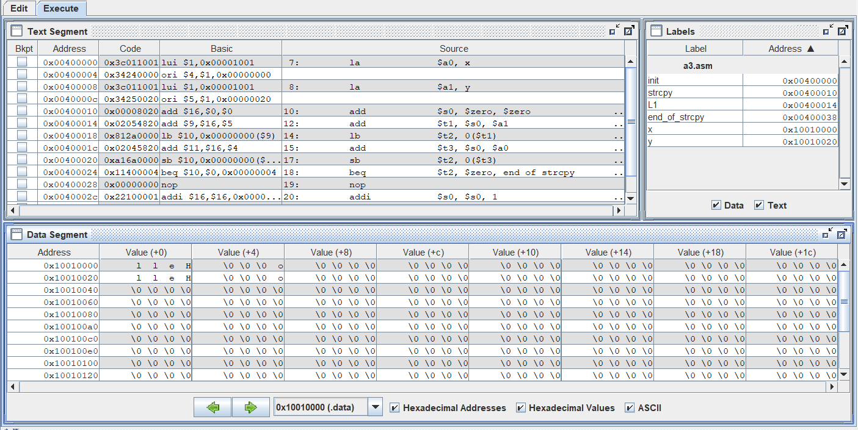

## Assignment 4

**Code:**

.data

string: .space 50

Message1: .asciiz "Nhap xau: "

Message2: .asciiz "Do dai xau la: "

.text

main:

get_string:

li $v0, 54

la $a0, Message1

la $a1, string

la $a2, 50

syscall

get_length:

la $a0, string # $a0 = address(string[0])

add $t0, $zero, $zero # $t0 = i = 0

check_char:

add $t1, $a0, $t0 # $t1 = $a0 + $t0

# = address(string[i])

lb $t2, 0($t1) # $t2 = string[i]

beq $t2, $zero, end_of_str # is null char?

addi $t0, $t0, 1 # $t0 = $t0 + 1 -> i = i + 1

j check_char

end_of_str:

end_of_get_length:

print_length:

li $v0, 56

la $a0, Message2

subi $a1, $t0, 1

syscall

**Comments:**

* The red code is the implementation of the required parts.

**Result:**

## Assignment 5

**Code:**

.data

string: .space 21

.text

main:

init:

la $a0, string # $a0 = address(string[0])

add $t0, $zero, $zero # $t0 = i = 0

li $s0, 20 # Maximum size of string

scan_char:

add $t1, $a0, $t0 # $t1 = $a0 + $t0

# = address(string[i])

li $v0, 12

syscall

sb $v0, 0($t1)

beq $v0, '\n', end_of_string # Stop if '\n' is inputted

addi $t0, $t0, 1

beq $t0, $s0, end_of_string # Stop if maximum size is reached

j scan_char

end_of_string:

add $s1, $zero, $a0 # Store address of string in $s1

# $a0 is dangerous to store in long term!

reverse_string:

subi $t0, $t0, 1

bltz $t0, exit

add $t1, $s1, $t0 # $t1 = $s1 + $t0

# = address(string[i])

li $v0, 11

lb $a0, 0($t1) # Load string[i]

syscall # Print string[i]

j reverse_string

exit:

**Result:**

