Lab Report 06

## Assignment 1

**Code:**

**Comments:**

* Input 1: (-2, 6, -1, 3, -2)
* Max sum = -2 + 6 – 1 + 3 = 6, w/ length = 4

$v0 = 4

$v1 = 6

* Input 2: (2, -3, 2, 5, -4)
* Max sum = 2 + -3 + 2 + 5 = 5, w/ length = 4



$v0 = 4

$v1 = 6

## Assignment 2

**Code:**

.data

A: .word 7, -2, 5, 1, 5, 6, 7, 3, 6, 8, 8, 59, 5

Aend: .word

.text

main: la $a0, A #$a0 = Address(A[0])

la $a1, Aend

addi $a1, $a1, -4 #$a1 = Address(A[n-1])

j sort #sort

after_sort: li $v0, 10 #exit

syscall

end_main:

#--------------------------------------------------------------

#procedure sort (ascending selection sort using pointer)

#register usage in sort program

#$a0 pointer to the first element in unsorted part

#$a1 pointer to the last element in unsorted part

#$t0 temporary place for value of last element

#$v0 pointer to max element in unsorted part

#$v1 value of max element in unsorted part

#--------------------------------------------------------------

sort: beq $a0, $a1, done #single element list is sorted

j max #call the max procedure

after_max: lw $t0, 0($a1) #load last element into $t0

sw $t0, 0($v0) #copy last element to max location

sw $v1, 0($a1) #copy max value to last element

addi $a1, $a1, -4 #decrement pointer to last element

j print

after_print: j sort #repeat sort for smaller list

done: j after_sort

#------------------------------------------------------------------------

#Procedure max

#function: fax the value and address of max element in the list

#$a0 pointer to first element

#$a1 pointer to last element

#------------------------------------------------------------------------

max:

addi $v0, $a0, 0 #init max pointer to first element

lw $v1, 0($v0) #init max value to first value

addi $t0, $a0, 0 #init next pointer to first

loop:

beq $t0, $a1, ret #if next=last, return

addi $t0, $t0, 4 #advance to next element

lw $t1, 0($t0) #load next element into $t1

slt $t2, $t1, $v1 #(next)<(max) ?

bne $t2, $zero, loop #if (next)<(max), repeat

addi $v0, $t0, 0 #next element is new max element

addi $v1, $t1, 0 #next value is new max value

j loop #change completed; now repeat

ret:

j after_max

#------------------------------------------------------------------------

#Procedure print

#------------------------------------------------------------------------

print: add $s7, $v0, $zero #Save

add $s6, $a0, $zero #Save

la $s0, A #$s0 = Address(A[0])

la $s1, Aend

addi $s1, $s1, -4 #$s1 = Address(A[n-1])

loop2: blt $s1, $s0, endprint #exit if Aned < A[i]

li $v0, 1 #service 01: print integer

lw $a0, 0($s0) #value of A[i]

syscall

li $v0, 11

li $a0, ' ' #print space

syscall

addi $s0, $s0, 4 #Move to A[i+1]

j loop2

endprint: li $v0, 11

li $a0, '\n' #print enter

syscall

add $v0, $s7, $zero #Load

add $a0, $s6, $zero #Load

j after_print

**Comments:**

* Input: 7, -2, 5, 1, 5, 6, 7, 3, 6, 8, 8, 59, 5

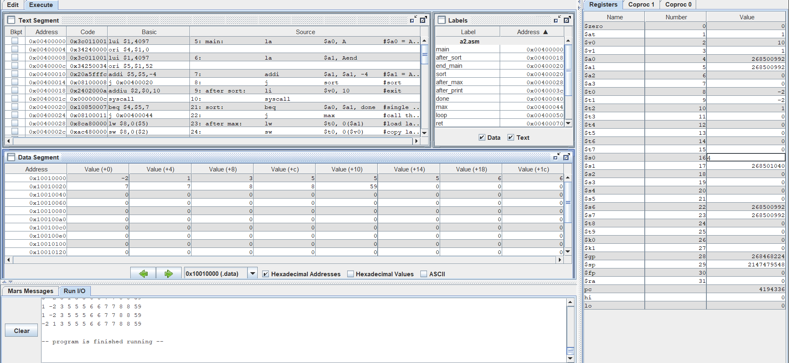

* Input: 6, 3, 7, 2, 0, 9, 1, 8, 4, 5

## Assignment 3

**Code:**

.data

A: .word 7, -2, 5, 1, 5, 6, 7, 3, 6, 8, 8, 59, 5

Aend: .word

.text

main:

lui $s0, 0x1001 # A[0]

li $t0, 0 # i = 0

li $t1, 0 # j = 0

li $s1, 13 # n = A.length

li $s2, 13 # n - i for inner loop

add $t2, $zero, $s0 # For iterating addr by i

add $t3, $zero, $s0 # For iterating addr by j

addi $s1, $s1, -1

outer_loop:

li $t1, 0 # j = 0

addi $s2, $s2, -1 # Decrease size for inner_loop

add $t3, $zero, $s0 # Reset addr itr j

inner_loop:

lw $s3, 0($t3) # A[j]

addi $t3, $t3, 4 # Addr itr j += 4

lw $s4, 0($t3) # A[j+1]

addi $t1, $t1, 1 # j++

slt $t4, $s3, $s4 # Set $t4 = 1 if $s3 < $s4

bne $t4, $zero, cond

swap:

sw $s3, 0($t3)

sw $s4, -4($t3)

lw $s4, 0($t3)

cond:

bne $t1, $s2, inner_loop #j != n-i

j Print

EndPrt:

addi $t0, $t0, 1 #i++

bne $t0, $s1, outer_loop #i != n

li $t0, 0

addi $s1, $s1, 1

exit:

li $v0, 10

syscall

#------------------------------------------------------------------------

# Procedure Print

#------------------------------------------------------------------------

Print: add $s7, $v0, $zero # Save

add $s6, $a0, $zero # Save

la $t8, A # $t8 = Address(A[0])

la $t9, Aend

addi $t9, $t9, -4 # $t9 = Address(A[n-1])

LoopPrt: blt $t9, $t8, EndLoopPrt # Exit if Aend < A[i]

li $v0, 1 # Service 01: print integer

lw $a0, 0($t8) # Value of A[i]

syscall

li $v0, 11

li $a0, ' ' # Print space

syscall

addi $t8, $t8, 4 # Move to A[i+1]

j LoopPrt

EndLoopPrt: li $v0, 11

li $a0, '\n' # Print enter

syscall

add $v0, $s7, $zero # Load

add $a0, $s6, $zero # Load

j EndPrt

**Result:**

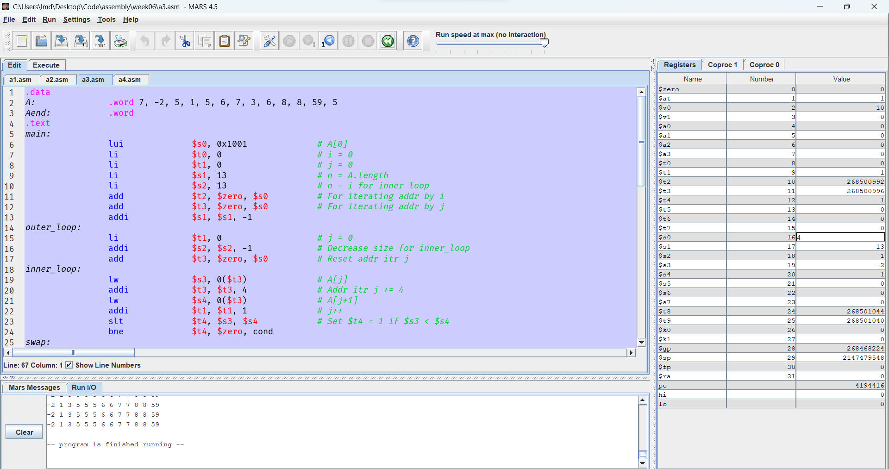

## Assignment 4

**Code:**

.data

A: .word 7, -2, 5, 1, 5, 6, 7, 3, 6, 8, 8, 59, 5

Aend: .word

.text

init: la $s0, A # Array A

li $s1, 13 # Length of A

li $s2, 1 # i

li $s3, 0 # j

li $s4, 0 # v

li $t0, 0 # Address of A[i]

li $t1, 0 # Address of A[j]

li $t2, 0 # Value of A[i]

li $t3, 0 # Value of A[j]

Loop1: sll $t0, $s2, 2 # $t0 = 4 * i

add $t0, $t0, $s0 # Address(A[i])

lw $s4, 0($t0) # v = A[i]

addi $s3, $s2, -1 # j = i - 1

sll $t1, $s3, 2 # $t1 = 4 * j

add $t1, $t1, $s0 # Address(A[j])

Loop2: lw $t3, 0($t1) # Load A[j]

blt $t3, $s4, EndL2 # Continue looping if A[j] >= v

sw $t3, 4($t1) # A[j+1] = A[j]

addi $s3, $s3, -1 # --j

addi $t1, $t1, -4 # Keep memory access consistent with j

bge $s3, $0, Loop2 # Loop if j >= 0

EndL2: sw $s4, 4($t1) # A[j+1] = v

addi $s2, $s2, 1 # ++i

j Print

EndPrt: blt $s2, $s1, Loop1 # Loop while i < A.length

Exit: li $v0, 10 # Load exit operation

syscall

#------------------------------------------------------------------------

# Procedure Print

#------------------------------------------------------------------------

Print: add $s7, $v0, $zero # Save

add $s6, $a0, $zero # Save

la $t8, A # $t8 = Address(A[0])

la $t9, Aend

addi $t9, $t9, -4 # $t9 = Address(A[n-1])

LoopPrt: blt $t9, $t8, EndLoopPrt # Exit if Aend < A[i]

li $v0, 1 # Service 01: print integer

lw $a0, 0($t8) # Value of A[i]

syscall

li $v0, 11

li $a0, ' ' # Print space

syscall

addi $t8, $t8, 4 # Move to A[i+1]

j LoopPrt

EndLoopPrt: li $v0, 11

li $a0, '\n' # Print enter

syscall

add $v0, $s7, $zero # Load

add $a0, $s6, $zero # Load

j EndPrt

**Result:**

