|  |  |
| --- | --- |
| **Midterm Exam 20221**  **STT**  Subject: IT3290E – Database Lab Group: 3  Date: Dec 8, 2022, Duration: **60 min** | |
| Student ID: 20200164  Student Name: Le Minh Duc | **Note:** |

**For each question, copy your query and its result including the status bar (print screen)**

Example: List all customers

select * from customers

* 1. Display the list of Customer in alphabetical order according to city

**Code**:

select * from customers order by city;

**Results**:

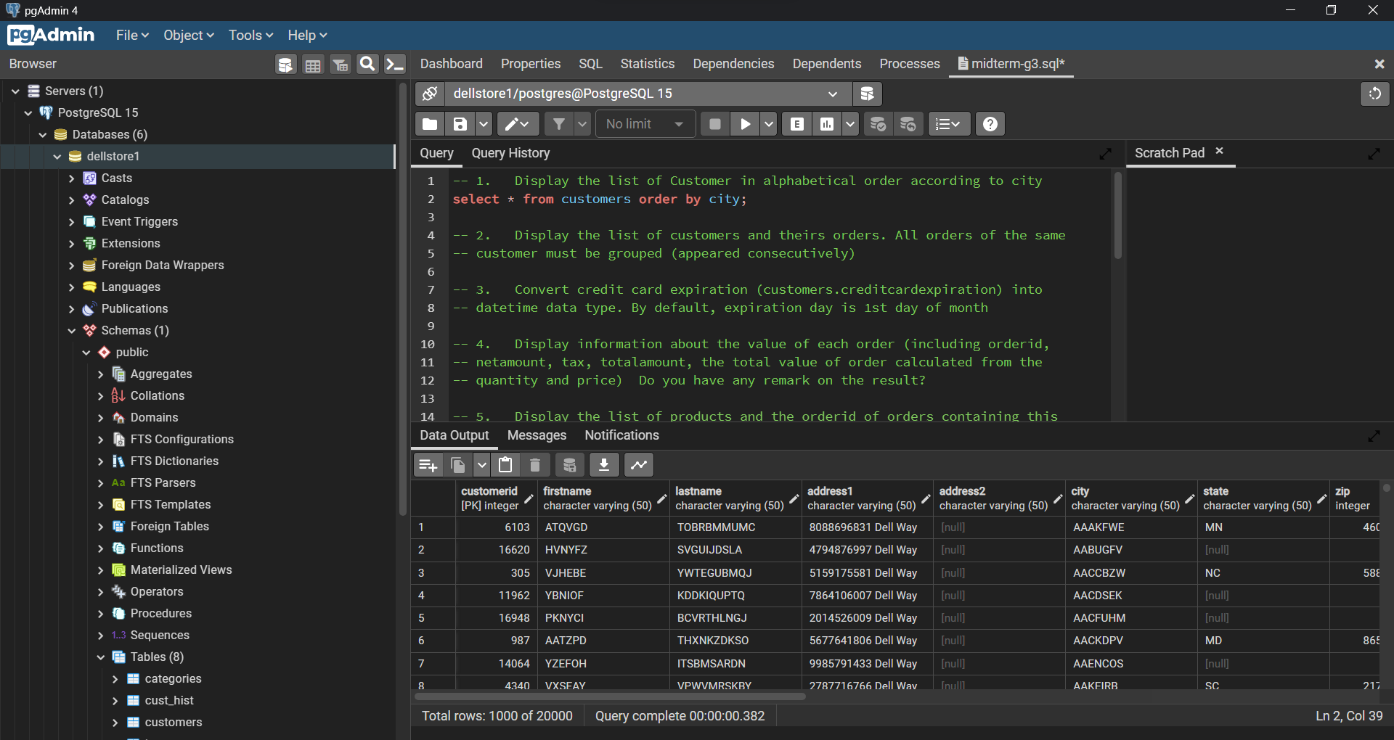

* 1. Display the list of customers and theirs orders. All orders of the same customer must be grouped (appeared consecutively)

**Code:**

select customerid, orderid

from orders

order by customerid, orderid;

**Results**:

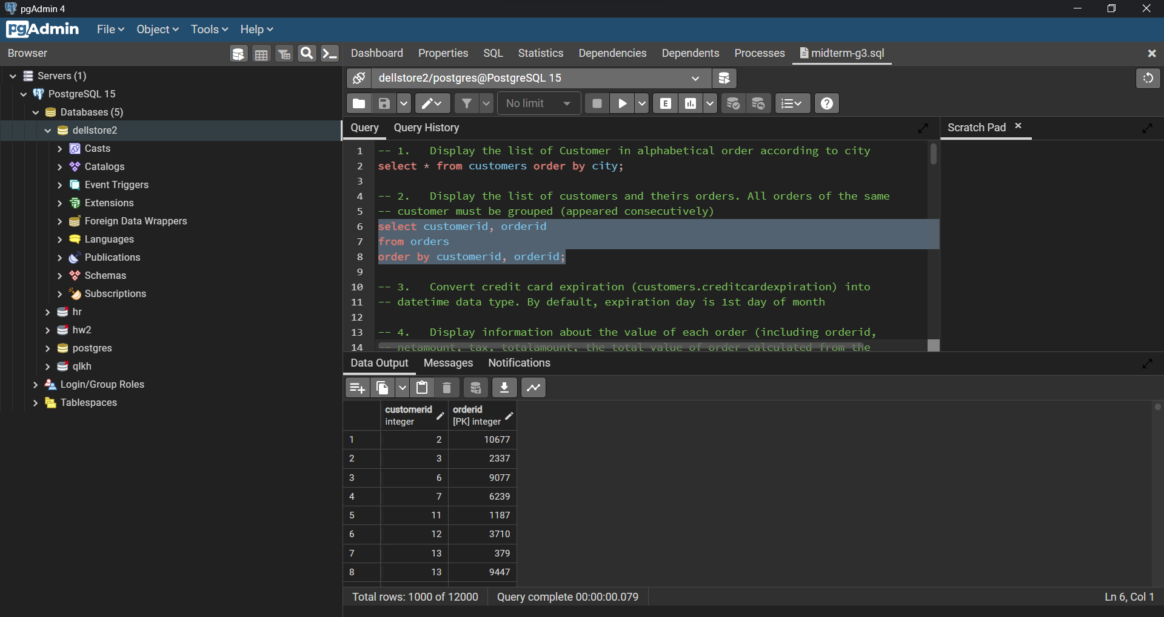

* 1. Convert credit card expiration (customers.creditcardexpiration) into datetime data type. By default, expiration day is 1st day of month

Code:

Results:

* 1. Display information about the value of each order (including orderid, netamount, tax, totalamount, the total value of order calculated from the quantity and price) Do you have any remark on the result?

**Code**:

select o.orderid, o.netamount, o.tax, o.totalamount, sum(ol.quantity * p.price)

from orders o

join orderlines ol on ol.orderid = o.orderid

join products p on p.prod_id = ol.prod_id

group by o.orderid;

**Results:**

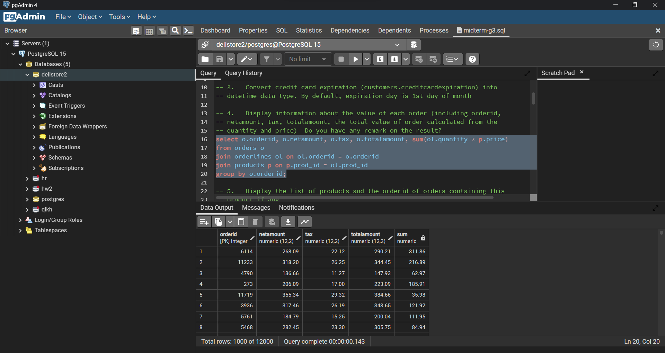

* 1. Display the list of products and the orderid of orders containing this product if any

**Code:**

select p.prod_id, ol.orderid

from products p

left join orderlines ol on ol.prod_id = p.prod_id

order by p.prod_id, ol.orderid;

**Results:**

* 1. Display the list of products appeared in the order(s) on Dec 31, 2004

**Code:**

select distinct prod_id

from orderlines

where orderdate = '2004-12-31';

**Results:**

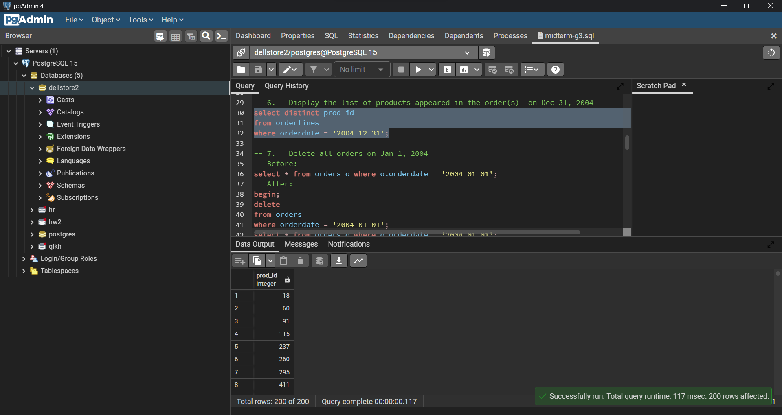

* 1. Delete all orders on Jan 1, 2004

**Code**:

delete

from orders

where orderdate = '2004-01-01';

select * from orders o where o.orderdate = '2004-01-01';

**Results**:

* 1. Do you have any comment/remarks on the previous query (number 7)

All records specified has been deleted.

* 1. Display the list of customers whose credit card is expired in June 2011

**Code:**

select *

from customers c

where c.creditcardexpiration = '2011/06';

**Results**:

* 1. Display the list of customers without information of state

**Code:**

select * from customers where state is null;

**Results:**

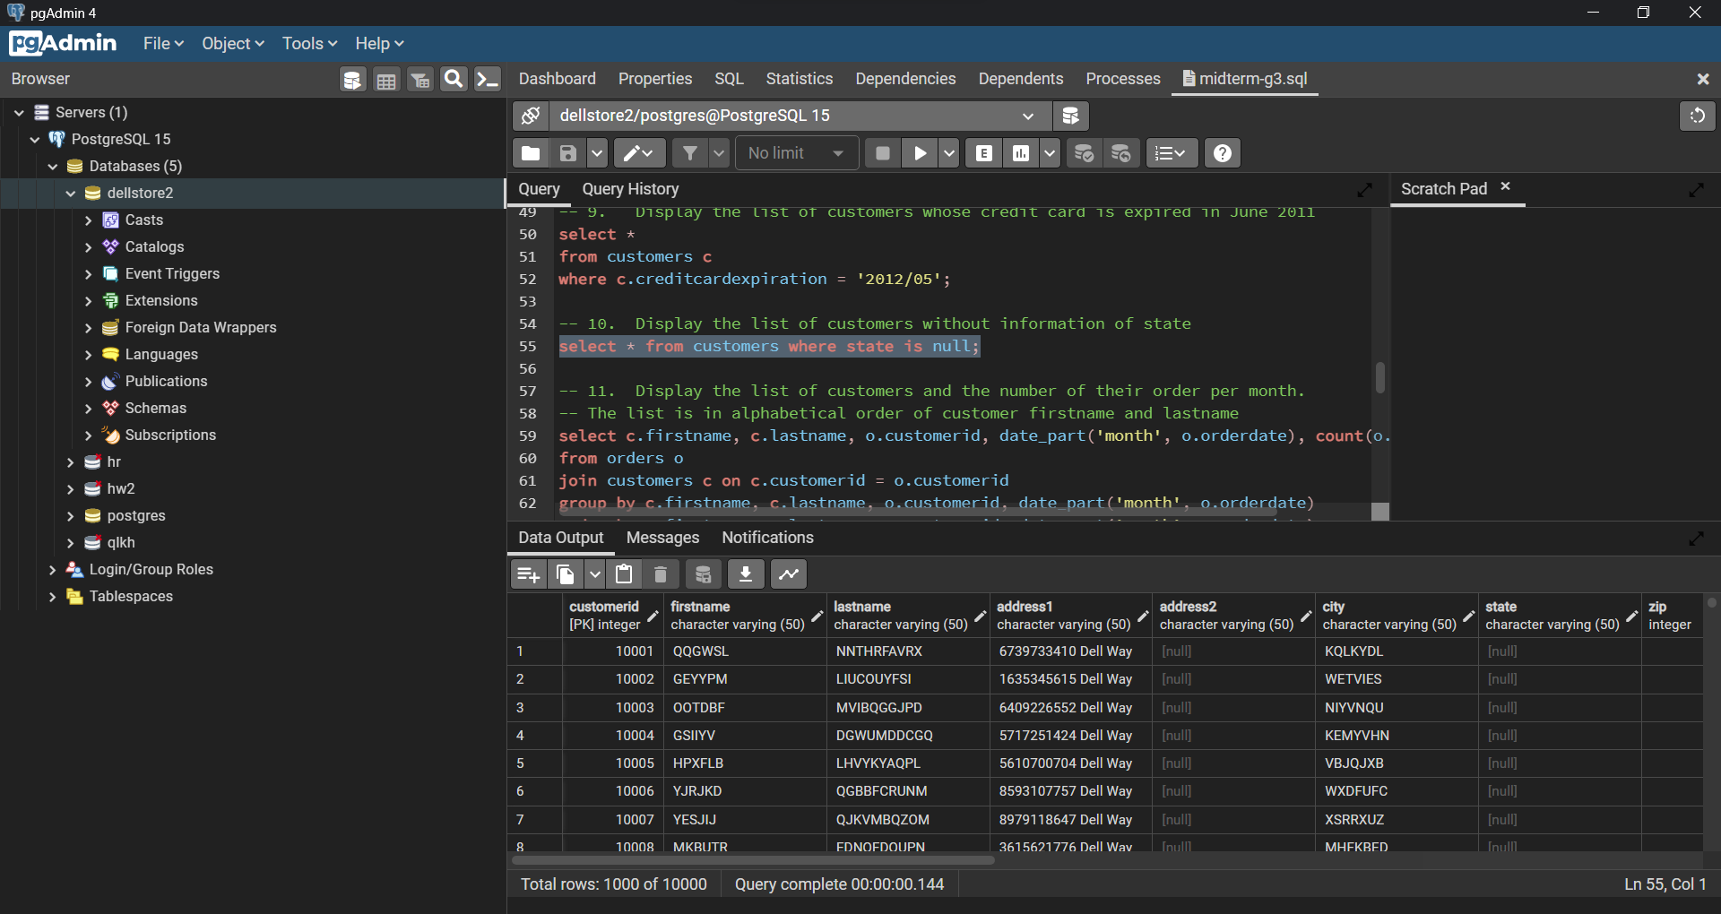

* 1. Display the list of customers and the number of their order per month. The list is in alphabetical order of customer firstname and lastname

Code:

select c.firstname, c.lastname, o.customerid, date_part('month', o.orderdate), count(o.orderid)

from orders o

join customers c on c.customerid = o.customerid

group by c.firstname, c.lastname, o.customerid, date_part('month', o.orderdate)

order by c.firstname, c.lastname, o.customerid, date_part('month', o.orderdate);

Results:

* 1. Display the list of products having the greatest total ordered quantity

Code:

with prod_total as (

select prod_id, sum(quantity) total

from orderlines

group by prod_id

)

select prod_id, total

from prod_total

where total = (select max(total) from prod_total)

Results:

* 1. Display the list of products having the total ordered quantity greater than the quantity in stock

Code:

with prod_total as (

select orderlines.prod_id, quan_in_stock, sum(quantity) total

from orderlines

join inventory on inventory.prod_id = orderlines.prod_id

group by orderlines.prod_id, quan_in_stock

)

select prod_id, quan_in_stock, total

from prod_total

where total > quan_in_stock;

Results:

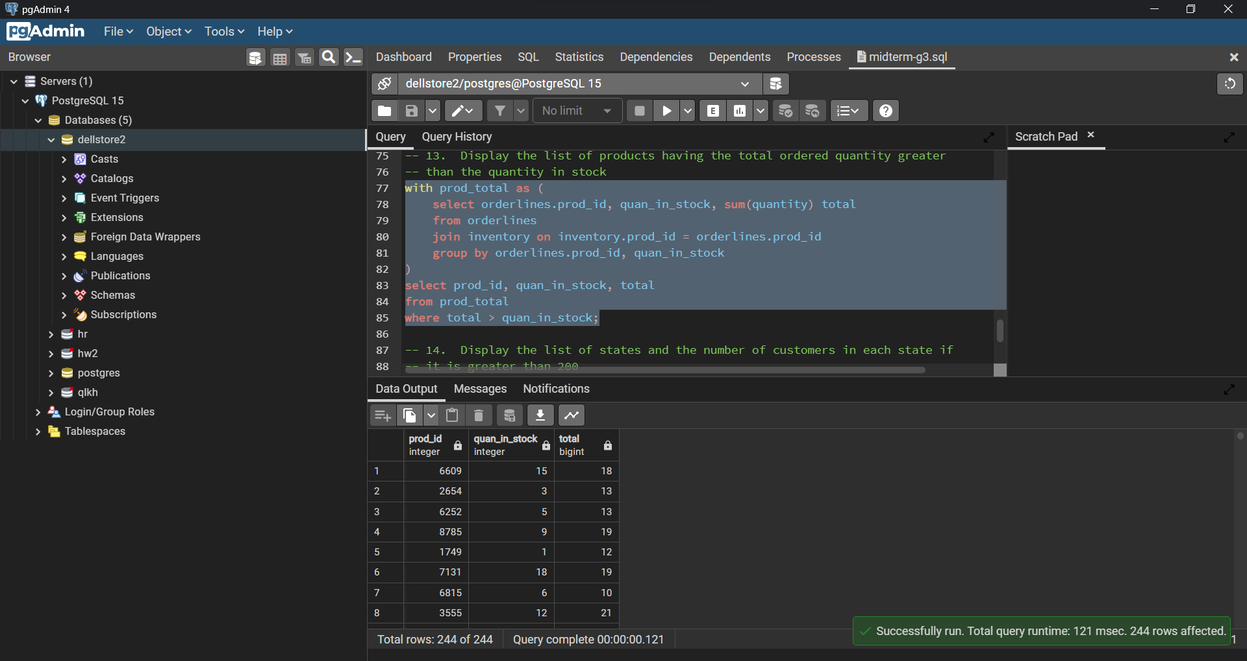

* 1. Display the list of states and the number of customers in each state if it is greater than 200

Code:

select c.state, count(c.customerid)

from customers c

where c.state is not null

group by c.state

having count(c.customerid) > 200;

Results:

