**ISSUE**

============= Issue 1 =============

**Type:** Issue

**Severity:** Low

**Title:** [Login] - The cursor does not focus on Email field by default

**Steps:**

1. Open the link: http://ktvn-test.s3-website.us-east-1.amazonaws.com/
2. Observe the page

**Expected result:** The cursor focused on the Email field by default

**Actual result:** The cursor does not focus on the Email field



============= Issue 2 =============

**Type:** Issue

**Severity:** Medium

**Title:** [Login] - The Tab function does not work properly

**Steps:**

1. Open the link: http://ktvn-test.s3-website.us-east-1.amazonaws.com/
2. The Login page is displayed
3. Try to press Tab key several times to verify this function

**Expected result:** The Tab function works properly

**Actual result:** The Tab function works well for Email and Password fields. But not for Login button. User cannot login to the system by Tab and Enter keys.

============= Issue 3 =============

**Type:** Issue

**Severity:** Medium

**Title:** [Login] - User cannot login to the system by Enter key

**Steps:**

1. Open the link: http://ktvn-test.s3-website.us-east-1.amazonaws.com/
2. The Login page is displayed
3. Input correct Username
4. Input correct Password
5. Press Enter key

**Expected result:** The User is logged in to the system successfully

**Actual result:**

* At step 5: Nothing happen

============= Issue 4 =============

**Type:** Issue

**Severity:** Critical

**Title:** [Login] - User can login to the system without Username and Password

**Steps:**

1. Open the link: http://ktvn-test.s3-website.us-east-1.amazonaws.com/
2. The Login page is displayed
3. Leave Username blank
4. Leave Password blank
5. Click Login button

**Expected result:**

- Error message "Email is required" is displayed under Email field

- Error message "Password is required" is displayed under Password field

**Actual result:** User is logged in the system successfully

============= Issue 5 =============

**Type:** Issue

**Severity:** Major

**Title:** [Parent Portal] - Admin cannot change the status of request

**Steps:**

1. Open the link: http://ktvn-test.s3-website.us-east-1.amazonaws.com/
2. The Login page is displayed
3. Input valid Admin username
4. Input valid Admin password
5. Click Login button > Navigating to Parent Portal page
6. Select one row and click on Request Status of row
7. Select another status (ex: pending, approved…)

**Expected result:** Admin can change the status of request successfully and the new status is displayed in the row.

**Actual result:** Admin cannot change the status of request. Admin can select the new status, but it does not display in the row.

============= Issue 6 =============

**Type:** Issue

**Severity:** Medium

**Title:** [Parent Portal] - Missing sort function for Student ID and User columns

**Steps:**

1. Open the link: http://ktvn-test.s3-website.us-east-1.amazonaws.com/
2. The Login page is displayed
3. Input valid Admin username
4. Input valid Admin password
5. Click Login button > Navigating to Parent Portal page
6. Observe

**Expected result:** Have the sort function for: Request Status, Date Submitted, Requester, Student ID, First Name, Last Name, DOB and User columns.

**Actual result:** Missing sort function for Student ID and User columns.

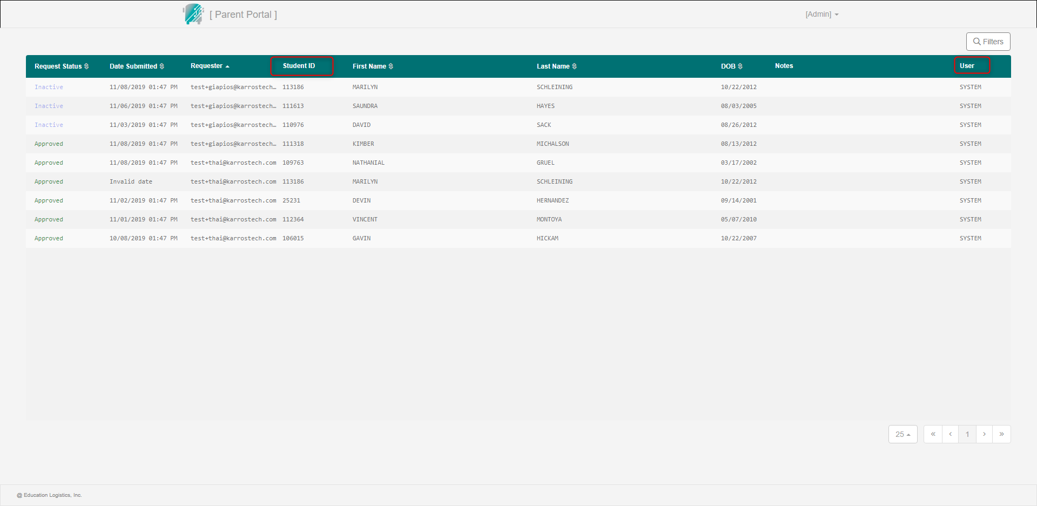

============= Issue 7 =============

**Type:** Issue

**Severity:** Major

**Title:** [Parent Portal] - Admin adds/edits note unsuccessfully

**Steps:**

1. Open the link: http://ktvn-test.s3-website.us-east-1.amazonaws.com/
2. The Login page is displayed
3. Input valid Admin username
4. Input valid Admin password
5. Click Login button > Navigating to Parent Portal page
6. Select a row that you want to add/edit note > Click on Note cell
7. Input the note
8. Click Save button

**Expected result:** Make sure that the note added/edited successfully.

**Actual result:** Admin adds/edits note unsuccessfully after step 8.

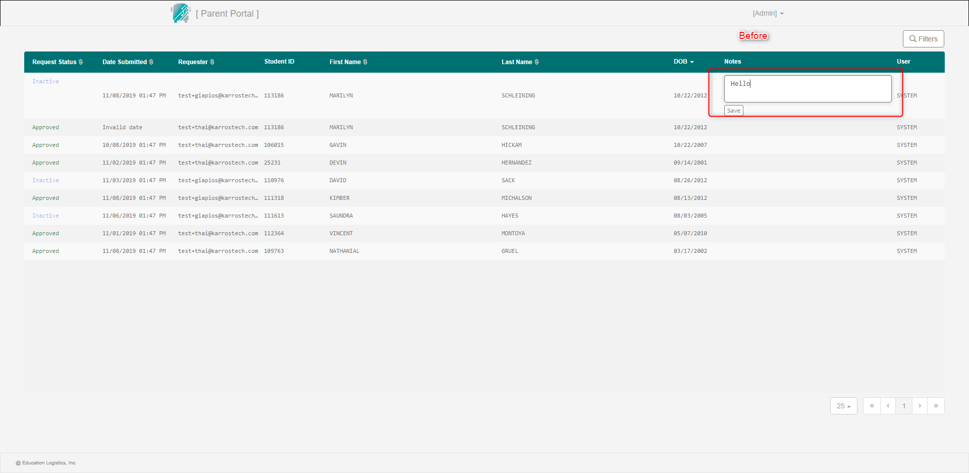

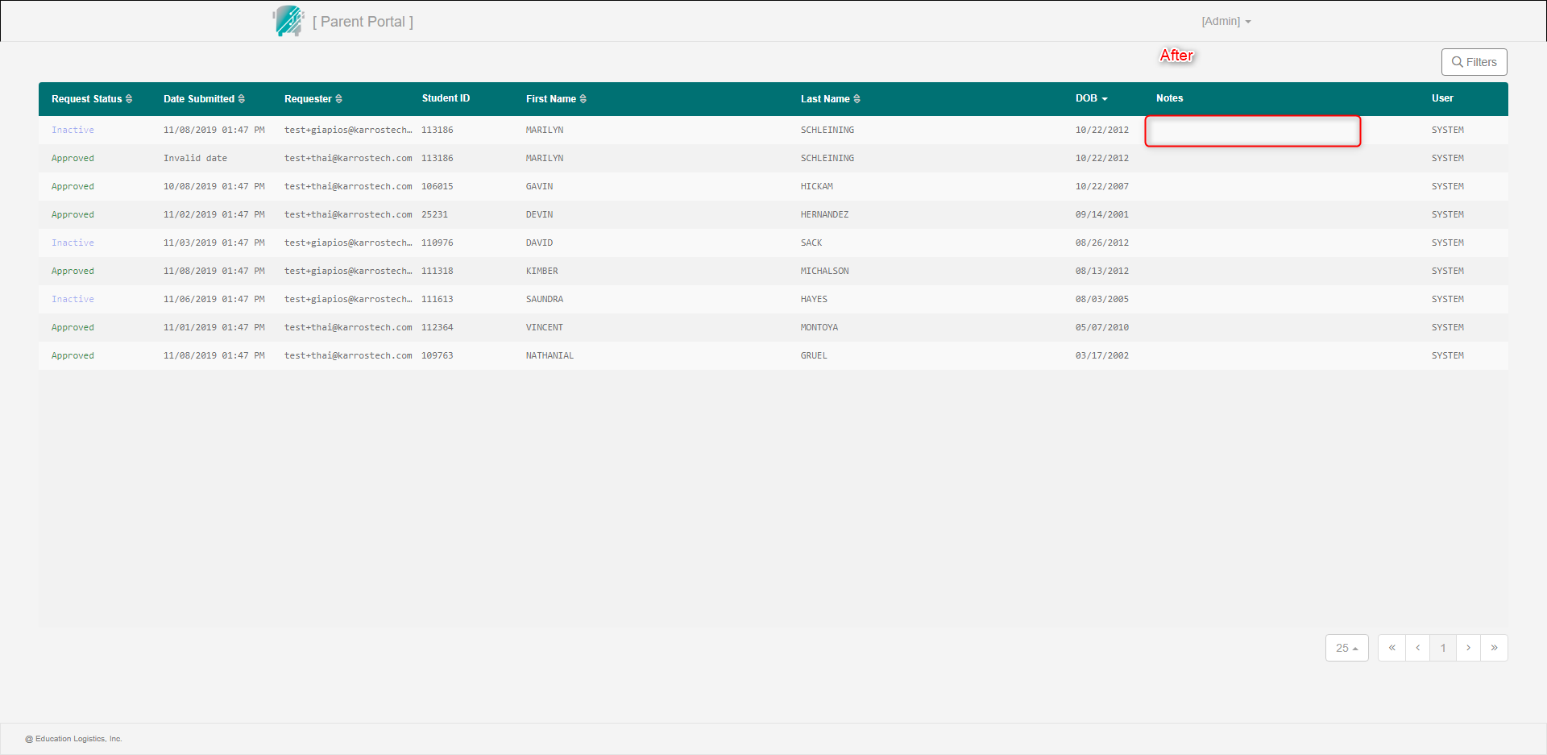

============= Issue 8 =============

**Type:** Issue

**Severity:** Medium

**Title:** [Parent Portal] - Missing the total records show per page text

**Steps:**

1. Open the link: http://ktvn-test.s3-website.us-east-1.amazonaws.com/
2. The Login page is displayed
3. Input valid Admin username
4. Input valid Admin password
5. Click Login button > Navigating to Parent Portal page
6. Observe

**Expected result:** Have total records show per page text (ex: showing <x> of <total records>).

**Actual result:** Missing the total records show per page text.

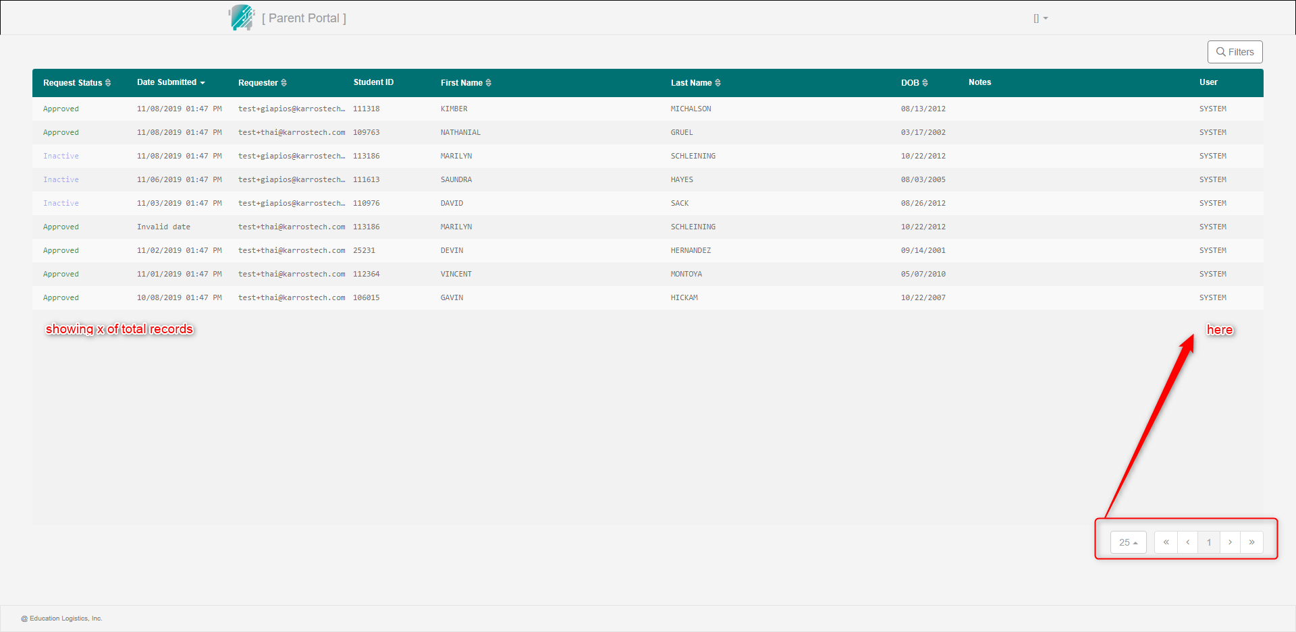

============= Issue 9 =============

**Type:** Issue

**Severity:** Critical

**Title:** [Parent Portal] - The Filter function does not work.

**Steps:**

1. Open the link: http://ktvn-test.s3-website.us-east-1.amazonaws.com/
2. The Login page is displayed
3. Input valid Admin username
4. Input valid Admin password
5. Click Login button > Navigating to Parent Portal page
6. Click on Filters button > Filters popup is opened
7. Select Approved status (ex)
8. Click Apply Filters button

**Expected result:** The Filter function works as expected. In this case, all Approved records are shown.

**Actual result:** The Filter function does not work. In this case, Admin can select the filter but there is no result response.

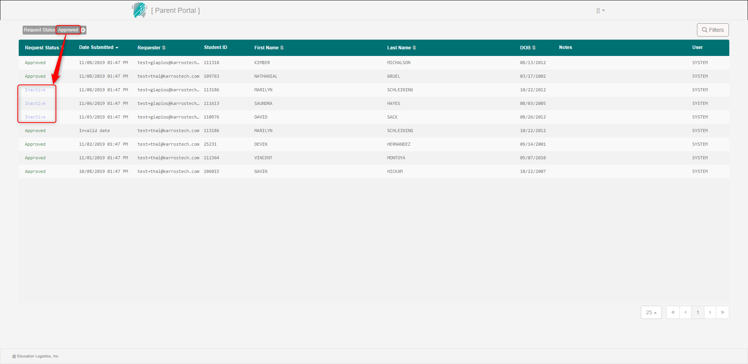

============= Issue 10 =============

**Type:** Issue

**Severity:** Medium

**Title:** [Parent Portal] - The Student ID field accepts character(s).

**Steps:**

1. Open the link: http://ktvn-test.s3-website.us-east-1.amazonaws.com/
2. The Login page is displayed
3. Input valid Admin username
4. Input valid Admin password
5. Click Login button > Navigating to Parent Portal page
6. Click on Filters button > Filters popup is opened
7. Input character(s) in the Student ID field

**Expected result:** The Student ID field only accepts numeric.

**Actual result:** The Student ID field accepts character(s).

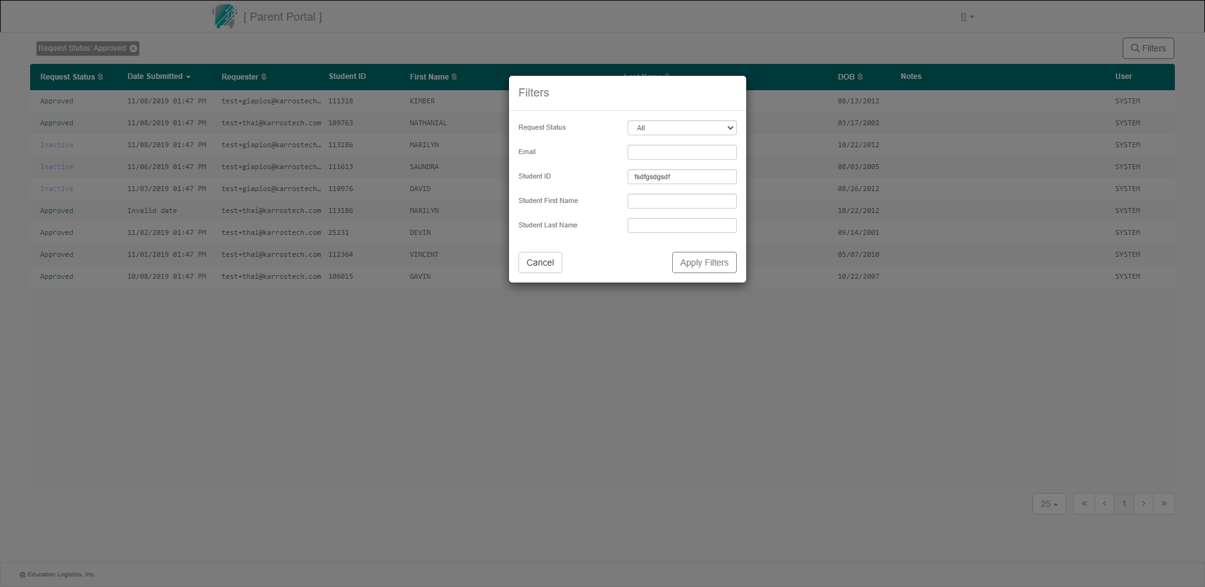

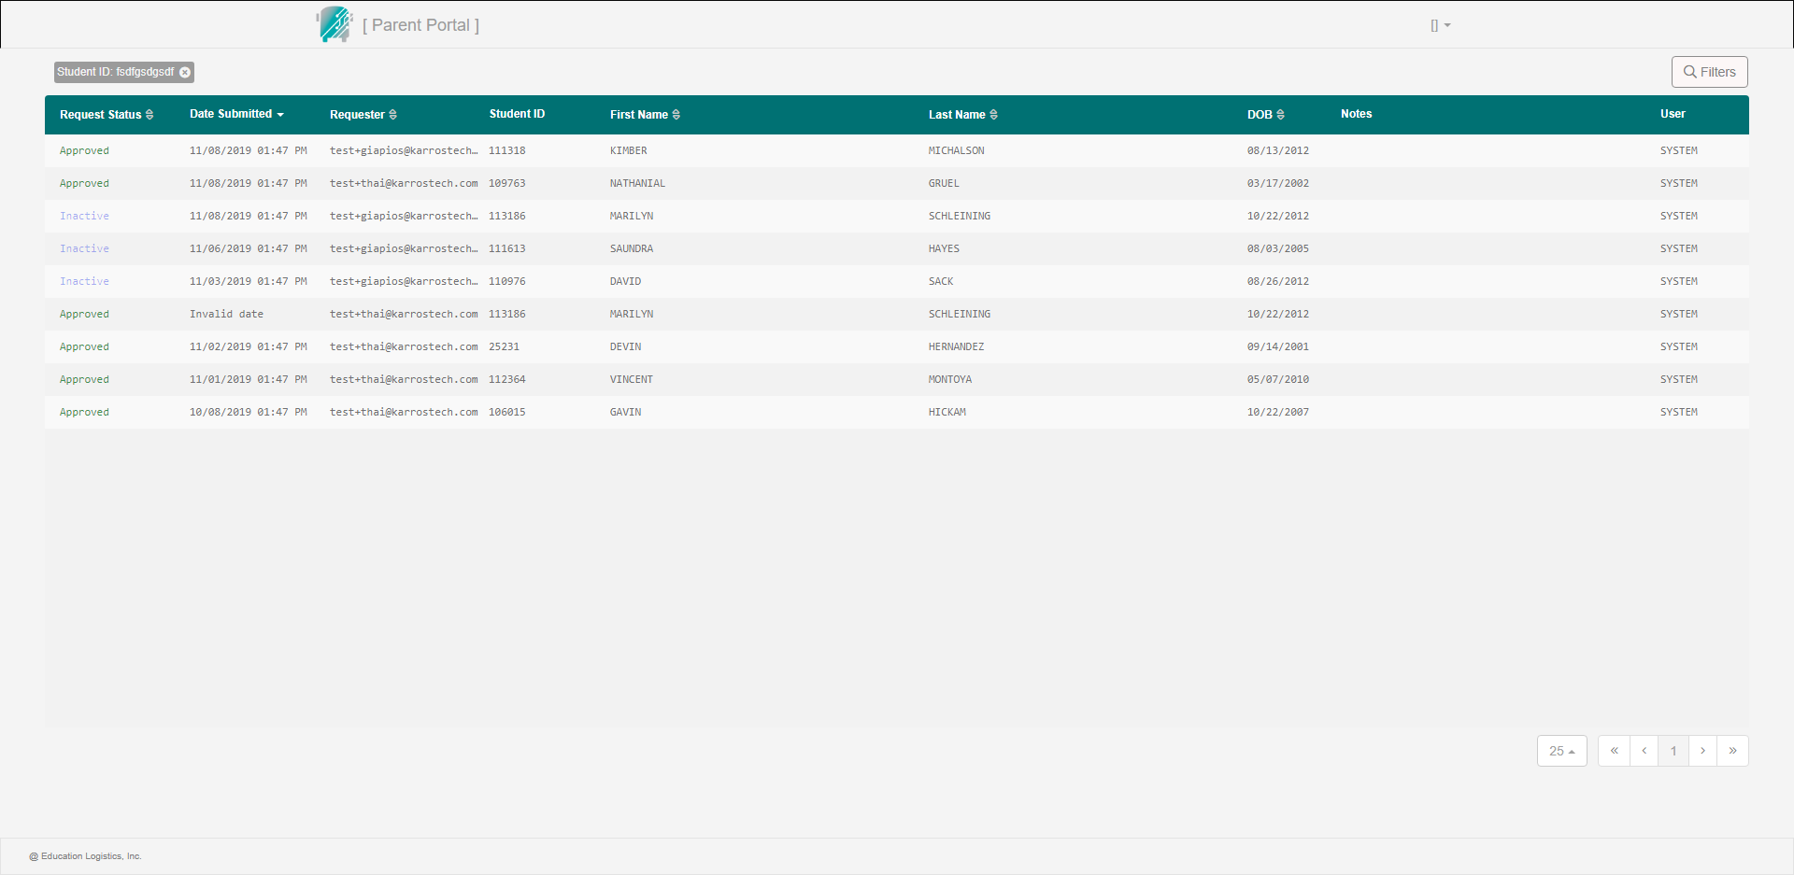

============= Issue 11 =============

**Type:** Issue

**Severity:** Medium

**Title:** [Parent Portal] - Missing the Profile name after refreshing Parent Portal page.

**Steps:**

1. Open the link: http://ktvn-test.s3-website.us-east-1.amazonaws.com/
2. The Login page is displayed
3. Input valid Admin username
4. Input valid Admin password
5. Click Login button > Navigating to Parent Portal page
6. Refresh the page
7. Observe

**Expected result:** The Parent Portal page is displayed fully and clearly.

**Actual result:** Missing the Profile name after refreshing Parent Portal page.

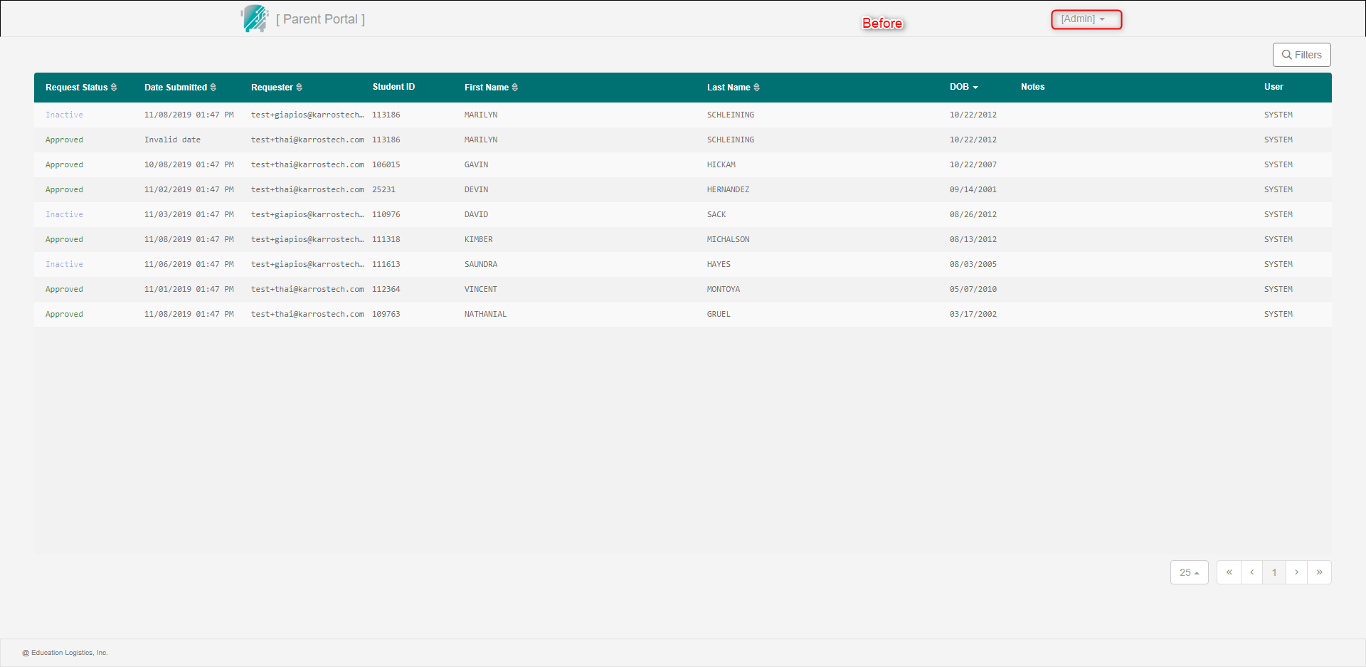

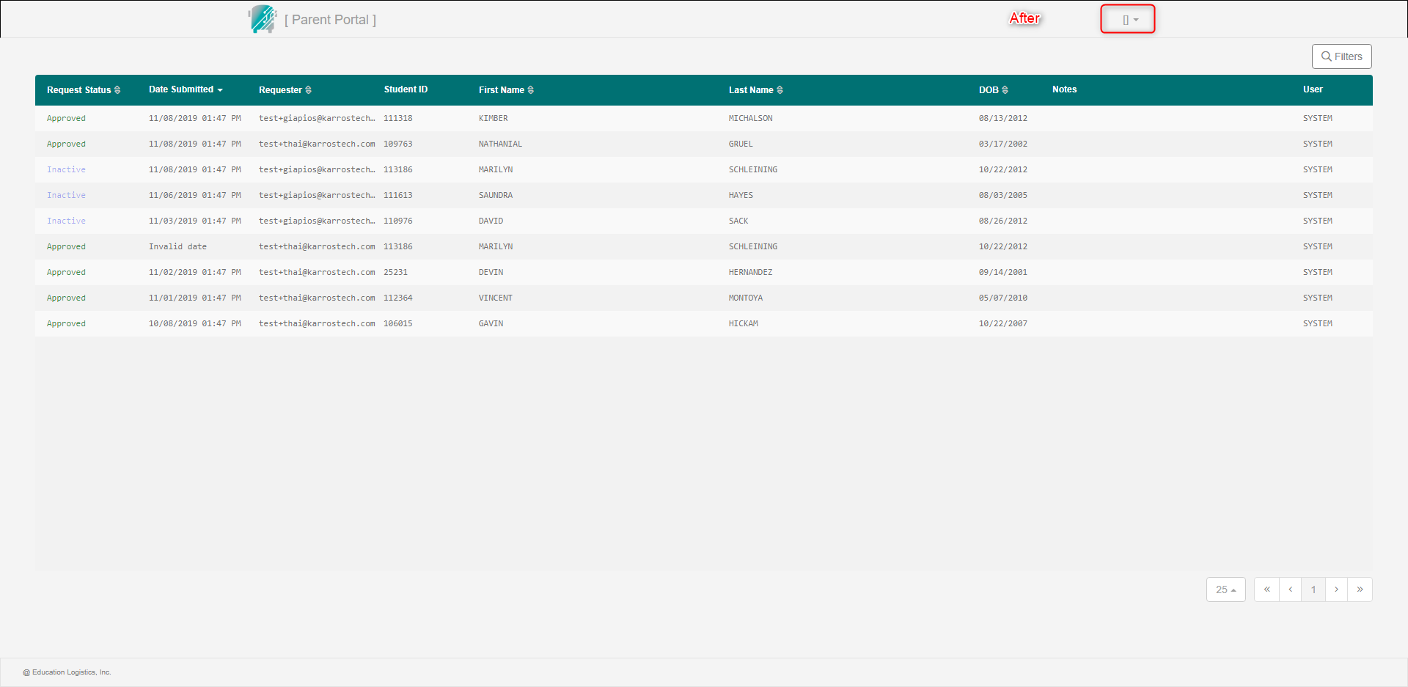

============= Issue 12 =============

**Type:** Issue

**Severity:** Major

**Title:** [Parent Portal] - User can submit a request with invalid date.

**Steps:**

1. User submits a request with invalid date

**Expected result:** Make sure that user cannot submit a request with invalid date.

**Actual result:** User can submit a request with invalid date.

