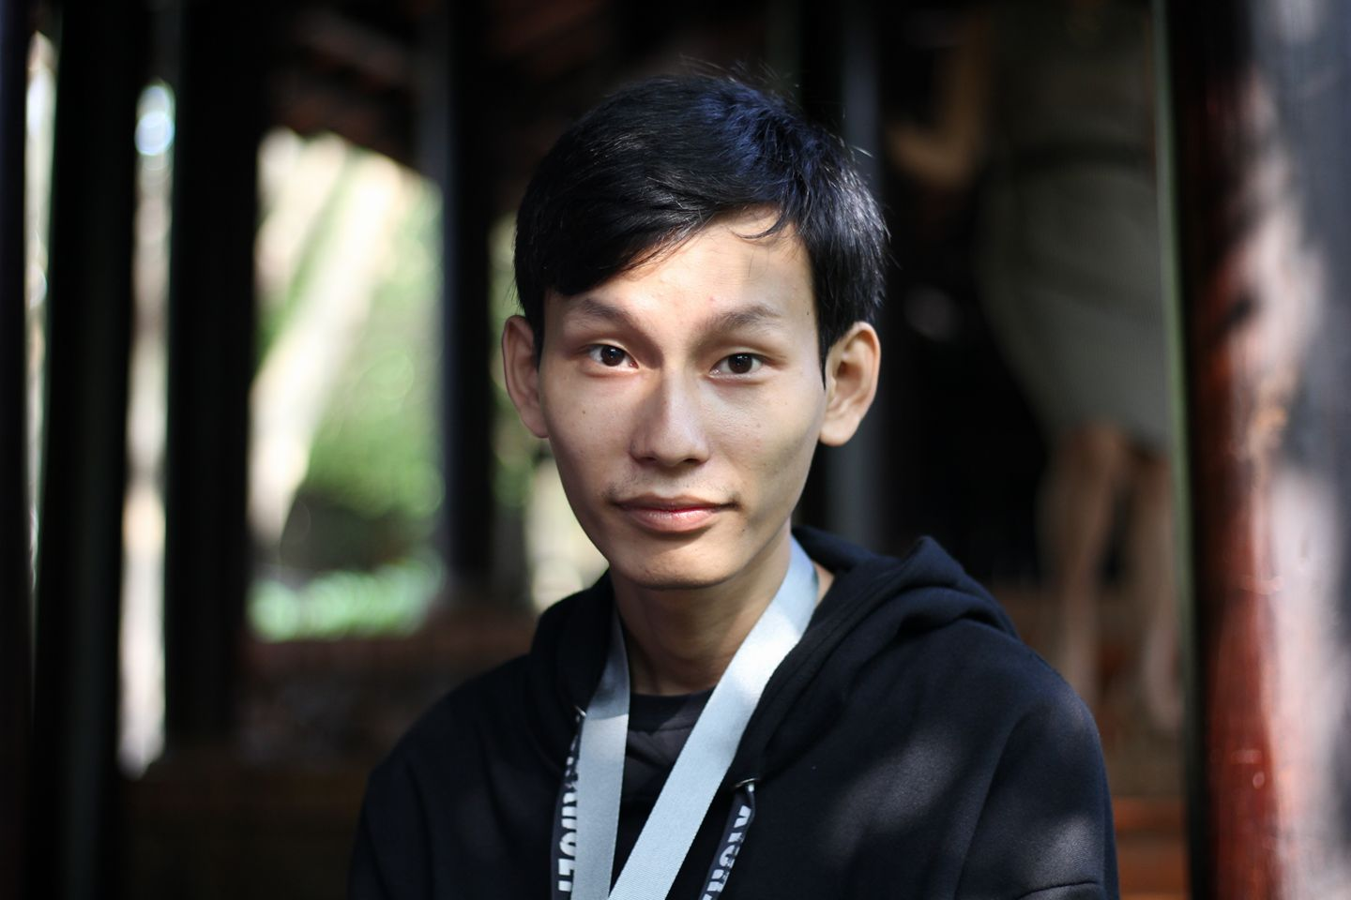

**STUDY TECHNOLOGY INFORMATION**

Final year student of software engineering.

**IN HOCHIMINH UNIVERSITY OF FOOD INDUSTRY.**

BIRTHDAY: 14/03/1997

SEX: MALE

PHONE: 0835191909

EMAIL: [duc.lp1403@gmail.com](mailto:duc.lp1403@gmail.com)

ADDRESS:No.910/26/5 Tan Ky Tan Quy, Binh Hưng Hoa Ward, Binh Tan Distric, Ho Chi Minh City.

**ACTIVITY**

*08/2015 - present*

**SOME PROJECT:**

-Bookshop website (php/mysql).

-Mobileshop website (Language Asp.Net/SQL Server).

-Find job application: 1 version Android and 1 version winform. Users can search jobs.

**EDUCATION**

*08/2015 –* *present*

**FRONTEND INTERNS**

Participate in the Frontend programming practice that combines Bootstrap and JavaScript. Completed and accompanied by a certificate.

**IN GIANGHANGVN Co.Ltd.**

*09/04/2018 - 08/08/2018*

**MEMBER OF TEAM MARKETING & MEDIA**

Get the design from the designer and exchange to convert into website interface. Operation and maintenance of the website on Magento platform and website on Opencart platform.

**IN TOP Co.Ltd.**

*24/04/2017 - 5/01/2018*

**WORK EXPERIENCE**

Find a job in a professional environment and active.Therefore to be able to promote the strengths of self and learn, grasp the advanced technology of the era.

*08/2015 - present*

**VISIT ADDRESSED AND ACTIVITIES OF THE SCHOOL.**

**IN HOCHIMINH UNIVERSITY OF FOOD INDUSTRY.**

*07/2016 - 08/2016*

**MEMBER OF ”PHUOT THIEN NGUYEN”**

Volunteer.

Gather gifts and distribute to Vung Tau Orphanage. - Share, encourage the children overcome difficulties, help them have optimistic thoughts.

**ABOUT ME**

- I think myself is cheerful, sociable. I like innovation and create something ”new”.

- Full Information:

<https://duclp1403.github.io/cvonline>

INFO

GIT/GITHUB

WORK GROUP

MYSQL/MS SQL/ POSTGRESSQL

ANGULARJS

JQUERY

.NET/C#

PHP

HTML / CSS / JAVASCRIPT

SKILL

**OBJECTIVE**

FINAL YEAR STUDENT

PHU DUC LAM