Student Name: Nguyen Minh Duc

3DGraphic Lab 1: Rendering with Blender

1. First experiments, objects, materials, shading:
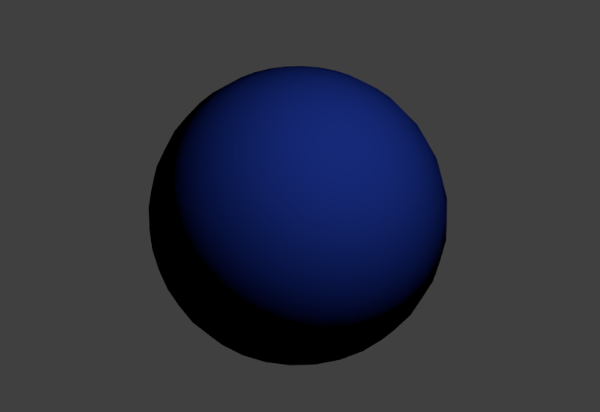
Illustration 1: Specular intensity = 0
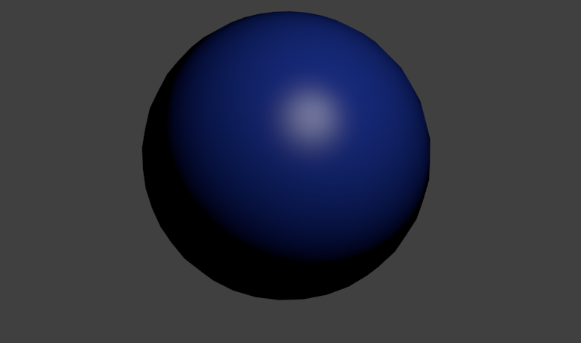
Illustration 2: Specular intensity = 0.5, hardness = 50

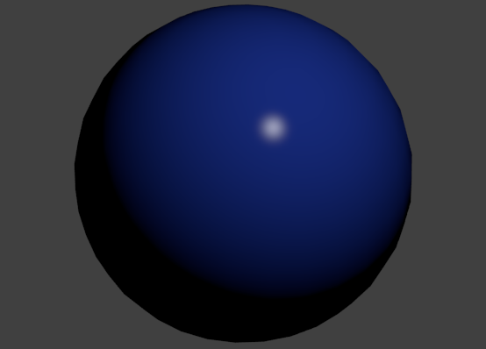
Illustration 4: Specular Intensity = 1, hardness = 500
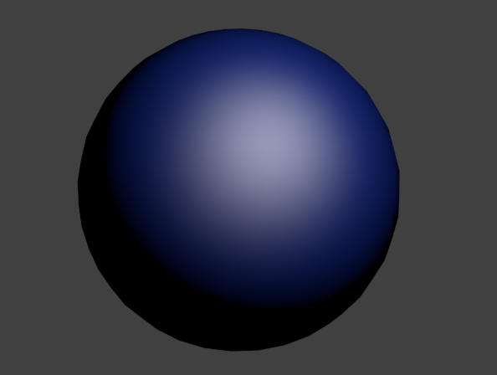
Illustration 3: Specular intensity = 1, hardness = 10

2. In this exercise, we can see that the ball with the mirror option reflect the other balls and the light sources pointing to it. The ball with the transparent option let us see through it.
The shadow of the ball are casted on the plane. Overlapping shadows appear as black however it should only be a little darker. The shadow is not realistic.
We can make the shadow more realistic by using the ray tracing algorithm to compute the light intensity at a given point on the plane.

3. The four steps in creating a model of the earth:
- Step 1: The normal map is the map that define the bump level of a surface because the earth surface is not flat, there are mountains and oceans so the bump map applied to the normal component will help define the shape and height of the terrains.
- Step 2: After defining the terrains, we need to color it with the correct color. The sea must be blue and the land must be green or gray. We will load the color texture and cover the sphere.
- Step 3: The lighting diffuse and specular of the earth is different for different location so we must define our own specular map and add it as a texture so that we can get a more realistic earth model.
- Step 4: To make a realistic earth model, we need to add a cloud layer. The sphere that have the cloud texture must be transparent where there is no cloud and white at where there is cloud. So we set this sphere to be completely transparent at first and then it will use the transparent parameters from our cloud texture.
4. More textures, environment mapping and chrome effect
Image 1: The emit parameter is used to specify the object emitting light.
Image 2: The countryenv image appears to be glowing and life like
In image 3 and image 4 the difference is the projection of the image onto the sphere. The projection of image 3 is spherical so towards the edge of the sphere the image is distorted because of the spherical coordinate. In image 4, the projection is generated so the image is less distorted towards the edge of the sphere. In spherical projection the edge of the sphere is mapped to the edge of the image as the image is rectangular and the sphere is round so the distortion is clearly seen at the edge and the image is preserved at the center.

5.

