**ASSIGNMENT 1 FRONT SHEET**

|  |  |  |  |
| --- | --- | --- | --- |
| **Qualification** | **BTEC Level 5 HND Diploma in Computing** | | |
| **Unit number and title** | Unit 13: Computing Research Project | | |
| **Submission date** | 15/12/2022 | **Date Received 1st submission** |  |
| **Re-submission Date** |  | **Date Received 2nd submission** |  |
| **Student Name** | Mai The Duc | **Student ID** | GCH200681 |
| **Class** | GCH0907 | **Assessor name** | Nguyen The Lam Tung |
| **Student declaration**  I certify that the assignment submission is entirely my own work and I fully understand the consequences of plagiarism. I understand that making a false declaration is a form of malpractice. | | | |
|  |  | **Student’s signature** |  |

**Grading grid**

|  |  |  |  |  |  |  |  |  |  |
| --- | --- | --- | --- | --- | --- | --- | --- | --- | --- |
| P1 | P2 | P3 | P4 | P5 | M1 | M2 | M3 | D1 | D2 |
|  |  |  |  |  |  |  |  |  |  |

|  |  |  |
| --- | --- | --- |
| **❒ Summative Feedback: ❒ Resubmission Feedback:** | | |
| **Grade:** | **Assessor Signature:** | **Date:** |
| **Internal Verifier’s Comments:** | | |
| **Signature & Date:** | | |

Table of Contents

Introduction 5

I. Introduction the purpose of the research 5

I.1. Purpose of the research 5

I.2. Research’s aims and objectives 5

II. Literature review 6

II.1. Research methodologies 6

A. Primary research 6

B. Secondary research 7

C. Qualiative 8

D. Quantiative 9

E. Research processes 10

II.2. Research methods that will be used in this research 11

II.2.1. Sequential research 11

II.2.2. Interview 11

II.2.3. Survey 12

II.3. Secondary research 12

1. What is medical device? 12

2. What are wearable medical devices used for? 13

3. What advantages do wearable medical devices offer? 17

4. How can we recycle wearable medical devices? 18

II.4. conclusion on secondary researches 18

II.5. Initial hypothesis 19

III. Primary research 19

III.1. Design 19

III.2. Interview question 20

III.3. Survey question 22

IV. Analyse the result of the primary research 26

IV.1. Interview 26

IV.2. Survey 27

IV.3. Justification the hypothesis with primary research 33

IV.4. Recommendations 33

Research Proposal Form 34

Research Ethics Approval Form 37

References 41

# Introduction

I'll introduce wearable medical devices in this report. The focus of the research will be made clear. As a result, both the primary study and the secondary research will be discussed in this work. There will be research-related questions and issues on the subject of wearable medical devices. Data from interviews and surveys will be gathered and documented. They will also be evaluated, and conclusions will be made.

# I. Introduction the purpose of the research

## I.1. Purpose of the research

A new technological era is emerging, and with the advent of technology 4.0, we have witnessed a significant digital transformation across numerous industries. The health industry is comparable to other sectors of the economy. The digital transition has advanced greatly thanks to wearable medical technology. These tools make it simple for hospitals and users to maintain and conduct research that enhances public health. Through this study, we will discover more about how these technologies can change people's lives.

## I.2. Research’s aims and objectives

We want to make things simpler and more convenient in practically every aspect of our lives. If there is something we need to do, we want it to fit into our schedules as easily as possible. This is the major justification for the widespread use of wearable technology in healthcare, especially for preserving and monitoring our health. Medical wearables monitor a patient's health, detect anomalies, and even treat medical diseases using sensors, actuators, software, and electronic patches applied to the skin. Wearable vital signs monitor, a smart watch glucose monitor, or wearable pain management devices are a few examples. This study will demonstrate the types and the impacts of those devices on human life and environment.

Students in Hanoi serve as our research subjects as we study wearable medical gadgets that have a positive impact on life. We shall examine study data on these gadgets here. For the most comprehensive understanding of people's experiences and viewpoints, we will conduct interviews, surveys, and explore secondary data sources.

We conduct research on the many wearable medical device categories, user demographics, and activities. Discovering its advantages for users. We are interested in the outcomes of wearable medical technology and why. Also, we want to know more about the impact of those devices on environment. There will be inquiries like:

* What is wearable medical device?
* What are wearable medical devices used for?
* What advantages do wearable medical devices offer?
* Should people use wearable medical devices?
* Do wearable medical devices have bad impact on environment?
* How can we recycle wearable medical devices?

# II. Literature review

## II.1. Research methodologies

### A. Primary research

Primary research is a methodology that researchers use to gather data directly as opposed to relying on data from earlier research. Primary research is only done to address a specific issue that needs in-depth investigation (QuestionPro, 2022).

Primary research entails collecting previously uncollected data. It can be gathered through various means, such as interviews, surveys, observations, or self-conducted fieldwork. A primary source, such as an original study, document, artifact, or eyewitness account, will in turn be used as a result of the primary research (University of Southampton, 2022).

Primary research methods according to Purdue University (2022):

* Interviews: Individual or small-group question-and-answer sessions are known as interviews. Interviews are helpful when you want to get an expert or knowledgeable opinion on a topic because they provide a lot of information from a limited number of people.
* Surveys: Surveys are a more formalised form of questioning than interviews, involving bigger groups of respondents. When you want to find out what a larger population thinks, surveys can be useful because they give you a limited amount of data from a large number of people.
* Observations: Making organised notes about events in the world is a component of observation. When you want to learn more about a specific event without the slanted perspective of an interview, observations can give you insight about specific people, occasions, or locations.
* Analysis: analysis entails gathering data and putting it together in some way according to standards you create. When looking for a trend or pattern, they are helpful. Analyzing gender roles through the analysis of commercials from three major television networks would be one type of analysis.

### B. Secondary research

Secondary research, also known as desk research, is a research method that makes use of previously collected data. To improve the overall effectiveness of research, existing data is compiled and summarised. Research that has already been published in research reports and other similar documents is considered secondary research. These documents may be made available through online resources, public libraries, surveys that have already been completed, etc. Secondary research is much more affordable than primary research because it uses data that is already available, as opposed to primary research, which collects data from organisations or businesses directly or through the use of a third party (QuestionPro, 2022).

Instead of creating a new data set using primary research techniques, secondary research assimilates data from various sources using the research materials already in existence. The gathering of data for secondary research frequently involves using the internet, libraries, archives, schools, and organisational reports (Formplus Blog, 2022).

Data obtained online is referred to as online data. This method has become more popular recently due to the wide array of both free and paid research resources that are readily accessible online and can be quickly accessed with the click of a button (Formplus Blog, 2022).

Government and non-government archives are another place to find helpful research materials, and these archives typically have information that can be verified and offers helpful insights on various research contexts. In many cases, access to these data would require payment (Formplus Blog, 2022).

Public and private libraries offer access to research materials as well. Consider a library as a repository of knowledge that holds a collection of pertinent data that can be used as reliable information in a variety of research contexts (Formplus Blog, 2022).

Schools, faculties, and colleges are excellent sources of secondary data, particularly for academic research. This is due to the fact that more research is conducted in academic institutions than in other industries (Formplus Blog, 2022).

### C. Qualiative

To better understand ideas, opinions, or experiences, qualitative research involves gathering and analysing non-numerical data (such as text, video, or audio). It can be used to uncover intricate details about a situation or to spark fresh research concepts (Bhandari, 2022).

Traditionally, qualitative research techniques have been carried out in-person or over the phone. However, compared to conventional methods, the online research approach has many important advantages in terms of time and resource savings. Qualitative research is used to comprehend how individuals perceive their surroundings. To comprehend or explain the actions, motives, and traits of members of a target group, researchers turn to qualitative research (QuestionPro, 2022).

The following are the most popular qualitative research techniques:

* Case study
* Focus Groups
* Record-Keeping
* Qualitative observation
* Ethnographic research
* One-to-one interview

For example, one of the most popular techniques for conducting qualitative research is conducting in-depth interviews as known as one-to-one interview. One respondent is interviewed one-on-one in a personal setting. This approach is entirely conversational and provides chances to probe the respondent for specific information. The ability to collect precise information about people's beliefs and motivations is one of the benefits of this method. If the researcher is skilled and knowledgeable, asking the right questions can aid in the collection of relevant data. The researchers should ask follow-up questions to help them gather additional data if they need more information (QuestionPro, 2022).

### D. Quantiative

The procedure of gathering and analysing numerical data is known as quantitative research. It can be applied to identify trends and averages, formulate hypotheses, examine causality, and extrapolate findings to larger populations (Bhandari, 2022).

Quantitative research is the systematic investigation of phenomena through the collection of quantifiable data and the application of statistical, mathematical, or computational methods. Through the use of sampling techniques and the distribution of online questionnaires, polls, and surveys, for instance, quantitative research gathers data from current and potential customers. Which can be represented numerically as the results. A product or service's future can be predicted using these numbers, and changes can then be made as necessary (QuestionPro, 2022).

The most essential tool for all quantitative outcome research methodologies and studies is survey research. A sample of respondents was surveyed using a variety of methods, including online polls, online surveys, paper questionnaires, web-intercept surveys, etc. A survey is described as a research technique used to gather information from a pre-selected group of respondents in order to learn more and gain new perspectives on a variety of interesting topics. One of the most crucial components of conducting quantitative outcome research is survey distribution because of how simple it is and the vast number of people it can reach depending on the research time and research objective.

### E. Research processes

A researcher follows a set of sequential steps known as the research process to guarantee that every aspect of an investigation is finished to a high standard. Following the research process enables the researcher to cover all bases and make sure the data they collect is accurate and presented clearly (StudySmarter, 2019).

Making sure that all necessary steps are taken will help to ensure that the most accurate, trustworthy, and beneficial information is gathered. The research process aids in focusing the study and guarantees that all crucial areas are covered.

The research procedure is crucial because it can assist in raising the calibre of your research to the highest level. You can work more effectively and with greater focus by using the research process to see all the steps you must take for your research to be successful.

## II.2. Research methods that will be used in this research

In this research, primary, secondary, qualitative, and quantitative researches will be used. For research process, I use Sequential research to operate the project.6

I will use journals, web content, books, and other sources for secondary research to examine every facet of the wearable medical device. I'll be able to respond to many of my prepared questions using this technique. I will benefit greatly from using the internet to conduct my research on these devices in the most effective and accurate ways possible.

 I will use interviews and surveys to gather primary research, including qualitative and quantitative research. These two methods, in my opinion, will offer the most reliable source of data I can find.

### II.2.1. Sequential research

Sequential research define as sequence of tasks that must be completed one after the other. However, not all stages are applicable, and some tasks may need to be completed differently depending on the type of research being conducted.

### II.2.2. Interview

A qualitative research technique known as an interview relies on the collection of data through the use of questions. Two or more people participate in interviews, one of whom is the interviewer who asks the questions. According to George (2022), here are various interview types, which are frequently distinguished by their degree of structure.

* In structured interviews, questions are asked in a predetermined sequence.
* Unstructured interviews allow for more spontaneity.
* Semi-structured interviews are in-between.

In my research, I will use semi-structure to interview student. I believe that student is the best group for topic like this. They have the impressive ability to adapt with technology. Therefor, interview student will be the best choice to research. Besides, I will interview students in range of Hanoi city. Interview will be the best way to help me collect qualitative result.

### II.2.3. Survey

The process of conducting research using surveys that researchers send to survey respondents is known as survey research. To reach meaningful research conclusions, the survey data is statistically analysed after collection. There are many different methods for conducting research, but surveys have been proven to be one of the most effective and trustworthy methods. A single person or a group of people can be surveyed online to get their opinions on a crucial business issue. It consists of well-organized survey questions that entice respondents to respond. Survey research is frequently described as a quantitative method that involves posing a large number of survey questions to a sample of respondents in order to collect information. This research type includes individual recruitment, data collection, and analysis.

In this case, anyone in the university’s campus can do the survey. We will limit the pool at Greenwich University in Hanoi. We will use online Google form to operate this activity. The result we might get will be analysis and evaluate. Survey will be the best way to help me collect quantitative result.

## II.3. Secondary research

### What is medical device?

In the context of healthcare, wearable technology includes a wide range of supportive accessories and wearable medical devices. Medical wearables monitor a patient's health, spot anomalies, and even treat medical conditions using sensors, actuators, software, and electronic patches applied to the skin (Tan, 2022).

Electronic gadgets that consumers can wear, like smartwatches, are included in wearable technology in the healthcare industry. These gadgets are made to track users' personal health and exercise data. These gadgets can even instantly transmit a user's medical data to a physician or other healthcare specialist. As more consumers express interest in sharing their wearable data with their providers and insurers, the demand for wearables is anticipated to increase over the next few years (Phaneuf, 2022).

### What are wearable medical devices used for?

**Wearable Fitness Trackers**

The simplest and most inventive types of wearable technology are wearable fitness trackers, which are wristbands with sensors to monitor the user's heart rate and physical activity. By connecting to various smartphone apps, they offer wearers recommendations for their health and fitness. Users were drawn to the device by its sleek appearance and ability to track their daily step progress using its five indicator lights.

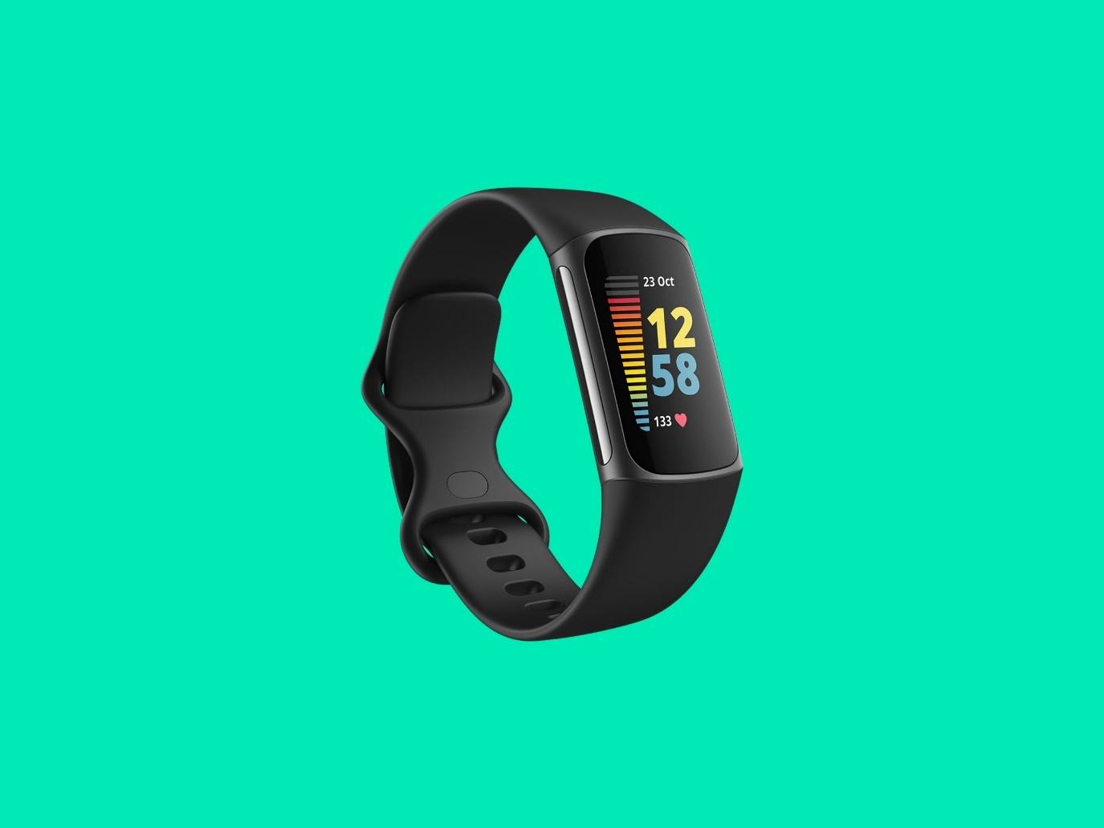

**Smart Health Watches**

Smartwatches, which formerly served only as timepieces and step counters, have evolved into clinically useful healthcare instruments. In order to track users' heart rhythms and notify those who are experiencing atrial fibrillation, Apple released the Apple Heart Study app in 2017. In 2021, the company unveiled the newest Watch model. A blood oxygen saturation monitor, native sleep tracking, a faster FDA-approved electrocardiogram (ECG) sensor, improved heart health monitoring, and fall detection that will automatically call 911 if it detects the wearer is not moving are all included in Apple's Series 7 model. Users of smartwatches can read notifications, send text messages, and make phone calls just like they would on their phones, but they also get some of the exercise and health tracking advantages of fitness trackers.

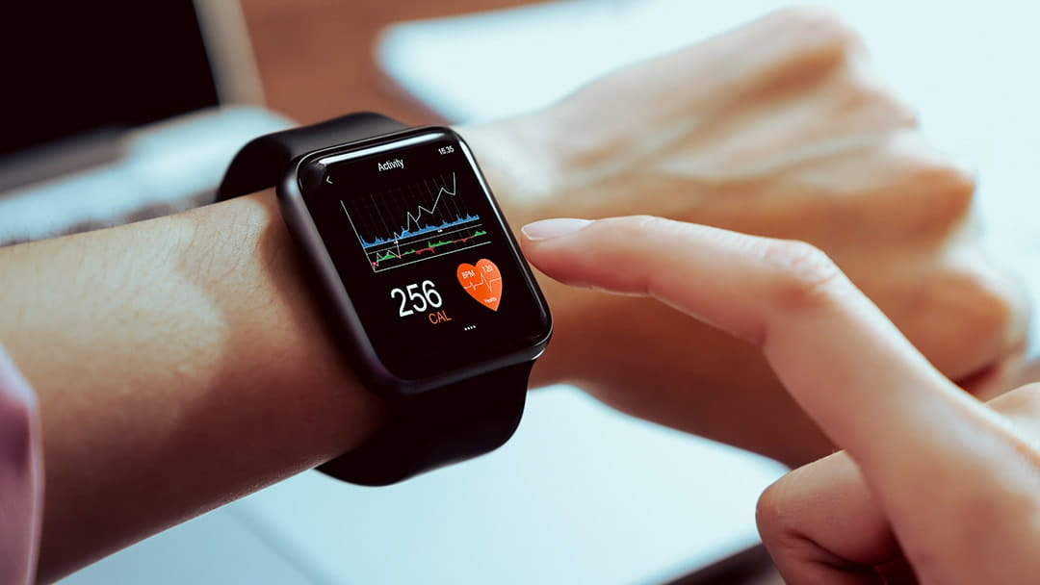

**Wearable ECG Monitors**

The ability to measure electrocardiograms, or ECGs, is what distinguishes wearable ECG monitors from some smartwatches as the cutting edge of consumer electronics. According to Business Insider, Withings' Move ECG wearable won best wearable at the 2019 Consumer Electronics Show. The Move ECG can measure an electrocardiogram, detect atrial fibrillation, and send the results to the user's physician. Along with automatic tracking for walking, running, swimming, and biking, it is also capable of measuring pace, distance, and elevation.

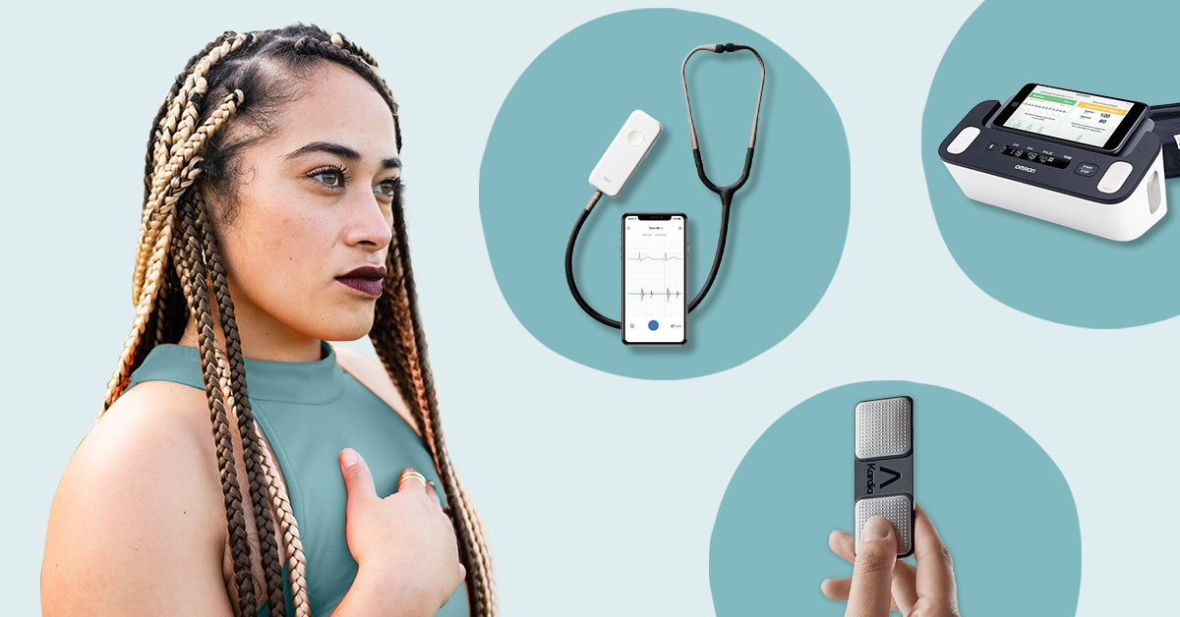

**Wearable Blood Pressure Monitors**

The first wearable blood pressure monitor, HeartGuide, was introduced by Omron Healthcare in 2019. HeartGuide is an oscillometric blood pressure monitor that can measure blood pressure as well as daily activity, such as steps taken, miles travelled, and calories burned. It may look like a typical smartwatch. Up to 100 readings can be stored in memory by HeartGuide, and all readings can be exported to the corresponding mobile app, HeartAdvisor, for analysis, comparison, and treatment planning. Users of HeartAdvisor can track, store, and share their data with their doctor while also learning how their personal habits affect their blood pressure.



There are many and many more wearable medical devices will be invented in the future. With the development of current technology, I believe that new technologies will help people take control of their health more. That's why ideas for new devices will help people in unpredictable ways.

### What advantages do wearable medical devices offer?

***1. Reduced burden on hospital staff***

Utilizing wearable medical device to determine which patients need to visit the clinic or hospital for urgent care will lower the number of visits, free up necessary bed space, and allow doctors and nurses to concentrate on the patients who are most in need of their care.

***2. Improved diagnosis***

Doctors have the best chance they've ever had to spot disease early and provide the most accurate diagnoses in clinic or remotely thanks to the real-time nature of wearable technology and the sheer depth of insight into a patient's vitals. Also, normal user can track down their on health very easy and fast with any kind of monitor.

***3. Convenience***

Smartwatches provide versatility. They combine tasks typically done on mobile devices, like checking email and messages, with the ability of wearable healthcare technology to track one's health, giving users a convenient one-stop shop.

***4. Better patient outcomes***

The preceding point explains this, but to elaborate, earlier and more accurate diagnoses allow patients to receive prompt and individualised care solutions that are most likely to produce the best health outcomes. In addition, they enjoy the convenience of remote monitoring rather than having to travel to a facility for treatment.

***5. Reduction in care costs***

There is undoubtedly room to cut costs associated with the current healthcare model by offering more remote healthcare services as well as personalised diagnoses and treatment plans. Optimizing inpatient services can help hospitals maximise their financial resources by ensuring that resources are used effectively.

### How can we recycle wearable medical devices?

Wearables should be recycled for a variety of reasons, the first (and most crucial) of which is that recycling helps lessen the negative effects of excessive landfill dumping. Already, the world produces a tremendous amount of waste, and as the trash decomposes, it produces greenhouse gases. Any action taken to lower greenhouse gas emissions will aid the fight against climate change.

The second reason is that not all discarded wearables are broken or irreparable. It is possible to disassemble the device and clean, modify, or combine some of its parts to make an entirely new product out of recycled materials. Utilizing recycled materials during production reduces energy usage and the need for scarce, precious resources.

If the batteries in wearables are dry-cell batteries, they can be thrown away, but recycling them is still far preferable. However, toxic chemicals like lithium, cadmium, mercury, and lead may be present in alkaline and rechargeable batteries, posing a risk to those who handle waste. Sending such batteries to facilities that handle hazardous waste is the best option.

You should recycle wearables because doing so supports a strong economy by generating jobs in the recycling and manufacturing sectors.

## II.4. conclusion on secondary researches

After secondary research, we know about the definition of wearable medical device. Wearable medical devices are self-contained, integrated systems used for monitoring and/or treating health conditions We know about the variations and how they work by providing accurate and timely patient data that can be used to help inform healthcare decisions. We know about their advantages such as convenience, continuous monitoring, the ability to detect and respond to trends quickly, remote access for patient and doctor interaction. And finally, we know more about how to recycle those devices and limit their environmental impact, to ensure that these devices do not become an additional strain on our already overburdened resources.

## II.5. Initial hypothesis

* Should people use wearable medical devices?

Our assumption is that everyone should use wearable medical devices because it is really useful for health. Through secondary research, its usefulness is not small. We believe that in a short period of time everyone will be able to adapt and everyone will get used to and own these medical devices.

* Do wearable medical devices have bad impact on environment?

On the other hand, it is because it becomes more popular with people that environmental problems will come up. We believe that if the number of users increases, the amount of equipment released into the environment every time it is replaced will also increase. This is obvious, so that's why each of us has a responsibility to protect the environment. For a healthier community!

# III. Primary research

## III.1. Design

In the primary research part, I chose interview and surveys to conduct.

For the interview part, I chose the audience as students who are currently studying at universities within Hanoi. I believe that at this age, they are people who can adapt well to new technological devices. Especially when wearable medical devices are a very hot technology. With the data that we collect, we will re-analyze and draw conclusions to be able to find answers to the research questions. We plan to interview 7 to 10 random students.

As for the survey, we plan to use QR codes to post on university bulletin boards. These universities also belong to the city of Hanoi. In addition, this survey we will be able to answer for all ages. That way they will only get more quantitative data. The survey will then also be used to assess the status and opinions of people about wearable medical devices.

## III.2. Interview question

These are the interview questions:

1. What is your name?
2. Where you from?
3. How old are you?
4. Do you have any wearable medical devices and if you have, how does it feel like?
5. How frequently you check on your health though that device?
6. Do you think everyone should have a device in any kind to keep track on their health and why?
7. What do you think about wearable medical devices impact on environment when people replace it with a new one?
8. Do you think recycle those devices is importance and will you recommend it to your family?

***The Result:***

Table: age of interview participants

The age of participants are around 18 – 21. They are from random university around Hanoi. We found them while going to famous universities. We have the opportunity to contact them and interview them when they agree. Here are the answers we found to be the best and most comprehensive.

**Do you have any wearable medical devices and if you have, how does it feel like?**

Well actually I have an apple smart watch. It has functions such as measuring heart rate, counting steps, and even a reminder to drink water. Recently I am in the process of getting into the habit of drinking at least 2 liters of water a day. It feels like this watch really has great features in addition to telling the time. It has given me more experience and understanding of my body and habits. Since using this device, I have been able to test and compare my ability and movement habits through the number of steps. At the same time, I also know my heart rate without having to go to the hospital for regular health check-ups, which is pretty cool, isn't it? Today's technology is full of surprises and fun.

***How frequently you check on your health though that device?***

I usually check my stats only at the end of the day, if I'm not busy. But when I'm having busy weeks, I can only check about three times a week. The good thing is that it is integrated as a clock, so when I have time, I just need to look at the application on it.

***Do you think everyone should have a device in any kind to keep track on their health and why?***

Actually, a device like this is not too expensive anymore, so I doubt anyone with the conditions can easily own it. With the development of technology today I believe that even the elderly needs this watch to be able to send emergency notifications to the hospital or loved ones. As for young people like us, owning devices like this is quite necessary because it helps to create good habits and suggests interesting health tips.

***What do you think about wearable medical devices impact on environment when people replace it with a new one?***

About that I haven't really thought of. But if you think about it, it would be bad. I think that not only wearable medical devices but also common electronics, all need to be recycled. Recycling is necessary to keep our environment clean and healthy.

***Do you think recycle those devices is importance and will you recommend it to your family?***

As mentioned above, I find recycling electronics extremely important. I hope that if everyone understands the importance of recycling, it will reduce the greenhouse effect, harmful emissions and many other problems related to environmental pollution. Personally, I will definitely recommend it to my relatives about its importance. I think this action is the responsibility of each person and the community.

## III.3. Survey question

These are the survey questions:







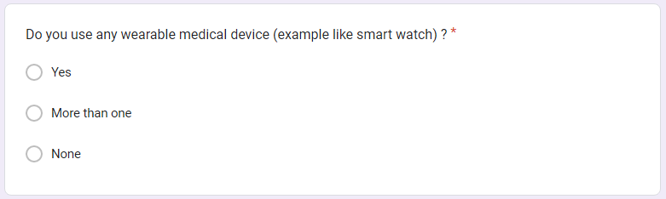

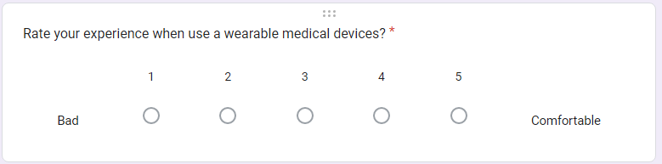

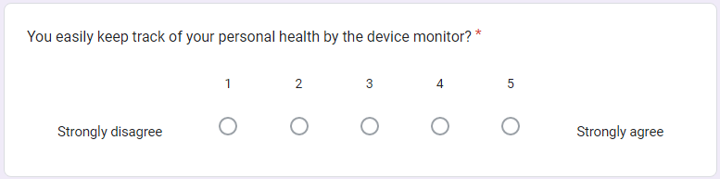

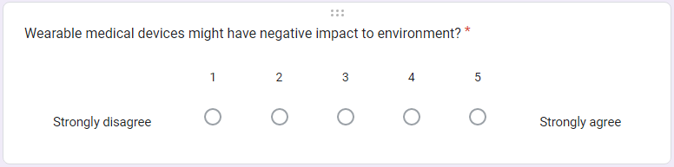

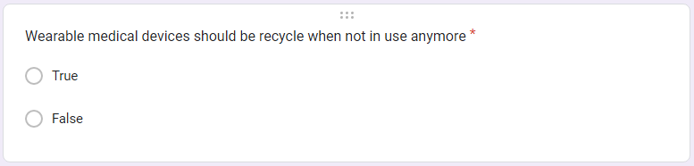



***The Result:***

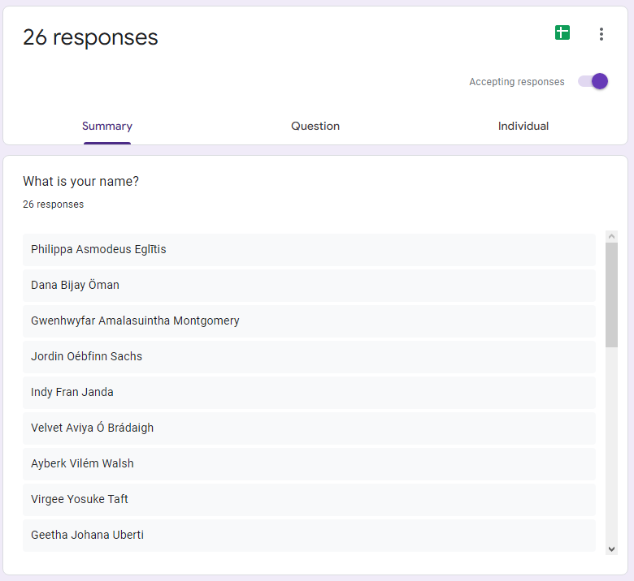

We receive 26 responses from student and staff from random university campus. They have difference age range and we happy about it. Survey really did help us a lot in quantitative research.

# IV. Analyse the result of the primary research

## IV.1. Interview

The interviews really gave us the most accurate view. We saw interest from participants when they described their use of wearable medical devices. Many applications have been launched such as counting steps, measuring heart rate, reminding to drink water, etc. Participants also know their habits through these devices. While it's not always continuous monitoring, with devices like these, they can safely check in when they feel unwell.

Because the target group is young, they are very active. They believe that everyone should have wearable medical devices. In addition, such devices also help the sick and elderly to send warning signals to relatives or hospitals to promptly help them.

When we asked more about the impact of these electronic devices on the environment, they had very surprising responses. Not a lot of people who think college-age students really think about it. However, they also believe that electromagnetic waste needs to be recycled to reduce emissions and natural resources.

Finally, the participants were eager to share important messages about the impact of e-waste recycling on not only their family members but also the community. This really lies our predictor.

## IV.2. Survey

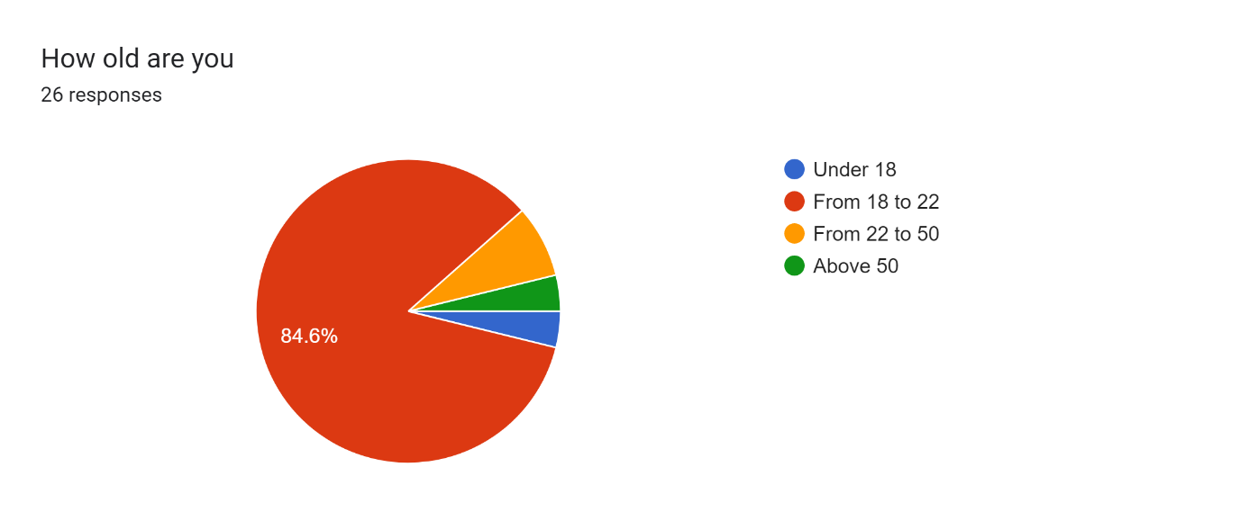

Participants ranged in age from 18 to 22, mostly university students. Only a few cases under 18 years old and over 50 years old participated in this survey. Behind the students are the teachers and staff of the school who also participated in the survey. That shows, our survey has reached quite a lot of people. This makes the amount of information we collect more accurate and can be assessed fairly.

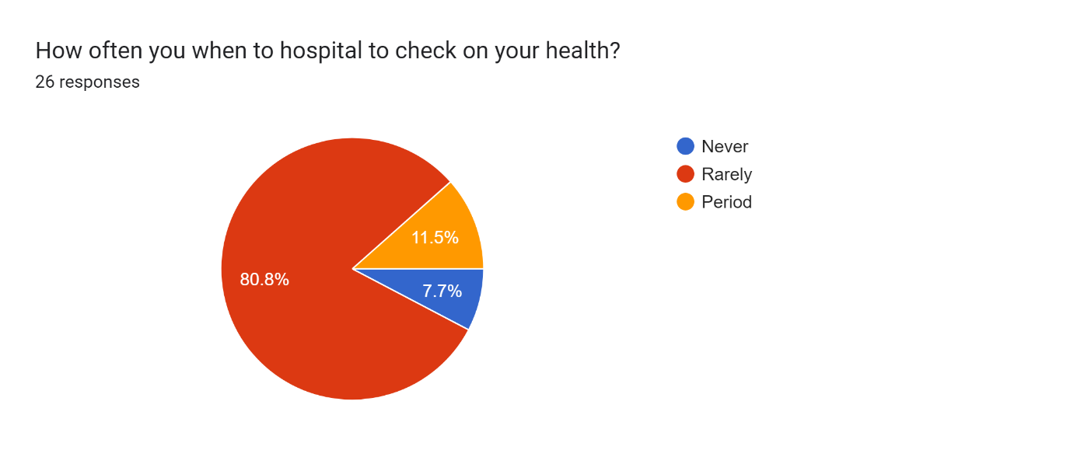

In this question, we find that survey participants rarely check their health. There were 7.7% never had a health check, 11.5% of the total was a moderate health check. The remaining 80.08% are rarely health checkups. These numbers are truly disturbing. People may have underlying illnesses that need to be discovered early. Subjective habits will bring bad things to health. So in the next question we will help participants approach the topic.

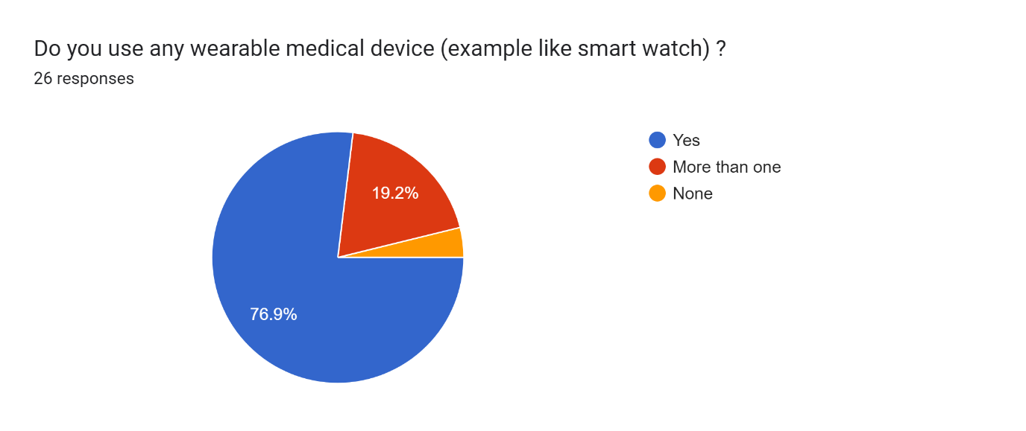

In this question, we want people to know what the survey is about. We obtained 76.9% of participants who owned at least one wearable medical device. 19.2% of people admit to owning two or more wearable medical devices. The very few remaining said that they do not own such a device at all. Through the results of this question, we conclude that wearable medical devices are very popular items, almost everyone has them. That makes our research easier and more accurate.

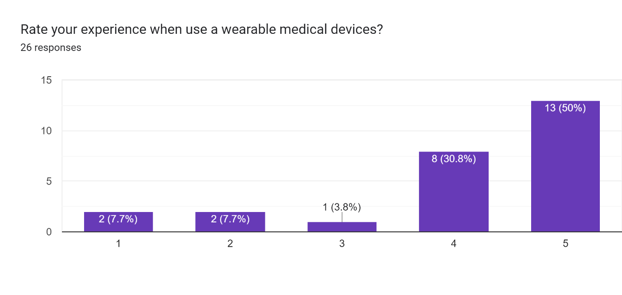

Users claim that their experience when owning these devices is extremely good. Up to half rated 5 degrees of satisfaction, and at the same time 30.8% rated it at 4. That means that wearable medical devices are extremely convenient and fun to use.

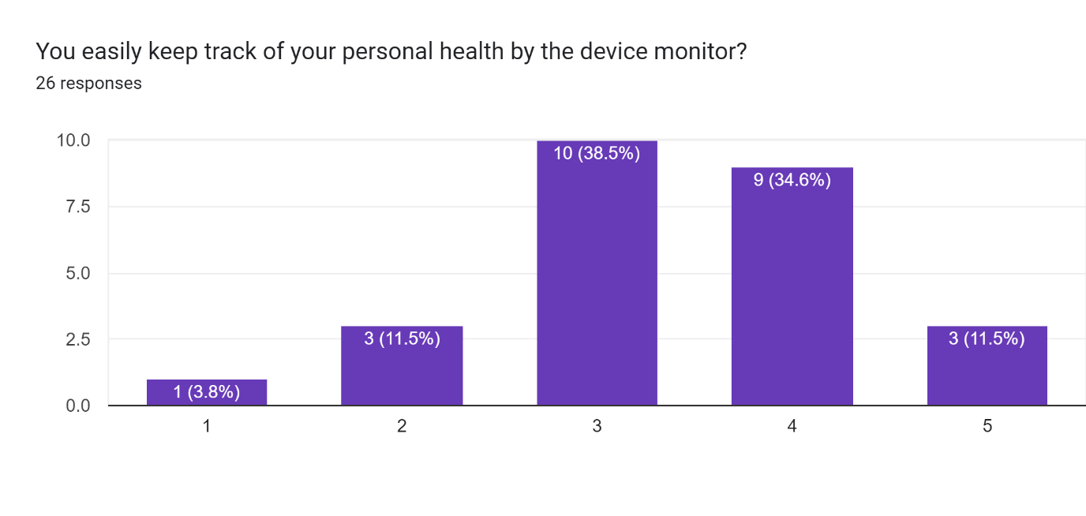

Different from the experience when using, when we ask more deeply about the accessibility of information when using wearable medical devices. It seems that because there is a lot of information, everyone's ability to access the necessary information is different. Through this question, we see that these electronic devices need to be further improved to be suitable for everyone.

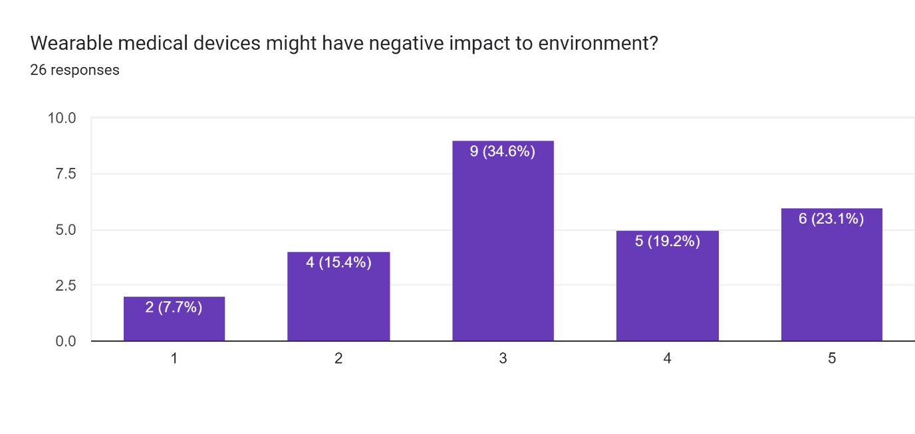

Move on to questions about the impact of suspended medical devices on the environment. 34.6% of the total chose neutral. At agreement levels 4 and 5, there is a total of 42.3%. The rest are a minority who think that these devices are not necessarily harmful to the environment.

This statistic shows that many people have not really thought much about this issue. Most people consider these devices to have an adverse effect on the environment. That's true because every time we upgrade technology, the old technology is thrown away. And the amount of waste at that time will increase and cause environmental pollution.

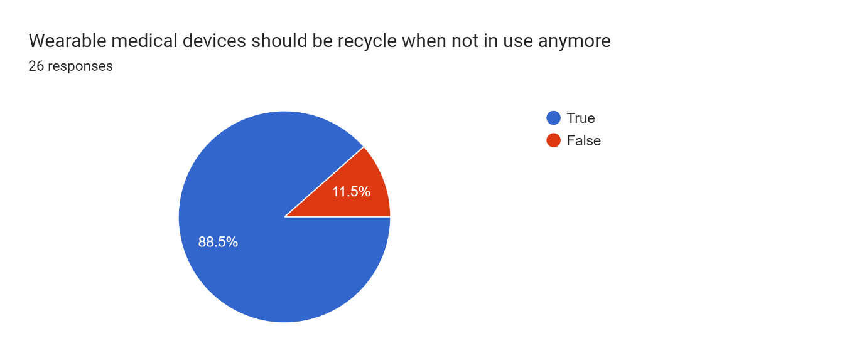

In this simple question, up to 88.5% of people think that recycling these devices is necessary. The remaining 11.5% means no. The fact that most people have good sense will bring a lot of good benefits to the community.

Especially in terms of the environment, we have had to deal with so many problems. It is extremely necessary for young people to be propagated about measures to help improve the natural environment instead of exploiting and destroying it.

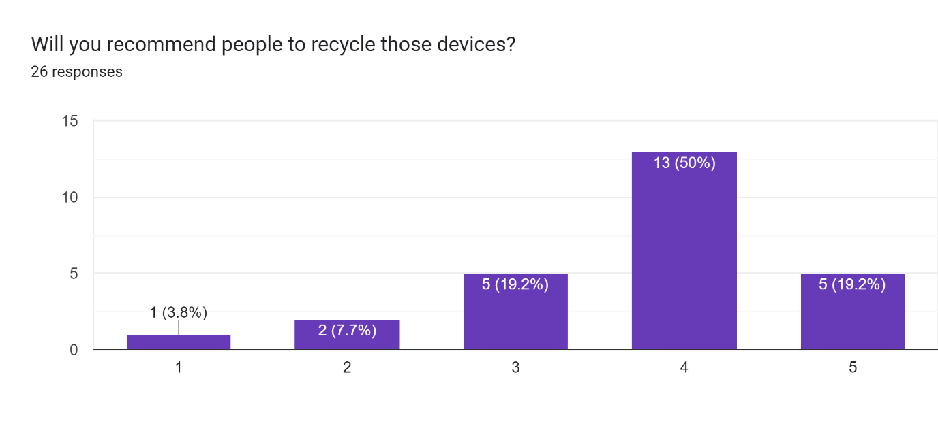

In the last question, half of the respondents chose level 4 as agreeing to refer others to recycle worn medical devices that are no longer in use. 19.2% at level 5 and at the same time level 3; the remaining few are in 1 and 2.

With this question we learned more about the importance of recycling discarded electromagnetic devices. The act of spreading the word about the importance of recycling these devices is beautiful. We welcome everyone who participates in the survey to have positive and correct thoughts.

With this set of questions, we have researched and answered more questions that we have posed.

## IV.3. Justification the hypothesis with primary research

* Should people use wearable medical devices?

Through interview, we learn that not just people should use wearable medical device, but also for elder users, it’s a need. Participants opened up us more about the possibilities and applications of these devices with the elderly. In addition, these devices also help young people set goals to exercise their own health.

* Do wearable medical devices have bad impact on environment?

With our survey, we learned that wearing medical devices after being discontinued will bring negative effects to the environment. Therefore, with a large number of people agreeing that we all need to responsibly recycle these electromagnetic devices in order to be able to protect the environment. What we learned from this even surpassed our hypothesis and our expectations.

## IV.4. Recommendations

It's a pity we only took a short time to prepare for this project, but if we could get more data, then everything would be more accurate.

In addition, if possible, we would like to exploit more types of information. We can expand the survey more. For example, interviewing older people.

If possible, we also want to interview experts in both health and technology to learn more from them about their experiences and research. That helps our research have deeper development directions and exploit more of this topic.

We should go to hospitals where we can directly observe doctors taking care of patients through wearable medical devices. Actual observations will give us an overview of what these devices bring to the medical field.

# Research Proposal Form

Student name: Mai T. Duc

Centre name: The

Student number: GCH200681

Date: 15/12/2022

Tutor: Nguyen The Lam Tung

Unit: GCH0907

Proposal title: Wearable Medical Devices impact on human life and environment

|  |
| --- |
| **Section One: Title, objective, responsibilities** |
| Title or working title of research project:  Wearable Medical Devices impact on human life and environment  Research project objectives:   * What is wearable medical device? * What are wearable medical devices used for? * What advantages do wearable medical devices offer? * Should people use wearable medical devices? * Do wearable medical devices have bad impact on environment? * How can we recycle wearable medical devices? |
| **Section Two: Reasons for choosing this research project** |
| Reasons for choosing the project:  The main topic is to research around digital transformation. Because of that, I think medical is a hot area to search about, especially smart wearable devices. Those devices have help people get track of their health accuracy without go to the hospital rapidly. Further more, it helps hospital gather information of client health research for science purpose. |
| **Section Three: Literature source searched** |
| 1. <https://www.scribbr.com/methodology/qualitative-research> 2. [www.scribbr.com/methodology/quantitative-research](http://www.scribbr.com/methodology/quantitative-research) 3. <https://www.formpl.us/blog/secondary-research> 4. <https://www.scribbr.com/methodology/interviews-research/> 5. <https://www.insiderintelligence.com/insights/wearable-technology-healthcare-medical-devices/> 6. owl.purdue.edu/owl/research_and_citation/conducting_research/conducting_primary_research/index.html 7. <https://www.questionpro.com/blog/primary-research/> 8. <https://www.questionpro.com/blog/qualitative-research-methods/> 9. <https://www.questionpro.com/blog/quantitative-research/> 10. <https://www.questionpro.com/blog/secondary-research/> 11. <https://www.studysmarter.co.uk/explanations/english/research-and-composition/research-process/> 12. sterlingmedicaldevices.com/thought-leadership/wearable-technology-in-healthcare/ 13. https://library.soton.ac.uk/sash/primary-research |
| **Section Four: Activities and timescales** |
| Activities to be carried out during the research project and likely duration:   1. Milestone one (16/11 – 21/11):  * Find topics for the research. * Evaluate those topics to choose one to research.  1. Milestone two (21/11 – 23/1):  * Review digital transforamtion and link to those topics last week. * Collect secondary research resource. * Evaluate those topics to choose one to research.  1. Milestone three (23/11 – 28/11):  * Collect secondary reseach resource. * Review and analyse those data.  1. Milestone four (28/11 – 30/11):  * Prepare plan. * Prepare research questions. * Collect data from secondary researches.  1. Milestone five (30/11 – 12/12):  * Preapre literature review. * Make primary research plan.  1. Milestone six (12/12 – 14/12):  * Prepare chart to justify the data.  1. Milestone seven (2/12 – 15/12):  * Finish report for assignment 1.  1. Milestone eight (15/12 – 17/12):  * Finish report for assignment 2.  1. Milestone nine (17/12 – 19/12 – 21/12):  * Presentation for the research. |
| **Section Five: Research approach and methodologies** |
| Type of research approach and methodologies you are likely to use, and reasons for your choice:   * Research process: sequential research. * Research classes: quanlitative and quantitative. * Research methods: interview, survey.   What your areas of research will cover:  Wearable Medical Devices impact on human life and environment. Our research will take place in Hanoi and we want to find out how those devices impact on society. Furthermore, we likely want to know the way to reduce negative impact of it to environment. |
| **Comment and agreement from tutor** |
| Comments (optional):  I confirm that the project is not work which has been or will be submitted for another qualification and is appropriate.  Agreed: ....................................................................................  (Name) ....................................................................................  (Date) ...................................................... |
| **Comment and agreement from project proposal checker (if applicable)** |
| Comments (optional):  I confirm that the project is appropriate.  Agreed: ....................................................................................  (Name) ....................................................................................  (Date) ...................................................... |

# Research Ethics Approval Form

|  |
| --- |
| **Section One: Basic details**  Project title: Wearable Medical Devices impact on human life and environment  Student name: Mai The Duc  Student number: GCH200681  Programme: BTEC Level 5 HND Diploma in Computing  School: Greenwich University Hanoi  Intended research start date: 2/12/2022  Intended research end date: 15/12/2022 |
| Section Two: Project summary  Please select all research methods that you plan to use as part of your project:  • Interviews ☑  • Questionnaires □  • Observations □  • Use of personal records □  • Data analysis ☑  • Action research □  • Focus groups □  • Other (please specify): .................................................................................................................................................. |
| **Section Three: Participants**  Please answer the following questions, giving full details where necessary.  Will your research involve human participants?  Yes  Who are the participants? Tick all that apply:  Children aged 12–16: □  Young people aged 17–18: ☑  Adults: ☑  How will participants be recruited (identified and approached)?  We went to some famous university in Hanoi and interview randomly.  Describe the processes you will use to inform participants about what you are doing:  When I approach them, first step is being nice and friendly. After that, ask them do they want to take an interview about wearable medical devices.  How will you obtain consent from participants?  I feel easily obtain consent from participants. Just ask properly and everything will be done.    Will this be written?  I did take note when interview.  How will it be made clear to participants that they may withdraw consent to participate at any time?  Right from the start of the conversation.  Studies involving questionnaires:  Will participants be given the option of omitting questions they do not wish to answer?  Yes: ☑ No: □  If No please explain why below and ensure that you cover any ethical issues arising from this:  Studies involving observation:  Confirm whether participants will be asked for their informed consent to be observed.  Yes: ☑   No: □  Will you debrief participants at the end of their participation (i.e. give them a brief explanation of the study)?  Yes: ☑   No: □  Will participants be given information about the findings of your study? (This could be a brief summary of your findings in general.)  Yes: ☑   No: □ |
| **Section Four: Data storage and security**  Confirm that all personal data will be stored and processed in compliance with the Data Protection Act (1998):  Yes: ☑  No: □  Who will have access to the data and personal information?  Only me.  **During the research:**  Where will the data be stored?  In my cell phone, PC, and laptop. Also, I did backup data on cloud too.  Will mobile devices (such as USB storage and laptops) be used?  Yes: ☑  No: □  If yes, please provide further details:  In my cell phone, PC, and laptop. Also, I did backup data on cloud too.  **After the research:**  Where will the data be stored?  There still be store on the cloud.  How long will the data and records be kept for and in what format?  Until the research is finally finish, it still be save on the cloud.  Will data be kept for use by other researchers?  Yes: □  No: ☑ |
| **Section Five: Ethical issues**  Are there any particular features of your proposed work which may raise ethical concerns?  No |
| **Section Six: Declaration**  I have read, understood and will abide by Research Ethics Policy:  Yes: ☑  No: □  I have discussed the ethical issues relating to my research with my Unit Tutor:  Yes: ☑  No: □  **I confirm that to the best of my knowledge:**  The above information is correct and that this is a full description of the ethics issues that may arise in the course of my research.  Name: Mai The Duc  Date: 15/12/2022  **Please submit your completed form to:** .............................................................................................................................................................. |

# References

Bhandari, P., 2022. *What Is Qualitative Research? | Methods & Examples.* [Online]   
Available at: https://www.scribbr.com/methodology/qualitative-research  
[Accessed 11 December 2022].

Bhandari, P., 2022. *What Is Quantitative Research? | Definition, Uses & Methods.* [Online]   
Available at: www.scribbr.com/methodology/quantitative-research  
[Accessed 11 December 2022].

Formplus Blog, 2022. *What is Secondary Research? + [Methods & Examples].* [Online]   
Available at: https://www.formpl.us/blog/secondary-research  
[Accessed 11 December 2022].

George, T., 2022. *Types of Interviews in Research | Guide & Examples.* [Online]   
Available at: https://www.scribbr.com/methodology/interviews-research/  
[Accessed 11 December 2022].

Phaneuf, A., 2022. *Latest trends in medical monitoring devices and wearable health technology.* [Online]   
Available at: https://www.insiderintelligence.com/insights/wearable-technology-healthcare-medical-devices/  
[Accessed 11 December 2022].

Purdue University, 2022. *What is Primary Research and How do I get Started?.* [Online]   
Available at: owl.purdue.edu/owl/research_and_citation/conducting_research/conducting_primary_research/index.html  
[Accessed 11 December 2022].

QuestionPro, 2022. *Primary Research: What It Is, Methods & Purposes.* [Online]   
Available at: https://www.questionpro.com/blog/primary-research/  
[Accessed 11 December 2022].

QuestionPro, 2022. *Qualitative Research Methods: Definition, Types & Examples.* [Online]   
Available at: https://www.questionpro.com/blog/qualitative-research-methods/  
[Accessed 11 December 2022].

QuestionPro, 2022. *Quantitative Research: What it is, Tips & Examples.* [Online]   
Available at: https://www.questionpro.com/blog/quantitative-research/  
[Accessed 11 December 2022].

QuestionPro, 2022. *Secondary Research – Definition, Methods and Examples..* [Online]   
Available at: https://www.questionpro.com/blog/secondary-research/  
[Accessed 11 December 2022].

StudySmarter, 2019. *Research Process.* [Online]   
Available at: https://www.studysmarter.co.uk/explanations/english/research-and-composition/research-process/  
[Accessed 11 December 2022].

Tan, J., 2022. *Wearable Technology in Healthcare.* [Online]   
Available at: sterlingmedicaldevices.com/thought-leadership/wearable-technology-in-healthcare/  
[Accessed 11 December 2022].

University of Southampton, 2022. *Primary research.* [Online]   
Available at: https://library.soton.ac.uk/sash/primary-research  
[Accessed 11 December 2022].