 | Author | Publisher | Date | Price | Image | Description
Sherlock Holmes | Arthur Conan Doyle | Literary publishers | 1887 | 20$/Full episodes |  | Referring to himself as a "consulting detective" in stories, Holmes is known for his excellent powers of observation, deduction, forensic science, and logical deduction, elements of which he applies when investigating. cases of a variety of clients, including Scotland Yard.
Death on the Nile | Agatha Christie | Collins Crime Club | 1/11/1937 | 15$/Episodes |  | The work is about a murder that happened on a cruise ship on the Nile while detective Hercule Poirot was on vacation in Egypt. This is one of Agatha Christie's most beloved novels, which has been adapted into plays and movies many times.
The Silence of the Lambs | Thomas Harris | ST. Martin’s Press | 19/5/1998 | 17$/Episodes | 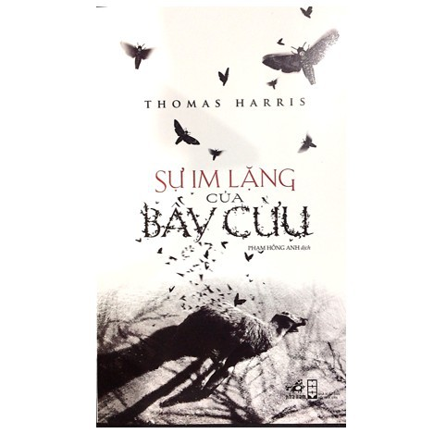 | The Silence of the Lambs is the story of a tense mind battle between FBI police woman Clarice Starling and cannibal doctor Hannibal Lecter. In order to find clues to the case of kidnapping the senator's daughter, Starling has to go to the Tri Vien Nursing Home to get information about the case.
Inferno | Dan Brown | Doubleday | 14/5/2013 | 18$/Episodes | 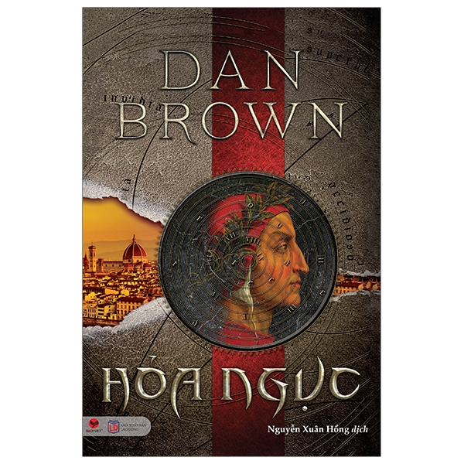 | The opening story is a bit confusing when the professor wakes up in an unfamiliar hospital and has almost lost all memories of the past few days. And at that time, he also had to immediately run away from a series of pursuers without knowing the reason. Still a familiar motif in our previous works, but we never seem to get bored, but on the contrary, we always anxiously follow each cleverly deciphered puzzle, code, and symbol. .
The Da Vinci Code | Dan Brown | Doubleday Fiction | 2003 | 19$/Episodes | 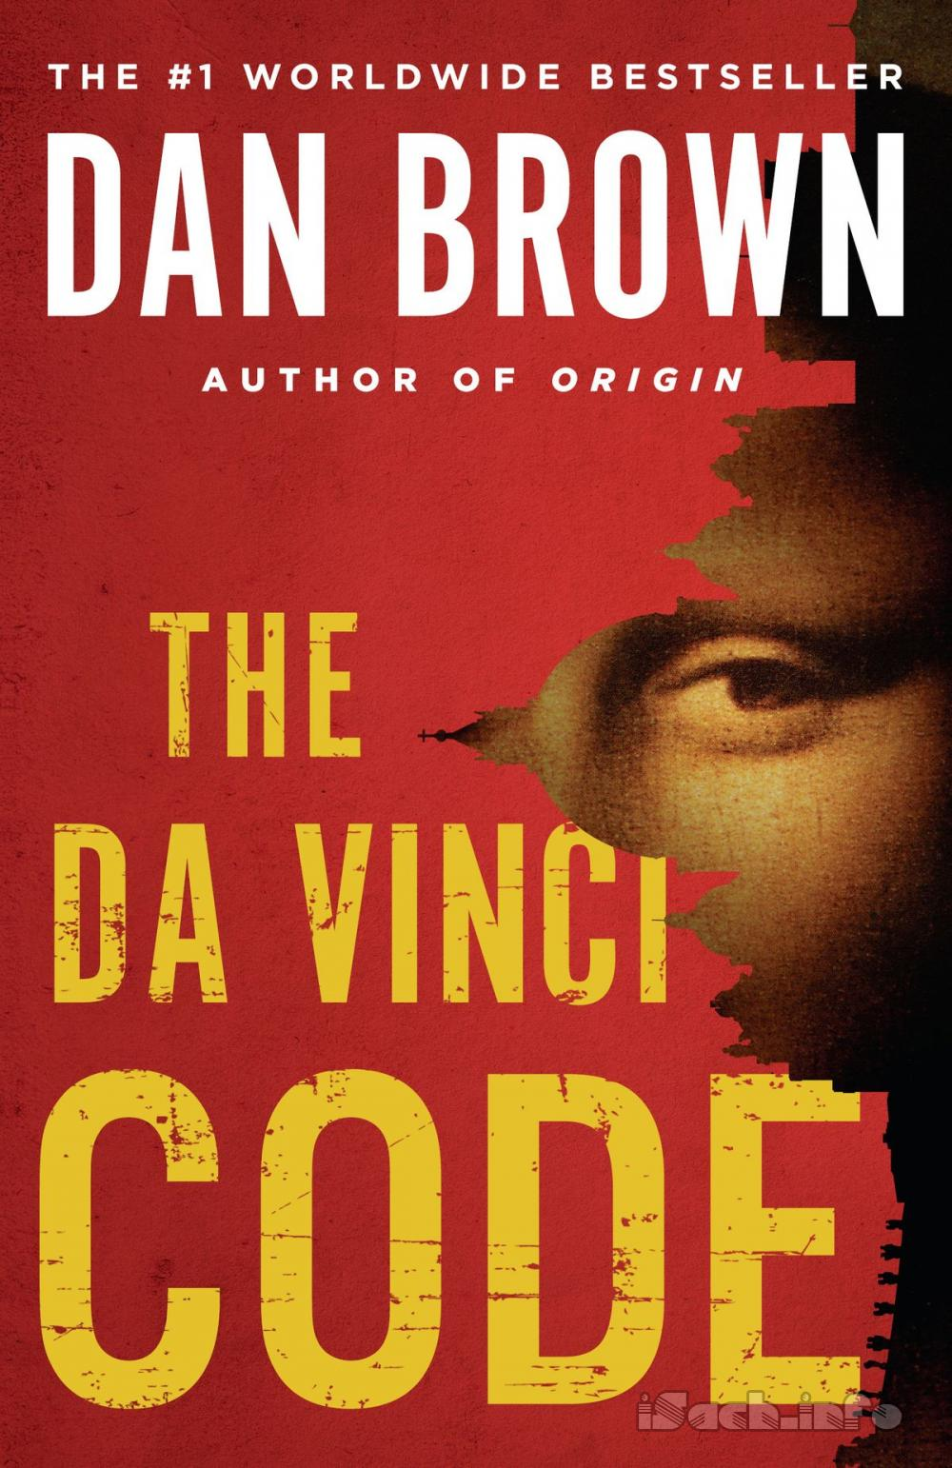 | The plot of the novel tells about the conspiracy of the Catholic Church to hide the truth about Jesus. The story implies that the Holy See of Rome knew about this plot for two thousand years, but still kept it a secret to maintain its power. Upon its publication, the novel strongly aroused curiosity around the world to find out the truth about the Legend of the Holy Grail, and Mary Magdalene's role in the history of the Catholic Church.

