**FPT ACADEMY INTERNATIONAL**



**FPT – APTECH COMPUTER EDUCATION**

**Organic Food**

|  |  |  |
| --- | --- | --- |
| **Supervis**  **or.** | **Lê Mộng Thúy** | |
| **Batch.** | **T1.2108.A0** | |
| **Group.** | **4** | |
| **Serial No.** | **Student Name** | **Enrollment Number** |
| **1** | **Nguyễn Đình Đức** | Student1331704 |
| **2** | **Đào Đức Minh** | Student1331703 |
| **3** | **Huỳnh Thị Xuân Mai** | Student1331706 |
| **4** | **Trần Văn Lưu** | Student1328507 |
| **5** | **Trịnh Lê Minh Thái** | Student1287967 |

Month 06 Year 2022

CONTENT

REVIEW 1 3

ACKNOWLEDGE 3

INTRODUCTION 3

PROBLEM DEFINITION 4

CUSTOMER'S REQUIREMENTS SPECIFICATIONS (CRS) 4

CLIENT: 4

TASK SHEET REVIEW 1 8

REVIEW 2 10

1. USECASE 10
2. DATA FLOW DIAGRAM (DFD) 39
3. ENTITY PROPERTIES 50
4. TABLE DESIGN 67
5. TASK SHEET REVIEW 2 77

REVIEW 3 78

* SITE MAP 79
* ORGANIC FOOD STORE WIREFRAME 81
* ORGANIC FOOD STORE SCREENSHOT 91
* Task sheet review 3 104

# REVIEW 1

## ACKNOWLEDGE

Our group would like to devote this chapter to express our sincere appreciation to all those who offered us valuable assistance during in carrying out this Project.

Firstly, we owe a debt of gratitude to our dedicated instructor, MS. Le Mong Thuy, whose suggestions and encouragement helped us to overcome not only technological challenges but also psychological tension. Without him, our work could not complete successfully.

Secondly, we highly appreciate the Project Team at the Head Office, which has provided us an excellent opportunity to apply what we learned into practice. We are certain that the experiences we gained from this project will facilitate our future career greatly.

Thirdly, we would also like to express my gratitude to all the staff members of my center for not only providing me with the opportunity to work with them on this project, but also for their support and encouragement throughout the process.

Finally yet importantly, we wish to say a personal thank you to all our dear classmates and team members who are always willing to support us openly and enthusiastically.

## INTRODUCTION

Organic production is an overall system of farm management and food production that aims at sustainable agriculture, high-quality products and the use of processes that do not harm neither the environment, nor human, plant or animal health and welfare.

consumers are anxious about food quality, production teachniques and provenance and they trust organic foods more easily. The food-related decision-making process is complex and is influenced by many determinants:

* + economic: cost, income, availability;
  + physical: accessibility, education, skills;
  + social: culture, family, and meal patterns;
  + psychological: mood, stress, guilt
  + personal: attitudes, beliefs, knowledge

To help consumers make an informed choice, our team have developed an online store where the consumers don’t need to waste much time to make a choice.It will provide its user the following features:

* Unregistered consumers who can register member account.
* Registered consumers can login and manage their account.
* consumers can search any products such as etc.
* consumers can search products by price.
* consumers can see products’ introduction before buying
* consumers can buy products after adding products to cart.
* consumers can view cart history and make change.
* consumers can check out.
* consumers can review order history.
* consumers can interact with website by giving question, feedback on contact us function.



## PROBLEM DEFINITION

After analyzing the project specifications of Organic Food, to fulfill customer’s requirements properly, we came to conclusion that in order to achieve the best result, we should deal with following queries:

**FROM THE VIEW POINT OF consumers**

* + A homepage will show the main products, suitable logo, display the logo on all the pages in the site.
  + A navigation header and footer that will include all the functions implemented in the website.
  + consumers can buy products, add product to cart, view cart and check out.
  + Registered consumers can login to their profile, view order history and receive email promotion/Coupon.

**FROM THE VIEW POINT OF THE ADMINISTRATOR**

* + A login page will grant access to Organic Food admin.
  + Admin can view, add, update, delete and manage products.
  + Admin can view, update, delete, find, lock, and unlock consumers account.
  + Admin can update, delete and manage orders.
  + Admin can update, or delete and manage registered user account.
  + Admin can manage and send newsletter.

**CUSTOMER'S REQUIREMENTS SPECIFICATIONS (CRS) CLIENT: Organic Food BUSINESS/PROJECT OBJECTIVE:**

The project is to design an online website for advertising and selling all types of organic food, for instance: vegetables, dairy, fruit, bakery, etc.

**INPUT TO THE SYSTEM:**

**Organic Food administrators need to provide:**

* + Information required in order to create an account to access the admin system.
  + Products are going to be shown on the website.
  + Payment Method and Shipping cost when ordering certain products.
  + Information required to create staff account within admin system.

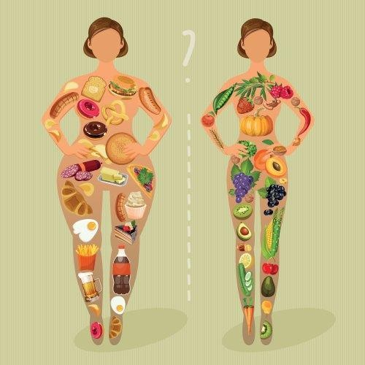◆

**Customers Organic Food need to provide:**

* + Personal information to buy products.
  + Email information to receive weekly promotion or deal and coupon.

**OUTPUT FROM THE SYSTEM:**

**Organic Food administrators will be able to:**

* + Login/Logout to the admin system.
  + Manage (view, add, update, delete, hidden) products, price.
  + Manage (view, add, update, delete, find, lock, unlock) consumers account.
  + Manage (view, add, update, delete) news.
  + Manage (view, add, update) products, order.

**Organic Food consumers will be able to:**

* + Register consumers' accounts.
  + Buy products after adding information.
  + View products that they have chosen.
  + View order history.

**Organic Food consumers will be able to:**

* + Register account.
  + Login/Logout to the account.
  + Search products they want to buy by name, price.
  + Add product to cart and checkout.
  + View purchase history.

**SCOPE OF WORK**

The application should perform the following functions:

**LOGIN:**

* + There are 3 types of accounts in the application (“admin”). Administrator will login as “admin”. Staff will login as “staff”. “Viewer” will login as “inspector”
  + For “admin”: can view the products id, name, add new, update, delete.
  + For “admin”: can view the consumers id, name, add new, update, delete, lock, unlock.
  + For “admin”: can view and manage view.
  + For “admin”: can view and manage order.
  + For “staff” : can perform the same function as admin but will be restricted to View, Add New, Update info

**ORDERING PRODUCTS:**

* + When consumers choose a product and the selected product will be added to the cart.
  + consumers can buy products at shopping cart after pressing the “Checkout” button and fill in the information.

**DATABASE:**

* + The information about products, consumers , news, orders will be stored in the database.
  + The information from the contact us page.

**HARDWARE/ SOFTWARE REQUIREMENTS:**

**HARDWARE**

**Web Server**

|  |  |
| --- | --- |
| **Processor** | Intel Core I7 or higher. |
| **Memory** | 32 GB RAM or greater. |
| **Modem/ADSL** | Internet access is required. |

**Client**

|  |  |
| --- | --- |
| **Processor** | Intel Core I5 or higher. |
| **Memory** | 8 GB RAM or greater. |
| **Monitor** | Super VGA (1024x768) or higher resolution. |
| **Modem/ADSL** | Internet access is required. |

**SOFTWARE**

**Web Server**

|  |  |
| --- | --- |
| **Operation System** | Window 7 or later. |
| **Browser** | Google Chrome version 35. |
| **Database** | MySQL. |
| **Software** | Internet Information Service |
| PHP - Laravel framework |

**Client**

|  |  |
| --- | --- |
| **Operation System** | Window 7 or higher. |
| **Browser** | Google Chrome version 35. |

**DEVELOPMENT SOFTWARE**

* + Microsoft Windows 10.
  + MySQL.
  + Visual Studio Code.
  + Google Chrome.
  + XAMPP.

**TECHNOLOGY**

* + PHP - Laravel framework.
  + JQuery.
  + Javascript.
  + HTML/CSS/Bootstrap.

## TASK SHEET REVIEW 1

|  |  |  |  |  |  |  |  |
| --- | --- | --- | --- | --- | --- | --- | --- |
| **Project: Organic Food** | | **Project Name** | **Activity Plan**  **Prepare d By** | **Date of Preparation of Activity Plan:** | | | |
| **Sr./No.** | **Task** | **Actual Start Date** | **Actual Days** | **Team member**  **name** | **Status** |
| **1** | **Acknowledgment** | **Organic food** | Nguyễn Đình  Đức | 03-June  -22 | 1 | Đức/Mai | Completed |
| **2** | **Introduction** | 03-June  - 22 | 1 | Minh/Mai/ Lưu | Completed |
| **3** | **Problem Definition** | 03-June  - 22 | 1 | Đức/Phong Minh | Completed |
| **4** | **Customer**  **Requirement Specification (CRS)** | 03-June  - 22 | 1 | Đức/Minh  /Mai/Lưu/ Phong | Completed |

|  |  |  |  |  |  |  |  |
| --- | --- | --- | --- | --- | --- | --- | --- |
|  |  |  |  |  |  |  |  |

|  |  |  |  |  |  |  |  |  |  |
| --- | --- | --- | --- | --- | --- | --- | --- | --- | --- |
| **5** | **Scope of Work** |  |  | | 03-June  - 22 | 1 | Đức/Minh  /Lưu/ Phong | Completed | |
| **6** | **Hardware/Softwa re Requirement** | 03-June  - 22 | 1 | Đức/Phong Lưu | Completed | |
| **7** | **Task Sheet** | 03-June  - 22 | 1 | Mai | Completed | |
| Date: 03-June-22 | | | | | | | | |  |
| **Signature of Instructor:**  **Ms. LE MONG THUY** | | | | **Signature of Team Leader:**  **NGUYỄN ĐÌNH ĐỨC** | | | | |  |

# REVIEW 2

## USE CASE



**customer**

**LOGIN AS customer:**

|  |  |  |
| --- | --- | --- |
| **Author** |  | |
| **Use Case Name** | Login | |
| **Actors** | Customer | |
| **Description** | Customer who has registered an account can login | |
| **Requirements** | Customer provides username and password | |
| **Pre-conditions** | consumers must register an account | |
| **Post-conditions** | Success: consumers is logged in to website | |
| Fail: Refill information | |
| **Basic flow** | **Actor’s actions:** | **System’s responses:** |
| 1. consumers clicks ‘Login’ button on Home  Page.  3. Actor inputs Email and Password, then click the ‘Login’ button. | 2. System redirects to Login Page with the following controls:   * “Email” text field * “Password” text field * “Login” button  1. System checks the information. 2. System redirects to Customer’s dashboard. |
| **Exceptions** | **Actor’s actions:** | **System’s responses:** |
| 1. Actor inputs invalid email and passwor  d. | System redirects to Login page with the following controls:  - “Email” text field |

|  |  |  |
| --- | --- | --- |
|  |  | * “Password” text field * “Login” button   System shows message: “Invalid email and password”. |

**REGISTER AS customer:**

|  |  |  |
| --- | --- | --- |
| **Author** |  | |
| **Use Case Name** | Register as customer | |
| **Actors** | Customer | |
| **Description** | Customer who has registered an account can login | |
| **Requirements** | Customer registers an account on the website and becomes a member | |
| **Pre-conditions** | Customer provides their register information | |
| **Post-conditions** | Success: consumers creates a User account in this website | |
| Fail: Refill information | |
|  | **Actor’s actions:** | **System’s responses:** |
|  | 1. consumers clicks “Register” button on  Home Page. | 2. System redirects to Register page and displays Registration form with the following controls: |
| **Basic flow** |  | - “Username” text field |
|  |  | - “Password” text field |
|  |  | - “Confirm Password” text field |
|  |  | - “Email” text field |

|  |  |  |
| --- | --- | --- |
|  | 3. consumers inputs register’s information and click “Register” button. | * “Phone” text field * “Register” button * “Reset” button  1. System validates the information. 2. System inserts the account into database 3. System show success message. |
| **Exceptions** | **Actor’s actions:** | **System’s responses:** |
| * Actor left “Username” text field blank. * Username has already existed. * Actor left “Password” text field blank. * Actor left “Confirm Password” text field blank. * Password and confirm password don’t match. * Actor left “Email” text field blank. * Email has already existed. * Actor left “Phone” text field blank. * Input phone is not numeric format or phone length is not between 8 and 14 characters. * Actor left “Email” text field blank or input an invalid email address. | System displays message to customer:   * “Username cannot be blank”. * “This Username has already existed”. * “Password cannot be blank”. * “Confirm Password cannot be blank”. * “Confirm Password does not match password.”. * “Email cannot be blank”. * “This Email has already existed”. * “Phone cannot be blank”. * “The phone number should be numeric only and must be between 8 and 14 digits”. * “Email is invalid”. |

**SEARCH PRODUCTS:**

|  |  |  |
| --- | --- | --- |
| **Author** |  | |
| **Use case name** | Search product | |
| **Actors** | Registered Customer/ New Customer | |
| **Description** | Customer can search product | |
| **Requirements** | Customer provides search phrase | |
| **Pre-conditions** | N/A | |
| **Post-conditions** | Success: Show product that matches search phrase | |
| Fail: No product is shown | |
| **Basic flow** | **Actor’s actions:** | **System’s responses:** |
| 1. Actor inputs search phrase.  3. Actor clicks product’s name in list or view every product that matches search phrase. | 2. System shows list of products that match the search phrase. |

**VIEW PRODUCT DETAIL:**

|  |  |
| --- | --- |
| **Author** |  |
| **Use case name** | View product |
| **Actors** | Registered Customer/ New Customer |
| **Description** | Customer can view product detail |

|  |  |  |
| --- | --- | --- |
| **Requirements** | Customer select product to show product’s detail | |
| **Pre-conditions** | N/A | |
| **Post-conditions** | Success: Display product detail matching the selected product | |
| Fail: No product is shown | |
| **Basic flow** | **Actor’s actions:** | **System’s responses:** |
| 1. Actor select product | 2. System shows product’s detail matching selected product |

**CREATE CART:**

|  |  |  |
| --- | --- | --- |
| **Author** |  | |
| **Use case name** | Create cart | |
| **Actors** | Registered customer | |
| **Description** | Customer can add product to their cart | |
| **Requirements** | Customer must choose at least one product | |
| **Pre-conditions** | Customer must log in before adding product | |
| **Post-conditions** | Success: Actor add product to cart successfully | |
| Fail: Refill information | |
| **Basic flow** | **Actor’s actions:** | **System’s responses:** |
| 1. Actor chooses a product and click “Add to cart”. | 2. System adds selected product to cart by id of this product. |

|  |  |  |
| --- | --- | --- |
| **Exceptions** | **Actor’s action** | **System’s response** |
| 1. Actor inputs more products than there are in stock. | 2. System shows messages:  - “Product out of stock”. |

**VIEW CART:**

|  |  |  |
| --- | --- | --- |
| **Author** |  | |
| **Use case name** | View cart | |
| **Actors** | Registered customer | |
| **Description** | Customer can view their cart | |
| **Requirements** | N/A | |
| **Pre-conditions** | Customer must log in before view cart | |
| **Post-conditions** | Success: Customer can view their cart | |
| Fail: Refill information | |
| **Basic flow** | **Actor’s actions:** | **System’s responses:** |
| 1. Actor click on “Cart” icon. | 2. System shows cart and added products. |
| **Alternative flow** | 1. Actor clicks “x”– Close button- on table  3. Actor change quantity of a product  5. Actor clicks “x” – close button – in the right side of each product. | 2. System redirects to current page.  4. System update quantity of this product into cart.  6. System removes this product from cart. |

**CHECKOUT:**

|  |  |  |
| --- | --- | --- |
| **Author** |  | |
| **Use case name** | Check out and Place order | |
| **Actors** | Registered customer | |
| **Description** | Customer can order products | |
| **Requirements** | Customer must has at least 1 product in cart | |
| **Pre-conditions** | Customer must log in before adding product | |
| **Post-conditions** | Success: Actor order successfully | |
| Fail: Refill information | |
| **Basic flow** | **Actor’s actions:** | **System’s responses:** |
| 1. Actor click “Add to cart” button or “Cart” icon.  3. Actor clicks “Check out with” button.   1. Actor inputs order information then click “Place Order” button. 2. Actor inputs Card owner’s name, card   number and security code if actor choose payment by credit card.  9. Actor views order’s status in Order page. | 2. System shows cart and added products.  4. System shows all products in cart with calculated total price and show following controls:   * “Customer name” text field. * “Phone” text field. * “Address” text field. * “Province” select box. * “Delivery time frame” select box. * “Payment” table. |

|  |  |  |
| --- | --- | --- |
|  |  | Systems shows Payment tab type according to type of payment actors choose. |

|  |  |  |
| --- | --- | --- |
|  |  | 1. System validates information. 2. System redirects to Order page and   show order’s status. |
| **Alternative flow** | 1. Actor clicks “x”– Close button- on table  3. Actor clicks “X” button on each product.  5. Actors clicks “Home” button. | 2. System redirects to cart page.  4. System removes product from cart.  6. System redirect to Home pages. |
| **Exceptions** | **Actor’s action** | **System’s response** |
| 1. Actor inputs more products than there are in stock. 2. Actor left “Billing name” text field blank. 3. Actor left “Address” text field blank. 4. Actor left “Delivery date” blank. 5. Actor left “Delivery time frame” blank. 6. Actor left “Payment” dropdown blank. 7. Actor inputs invalid card information. | 8. System shows messages:   * “Product out of stock”. * “Order name must not be blank”. “Address must not be blank”. “Must choose a delivery date”.   “Must choose a delivery time frame”.  “Must choose a payment method”. “Invalid card”. |

**VIEW ORDER HISTORY:**

|  |  |
| --- | --- |
| **Author** |  |
| **Use case name** | View order history |
| **Actors** | Registered customer |

|  |  |
| --- | --- |
| **Prepared by: All** | **Approved by: Lê Mộng** |

|  |  |
| --- | --- |
| **members** | **Thúy** |
| **Project Group No: 4** | **Version: 1.0** |

|  |  |  |
| --- | --- | --- |
| **Description** | Customer can view their order history | |
| **Requirements** | N/A | |
| **Pre-conditions** | Customer must log in to website | |
| **Post-conditions** | Success: Customer can view their order. | |
| Fail: Customer cannot see their order. | |
| **Basic flow** | **Actor’s actions:** | **System’s responses:** |
| 1. Actor chooses “Account” icon on Menu  3. Actor chooses “Purchase history” on  sides bar.  5. Actor selects the order that they want to view in “Purchase history” and clicks “View” Button. | 2. System redirects to Account page.  4. System redirects to “Purchase history” page and displays a list of existing orders and their status.   1. System validates inputs by id of Order. 2. System displays all order’s detail and its status. |

**CANCEL ORDER:**

|  |  |
| --- | --- |
| **Author** |  |
| **Use case name** | Cancel order |
| **Actors** | Registered customer |
| **Description** | Customer can cancel their order |
| **Requirements** | Customer provides order’s id to cancel |
| **Pre-conditions** | Customer must log in to website and only can cancel when this order has not been confirmed by admin |

|  |  |
| --- | --- |
| **Prepared by: All**  **members** | **Approved by: Lê Mộng**  **Thúy** |



|  |  |
| --- | --- |
| **Project Group No: 4** | **Version: 1.0** |

|  |  |  |
| --- | --- | --- |
| **Post-conditions** | Success: Cancel successfully. | |
| Fail: Order cannot cancel. | |
| **Basic flow** | **Actor’s actions:** | **System’s responses:** |
|  | 1. Actor chooses “Account” icon on Menu  3. Actor chooses “Purchase history” on sides bar. | 2. System redirects to Account page.  4. System redirects to “Purchase history” page and displays a list of existing orders. |
|  | 5. Actor selects the order that they want to cancel in “Purchase history” and clicks “Cancel” Button. | 6. System validates inputs by id of order. |
|  |  | 7. System change order status in database. |
|  |  | 8. System displays message: successful for error. |

**ADMIN**

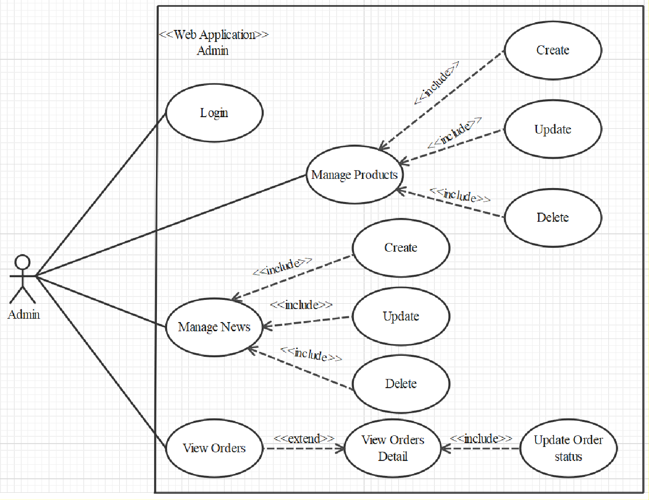

**LOGIN**

|  |  |
| --- | --- |
| **Author** |  |
| **Use case name** | Login |
| **Actor** | Admin |

|  |  |
| --- | --- |
| **Prepared by: All**  **members** | **Approved by: Lê Mộng**  **Thúy** |
| **Project Group No: 4** | **Version: 1.0** |

|  |  |  |
| --- | --- | --- |
| **Description** | When admin wants to manage products, news, views orders and orders detail | |
| **Requirements** | Admin provides username and password | |
| **Pre-conditions** | Admin must be exist on database | |
| **Post-conditions** | Success: Admin is logged in to website admin | |
| Fail: refill information | |
| **Basic flow** | **Actor’s actions:** | **System’s responses:** |
| 1. Actor clicks on ‘Login’ button.  3. Actor inputs Email and Password, then click the ‘Login’ button. | 2. System redirects to Login Page with the following controls:   * 'Email' text field * 'Password' text field * 'Login' button  1. System validates the information. 2. System redirects to Admin website |
| **Exceptions** | **Actor’s actions:** | **System’s responses:** |
| 1. Actor inputs invalid email and password | System redirects to Login page with the following controls:   * ‘Email’ text field * ‘Password’ text field * ‘Login’ button. |

|  |  |
| --- | --- |
| **Prepared by: All**  **members** | **Approved by: Lê Mộng**  **Thúy** |



|  |  |
| --- | --- |
| **Project Group No: 4** | **Version: 1.0** |

**PRODUCTS**

* + - 1. Create new Product

|  |  |  |
| --- | --- | --- |
| **Author** |  | |
| **Use case name** | Create new product | |
| **Actor** | Admin | |
| **Description** | When admin wants to create a new product | |
| **Requirements** | Actor provides product’s information | |
| **Pre-conditions** | Actor is logged in admin | |
| **Post-conditions** | Success: new product is added into the database | |
| Fail: refill information | |
|  | **Actor’s actions:** | **System’s responses:** |
|  |  | 2. System redirects to ‘Product’ page |
|  |  | and display a list of existing product. |
|  | 1. Actor chooses Product Tab on |  |
|  | menu. |  |
|  | 3. Actor clicks ‘Add New Product’ button. | 4. System displays a form with the following fields: |
|  |  | - id |
|  | 5. Actor inputs information to create |  |
|  | new product | - category_id |
| **Basic flow** |  | - sale_id |
|  |  | - name |
|  |  | - name_slug |
|  |  | - description |

|  |  |  |
| --- | --- | --- |
|  |  | - price |

|  |  |  |
| --- | --- | --- |
|  |  | * view_count * quantity * active * detail * image  1. System validates inputs. 2. System adds product into database. 3. System displays confirmation message or error message. |

* + - 1. Update Product

|  |  |  |
| --- | --- | --- |
| **Author** |  | |
| **Use case name** | Update product’s detail | |
| **Actor** | Admin | |
| **Description** | When admin wants to update product | |
| **Requirements** | Admin provides product’s information | |
| **Pre-conditions** | Actor is logged in admin | |
| **Post-conditions** | Success: product is updated in the database | |
| Fail: refill information | |
|  | **Actor’s actions:** | **System’s responses:** |

|  |  |  |
| --- | --- | --- |
|  | 1. Actor chooses Product Tab on | 2. System redirects to ‘Product |
| menu. | Details’ |
|  | page and display a list of |
|  | existing |

|  |  |  |
| --- | --- | --- |
|  | 3. Actor clicks on ‘View Details’ on a product. | product.  4. System displays a form with the following fields.   * category_id * sale_id * name * name_slug * description * price * view_count * quantity * active * detail * image  1. System validates inputs. 2. System update product into database. 3. System displays confirmation message or error message. 4. System redirects to product’s detail   page. |
|  | 5. Actor chooses the criteria they want to update and input information. |
| **Basic flow** |  |

* + - 1. Delete Product

|  |  |
| --- | --- |
| **Author** |  |
| **Use case name** | Delete Product |

|  |  |
| --- | --- |
| **Prepared by: All** | **Approved by: Lê Mộng** |

|  |  |
| --- | --- |
| **members** | **Thúy** |
| **Project Group No: 1** | **Version: 1.0** |

|  |  |  |
| --- | --- | --- |
| **Actor** | Admin | |
| **Description** | When admin wants to delete product from the database | |
| **Requirements** | Admin provides product’s information | |
| **Pre-conditions** | Actor is logged in admin | |
| **Post-conditions** | Success: product is delete in the database | |
| Fail: product is not delete from the database | |
| **Basic flow** | **Actor’s actions:** | **System’s responses:** |
| 1. Actor chooses Product Tab on menu.  3. Actor clicks ‘Delete’ button. | 2. System redirects to ‘Product List’ page and display a list of existing product.   1. System delete product in the database 2. System displays confirmation or error. |

**MANAGE**

**CREATE NEW MANAGE**

|  |  |
| --- | --- |
| **Author** |  |
| **Use case name** | Create News |
| **Actor** | Admin |
| **Description** | When admin wants to create a News |

|  |  |
| --- | --- |
| **Prepared by: All members** | **Approved by: Lê Mộng Thúy** |



|  |  |
| --- | --- |
| **Project Group No: 4** | **Version: 1.0** |

|  |  |  |
| --- | --- | --- |
| **Requirements** | Admin provides New content | |
| **Pre-conditions** | Actor is logged in admin | |
| **Post-conditions** | Success: News content is added into the website | |
| Fail: admin can’t create News | |
|  | **Actor’s actions:** | **System’s responses:** |
|  | 1. Actor chooses News Tab on menu. | 2. System redirects to ‘News’ page and  display a list of News. |
|  | 3. Actor clicks ‘Add New Content’ button. | 4. System displays a form with the following fields: |
|  | 5. Actor inputs information to create news | - id |
|  |  | - name |
| **Basic flow** |  | - content |
|  |  | - image |
|  |  | 6. System validates inputs. |
|  |  | 7. System adds News into website. |
|  |  | 8. System displays confirmation message or error message. |

**UPDATE MANAGE**

|  |  |
| --- | --- |
| **Author** |  |
| **Use case name** | Update News on the website |
| **Actor** | Admin |

|  |  |
| --- | --- |
| **Prepared by: All** | **Approved by: Lê Mộng** |

|  |  |
| --- | --- |
| **members** | **Thúy** |
| **Project Group No: 4** | **Version: 1.0** |

|  |  |  |
| --- | --- | --- |
| **Description** | When admin wants to update news information | |
| **Requirements** | Admin provides News Content | |
| **Pre-conditions** | Actor is logged in admin | |
| **Post-conditions** | Success: News is updated in the website | |
| Fail: admin can’t update News | |
|  | **Actor’s actions:** | **System’s responses:** |
|  | 1. Actor chooses News Tab on menu. | 2. System redirects to ‘News’ page and  display a list of News. |
|  | 3. Actor clicks ‘View Details’ button. |  |
|  | 5. Actor chooses the criteria they want to update and input information. | 4. System displays a form with the following fields. |
|  |  | - name |
|  |  | - content |
|  |  | - image |
|  |  | 6. System validates inputs. |
| **Basic flow** |  | 7. System update News Content to website. |
|  |  | 8. System displays confirmation message or error message. |
|  |  | 9. System redirects to Home. |

**DELETE MANAGE**

|  |  |
| --- | --- |
| **Author** |  |
| **Use case name** | Delete News |

|  |  |
| --- | --- |
| **Prepared by: All**  **members** | **Approved by: Lê Mộng**  **Thúy** |
| **Project Group No: 4** | **Version: 1.0** |

|  |  |  |
| --- | --- | --- |
| **Actor** | Admin | |
| **Description** | When admin wants to delete News from the website | |
| **Requirements** | Admin provides News Content | |
| **Pre-conditions** | Actor is logged in admin | |
| **Post-conditions** | Success: product is delete in the website | |
| Fail: product is not delete from the website | |
| **Basic flow** | **Actor’s actions:** | **System’s responses:** |
| 1. Actor chooses News Tab on menu.  3. Actor clicks ‘Delete’ button. | 2. System redirects to ‘News List’ page  and display a list of News.   1. System delete News in the website 2. System displays confirmation or error. |

**ORDER**

**VIEW ORDER**

|  |  |
| --- | --- |
| **Author** |  |
| **Use case name** | View Order |
| **Actor** | Admin |
| **Description** | When admin wants to know the order of the product |
| **Requirements** | Admin has at least 1 order on website. |

|  |  |
| --- | --- |
| **Prepared by: All**  **members** | **Approved by: Lê Mộng**  **Thúy** |



|  |  |
| --- | --- |
| **Project Group No: 4** | **Version: 7.7.7** |

|  |  |  |
| --- | --- | --- |
| **Pre-conditions** | Actor is logged in admin | |
| **Post-conditions** | Success: product is shown in the website | |
| Fail: Page View Order cannot see from the website | |
| **Basic flow** | **Actor’s actions:** | **System’s responses:** |
| 1. Actor chooses View Order on menu.  3. Actor clicks ‘View’ button. | 2. System redirects to ‘Order List’ page  and display a list of Order.   1. System show Order in the website. 2. System displays confirmation or error. |

**VIEW ORDER DETAIL**

|  |  |  |
| --- | --- | --- |
| **Author** |  | |
| **Use case name** | View Order Detail | |
| **Actor** | Admin | |
| **Description** | When admin wants to see View Order Detail from the website | |
| **Requirements** | Admin has at least 1 order on website. | |
| **Pre-conditions** | Actor is logged in admin | |
| **Post-conditions** | Success: Admin can view Order Detail on the website | |
| Fail: Admin cant’ view the Order Detail on the website | |
|  | **Actor’s actions:** | **System’s responses:** |

|  |  |  |
| --- | --- | --- |
|  |  | 2. System redirects to ‘Order List’ page |
| **Basic flow** | 1. Actor chooses View Order on menu.  3. Actor clicks ‘Detail’ button. | and display a list of Order.  4. System show Order Details in the website |
|  |  | 5. System displays confirmation or error. |

**UPDATE ORDER STATUS**

|  |  |  |
| --- | --- | --- |
| **Author** |  | |
| **Use case name** | Update Order Status | |
| **Actor** | Admin | |
| **Description** | When admin wants to update Order Status from the website | |
| **Requirements** | Admin has at least 1 order on website. | |
| **Pre-conditions** | Actor is logged in admin | |
| **Post-conditions** | Success: Admin can update Order Status on the website | |
| Fail: Admin can’t update Order Status on the website | |
| **Basic flow** | **Actor’s actions:** | **System’s responses:** |
| 1. Actor chooses View Order Tab on menu.  3. Actor clicks ‘Delete’ button. | 2. System redirects to ‘Order List’ page  and display a list of Order.  4. System update Order Status in the website |



|  |  |  |
| --- | --- | --- |
|  |  | 5. System displays confirmation or |

|  |  |  |
| --- | --- | --- |
|  |  | error. |

**WEBSITE ADMINISTRATOR**

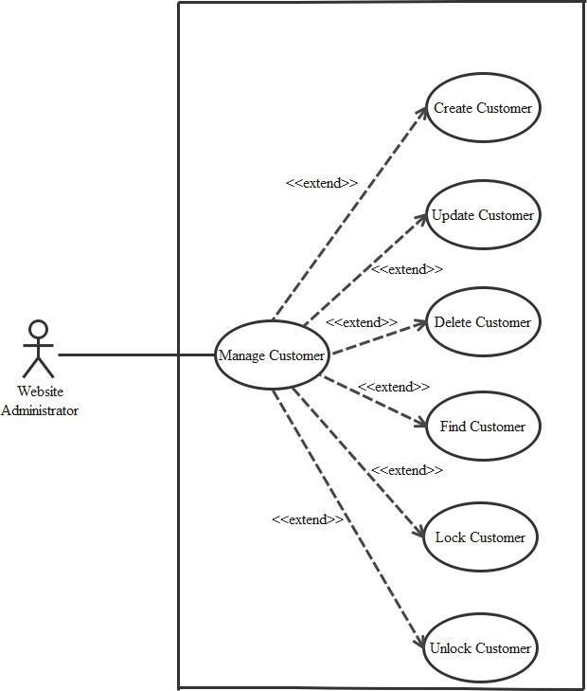

**CREATE CUSTOMER**

|  |  |  |
| --- | --- | --- |
| **Author** |  | |
| **Use case name** | Create Customer | |
| **Actor** | Admin | |
| **Description** | When admin wants to create customer | |
| **Requirements** | Actor provides consumers information | |
| **Pre-conditions** | Actor is logged in admin | |
| **Post-conditions** | Success: new Customer is added into the database | |
| Fail: refill information | |
| **Basic flow** | **Actor’s action** | **System’s responses:** |
| 1. Actor chooses Customer Tab on menu.  3. Actor clicks ‘Add New Customer’ button.  5. Actor inputs information to create Customer. | 2. System redirects to ‘Customer’ page  and display a list of existing Customers.  4. System displays a form with the following fields:   * id * fullname * username * password * address * phone * email * birthday |

|  |  |  |
| --- | --- | --- |
|  |  | * gender * active  1. System validates inputs. 2. System adds new consumers into database. 3. System displays confirmation message or error message. |

**UPDATE CUSTOMER**

|  |  |  |  |  |
| --- | --- | --- | --- | --- |
| **Author** |  | | |  |
| **Use Case Name** | Update Customer | | |
| **Actors** | Admin | | |
| **Description** | When admin wants to Update customer | | |
| **Requirements** | Actor provides consumers information | | |
| **Pre-conditions** | Actor is logged in admin | | |
| **Post-condition** | Success: Customer is update into the database | | |
| Fail: refill information | | |
| **Basic flow** | **Actor’s action** | | **System’s responses:** |
| 1. Actor chooses Customer Tab on menu.  3. Actor clicks on ‘View Details’ on a  Customer  5. Actor chooses the criteria they want to update and input information. | | 2. System redirects to ‘Customer’ page  and display a list of existing Customers.  4. System displays a form with the following fields:   * fullname * username |
| **Prepared by: All members** | | **Approved by: Lê Mộng Thúy** | | |



|  |  |
| --- | --- |
| **Project Group No: 4** | **Version:1.0** |

|  |  |  |
| --- | --- | --- |
|  |  | * password * address * phone * email * birthday * gender * active  1. System validates inputs. 2. System update customer into database. 3. System displays confirmation message or error message. 4. System redirects to customer’s detail   page. |

**DELETE CUSTOMER**

|  |  |
| --- | --- |
| **Author** |  |
| **Use Case Name** | Delete Customer |
| **Actors** | Admin |
| **Description** | When admin wants to delete customer |
| **Requirements** | Actor provides consumers information |
| **Pre-conditions** | Actor is logged in admin |
| **Post-condition** | Success: Customer is delete from the database |

|  |  |
| --- | --- |
| **Prepared by: All** | **Approved by: Lê Mộng** |

|  |  |
| --- | --- |
| **members** | **Thúy** |
| **Project Group No: 4** | **Version: 1.0** |

|  |  |  |
| --- | --- | --- |
|  | Fail: Customer is not deleted from the database | |
| **Basic flow** | **Actor’s action** | **System’s responses:** |
|  | 1. Actor chooses Customer Tab on menu.  3. Actor clicks ‘Delete’ button. | 2. System redirects to ‘Customer’ page  and display a list of existing Customers. |
|  | 4. System delete consumers in the database. |
|  | 5. System displays confirmation message or error message. |

**FIND CUSTOMER**

|  |  |  |
| --- | --- | --- |
| **Author** |  | |
| **Use Case Name** | Find Customer | |
| **Actors** | Admin | |
| **Description** | When admin wants to find consumers by ID | |
| **Requirements** | Actor provides Customer’s id | |
| **Pre-conditions** | Actor is logged in admin | |
| **Post-condition** | Success: Show consumers that matches ID | |
| Fail: No consumers is shown | |
| **Basic flow** | **Actor’s action** | **System’s responses:** |
| 1 Actor inputs ID.  3. Actor clicks customer’s title in list or  view, which matches the ID. | 2. System show list of consumers that match the ID. |

**LOCK CUSTOMER**

|  |  |  |
| --- | --- | --- |
| **Author** |  | |
| **Use Case Name** | Lock Customer | |
| **Actors** | Admin | |
| **Description** | When admin wants to lock a customer | |
| **Requirements** | Actor provides Customer’s information | |
| **Pre-conditions** | Actor is logged in admin | |
| **Post-condition** | Success: set customer’s status into “Lock” and updated in database | |
| Fail: No changes are made | |
| **Basic flow** | **Actor’s action** | **System’s responses:** |
| 1. Actor chooses Customer row on User list and click “disable” button | 1. System updates Customer’s status   into database.   1. System displays confirmation message or error message. |

**UNLOCK CUSTOMER**

|  |  |
| --- | --- |
| **Author** |  |
| **Use Case Name** | Unlock Customer |
| **Actors** | Admin |
| **Description** | When admin wants to unlock a customer |

|  |  |  |
| --- | --- | --- |
| **Requirements** | Actor provides Customer’s information | |
| **Pre-conditions** | Actor is logged in admin | |
| **Post-condition** | Success: set customer’s status into “Unlock” and updated in database | |
| Fail: No changes are made | |
| **Basic flow** | **Actor’s action** | **System’s responses:** |
| 1. Actor chooses Customer row on User list and click “enabled” button | 1. System updates Customer’s status   into database.   1. System displays confirmation message or error message. |

## DATA FLOW DIAGRAM (DFD)

**LEVEL 0**

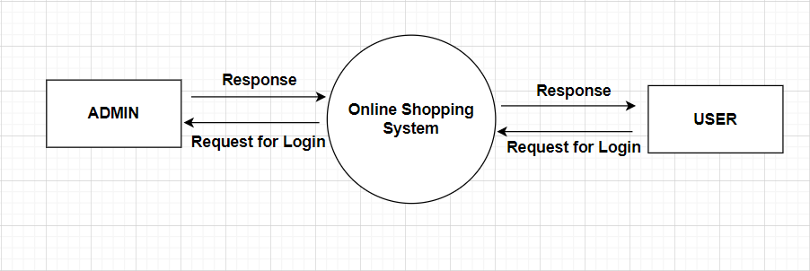

**ADMINSIDE LEVEL 1**

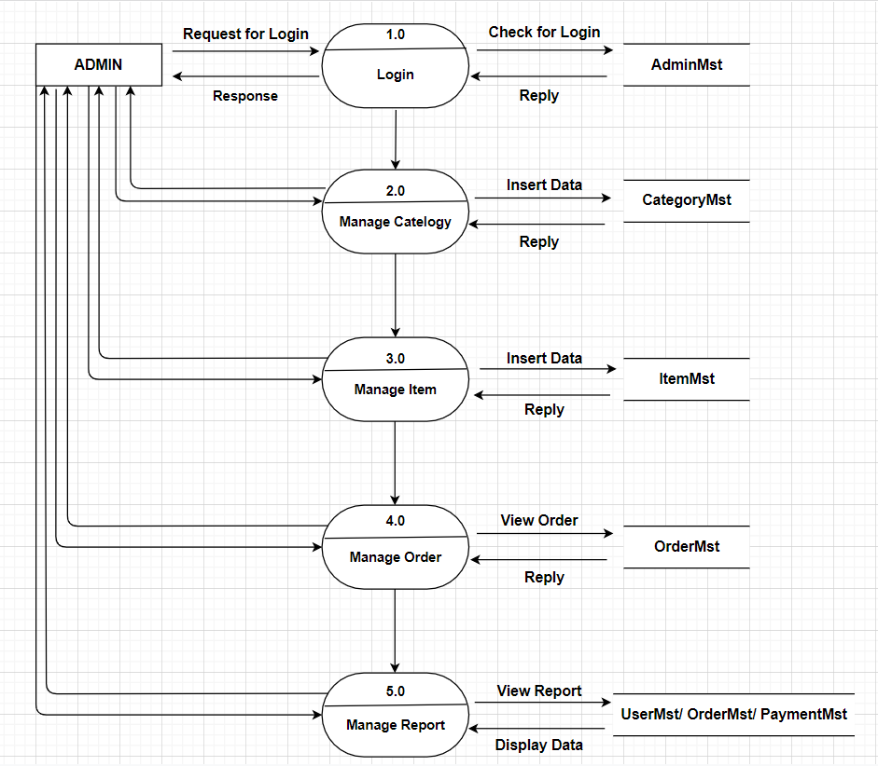

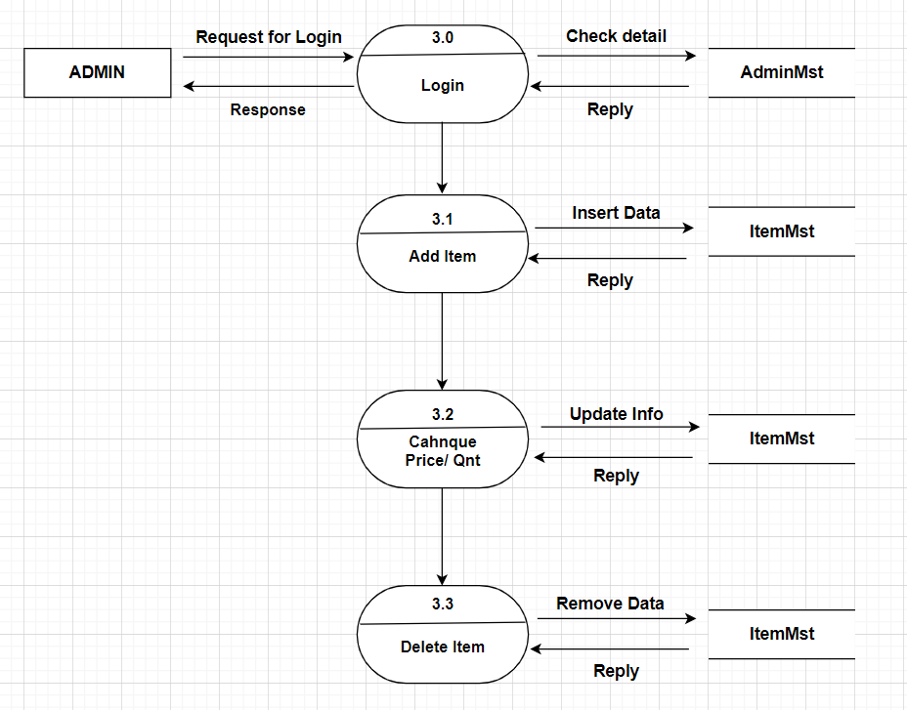

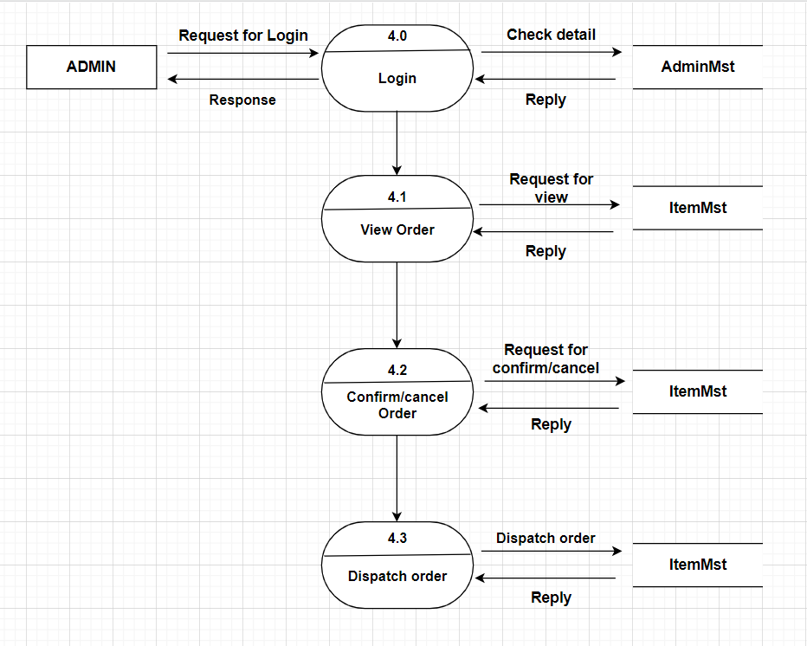

**ADMINSIDE LEVEL 4**

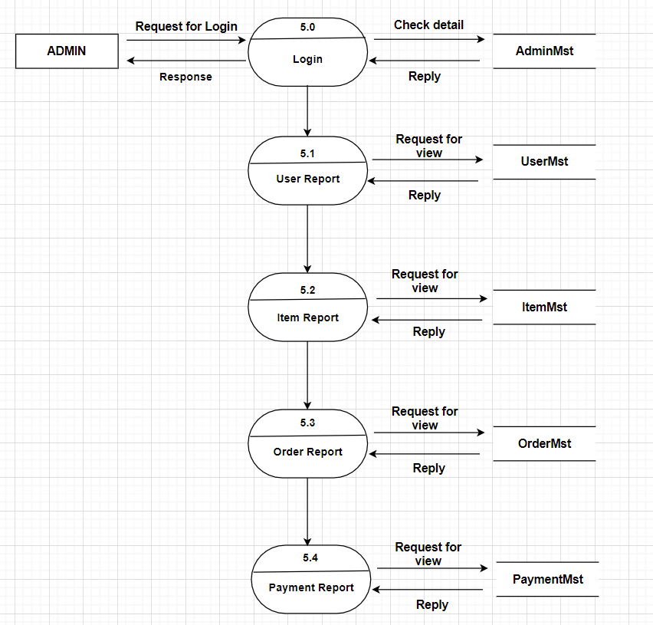

**USERSIDE LEVEL 1**

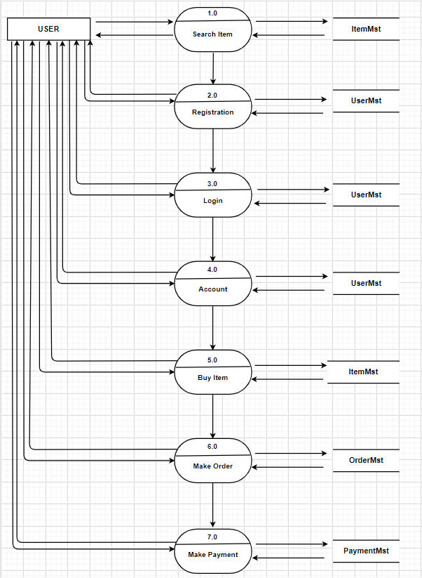

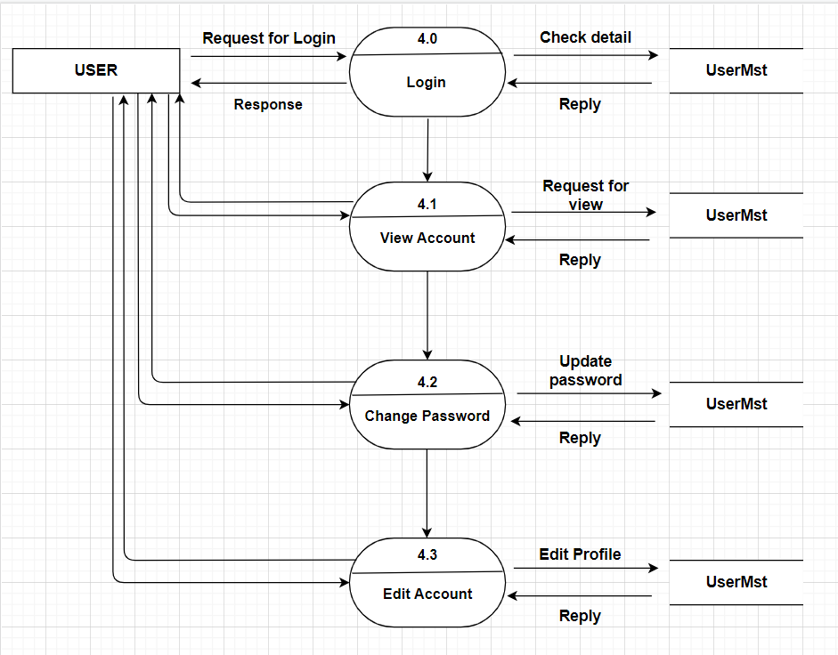

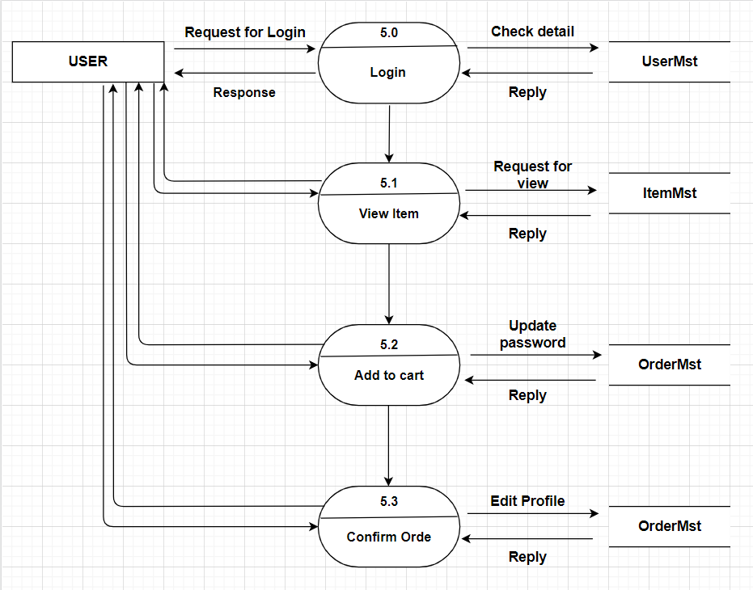

## ENTITY PROPERTIES

**Consumer**

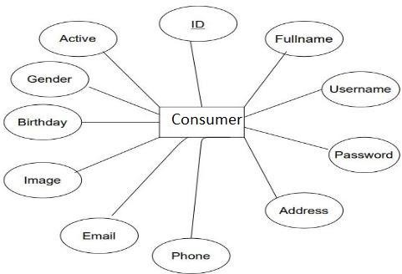

**ORDER**

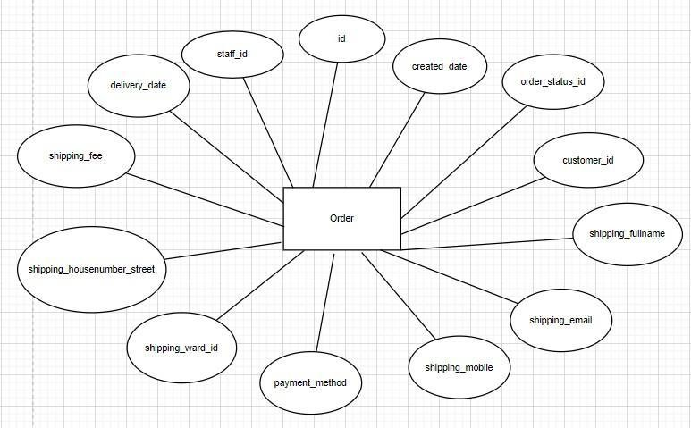

**ORDER_ITEM**

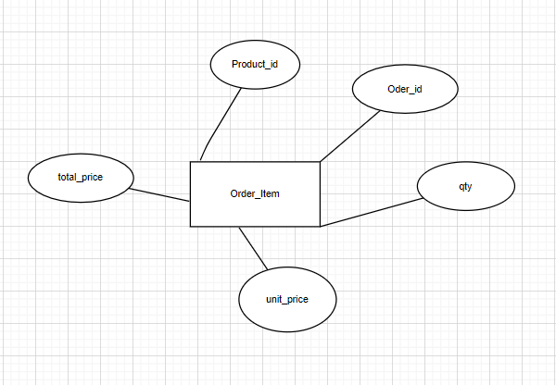

**CATEGORY**

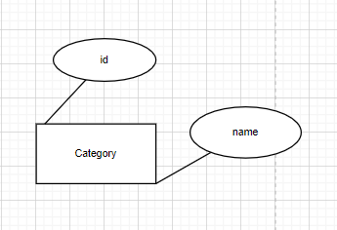

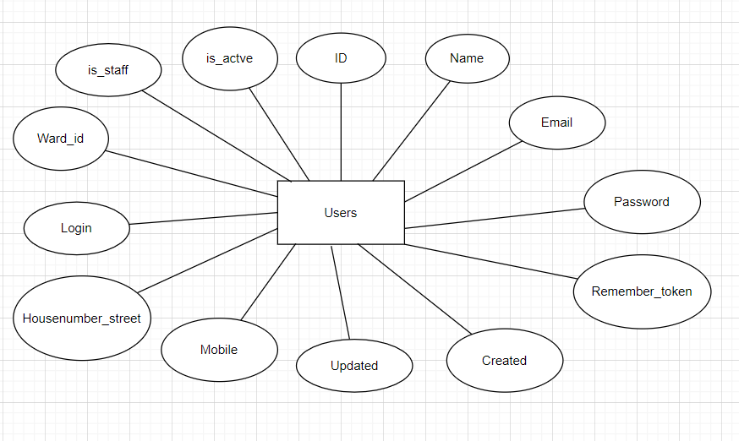**USER**

**STAFF**

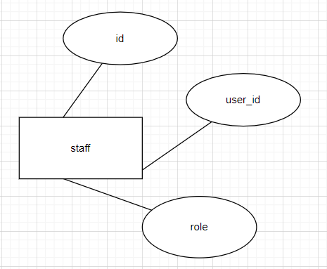

**PRODUCT**

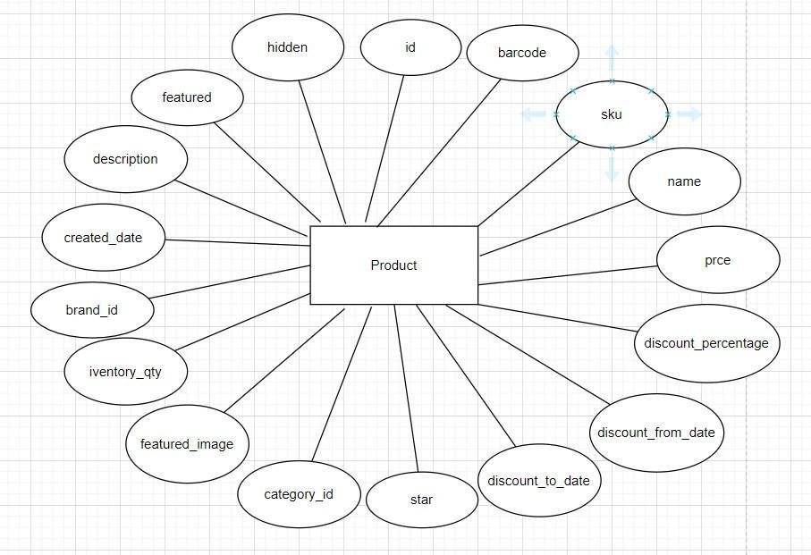

**ADMIN**

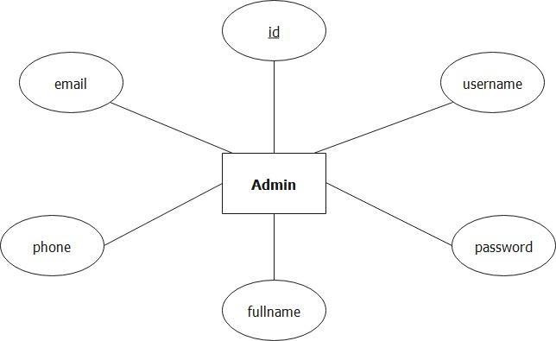

1. **ENTITY RELATIONSHIP DIAGRAM (ERD)**

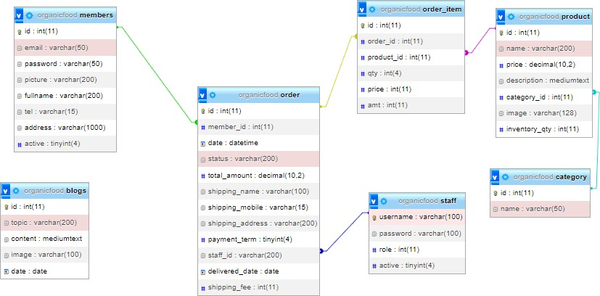

## TABLE DESIGN

**TABLE STRUCTURE FOR TABLE CATEGORY**

|  |  |  |  |
| --- | --- | --- | --- |
| **TABLE CATEGORY** | | | |
| **Column** | **Type** | **Nul**  **l** | **Default** |
| **id** | int(11) | No |  |
| **name** | varchar(200) | No |  |

**TABLE STRUCTURE FOR TABLE BLOG**

|  |  |  |  |
| --- | --- | --- | --- |
| **TABLE BLOG** | | | |
| **Column** | **Type** | **Nul**  **l** | **Default** |
| **id** | int(11) |  |  |
| **topic** | longtext |  |  |
| **image** | varchar(128) |  |  |
| **date** | datetime |  |  |

**TABLE STRUCTURE FOR TABLE ORDER**

|  |  |  |  |
| --- | --- | --- | --- |
| **TABLE ORDER** | | | |
| **Column** | **Type** | **Nul**  **l** | **Default** |
| **id** | int(11) | No |  |
| **member_id** | int(11) | No |  |
| **date** | datetime | No |  |
| **status** | varchar | No |  |
| **total_amount** | decimal(10,2) | No |  |
| **shipping_name** | varchar(255) | Yes |  |
| **shipping_mobile** | varchar(15) | No |  |
| **shipping_address** | varchar(200) | No |  |
| **payment_term** | tinyint(4) | Yes |  |

|  |  |  |  |
| --- | --- | --- | --- |
| **staff_id** | int(11) | No |  |
| **delivery_date** | int(11) | Yes |  |
| **shipping_fee** | int(11) | Yes |  |
| **delivered_date** | date | Yes |  |

|  |  |
| --- | --- |
| **Prepared by: All**  **members** | **Approved by: Lê Mộng**  **Thúy** |
| **Project Group No: 1** | **Version: 1.0** |

**TABLE STRUCTURE FOR TABLE ORDER_ITEM**

|  |  |  |  |
| --- | --- | --- | --- |
| **TABLE ORDER_ITEM** | | | |
| **Column** | **Type** | **Nul**  **l** | **Default** |
| **id** | int(10) | No |  |
| **order_id** | int(10) | No |  |
| **product_id** | int(11) | No |  |
| **qty** | int(11) | No |  |
| **unit_price** | int(11) | No |  |
| **total_price** | int(10) | No |  |

**TABLE STRUCTURE FOR TABLE PRODUCT**

|  |  |  |  |
| --- | --- | --- | --- |
| **TABLE PRODUCT** | | | |
| **Column** | **Type** | **Nu** | **Default** |

|  |  |  |  |
| --- | --- | --- | --- |
|  |  | **ll** |  |
| **id** | int(11) | No |  |
| **name** | varchar(200) | No |  |
| **price** | decimal(10,2) | No |  |
| **description** | mediumtext | yes |  |
| **category_id** | int(11)) | No |  |
| **image** | varchar(128) | No |  |
| **inventory_qty** | int(11) | No |  |

**TABLE STRUCTURE FOR TABLE STAFF**

|  |  |  |  |
| --- | --- | --- | --- |
| **TABLE STAFF** | | | |
| **Column** | **Type** | **Null** | **Default** |
| **username** | int(11) | No |  |
| **password** | varchar(200) | No |  |
| **role** | tinyint(4) | No | inspector |
| **active** | tinyint(4) | No |  |

**TABLE STRUCTURE FOR TABLE MEMBERS**

|  |  |  |  |
| --- | --- | --- | --- |
| **TABLE MEMBERS** | | | |
| **Column** | **Type** | **Null** | **Default** |
| **id** | bigint(20) | No |  |
| **fullname** | varchar(255) | No |  |
| **email** | varchar(255) | No |  |
| **picture** | varchar(128) | Yes | NULL |
| **password** | varchar(255) | No |  |

|  |  |  |  |
| --- | --- | --- | --- |
| **tel** | int(11) | No | NULL |
| **address** | varchar(200) | No | NULL |
| **Active** | tinyint(4) | Yes | NULL |

## TASK SHEET REVIEW 2

|  |  |  |  |  |  |  |  |
| --- | --- | --- | --- | --- | --- | --- | --- |
| **Project: Organic Food** | | **Project Name** | **Activity Plan Prepared By** | **Date of Preparation of Activity Plan:** | | | |
| **Sr./No.** | **Task** | Actual Start Date | Actual Days | Team member name | Status |
| **1** | **Use Case** | **Organic food** | Mai | 5-June-22 | 3 | Mai | Completed |
| **2** | **Data Flow**  **Diagram (DFD)** | 5-June-22 | 3 | Đức/ Phong Lưu | Completed |
| **3** | **Entity**  **Relationship Diagram (ERD)** | 6-June-22 | 3 | Đức, Minh | Completed |
| **4** | **Entity Properties** | 7-June-22 | 3 | Minh/Lưu | Completed |
| **5** | **Table Design** | 7-June-22 | 3 | Mai | Completed |



Nguyen Dinh Duc

**Signature of Team Leader:**

Ms. Le Mong Thuy

**Signature of Instructor:**

# REVIEW 3

## SITE MAP

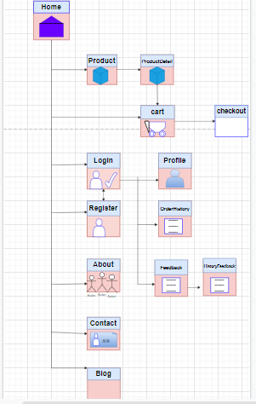**HOME SITE MAP**

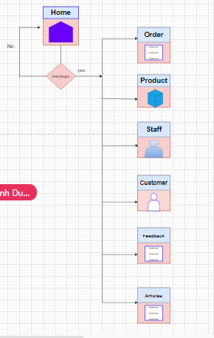**ADMIN’S SITE MAP**

1. **ORGANIC FOOD STORE WIREFRAME**

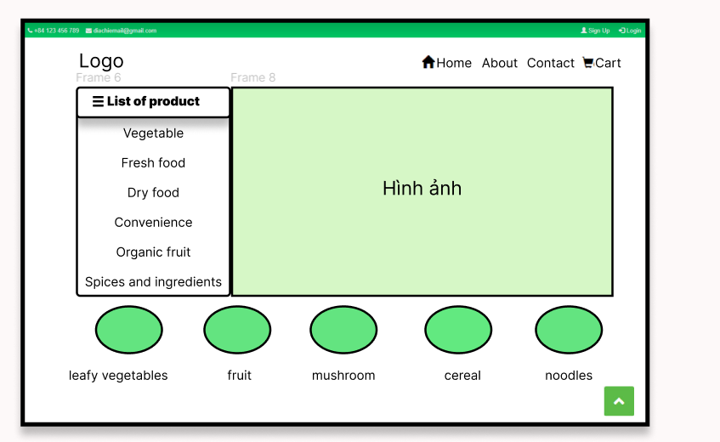**HOMEPAGE**

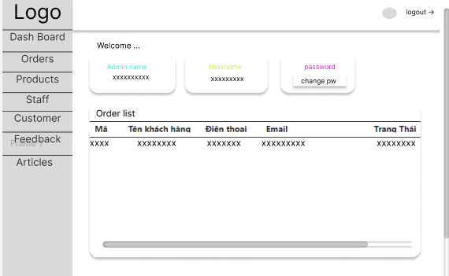**ADMIN**

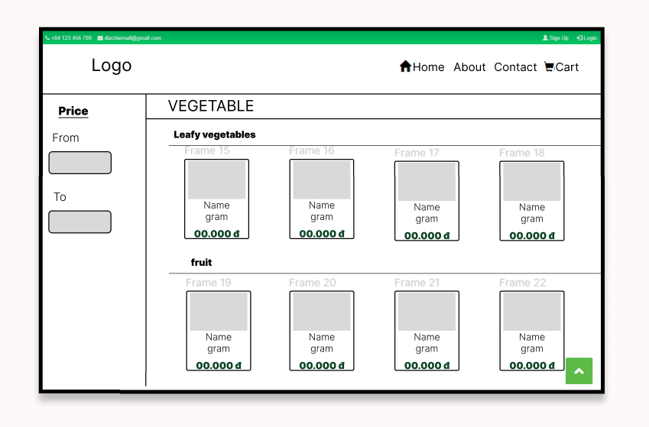**PRODUCT**

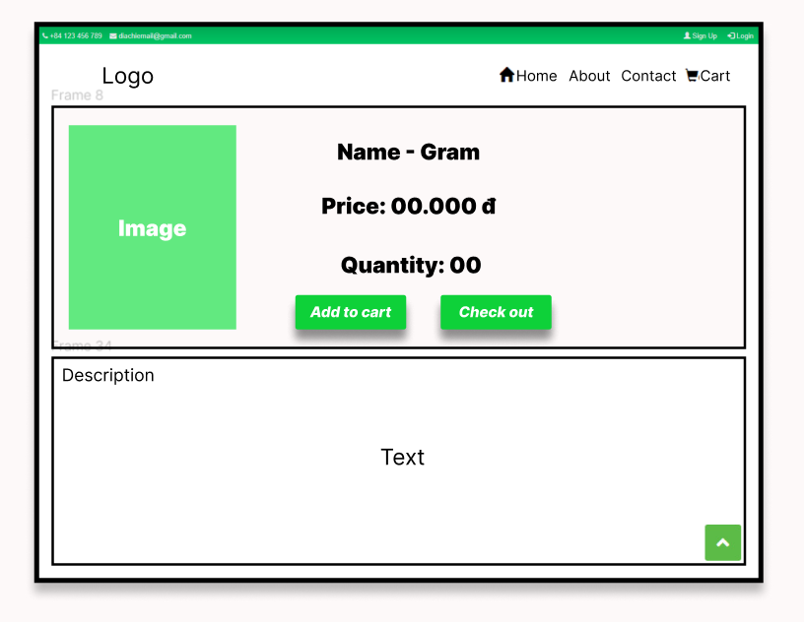**PRODUCT DETAIL DESCRIPTION**

**USER ACCOUNT PROFILE**

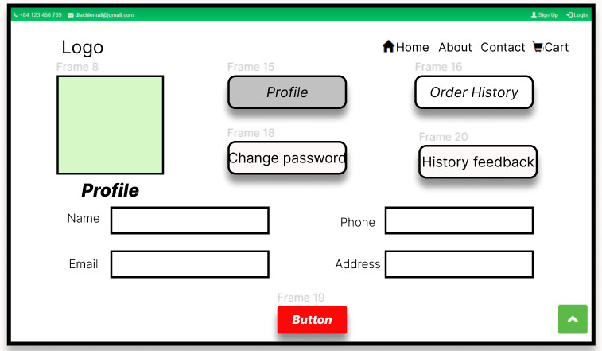

**USER ACCOUNT ORDER HISTORY**

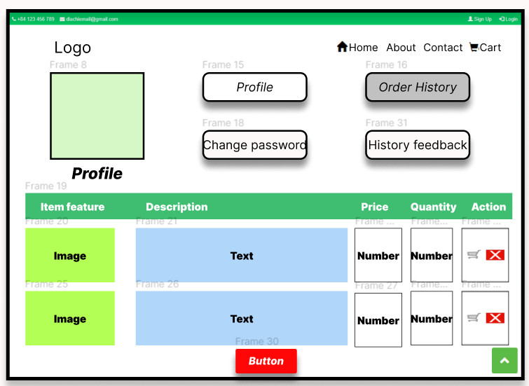

**USER ACCOUNT CHANGE PASSWORD**

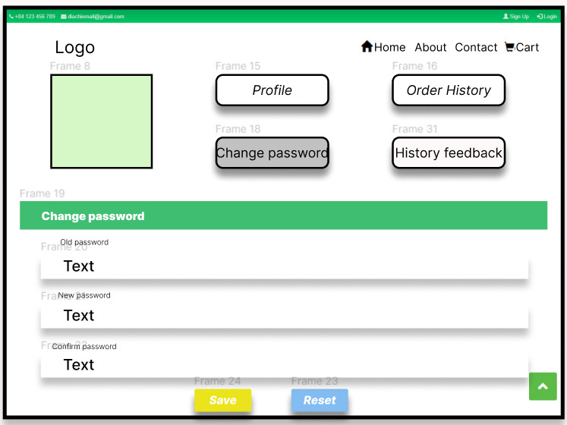

**USER ACCOUNT HISTORY FEEDBACK**

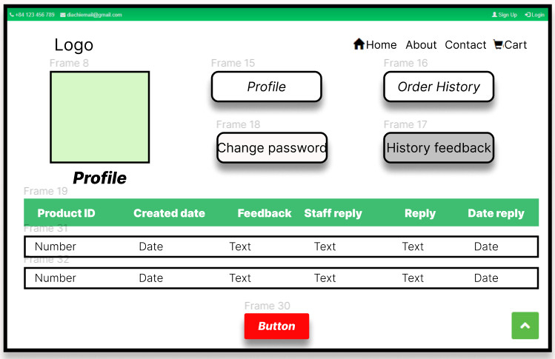

1. **Organic Food STORE SCREENSHOT**

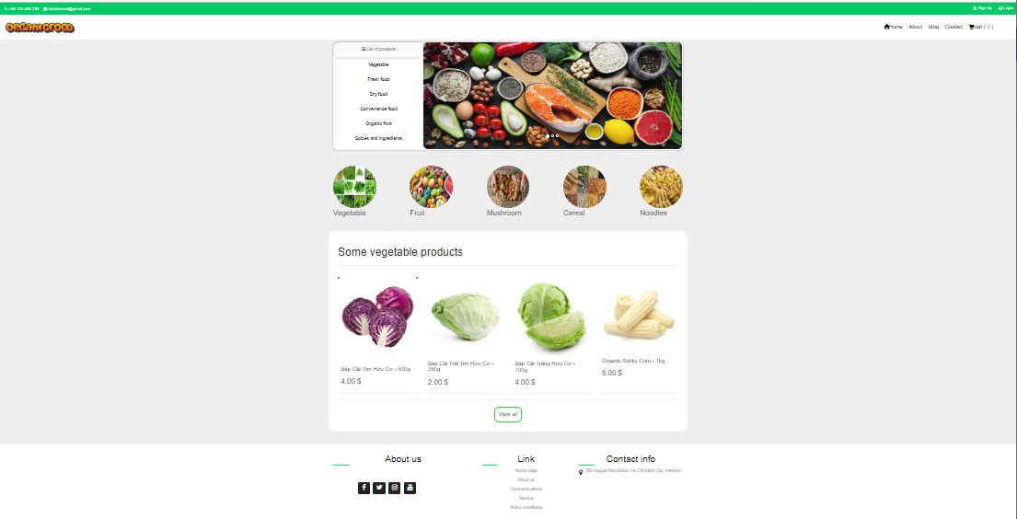**HOME PAGE**

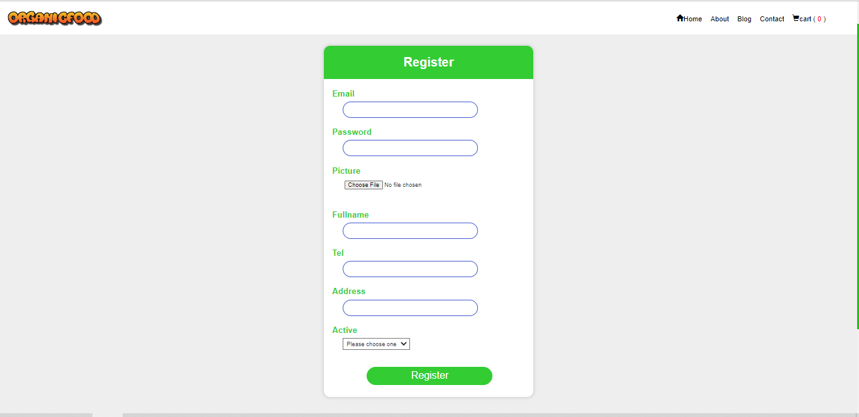**REGISTER PAGE**

**LOGIN PAGE**

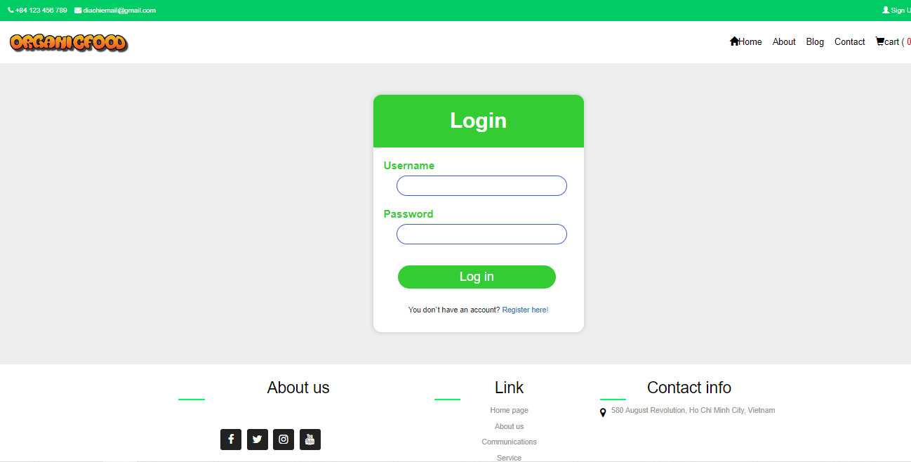

**PRODUCT**

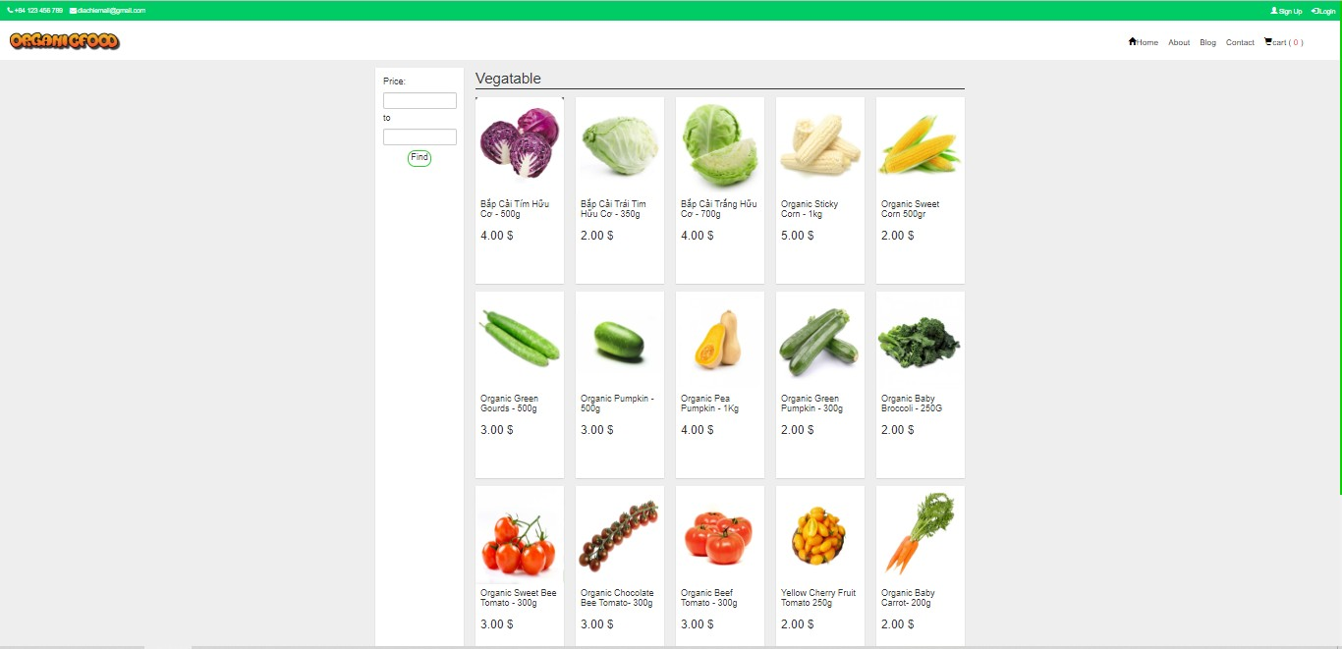

**PRODUCT DETAIL**

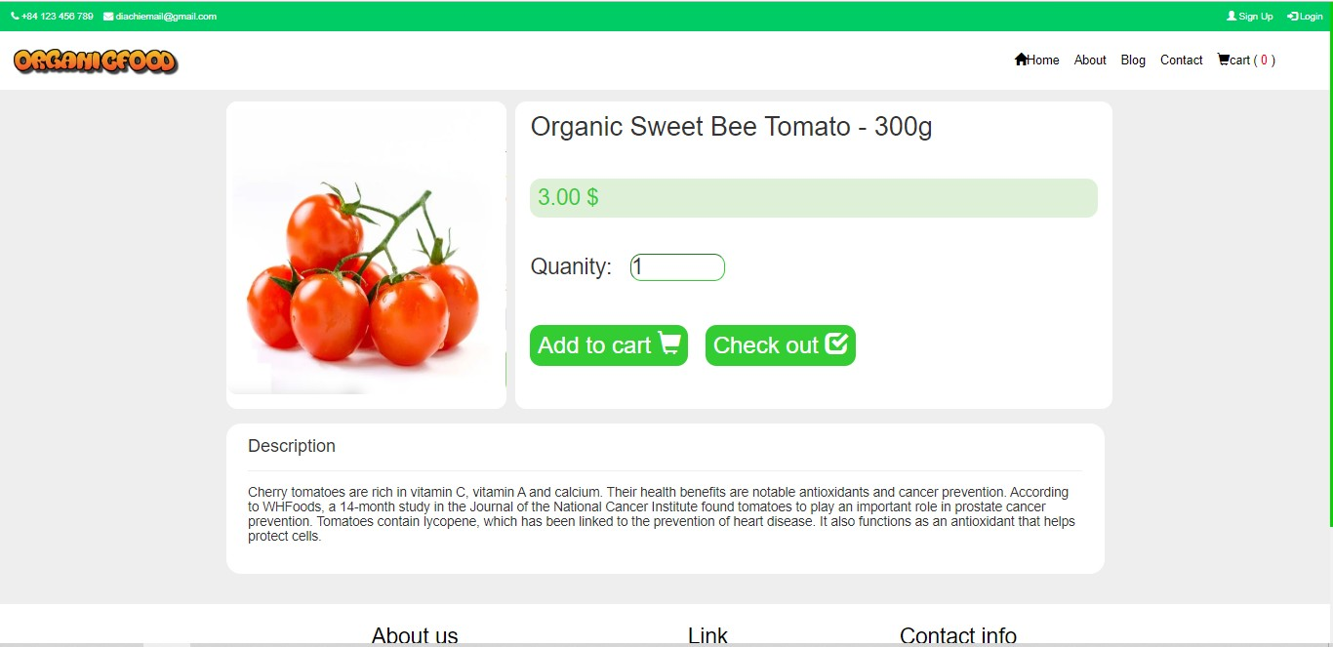

**USER ACCOUNT**

**BLOG**

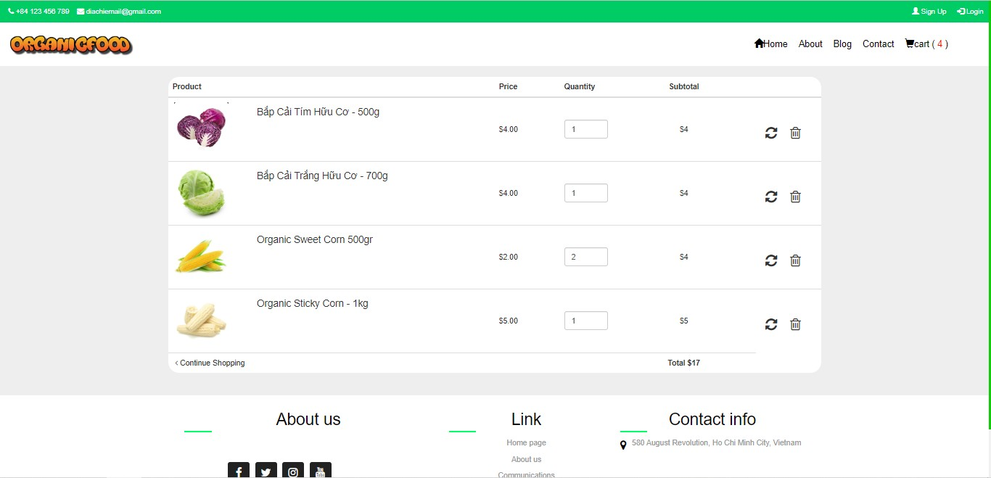**CART**

**CHECK-OUT**

1. **TASK SHEET REVIEW 3**

|  |  |  |  |  |  |  |  |
| --- | --- | --- | --- | --- | --- | --- | --- |
| **Project: Organic Food** | | **Project Name** | **Activity Plan Prepare d By** | **Date of Preparation of Activity Plan:** | | | |
| **No** | **Task** | **Actual**  **Start Date** | **Actual Days** | **Team**  **member name** | **Status** |
| **1** | **Database Design** |  |  | 10-June-22 | 30 | Đức | Completed |
| **2** | **Front-end layout** |  |  | 10-June-22 | 1 | Đức/Mai/Minh | Completed |
| **3** | **Back-end layout** |  |  | 10-June-22 | 1 | Đức/Mai/Minh | Completed |
| **4** | **Admin dashboard** |  |  | 10-June-22 | 30 | Đức | Completed |
|  | **CRUD – order,** |  |  |  |  |  |  |
| **5** | **order-item, product,** |  |  | 10-June-22 | 30 | Đức/Mai/Minh | Completed |
|  | **user, staff,** |  |  |  |  |  |  |
|  | **authorizations,** |  |  |  |  |  |  |
|  | **transport** |  |  |  |  |  |  |
|  | **Admin**  **SendEmail Functions** | **Organic** |  |  |  |  |  |
| **9** | **food** | Đức | 10-June-22 | 3 | Đức/Mai/Minh | Completed |
| **10** | **Home page** |  |  | 10-June-22 | 1 | Đức | Completed |
| **11** | **Products** |  |  | 10-June-22 | 1 | Đức | Completed |

|  |  |  |  |  |  |  |  |
| --- | --- | --- | --- | --- | --- | --- | --- |
| **12** | **Product detail page** |  |  | 10-June-22 | 1 | Đức | Completed |
| **13** | **Login/Register** | 10-June-22 | 1 | Mai/Minh | Completed |
| **14** | **Social Login** | 10-June-22 | 1 | Mai/Minh | Completed |
| **15** | **Blog** | 10-June-22 | 3 | Lưu | Completed |
| **16** | **Cart** | 10-June-22 | 2 | Đức | Completed |
| **17** | **Checkout** | 10-June-22 | 2 | Đức | notCompleted |
| **19** | **About us** | 10-June-22 | 1 |  | Completed |
| **20** | **Contact us** | 10-June-22 | 1 |  | Completed |
| **21** | **User Account** | 10-June-22 | 1 | Đức | Completed |
| **23** | **Purchase history** | 10-June-22 | 1 | Mai/Minh | Completed |
| **24** | **Content Collection** | 10-June-22 | 1 | Đức Thịnh | Completed |
| **25** | **UI/UX testing** | 10-June-22 | 30 | Mai/Minh | Completed |



**Nguyen DInh Duc**

**Signature of Team Leader:**

**Ms. Le Mong Thuy**

**Signature of Instructor:**