INSTRUCTIONS
Please read the instructions carefully before doing the questions.
- You can use materials in your computer, notebook and text book.
- You are NOT allowed to use any device to share data with others.
Beside the above conditions, students must follow the following requirements:
- The work must complete by using Visual Studio 2019
- The .NET Framework must be 3.5
- Create a folder named RollNo_Name_PRN292 (1) , e.g. 01245_LongNT_PRN292.
- THIS PART IS VERY IMPORTANT, PLEASE READ IT CAREFULLY AND FOLLOW THE INSTRUCTIONS.
- Create only one solution and three projects corresponding with three question below.
- You are given a database script (.sql file) in Zip file. Execute the script before doing these questions
- For Question related to webform, you have to create Web Application instead of Website.
- You are not allowed to use ObjectDataSource, SqlDataSource.
- You are not allowed to use Lambda syntax.
- Just one of above requirements is violated, your work will be considered as invalid.
On completion, submit the whole folder (1).

Question 1
(3 points)
You are asked to write a console application that includes Employee and EmployeeList class.
The Employee class contains:
- Three private field:
- int employeeid
- string employeename
- string address
and three public properties EmployeeID, EmployeeName, Address that get and set value for those private fields. (0.5 point)
- Nessary constructors. (0.5 point)
- Two public methods
- string ToString() override the ToString() function of Object class and return the string contains employee’s information by the format (0.5 point):
“xxx – yyy – zzz”
with xxx is the id, yyy is the name and zzz is the address of the employee.
- void ReadFromString(string line).
The line is the string of the format xxx|yyy|zzz, with xxx is the id, yyy is the name and zzz is the address of the Employee
This function reads the data from line and pass information to the properties of the object.
(0.5 point)
The EmployeeList class contains:
- the data structure (may be List or ArrayList or something) that allows storing information about list of employee. (each employee is one Employee object).
- Nessary constructors.
- Two public methods:
- void ReadFromFile(string filename) that read successive lines of the file named filename and call the Employee.ReadFromFile(string line) to include information for each employee in the list. (0.5 point)
- void Display() that display the number of employees in the list and call the Employee.ToString() to write list of employee’s information to the Console, each employee on one line. (0.5 point)
Note:
Your classes need to match for the following main function:
static void Main(string[] args)
{
Employee e = new Employee(1, "trung", "Ha Noi");
Console.WriteLine(e.ToString());

Employee s = new Employee();
s.ReadFromString("2|Hung|Hai Duong");
Console.WriteLine(s.ToString());

EmployeeList emplist = new EmployeeList();
emplist.ReadFromFile(@"D:\data.txt");
emplist.Display();
Console.ReadLine();
}
With the content in data.txt look like the image below:
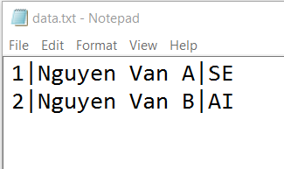
Your application should display like following:
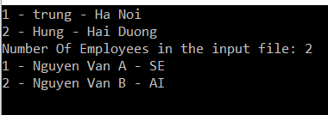

Question 2
(3.5 points)
(0 will be given to the work that not using database connection string in App.config file)
You are asked to write a window form application like figure below:
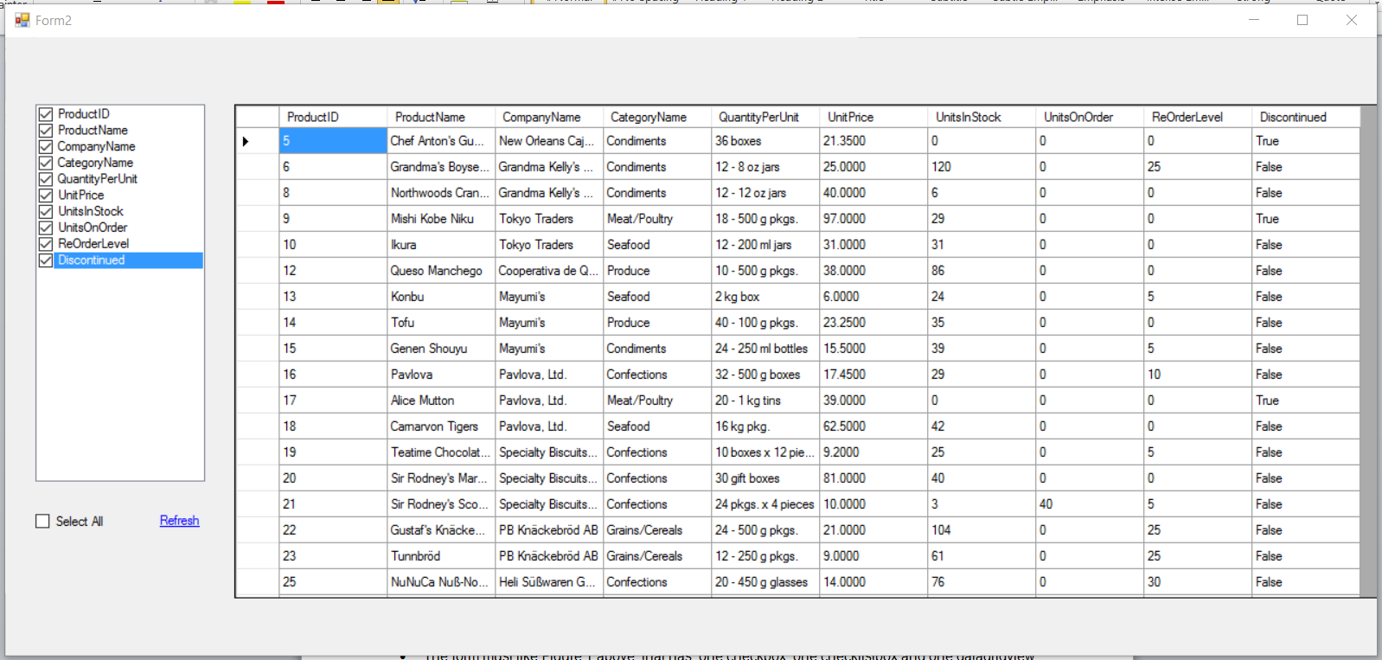
Figure 1 – The design of requirement form.

Your tasks include several of following steps:
- The form must like Figure 1 above, that has: one checkbox, one checklistbox and one datagridview controls.
The checklistbox has ten fixed items as shown in Figure 1. When the form loads all checklistbox item are selected. (1 point)
- Load all products in database into datagridview controls, like Figure 1. (1 point).
(The CompanyName is company’s name of the supplier of product)
- User can select or deselect some properties in the checklistbox and click on Refresh link label, the columns of datagridview change accordingly. Only selected properties in the checklistbox are displayed on datagridview. (1 point)
The function bool CheckedListBox.GetItemChecked(int index) tell you if the index-th item in CheckedListBox is being checked.
- User can use the Select All checkbox to select or deselect all properties (0.5 point).
You can see below figures to understand more about the above requirements:
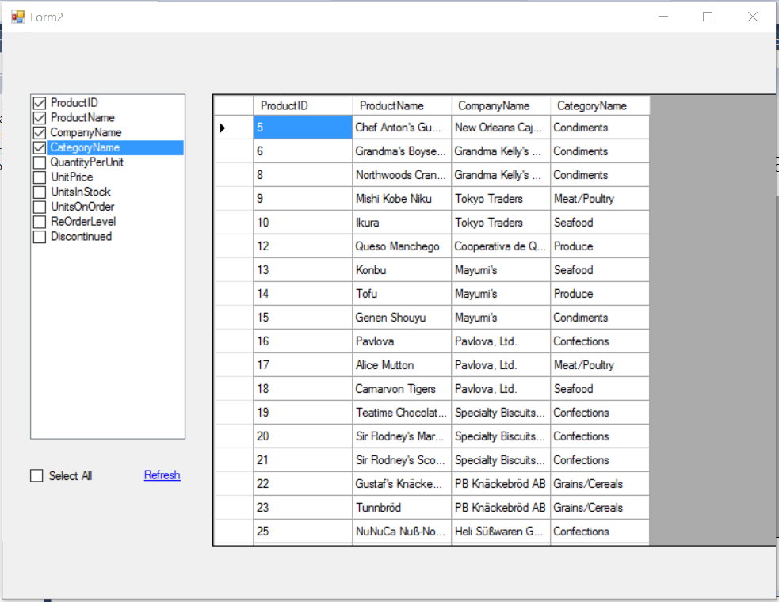
Figure 2 – The datagridview while first four properties are selected
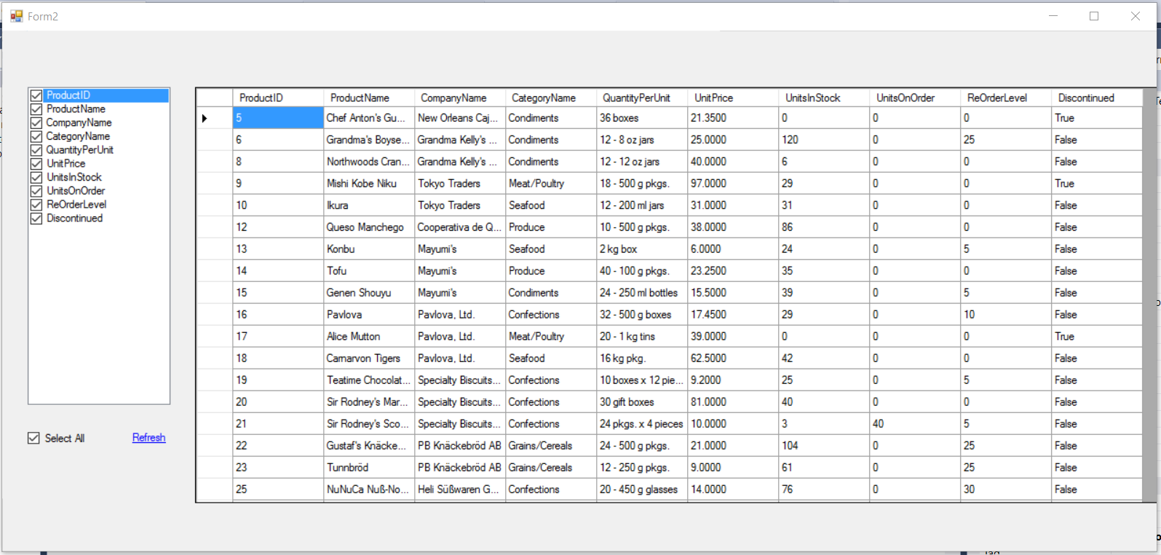
Figure 3 – The data in case “Select All” checkbox is checked
Question 3
(3.5 points)
You are asked to write a Webform application that allow to add new product into database. (0 will be given to the work that not using database connection string in Web.config file)
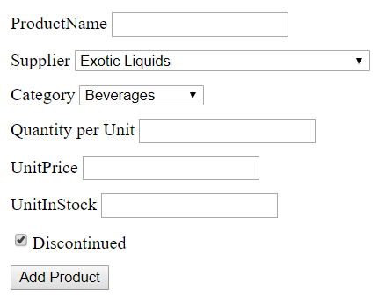
Figure 1 – “Add product” page
- The page is designed as shown in Figure 1, the Discontinued checkbox is checked by default.
- List of all suppliers and categories are loaded from database and shown in dropdownlists. The first item of each list is selected by default. (2 point)
- When user click on “Add product” button you must check:
  - Product name must not be blank.
  - The “Quantity per unit” must be in format “xxx ml” with xxx is one integer number.
  - The UnitPrice must be a integer number between 10 and 100.
  - The UnitInStock must be a positive integer number.
By using the validation controls.
Show the message to notify user if these constraints are not satisfied like the Figure 2.
(1 point)
- If all constraints are satisfied, add this information as one product into database. (0.5 point)
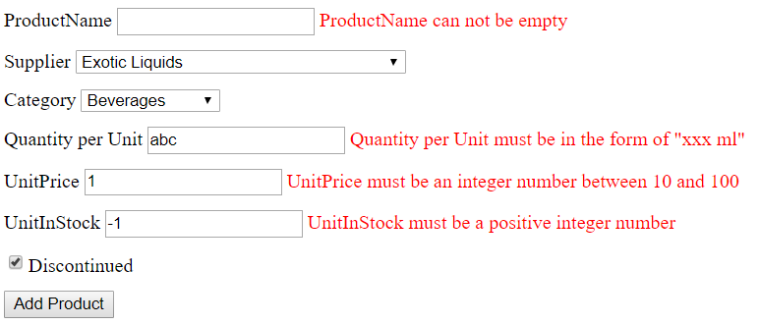
Figure 2 – Warning when data does not meet the conditions.

