<PSP> Sushi Tuyenbeoo Website

Version No. 0.1

**Confidentiality**

This document contains proprietary information that is confidential. Disclosure of this document in full or in part, may result in material damage. Written permission must be obtained prior to the disclosure of this document to a third party.

# Document Sign-Off

|  |  |  |  |
| --- | --- | --- | --- |
| **Role** | **Name** | **Signature** | **Date** |
| Author | [Name of the Document Author] |  |  |
| Reviewer | [Name of the affected parties and independent reviewers] |  |  |
| Approver | [Name of the User PM] |  |  |
| Approver | [Name of the Author’s HOD (or delegate viz IT Project Manager’s supervisor/ Team Lead)] |  |  |
| TISO Approver | [Name of the TISO approver, if applicable] |  |  |

*Note: If applicable, Technology Information Security Office acknowledgement is required for version 1.0. For subsequent versions, Technology Information Security Office acknowledgement is only required if the changes are related to security issues.*

# Document Change Control

|  |  |  |  |
| --- | --- | --- | --- |
| **Version** | **Impl. Date** | **Authors** | **Summary of Changes** |
| 0.1 | 2-Feb-2023 | Duc Nguyen | Original. |
|  |  |  |  |
|  |  |  |  |
|  |  |  |  |

**Contents**

Document Sign-Off 2

1. Introduction 4

2. Functional Requirements 4

2.1 General Assumptions 4

2.2 General Dependencies 4

2.3 Glossary 4

2.4 List of User stories 5

2.5 Process overview 6

3. Detailed Functional Requirements 6

3.1 User Story : WEB-01 6

3.1.1 Website procedure 6

3.1.2 Screen/Flow Diagram 6

3.1.3 Pre-requisite 6

3.1.4 Data/Input Fields 7

3.1.5 Exception Scenarios 7

3.1.6 Report 7

3.2 User Story : WEB-02 7

3.2.1 Customer uses OneToken for authorization 7

3.2.2 Screen/Flow Diagram 7

3.2.3 Pre-requisite 7

3.2.4 Data/Input Fields 7

3.2.5 Exception Scenarios 7

3.2.6 Report 7

4. Report 8

4.1 Administration Maintenance Report 8

4.1.1 Function Reference 8

4.1.2 Purpose 8

NA 8

4.1.3 Processing 8

NA 8

4.1.4 Report Layout 8

NA 8

5. General requirements 8

5.1 Regional support 8

5.2 Language Preferences 8

5.3 Data Specifications 8

5.3.1 No index entries found. Data definitions 8

5.3.2 Data Quality 8

5.3.3 Data Housekeeping 8

5.3.4 Messages 8

6. Appendices 8

1. Introduction

This is the personal project about creating a restaurant website has name Sushi Tuyenbeoo. A basic website with some basic fuction such as login/log out, sign up, booking, and order. This project is for learning purpose only

This document shall display detailed information about Sushi Tuyenbeoo website feature. The feature allows customer to be communicate with different types of website to proceed the transaction.

1. Functional Requirements
   1. General Assumptions

|  |  |
| --- | --- |
| **S/No** | **General Assumptions** |
|  |  |
|  |  |
|  |  |

* 1. General Dependencies

|  |  |
| --- | --- |
| **S/No** | **Dependencies** |
|  |  |
|  |  |
|  |  |

* 1. Glossary

|  |  |  |
| --- | --- | --- |
| **S/No** | **Term** | **Description** |
|  |  |  |
|  |  |  |
|  |  |  |
|  |  |  |
|  |  |  |

* 1. List of User stories

|  |  |  |  |  |  |
| --- | --- | --- | --- | --- | --- |
| # | ID | Story | As a <user> | I want to <perform a function> | So that I can <achieve goal/benefit> |
| 1 | WEB-01 | Landing Page | Restaurant Owner | View the information of my restaurant | Use it for SEO |
| 2 | WEB-02 | Reservation | Customer | Book a table | Be served when I come without waiting to be served |
|  |  |  |  |  |  |
|  |  |  |  |  |  |
|  |  |  |  |  |  |
|  |  |  |  |  |  |
|  |  |  |  |  |  |

* 1. Process overview

1. Detailed Functional Requirements

**Notes:** This mock-up shows off what the design will actually look like and will be used for website presentations. It’s not the final version.

* 1. User Story : WEB-01
     1. Website landing page screen

|  |  |  |
| --- | --- | --- |
| As a <user> | I want to <perform a function> | So that I can <achieve goal/benefit> |
| WEB-01 | Landing Page | Restaurant Owner |
| Acceptance Criteria | | |
| 1. **Can access to the website** 2. **The page have the information (mention in 3.1.2)** | | |

* + 1. Screen/Flow Diagram
* **Flow Diagram**
* **Graphical user interface, website

  Description automatically generatedScreen**
  + 1. Pre-requisite
    2. Data/Input Fields

NA

* + 1. Exception Scenarios

NA

* + 1. Report

NA

* 1. User Story : WEB-02
     1. Customer Booking table in landing page

|  |  |  |
| --- | --- | --- |
| As a <user> | I want to <perform a function> | So that I can <achieve goal/benefit> |
| Customer | Book a table | Be served when I come without waiting to be served |
| Acceptance Criteria | | |
| 1. Customer can fill information and submit the booking 2. The information of the booking was saved in database | | |

* + 1. Screen/Flow Diagram
* 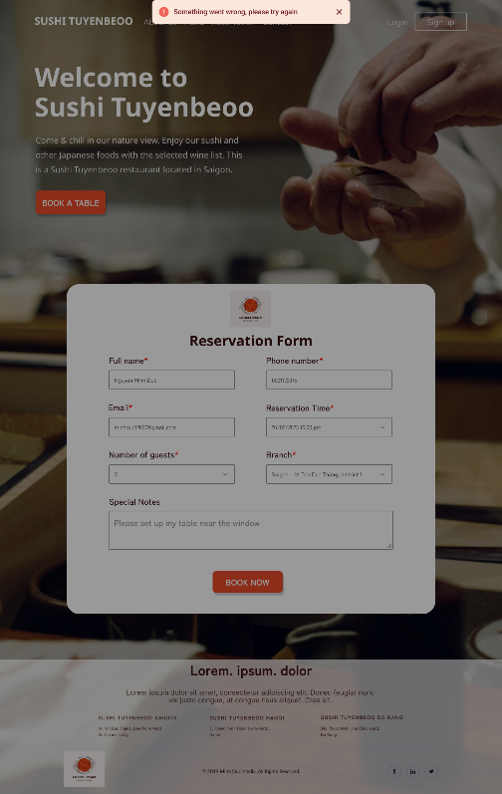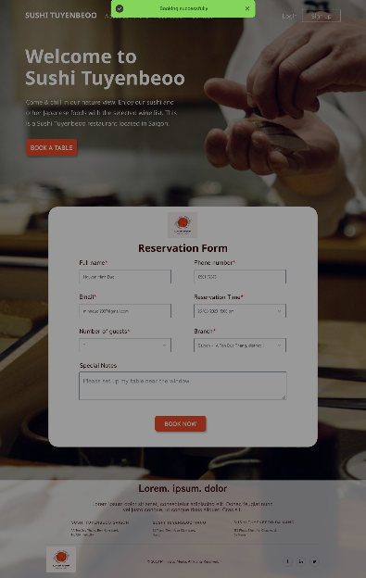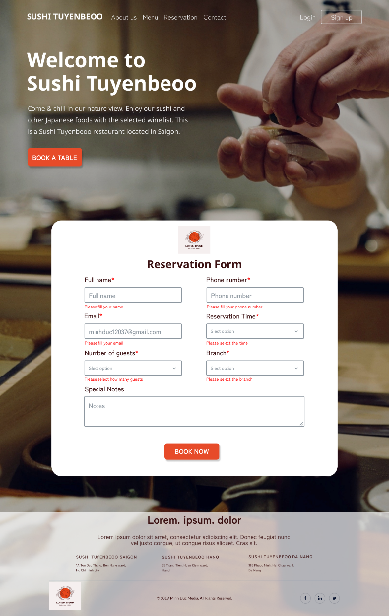Graphical user interface, website

  Description automatically generated**Screen:**
  + 1. Pre-requisite
* Customer accounts are operated to use OneToken
  + 1. Data/Input Fields

|  |  |  |  |  |  |
| --- | --- | --- | --- | --- | --- |
| Field Name | Description | Type | Mandatory? | Allowed Value/ Validation | Remarks/Data type/Length |
|  |  |  | N/A | N/A | N/A |
|  |  |  |  |  |  |

* + 1. Exception Scenarios

Table of exceptional scenarios

* + 1. Report

NA

* 1. User Story : WEB-02
     1. Customer uses OneToken for authorization

|  |  |  |
| --- | --- | --- |
| As a <user> | I want to <perform a function> | So that I can <achieve goal/benefit> |
| N/A | N/A | N/A |
| Acceptance Criteria | | |
|  | | |

* + 1. Screen/Flow Diagram
    2. Pre-requisite
* Customer accounts are operated to use OneToken
  + 1. Data/Input Fields

|  |  |  |  |  |  |
| --- | --- | --- | --- | --- | --- |
| Field Name | Description | Type | Mandatory? | Allowed Value/ Validation | Remarks/Data type/Length |
|  |  |  | N/A | N/A | N/A |
|  |  |  |  |  |  |

* + 1. Exception Scenarios

Table of exceptional scenarios

* + 1. Report

NA

1. Report
   1. Administration Maintenance Report
      1. Function Reference

NA

* + 1. Purpose

NA

* + 1. Processing

NA

* + 1. Report Layout

NA

1. General requirements
   1. Regional support
   2. Language Preferences
   3. Data Specifications
      1. No index entries found. Data definitions

NA

* + 1. Data Quality

NA

* + 1. Data Housekeeping

NA

* + 1. Messages

NA

1. Appendices

NA