BÁO CÁO CAPTSONE

Nhóm: Trương Văn Đại - Nguyễn Minh Đức

Link deploy:

Link github: <https://github.com/ducnm2k/Diner>

Link youtube: [2022 10 17 15 26 41](https://www.youtube.com/watch?v=UVkKQCCGHeA&feature=youtu.be)

[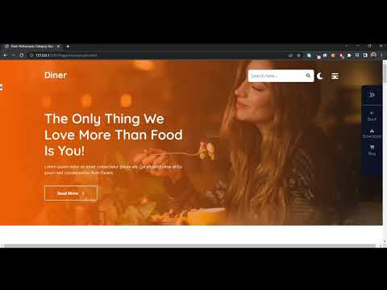](https://www.youtube.com/watch?v=UVkKQCCGHeA&feature=youtu.be)

Page:

|  |  |
| --- | --- |
| --- Trương Văn Đại --- | --- Nguyễn Minh Đức --- |
| Home - Index | Landing |
| Contact | About |
| Service | 404 |