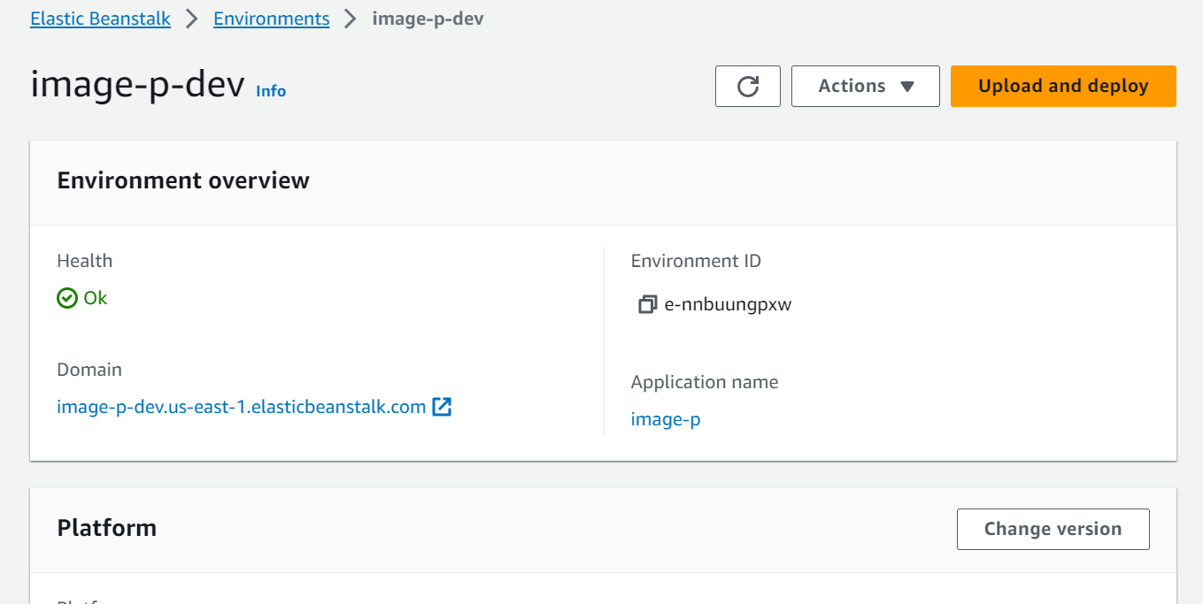

Link: <http://image-p-dev.us-east-1.elasticbeanstalk.com/filteredimage>

<http://image-p-dev.us-east-1.elasticbeanstalk.com/filteredimage?image_url=https://upload.wikimedia.org/wikipedia/commons/b/bd/Golden_tabby_and_white_kitten_n01.jpg>

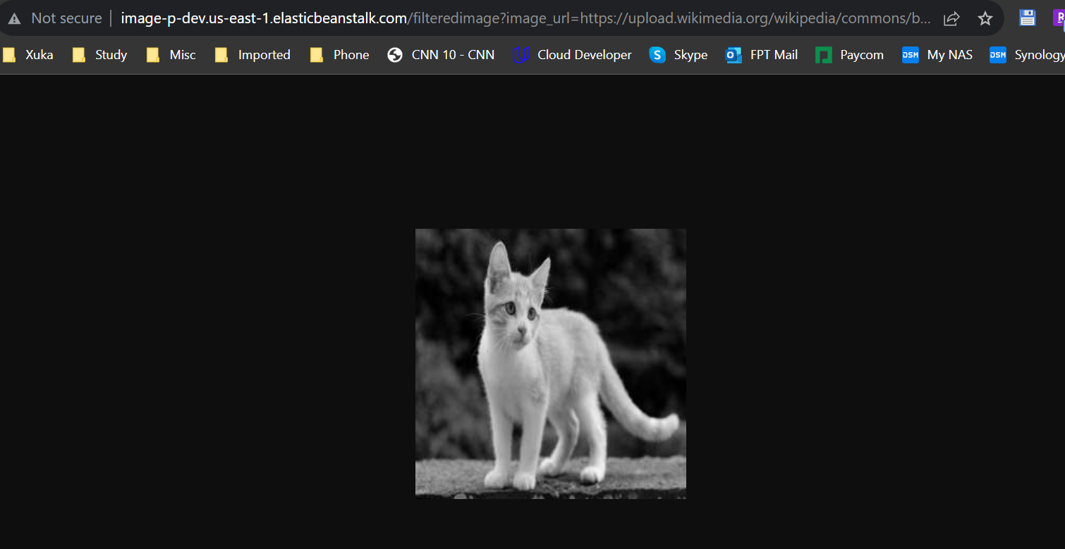

<http://image-p-dev.us-east-1.elasticbeanstalk.com/filteredimage?image_url=https://upload.wikimedia.org/abcd>

