

***Individual report of COMP1640 Enterprise Web Software Development.***

Student name: Nguyen Trung Duc

Student ID: GCH17377

Team group: group 4

Coursework: COMP1640

Assessor name: Lai Manh Dung

***Member of group:***

|  |  |
| --- | --- |
| Name | Roles |
| Nguyen Trung Duc | Programmer |
| Vu Manh Hung | Scrum Master, Web Designer |
| Pham Van Toan | Programmer |
| Ta Van Duc | Programmer, Web Designer |
| Mac Xuan Hung | Database Designer, Programmer |
| Igbo Kingsley Chinedu | Tester |

***Commitment point:***

URL to our video/screencasts: https://youtu.be/18-sNkgUWgs

URL to code repository: https://github.com/ducnt0706/etutoringreact/tree/master/myetutoring

URL to our website: https://etutoring-contact.web.app/

User name and password:

|  |  |  |
| --- | --- | --- |
| Roles | User Name | Password |
| Admin | ducnt0706@gmail.com | comp1640 |
| Tutor | ducntgch17377@fpt.edu.vn | nguyentrungduc |
| Student | hungvm0510@gmail.com | nhokidlee01 |

*Notice: Because of Google's identity verification feature, if you are required to enter the code you are entering please contact us at contact +84379345690,* *+84961209037 or +84355637668*

URL to Presentation: https://docs.google.com/presentation/d/10uGCNa7F-chyalw_ZonSh86xlTcZHHkZSa7BkK33QGg/edit?fbclid=IwAR0q0fYKkipMJDg0cRJqxFHJCWY5qmyUpF5fDLLlgIofLtrvbSObsQpLy5k#slide=id.g7750455d92_0_181

URL to Scrum Document(Product Backlog, Sprint Backlog, Meetings): <https://docs.google.com/spreadsheets/d/1-RUEJYo5Lny6isgM2q6tOEQ82aXr2Vx12254QAtZBOg/edit?fbclid=IwAR3Ac7qYK7_udesc65RiesaK3J-v5ul3KfM_-c6Qfa6x-XVUBBolTCYwIGI#gid=494110541>

URL to Other Document: <https://trello.com/b/LUvsNa1p/etutoringcomp1640>

***Technologies:***

* **Front-end:** Html, Css, Bootstrap framework, React.
* **Back-end:** Firebase SDK (Firestore, Firebase storage, Firebase authentication).
* **Database:** Using noSQL database as Firestore on Firebase

Table of Contents

List of figures: 4

List of tables: 4

1. Introduction: 5

2. Evaluation: 5

2.1 Evaluation of product: 5

2.2 Evaluation of process: 10

2.3 Self-evaluation: 11

2.4 Evaluation of team: 12

2.5 Lesson learn: 16

3. Conclusion: 17

References 17

# List of figures:

Figure 1: Login function 7

Figure 2 Contact card 8

Figure 3 Personal dashboard 9

# List of tables:

Table 1Product functions evaluation 7

Table 2 Advantages and disadvantages of E-Tutoring system 10

Table 3 Evaluate team members 15

# Introduction:

Nowadays, websites still play an important role in information technology industry in particular and all aspects of life in general. Over a long period of time, people have created many new types of technologies that allow the development of a website more quickly and steadily. In fact, every year worldwide, there are many projects that fail or encounter difficulties. And one of the aspects that directly affect the success of a website project is the management process. According to Chaos research (2012), about 21% of projects fail and 42% have problems applying traditional software development solutions. Luckily, an agile development model includes scrum that was born with advances that helped solve problems of traditional methods. Today, it is one of the most popular processes in managing projects.

Within the scope of this course, based on the instructor's guidance, we will learn about the Agile Scrum process to apply it in the practice of developing a web-based secure role-based system. In each stage of system development, we take on the roles of database designer, a programmer, a web designer and a tester and work on the Agile Scrum process.

About the scenario: We received a request to build a web-based secure role-based system for the communication and learning of a large university (E-Tutoring). Accordingly, the product will have to meet a number of criteria to ensure maintaining communication and information exchange between two main roles: tutor and student. This report reflects and assesses about my own process and E-Tutoring system during applying Agile Scrum model.

# Evaluation:

## Evaluation of product:

In this section, I will reflect and make personal assessments on the group's finished products. This evaluation is based on the criteria and requirements set out in the specification section and some other important criteria necessary for a web-based secure role-based system product. To ensure objectivity for this assessment, I used my weighted scoring to score and rank for the criteria set.

The criteria set when ranking the features of a group's products include:

* Requirement meet: it is used to evaluate whether the function has responded to a given request.
* Customer value: are evaluation criteria on the interface and user experience.
* Performance: evaluation criteria for processor speed, optimize user workflow other factors in terms of site performance.
* Risk: includes issues regarding legal policies, security and access to user information as well as the ability to back-up data when an incident occurs.

|  |  |  |  |  |  |  |
| --- | --- | --- | --- | --- | --- | --- |
| Criteria | Requirement meet | Customer value | Performance | Risk | Total weighted score | Meet |
| weight | 50 % | 30% | 10% | 10% | 5 |  |
| The login page ensures that student and staff data is only accepted from the university MIS system | 5 | 5 | 5 | 3 | 4.8 | 96% |
| Personal dashboard of student summarizes their interaction with the personal tutor. | 4 | 4 | 4 | 4 | 4 | 80% |
| Personal dashboard of tutor summarizes their interaction with their students | 4 | 5 | 4 | 4 | 4.3 | 86% |
| Authorized staff has a personalized control panel that statistics student information and can access to the dashboards of other staff. | 4 | 3 | 4 | 4 | 3.7 | 74% |
| Create contacts by assigning a tutor to one or more students | 5 | 4 | 5 | 3 | 4.5 | 90% |
| Send notifications to student and tutor whenever important events by email | 0 | 0 | 0 | 0 | 0 | 0 |
| The system will serve all students and tutors for messaging, arranging and recording meetings, or creating posts to upload documents and comments on it. | 4 | 4 | 4 | 4 | 4 | 80% |

And here is a comparison of results:

|  |  |  |
| --- | --- | --- |
| Weight  Score | Rating name | Description |
| 0 | Not meet | The function does not meet or miss with the requirement |
| 1 | Slightly meet | Limited functionality and dissatisfaction compared to requirement. Serious flawed existence functions cannot easily be solved around |
| 2 | Partly meet | The function has slight imperfections in meeting with requirement. These limits may be addressed by effort. |
| 3 | Mostly meet | The function largely meets the requirement. Shortcomings can be easily solved with minimum effort |
| 4 | Fully meet  (option) | Function adequately meets the requirement. Additionally, the optional function can have vendor standard product. |
| 5 | Fully meet | Function adequately meets the requirement with vendor standard product |

Table Product functions evaluation

From the weighted score table, the functions of the final product meet most and fully of the requirements set out in the specification. The system lacks only one function: sending notification email to student and tutor whenever an event occurs.

* The login page of the system fully meets (96%) the requirements set out with a high score. The login interface design is simple but still very beautiful, the simple login script using google authentication both ensures the security and optimizes the code, hackers cannot have the opportunity to access the system.

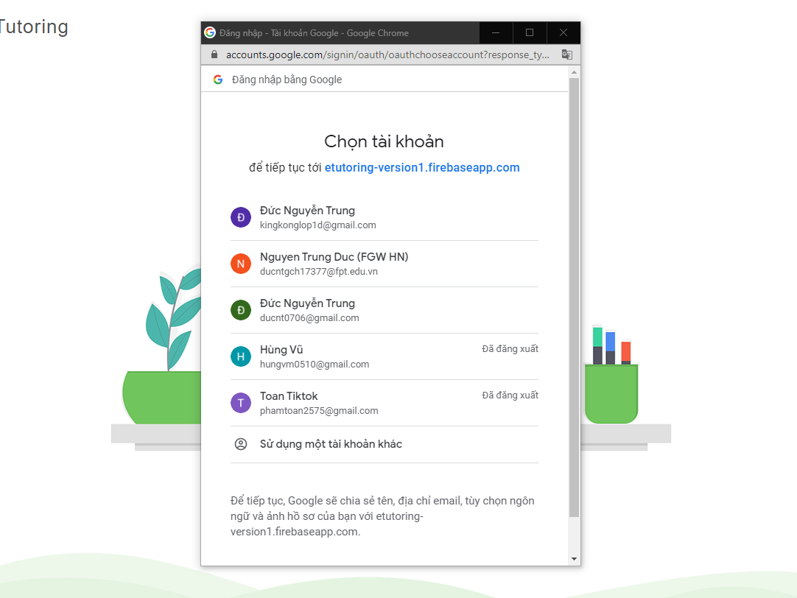

Figure : Login function

* The function of creating contact assigning personal tutor with their students is beautifully designed with contact cards, using minimalist icons, bright colors to help users easily check information. Speed ​​to save and load data quickly. This function meets 90%

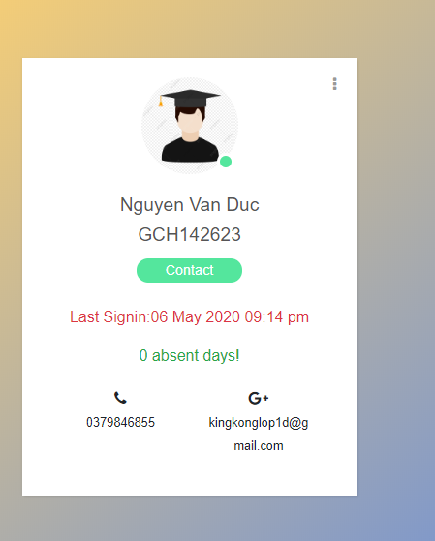

Figure Contact card

* The personal dashboard of student and tutor has been designed in a minimalist manner including navigation bars and common icons that make the user experience easy to use.

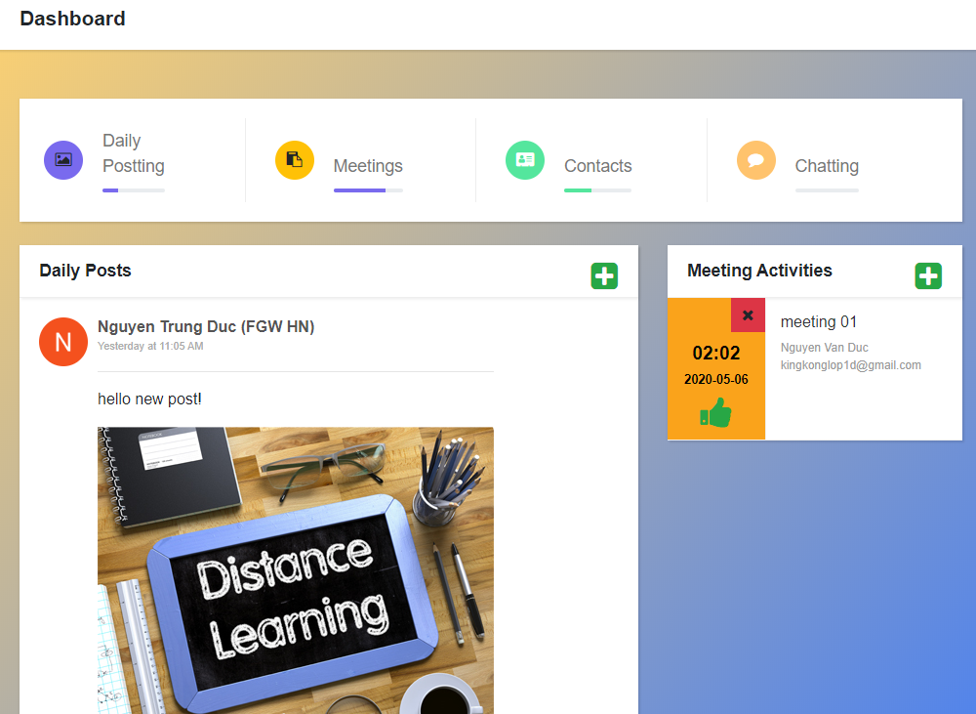

Figure Personal dashboard

* Functions like posting, blogging, comments, create meeting, verify meeting are complete and easy to use. Nice interface design, however, the only minus is the interface on devices such as phones and tablets that are not really beautiful. This function meets 80%

The next section, I will summarize the advantages and disadvantages of the entire system. Firstly, I will say advantages of our E-Tutoring:

* Website interface: Our E-tutoring has a complete and beautiful interface. Bright images and eye-catching colors with gradients create a sense of harmony. Therefore, it can attract users. The layout of the website is harmonious, complete and reasonable. The content is presented briefly and is replaced by icons if necessary. Website with brand logo, popups appear only when necessary.
* Performance: Website deployed on firebase ensures continuous and uninterrupted operation. Average page load speed is about 0.1 seconds displaying the first content of the web page. Average content display speed after real-time data change of 0.5s.
* Functions: The functions of our website meet 95% of the requirements set by our customers. It is easy to use; users can immediately understand how to use it. Each function focuses on the necessary, minimalistic, cumbersome procedures are eliminated.
* Security: The website has two layers of security that make it difficult for hackers to access the system. The first layer of security, the account authentication feature of google, ensures that unauthorized logins cannot be performed. The data stored in the database is protected by firebase rules that prevent read and modify permissions if the login is not performed.

However, I admit that the system has many disadvantages including the following:

|  |  |  |
| --- | --- | --- |
| Aspect | Disadvantage | Solution |
| Website interface | The interface for authorized staff is quite simple, the buttons, toolbar ... have not really attracted users. Information on the dashboard is complex, not focused on the main content. Many inactive navigations make cumbersome | Remove unnecessary content on the interface, change the text with icons if necessary. Important content uses striking colors or larger font sizes |
| Performance | The performance of the entire site is still quite slow. The maximum response time for the first interaction can be about 1.3 s. | Distribute smaller JS files, minimize Css files, and delete unnecessary resources like images, Css file. Turn on text compression |
| Security | There is no policy of strict binding with 3rd parties in the storage and use of user data in providing authentication services by Google and data storage on Firestore. | Add security policies and necessary legal conditions |
| Functions | Not guarantee all the required functions from the requirement. The system lacks email notification to students and tutors whenever important events occur. | Additional missing feature |

Table Advantages and disadvantages of E-Tutoring system

## Evaluation of process:

In this section, I will continue to make assessments about the process of applying Srcum in our team. Our process began by receiving a list of requirements from our customers. Following the Scrum model, we did the Sprint Planning Meeting before starting the project. At this meeting, based on the requirement we received, we outlined the product backlog based on the user stories received. However, the first obstacle we encountered was probably still confused between Scrum project development and waterfall model. For example, at first, we were distracted by dividing the system into two development parts, front-end development and then back-end development instead of planning each user story. However, because of the explanation of the lecturers, we have realized the difference in Scrum model and have a complete product backlog.

Based on the product backlog items, we continued to plan and target these items with specific tasks divided by each team member. Normally, the time to conduct a sprint lasts for 4 days, each team member takes on a different role: database designer, programmer, tester. To keep track of the work, after every working day I and the other members have to fill the remaining work time in the sprint backlog. And to ensure that members do not delay sprint time. About 2 days, we organized a short meeting within 15 minutes (as known as daily meeting). Here, we discussed each sprint's progress and solve each member's difficulties together. However, the biggest difficulty we encountered was probably not being able to conduct face-to-face meetings due to the epidemic. Therefore, daily scrums are usually held on google meetings. To overcome this problem, we extended the meeting time by 10 minutes, using tools like presentation on google meeting with online dashboard tool, everyone would listen to the presenter.

The next obstacle I and the team members encountered was not being able to hold regular review sprint meetings. Because this project is for academic purposes only, there are no customers participating in these meetings. And to solve this problem, after 4 days for each sprint, we organized 2 sprint review meetings and sprint retrospective meeting at the same time in 2 hours. Here, team members will replace the product owner role to evaluate the recently completed feature. We ourselves will decide whether to continue to develop new sprint or unsatisfactory sprint development and draw lessons.

As for me, apart from the common difficulties that the whole development team encountered, the biggest obstacle for me was probably maintaining harmony with the other members throughout the sprint backlog. For example, my main role in every sprint is a back-end programmer so I often have to wait for other members to build the front-end first. If the front-end development process is delayed, my work must also be stopped. The solution to this problem, at every daily meeting, I often ask my teammates about their problems, if it’s necessary I can help them to overcome together.

## Self-evaluation:

The next part of this report will talk about my contribution to the team as well as to the product. In this project, my main role is back-end programmer. However, the first time before starting the project, I was sprint savvy. So, before I started sprint backlog one, I was the scrum master. In this role, I organized the first meeting to plan a sprint planning meeting. At this meeting, I shared with all the members about everything I know about Srum. Then we discuss how to create a Product backlog based on user stories. And after the team had a product backlog and the team members understood their role for the team and the scrum process, a member of my guest kept the position of a scrum master to monitor the process, I came back with the main role is back-end programmer.

During group meetings, I tried to suggest the main issues the group needs to address, and provide feedback if another member loses focus. Sometimes, my teammates were slow to provide a functional interface so I could not continue to code back-end for it, I often asked them to help and overcome difficulties together. For example, Chinedu and I coded the login function for the tutor role together. He had difficulty using bootstrap to make the site more beautiful. When I realized that, I provided him with scholarly literature on how to use bootstrap and reading it with him to understand each other's work. Since then, our work has become smooth.

As for my role as a back-end programmer, I did not wait for reminders or assignments from others. After completing the back-end for a sprint, I continued to learn about technology and solutions for the next sprint. In the process, I realized that the most difficult thing was not to find a solution to a problem. Sometimes, I applied the right solution to solve that problem but still have a technical error that makes it not work as expected. However, I am always flexible in finding a way to solve the problem, I often used to debug and testing tools to find it, in case I didn't find the error, I found another solution to replace it. So. For example, I had difficulty passing the props value from the parent component to child components in the deeper layer by passing the normal props of react. After having tried many times, I decided to find a new solution using React's use-Context library and it worked.

However, I also have many disadvantages that I need to overcome. Firstly, I usually attend the daily meeting more than 5 minutes later, which makes other members spend time waiting and extending the meeting time. To fix it, I installed a software that reminded me of the time on my smart phone and I fixed it from sprint 3. And finally, I believe that my efforts have contributed a lot in the project completion on schedule and time set.

## Evaluation of team:

In this section, I will use a weighted scoring model with my own criteria and weighting to evaluate the contribution and skills of each team member including me. After that, it will reflect the details for each individual.

|  |  |  |  |  |  |  |
| --- | --- | --- | --- | --- | --- | --- |
| Member | Nguyen Trung Duc | Pham Van Toan | Mac Xuan Hung | Vu Manh Hung | Ta Van Duc | Igbo Kingsley Chinedu |
| **Behavior** | **Score (total:25)** | | | | | |
| Attend all meetings | 5 | 5 | 4 | 5 | 4 | 4 |
| Join the meeting on time | 4 | 5 | 4 | 4 | 4 | 4 |
| Complete the task on time | 4 | 4 | 4 | 4 | 4 | 4 |
| Fully prepared for each meeting | 5 | 4 | 5 | 5 | 4 | 5 |
| Notify when it is late or absent whenever the meeting takes place | 5 | 5 | 4 | 4 | 5 | 4 |
| Subtotal | 23 | 23 | 21 | 22 | 21 | 21 |
| **Teamwork** | **Score (total:40)** | | | | | |
| Join the discussion group | 5 | 5 | 5 | 3 | 3 | 3 |
| Suggestions and ideas for group | 5 | 5 | 4 | 4 | 4 | 4 |
| Is open to criticism/questioning | 4 | 4 | 5 | 4 | 5 | 5 |
| Recognize the expertise of others | 4 | 4 | 4 | 5 | 5 | 5 |
| Do not interrupt group discussions | 4 | 4 | 5 | 4 | 5 | 5 |
| Ready for give and receive; flexible | 5 | 5 | 5 | 5 | 5 | 5 |
| Listen to others | 4 | 4 | 5 | 5 | 5 | 4 |
| Follow the calendar and plan | 5 | 5 | 4 | 3 | 4 | 3 |
| Subtotal | 36 | 36 | 37 | 33 | 36 | 34 |
| **Leadership** | **Score (total:35)** | | | | | |
| Make suggestions to other members | 4 | 5 | 4 | 4 | 4 | 4 |
| Shares leadership with other members | 5 | 4 | 5 | 4 | 4 | 4 |
| Propose important issues to discuss | 5 | 3 | 4 | 4 | 4 | 4 |
| Focus everyone's attention on main issue | 5 | 4 | 5 | 4 | 4 | 4 |
| No waiting for work from others | 5 | 5 | 5 | 4 | 4 | 4 |
| Help others finish their work | 4 | 5 | 5 | 4 | 4 | 4 |
| Pulls team members together | 4 | 4 | 5 | 4 | 4 | 4 |
| Subtotal | 32 | 30 | 33 | 28 | 28 | 28 |
| **Technical Competency** | **Score (total:25)** | | | | | |
| Can explain own work to others | 3 | 5 | 4 | 4 | 4 | 4 |
| Able to fix technical errors | 5 | 5 | 4 | 3 | 4 | 3 |
| Conducts research as needed | 4 | 4 | 4 | 4 | 4 | 4 |
| Create accurate statistical data | 4 | 4 | 4 | 5 | 4 | 4 |
| Participates in “number crunching” | 4 | 5 | 4 | 5 | 5 | 5 |
| Subtotal | 20 | 23 | 20 | 21 | 21 | 20 |
| **Work Product** | **Score (total:25)** | | | | | |
| Write as agreed upon | 4 | 4 | 5 | 5 | 5 | 5 |
| Finish the complete work | 5 | 5 | 5 | 4 | 5 | 5 |
| Ability to write professionally | 4 | 4 | 5 | 5 | 4 | 5 |
| Ability to present well | 4 | 4 | 4 | 4 | 4 | 5 |
| Expected consistent output | 5 | 5 | 4 | 4 | 4 | 4 |
| Subtotal | 22 | 22 | 23 | 22 | 22 | 24 |
| **OVERALL EVALUATION** |  | | | | | |
| Grade you would assign for project contribution (4.0, 3.3, 2.7 etc.) | 5 | 5 | 5 | 4 | 5 | 4 |
| Grade you believe they would assign you | 5 | 5 | 5 | 5 | 5 | 5 |
| Would you work with him/her again? Y/N | Yes | Yes | Yes | Yes | Yes | Yes |
| Relative contribution to projects (divide 100 points BETWEEN all your group members – total points allocated = 100) | Yes | Yes | Yes | Yes | Yes | Yes |

Table Evaluate team members

Our team includes of 6 members: Nguyen Trung Duc (back-end programmer), Vu Manh Hung (Scrum Master, web-designer), Ta Van Duc (font-end programmer, web-designer), Igbo Kingsley Chinedu (Tester, font-end programmer), Mac Xuan Hung (DB designer, programmer).

* Firstly, Igbo Kingsley Chinedu is the only foreigner in my group. He is a very active person in every group activity. In addition to his main role as a tester, he is also actively involved in front-end code for the interface parts of the tutor role. Because my task is to program the back-end, his work directly affects my process. However, he has never let me down, always completing tasks on time and being fully prepared for meetings. Every time he gets in trouble, he often shares with the group to find a solution together. At every meeting, he always participates fully and on time, if absent, will notify the group directly. Overall, despite the language differences, Chinedu and our team worked through it effectively.
* The next member is Pham Van Toan. He is the last team participant from another team. Despite being a latecomer, he immediately caught up with the team's progress. Toan became the main back-end programmer for the role of authorized staff functions. It can be said that he is someone who has experience in react languages ​​and is technically competent. Every time I had problems and needed solutions, he always suggested me interesting ideas and it helped me solve all those problems easily. Toan is a flexible member, he not only completes his job quickly without waiting for the impulses of others. He is also active in proposing new solutions and ideas to help accelerate the team. In the team, Toan is a very important member.
* Next, I want to evaluate Mac Xuan Hung. He is my best friend. However, in this report, I will assess his contributions to the group in the most objective way. Mac Xuan Hung is the main database designer, he is the one who sketches the whole system so we all have an overview of what we need to do. He always proposes important and focused ideas so the whole team can focus on the main issues and move towards a common goal. Besides providing vision for the whole group. He is also one of the important back-end developers for the student role, one of his major contributors is the chat between tutor and student. In short, Mac Xuan Hung is a streetlight to help the group keep the common goal.
* Referring to the front-end, I want to mention Ta Van Duc. He is the main role of the front-end programmer and website designer; he is the first person to help the team visualize the system's outline interface. He really is a person who has a deep understanding of the user interface and experience along with very good front-end programming skills. Many features in his front-end feature such as chat-box interface, posting was created with extremely nice interface .... Speaking of Ta Van Duc, he is considered a human creation.
* Finally, the most important member of the team. Vu Manh Hung in the main role is a scrum master. During project implementation, he is the supervisor of the entire workflow of all members in each sprint. Whenever a member delays a task, he immediately makes a comment so the sprint can continue, or simply motivates members to actively accomplish their work towards a common goal. Besides, he also acts as a back-end programmer for the staff role. Although the staff role interface is simple, it really helps his teammates to complete the assigned function. Vu Manh Hung is considered as the motivation for the team.

Overall, my team is a perfect team and work effectively. Fortunately, there is no conflict in the team. Everyone in the team behaves properly and cooperates. They listen to each other's opinions, and are willing to share difficulties to overcome together. I feel so lucky to have such teammates.

## 2.5 Lesson learn:

In a short time of 2 months, with the guidance of lecturer Lai Manh Dung, I did not have any knowledge about the scrum process, I was able to flexibly apply it to build a complex website. magazine. It runs on its own domain along with its development team. Throughout this process, I have learned many important lessons.

 Firstly, technically, I have gained an understanding of the new programming language, react, its structure and how it works. Then use it flexibly in combination with the firebase SDK and other libraries like bootstrap 4 to create complete functionality for a website.

Next, I have the opportunity to work in a team environment. Here, I found my good teammates. I have learned how to ensure a balance and good sense between giving personal opinions and listening to others. I was able to collaborate with others in completing a sprint backlog, which initially made it difficult for me to divide the tasks between the common and the private. In particular, in my group there is a member who is a foreigner, but for me this is an opportunity for me to be able to work in a team in an international multilingual environment. Overcoming all the aforementioned difficulties I had a very good team.

Finally, and perhaps the most important lesson, I learned and applied a professional scrum management model to develop a highly applicable website system. This is an important knowledge so I can be confident in the corporate environment. I have learned a lot of skills from following the scrum model. First, perhaps the time management skill, usually the development time for each system function according to the sprint is very short of 4 days. That made me have to plan details for tasks such as keyword research, finding solutions, choosing the right technology and executing code. Because of this, I have improved a lot in solving a problem.

However, besides that, I also realize that my close friends still have many disadvantages that need to be overcome as I often come over at the first meeting. And I solved it by setting alarms on my smartphone that reminded me whenever a meeting took place. Besides, I also need to improve a lot in the ability to present. Perhaps, I will take a training course on it. The lessons above for me are extremely valuable for my future work.

# Conclusion:

The Scrum model is really an effective and flexible model for developing a web-based secure role-based system in an enterprise environment with teams. We have seen the product created by applying a scrum management model that meets most customer requirements in a short time. Scrum shows effectiveness in team environment, when promoting strengths, creating cohesion and cooperation between developers and customers. There is no doubt that scrum is considered one of the most popular models today in an enterprise environment. It provides businesses with a process consistent with the construction of team projects, it creates close relationships with customers. So, the project always meets the requirement. Scrum will be one of the strong development models in the future.

# References

The standish group .(2012) *CHAOS MANIFESTO 2012: The Year of the Executive Sponsor*. Report number:64.