

***A RESEARCH IN KARAOKE APPLICATION ON ANDROID***

Student name: Nguyen Trung Duc

Report: COMP1682

Assessor name: Doan Trung Tung

## Domain:

In this section, we will explore concepts as well as clarify aspects of the domain karaoke application. Firstly, according to dictionary.cambridge.org, “Karaoke is a form of entertainment, originally from Japan, in which recordings of the music but not the words of popular songs are played, so that people can sing the words themselves.” Besides, Karaoke is a Japanese portmanteau word. It is a combination of two Japanese words, ‘Karappo’ which means ’empty’ and ‘Okesutura’ means ‘Orchestra’. This is simply understood based on the background music of famous songs to perform or sing.

Nowadays, wherever you perform karaoke, there is usually an interactive screen involved. The singer uses this to select their song and read the lyrics as they perform. It’s performed in bars and pubs worldwide or can also be performed in the comfort of your own home using karaoke machines, TV monitor systems or through downloadable karaoke apps.

*History:*

There’s some mystery surrounding how karaoke started. One belief is that it began in a Japanese snack bar when the owner invited guests to sing to backing tracks when the booked musician didn’t turn up. It is commonly accepted that karaoke was founded by the Japanese singer and inventor Daisuke Inoue, who built the world’s first karaoke machine, The Juke 8, in 1971. Inoue created the karaoke machine to help some artists in a local band get started.

Sing along music is widely accepted as the predecessor of Karaoke. The concept of sing-along began in the US in the 1960s with the American TV show, Sing Along with Mitch. The program included superimposed lyrics at the bottom of the tv screens, so viewers could sing along at home.

There is some dispute whether karaoke is Japanese of Filipino. There was an influx of musicians and performers from the Philippines into Japan at the time. These musicians brought “minus-one music” with them – cassette recordings which had versions of the same song available with and without lyrics.

The first karaoke machine was created in Japan in the early 1970s, and the industry grew from there. It started out in hotels and bars and was viewed as a gimmick. Over the years its popularity grew, with venues hosting regular nights. By the 1990s, karaoke spread to the rest of world.

Videoke is a lesser known variation of karaoke. Much like karaoke, the singer will perform lyrics from a digital screen to a backing track with a cursor to help them keep pace. But unlike the original version, the singer will be given a rating at the end of their performance. They have to follow timing and pacing cues throughout the song to try and achieve the 100 top score grade.

Videoke is mainly performed at home and it’s most popular in the Philippines. Any type of sing-along music is incredibly popular with the Filipinos; almost every home in the Philippines has some form of karaoke entertainment. If they don’t have a machine, they have a Magic Sing Microphone – a digital mic that connects to the TV to turn it into a karaoke player.

*The components of a karaoke application and karaoke application solutions:*

In this section, based on the knowledge and definitions studied, I will give an overview of the role and structure of a karaoke presentation device or software.

Frist at all, karaoke application makes it easier for users to perform or sing their favorite songs. In general, a Karaoke application will consist of two parts: the beat part (the instrumental music) and the lyrics display. In other words, a karaoke application will include sound and interface. In general, the beat of music (audio) processed in all karaoke applications is exactly the same. This is simply done by searching for available beats on music download sites like Spotify, Zing Mp3, etc. Then users only need to download and use it as the accompaniment of the instrument for the song... Or we can create our own beat music by using specialized software for music like FL Studio, Cubase ... However, within the scope of research and development of this project, I will not concern about create music beats on the aforementioned software, only use publicly provided beats on copyrighted music download sites. The second part of a karaoke application is the lyrics display, there are many solutions to accomplish this task and this is also the main difference that helps distinguish karaoke applications. Some solutions include:

Traditional karaoke application interface, it is designed like a video, the lyrics will be presented in turn to run the video, the singers simply follow the lyrics and sing along to avoid being unfamiliar with the lyrics.

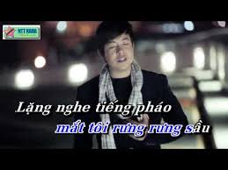

Karaoke application modern interface, with the modernization of technology, today, the interface of karaoke application is becoming more and more diverse. Some of the features listed are interactive video chat, scoring, chatting, etc. But one of the most important display features and will be thoroughly researched during the construction of this application is: Track user's voice in real time. This way the performers can more easily adjust the vocals to match the rhythm of the song.

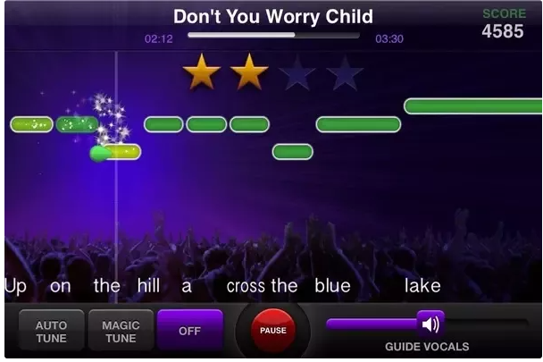

*Similar Karaoke app:*

Laptops, smartphones, and smart TVs play an important role in entertainment in this digital era. There are apps that can make your phone a karaoke device and you can enjoy karaoke without a karaoke machine. The apps for karaoke are very popular among people who love singing. Here is the list of few popular and best karaoke apps for your Android phone.

Yokee Karaoke: The Yokee is one of the best and popular karaoke app that lets you and your friends sing karaoke for free. This app has millions of karaoke songs, with music and lyrics. You can choose from a huge catalog of music genres: Pop, R&B, Rock, Rap, Hip-Hop, Country, Latin, French, Russian, JPop and more. You can also use special audio and video effects and share what you make with the singers’ community in this app. The Yokee Karaoke app has over 100 million Karaoke fans who use this app to enjoy Karaoke. You cannot just record karaoke; you can also share your performance with the world. The app keeps adding new song daily, so you always have choices of new song to sing.

Smule – The Social Singing App: The Smule karaoke app has millions of free songs with music and lyrics. It is a social singing app where you can sing and make music with friends and fans around the world. The app gives a platform to sing solo or duet with people across the globe. This free karaoke app has many audio effects and video filters that you can use while singing your favorite karaoke songs. You can even sing live for friends and fans on this app.

WeSing: WeSing is the karaoke singing app by Tencent Music Entertainment. You can record your performances on any of your favorite songs and share your talent on the internet. You can record and edit karaoke songs. Use pitch correction and check it in real-time. You can also add video filters to make your recording more professional. The app also has voice effects to make your recordings more interesting. The WeSing app has huge high-quality library covers hit songs. It also supports duets with celebrities.