House Price Prediction — Final Report
Table of Contents


IT5315E — Business Analytics · Group Project · Final Report

How Much Is This House Worth —
and How Sure Are We?
House Price Prediction for a Real Estate Listing Platform:
from raw data to a monitored, deployed valuation tool
Member | Student ID | Role
Đỗ Hoàng Việt | 20252744M | Data Engineer — synthetic data, data dictionary, cleaning
Nguyễn Minh Huyền | 20252007M | Data Analyst — EDA, visualization of price drivers
Nguyễn Thị Huyền Trang | 20251322M | ML Engineer (Modeling) — features, regression models
Bùi Tá Cường | 20242430M | ML Engineer (Evaluation) — CV, residuals, interval calibration
Nguyễn Tiến Đức | 20252076M | MLOps Lead — deployment, API, monitoring
Live valuation tool: house-price-analytics-tjpb7ntxsd6kzbapp7bymmv.streamlit.app
Source code: github.com/ducnt3/house-price-analytics
Prediction API: FastAPI, POST /predict — run locally via uvicorn app.api.main:app

Executive summary
This project builds the complete lifecycle of an analytics product for a real estate listing platform: a model that answers, for any property, "what is its estimated market price — and how confident is that estimate?" The result is a live, publicly accessible valuation tool backed by a documented, reproducible pipeline and a monitoring system that demonstrably detects when the model goes stale. The work follows the CRISP-DM lifecycle: business understanding comes first, and every technical metric we report (RMSE, MAE, MAPE, R², coverage) is derived from a business KPI rather than reported for its own sake (Section 1.3).
Data. The Kaggle Ames housing dataset (1,460 sales, 80 attributes) was extended with 12 synthetic contextual fields — amenity distances, renovation history, days-on-market, and a macro layer of interest rates and a market price index. The extension is anchored to the dataset's real sale dates (January 2006 – July 2010), so the data carries a genuine time axis through the financial crisis. All 175 sales from 2010 were held out as the "incoming stream" for post-deployment monitoring.
Model. Five regressors were compared under 5-fold cross-validation on the log-price target. Ridge regression achieved the best point accuracy (MAPE 8.99%, R² 0.916). We deployed the quantile-LightGBM system instead (MAPE 9.78%) because the business deliverable is a calibrated confidence range: three quantile models plus conformalized quantile regression yield an 80% interval whose coverage we verified empirically at 80.5% — after discovering that the naive quantile band covered only 59% while claiming 80%.
Product. The tool is deployed on Streamlit Community Cloud with the model running in-process, accompanied by a FastAPI prediction service sharing the same serving code. Interval width drives the user experience: ≈$35k ranges for typical homes, ≈$78k for high-value homes, with explicit advice to seek an appraisal when the range is wide.
Monitoring. Replaying 2010 month-by-month through Evidently against four pre-defined retraining triggers, the system recommends retraining from March 2010: the market rebounded faster than the training window, and the model's systematic bias grew to −7.9% by July. The exercise demonstrates the report's central operational lesson — input-drift detection shows that conditions changed, but only error and bias monitoring show that it matters.
Key numbers at a glance:
Item | Value
Listings after cleaning (training window / monitoring stream) | 1,458 (1,283 / 175)
Best point model (5-fold CV) | Ridge — RMSE $23,195, MAPE 8.99%, R² 0.916
Deployed model | Quantile LightGBM (p10/p50/p90) + CQR
Interval coverage: claimed / raw / after calibration | 80% / 59.1% / 80.5%
First retraining signal in the 2010 stream | March 2010 (RMSE & drift); bias alert from April

1 Introduction and business understanding

1.1 The pricing problem of a listing platform
A listing platform loses both ways when prices are wrong. An inflated asking price filters out serious buyers, extends time-on-market, and eventually forces a visible, credibility-damaging price cut. An underpriced home sells quickly but leaves the seller's money on the table — and sellers who later realize it blame the platform. Between these failure modes sits the agent, who must justify a number to both sides long before any formal appraisal exists.
The estimate alone is not enough; its reliability changes the decision. An estimate of $\$180k±\$18k$ supports listing immediately at the point price. The same point estimate at $±\$70k$ says the home is unusual for the market — order an appraisal before committing. A valuation tool that communicates only a point number hides exactly the information that determines how it should be used.

1.2 Approach: the CRISP-DM lifecycle
The work follows CRISP-DM (Cross-Industry Standard Process for Data Mining) — the reference methodology for analytics projects — rather than jumping straight to modeling. CRISP-DM insists that business understanding comes first and frames every later choice: the technical metrics we report exist only because a business objective demanded them (Section 1.3). Its six phases map onto the course's eight modules as follows.
CRISP-DM phase | What it means here | Module(s) · report §
Business understanding | Frame the pricing problem, define who is hurt by error, agree KPIs before touching data | M1 · §1
Data understanding | Assemble the Kaggle base + synthetic context; explore distributions, drivers, and the time axis | M1–M2 · §2–3
Data preparation | Clean with before/after evidence; engineer features; enforce leakage discipline and check multicollinearity | M3–M4 · §4–5
Modeling | Train and compare five regressors; build quantile models for a confidence range | M5 · §6–7
Evaluation | Cross-validate, analyze residuals, and verify interval coverage against the KPIs — not just accuracy | M5 · §6.3–7.3
Deployment | Ship a live tool + API, then monitor drift, error, and bias with pre-defined retraining triggers | M6–M7 · §8–9

1.3 Business question, success criteria, and the metrics they justify
Business question. Given a property's characteristics and location, what is its estimated market price, and how confident is that estimate?
A prediction is only useful if it changes a decision, so we fixed the business KPIs — the outcomes a platform actually cares about — before modeling, then derived the technical metric that measures each one. This is the chain that gives RMSE, MAE, MAPE and R² their meaning: each earns its place by answering a business question, not because it is a standard number to report.
Business goal | Business KPI (stakeholder language) | Technical metric | Target · result
Estimate close enough to act on | Typical error stays inside the margin agents negotiate within anyway | MAPE (relative error), reported with MAE in dollars | ≤ ~10% · 9.78% deployed (MAE ≈ $15k)
Don't distort platform market statistics | Valuations aren't systematically high or low across the portfolio | Mean signed error (bias) as % of median price | |bias| ≤ 5% · monitored, alerts in 2010 (§9)
Tell the user how much to trust the number | An "80% range" really contains the price 80% of the time | Empirical interval coverage on unseen data | ≈ 80% · 80.5% after calibration (§7)
Right-size uncertainty per home | Tight range for ordinary homes, wide range for unusual ones | Interval width by price segment | informative, not flat · $35k vs $78k (§7.4)
Catch big-dollar misses; explain price variation | Rare large errors are penalized; the model demonstrably captures real drivers | RMSE (selection + monitoring tripwire); R² (sanity/communication) | RMSE $24.4k drives §9 alert at 1.25×; R² 0.88–0.92
Read top-down, the table is CRISP-DM's business-understanding phase made concrete: the deliverable is a calibrated, unbiased, decision-changing estimate, and every metric in Sections 6–9 traces back to one of these rows.

1.4 Cost asymmetry of mispricing
Over- and under-valuation are not symmetric in business impact. Overpricing costs time: our synthetic days-on-market field encodes the empirical rule that homes priced above their neighborhood's typical level sit longer (Section 2.3), and every extra week on market weakens the negotiating position. Underpricing costs money directly at closing. The confidence range addresses both: it tells the seller how much downside protection an asking price near the upper bound still has, and warns when the model simply does not know.

2 Data: sources, synthetic extension, and trustworthiness

2.1 Sources
Base (required): the Kaggle competition dataset "House Prices — Advanced Regression Techniques" — 1,460 residential sales in Ames, Iowa with 80 structural, locational and condition attributes plus the sale price [1]. Competition rules prohibit redistribution, so the raw files are not committed to the repository; the README documents the download procedure and every derived artifact is committed instead.
Extension (required synthetic component): 12 contextual fields generated in Python with seeded randomness. Appendix A reproduces the full data dictionary — column, type, unit, valid range, and the generation logic or business assumption behind each field. Three design principles governed the generation, described next.

2.2 Principle 1 — a real time axis, not an invented one
The course requires monitoring "as new sales data arrives", which presupposes a time dimension the static Kaggle snapshot lacks. Rather than inventing listing dates, we anchored listing_date to the sale dates already inside the data (YrSold/MoSold): January 2006 – July 2010, 55 months. Two properties follow. First, internal consistency — no row is "listed" years after it actually sold, a contradiction any careful reviewer would find in an invented axis. Second, the window spans a genuine market narrative — the U.S. financial crisis — giving the macro layer a defensible shape.
A synthetic macro layer is overlaid on this axis: a local interest-rate series following the broad path of U.S. 30-year mortgage rates (6.25% in 2006, peaking 6.65% mid-2007, cut to 4.75% by 2010), and a market price index with a boom (+5.5% to mid-2007), a crisis decline (−10% peak-to-trough through 2009), and a +9.5% rebound during 2010. Each sale price is re-expressed under this index:
$${sale_price}_{i} = {SalePrice}_{i}×\frac{I(m_{i})}{\overset{‾}{I}}×ε_{i}, ε_{i}∼LogNormal(0, 0.02)$$
where $I(m_{i})$ is the index level in listing month $m_{i}$, $\overset{‾}{I}$ the window average, and $ε_{i}$ idiosyncratic negotiation noise. The original Kaggle price is preserved unmodified in sale_price_kaggle for full auditability.
The rebound is the designed drift signal: it occurs entirely inside the monitoring holdout (all 175 sales of 2010), so a model trained on 2006–2009 has never seen rising prices and under-predicts 2010 progressively — for an explainable business reason, not an arbitrary synthetic shock. Its magnitude was deliberately chosen to be detectable within a seven-month stream; sharp post-crisis recoveries of this size occurred in real U.S. metropolitan markets.
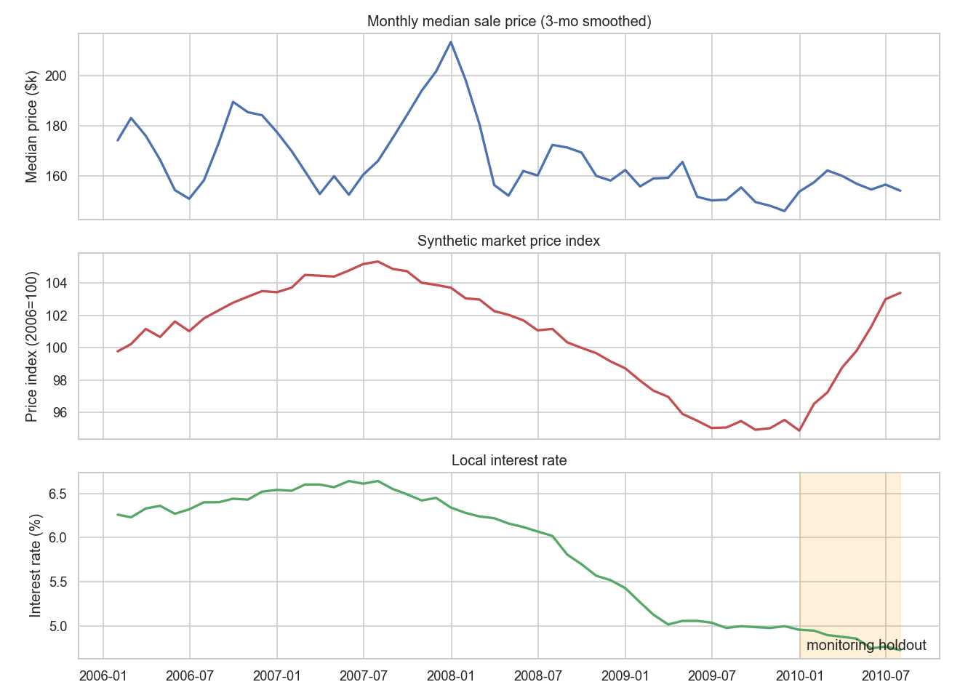
Figure 1 — Monthly median sale price, synthetic market index, and interest-rate series, 2006–2010. The shaded band marks the monitoring holdout; the 2010 rebound is visible only there.

2.3 Principle 2 — behavioral realism, generated conditionally
Purely random contextual fields would be easy to generate and worthless to analyze: they could not carry any signal for EDA or modeling. Every synthetic field is therefore generated conditionally on real structure:
- Amenity distances are a neighborhood property. In a small city, school or hospital access is decided by where the subdivision sits, not by a per-house lottery. Each of the 25 neighborhoods receives one base distance per amenity; individual homes scatter log-normally around it. The bases encode a stated assumption: pricier neighborhoods sit closer to schools and hospitals (families pay for access), while transit distance is drawn independently of price — bus lines follow arterial roads, not wealth. The realized correlations (−0.60 for schools, +0.10 for transit) match the assumptions and become testable EDA claims.
- Renovation fields agree with the real data. A home is flagged renovated exactly when the Kaggle remodel year exceeds its build year; renovation cost scales with living area and finish quality (≈$15–44 per sq ft, log-normal spread). No synthetic claim contradicts an observable Kaggle column.
- Days-on-market responds to pricing and to the market. Base of ~35 days, scaled by how far the home is priced above its neighborhood median (power 1.8) and by market coldness (index below its 6-month trend), so listings sit visibly longer during 2008–09 — median 38 days versus 32.5 in 2006.

2.4 Principle 3 — documented imperfections
Real listing pipelines produce dirty data. Because the Kaggle base is relatively clean, Module 3 would otherwise have little genuine work, so five realistic data-quality problems were injected deliberately — seeded, documented with exact rates, only into synthetic fields, and only before 2010 so the monitoring stream is never confused with dirt:
# | Field | Injected problem | Rate (realized)
1 | dist_school_km | Missing — field left blank at listing entry | 2% (26 rows)
2 | renovated | Inconsistent free-text labels: Y, yes, YES, N, no, NO | 4% (51 rows)
3 | days_on_market | Legacy sentinel 999 = "unknown" | 0.4% (5 rows)
4 | dist_transit_km | Entered in metres instead of km | 0.3% (4 rows)
5 | whole row | Home re-posted days later under a new listing id | 12 rows
Because the ground truth is known, the cleaning module can prove — not merely claim — that each problem was found and fixed (Section 4).

2.5 Trustworthiness is enforced, not asserted
Every property claimed above is encoded as an automated test: the time axis matches the real sale dates row-by-row; the monitoring stream contains no injected dirt; school distance correlates negatively with price while transit does not; renovation fields agree with the remodel column; the target carries the boom–crisis–rebound shape; and regeneration from the fixed seed reproduces the files byte-for-byte. A documented claim that could silently rot is worth little in an analytics product; the test suite makes the data dictionary binding.

3 Exploratory data analysis
The EDA (executed notebook in notebooks/) answers three business questions: what drives price, how the market moves over time, and which variables are redundant. It runs on the raw extended data, so the data-quality problems it surfaces hand off directly to cleaning.

3.1 The target is right-skewed — model on the log scale
Sale prices have median $162,900 against mean $181,407 with a long right tail to $779k; skewness 1.93. Untransformed, expensive homes would dominate any squared-error objective. After the transform
$$y = log\left(1+SalePrice\right)$$
skewness falls to 0.12, and multiplicative structure (a garage adds a percentage, not a fixed dollar amount) becomes additive — friendlier to linear baselines. All models in Section 6 predict $y$; metrics are reported after back-transforming to dollars.
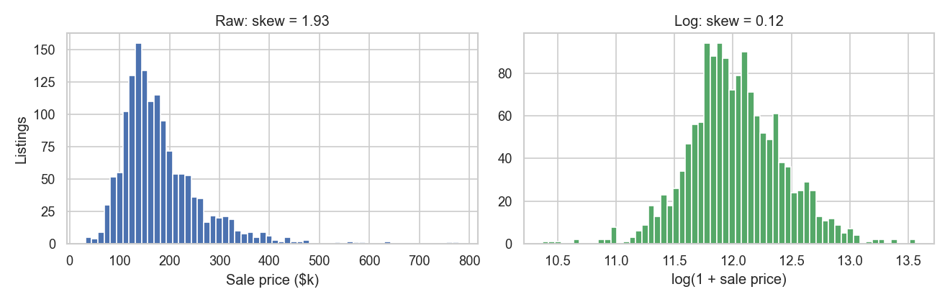
Figure 2 — Sale price distribution, raw (skew 1.93) and after log transform (skew 0.12).

3.2 What drives price
Overall quality (r = 0.79) and above-ground living area (r = 0.71) dominate — median price nearly quadruples from quality 3 ($85k) to quality 9 ($346k). The synthetic amenity fields behave exactly as designed: school distance r = −0.60, hospital −0.58, transit ≈ +0.10. Renovation cost correlates 0.69 with price but is partly derivative — it was generated from area × quality, so it echoes those drivers rather than adding independent signal; it is flagged for the multicollinearity check.
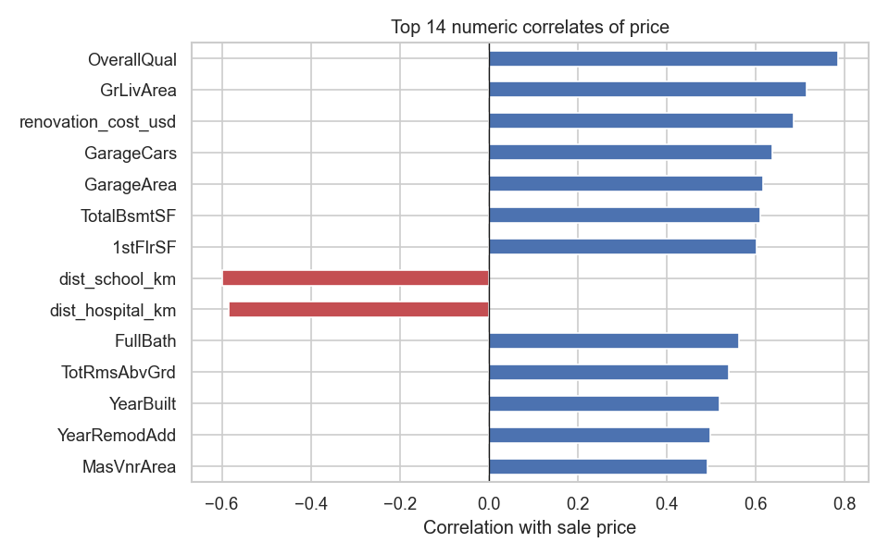
Figure 3 — Top numeric correlates of sale price. Red bars are negative correlations.
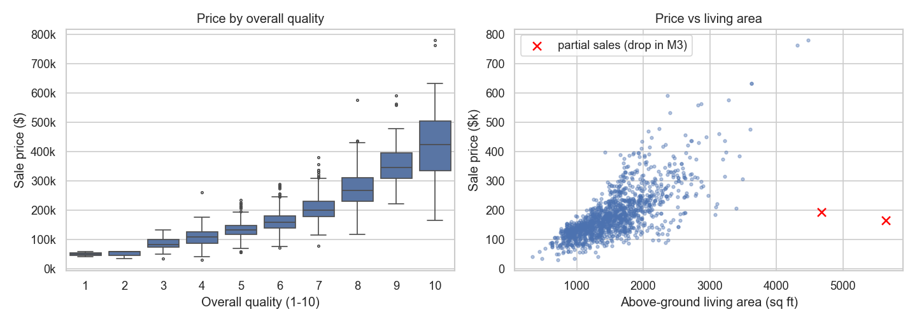
Figure 4 — Price by overall quality (left) and price vs living area (right). The two red crosses are the notorious Ames partial sales (Ids 524, 1299) — huge homes sold far below trend, removed with justification in cleaning.

3.3 Location: a 3.5× price lever, largely explained by amenities
Neighborhood medians span $90k (MeadowV) to $313k (NridgHt) — a 3.5× spread on physically comparable structures. The amenity panel explains much of the premium in our data: price falls steadily with school distance while the transit panel is flat. For the platform this is an actionable, falsifiable statement: school proximity is priced in; bus access is not.
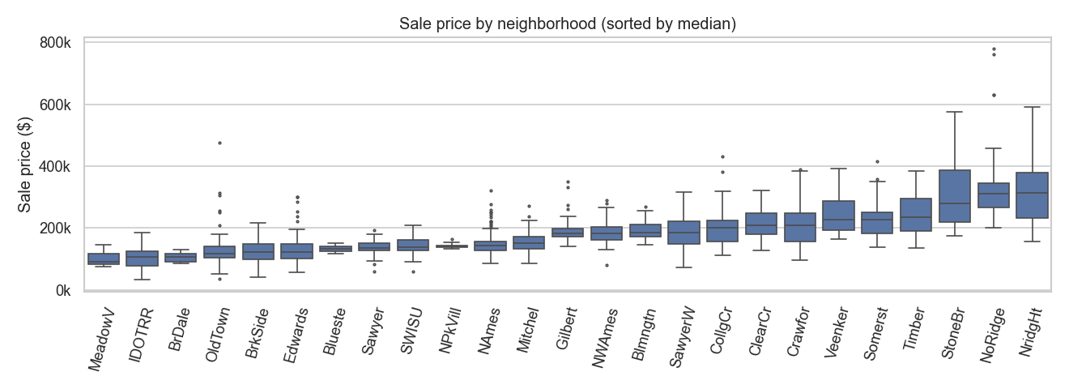
Figure 5 — Sale price by neighborhood, sorted by median.
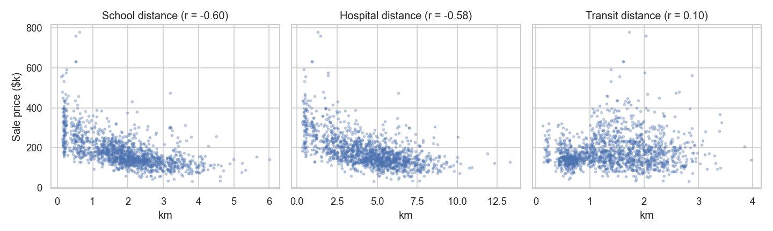
Figure 6 — Price vs distance to school / hospital / transit. The school and hospital relationships were generated as neighborhood-level tendencies; transit is deliberately unpriced.

3.4 The market moves — a price model ages
Figure 1 already showed the trend: +5% boom to mid-2007, −10% through 2009, and a rebound the training window never sees. Days-on-market lengthens in the cold market (median 38 days in 2008 vs 32.5 in 2006) and interest rates fall from 6.6% to 4.7%. The EDA's operational conclusion is the premise of Section 9: in a moving market, a fixed model is a depreciating asset; monitoring is not optional.

3.5 Multicollinearity: several variables say the same thing
Four pairs exceed |r| = 0.8: garage cars / garage area (0.88), rooms / living area (0.83), first-floor / basement size (0.82), year built / garage year (0.83) — plus the constructed renovation-cost echo. Left unaddressed, this destabilizes linear coefficients and muddies any "what drives price" story told from them. Section 5 prunes to one variable per concept and verifies with VIF.
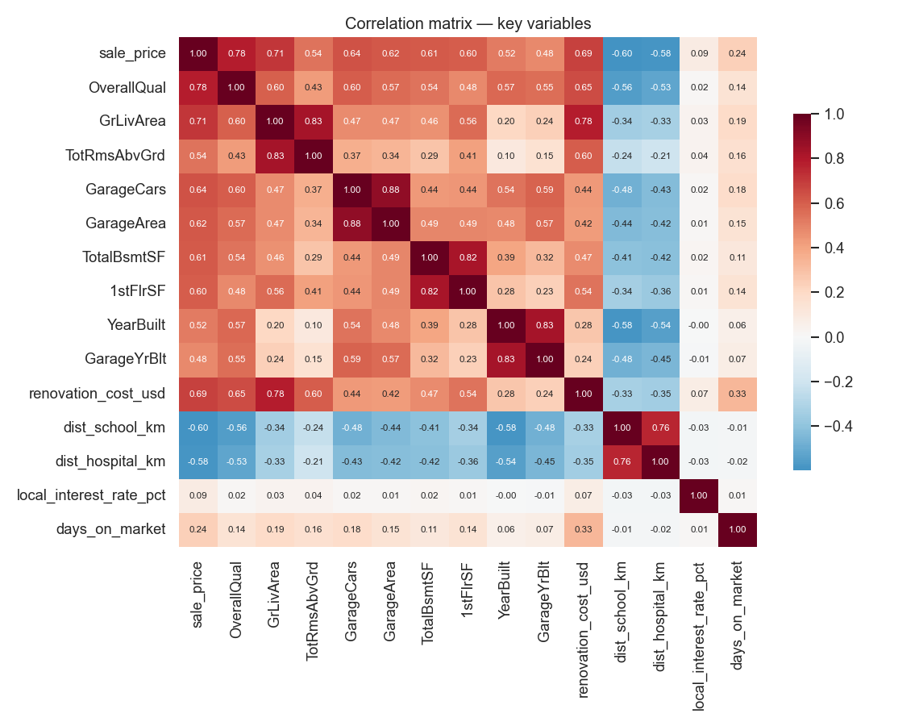
Figure 7 — Correlation matrix of key variables. Clusters of dark red off the diagonal are the redundancy groups.

4 Data cleaning
Every fix targets a diagnosed cause; nothing is dropped or imputed blindly. The cleaning script prints this evidence table on every run, and assertions guarantee no unexpected missing values leave the stage.
Step — problem and diagnosed cause | Fix | Before | After
Duplicate listings: same home re-posted under a new listing id | Keep the earliest posting (the original listing event) | 12 | 0
Renovation flag entered as free text (Y / yes / NO / …) | Normalize to canonical Yes/No | 51 | 0
Days-on-market sentinel 999 = "unknown" from a legacy export | To missing, then impute the listing-quarter median (market conditions drive DOM, so imputation stays within period) | 5 | 0
Transit distances implausibly > 100 km in a town ~10 km across — metre entry | Divide by 1,000 | 4 | 0
Missing school distances (blank at entry) | Neighborhood median — amenity access is a neighborhood property by construction | 26 | 0
Kaggle categoricals where NA means "no such feature" (pool, alley, fence…) | Explicit category, so "absent" is information rather than a gap | 7,480 cells | 0
LotFrontage genuinely missing | Neighborhood median — street frontage is set by the subdivision plan | 259 | 0
Partial-sale outliers: two homes > 4,000 sq ft sold far below trend (Figure 4) | Dropped — not market transactions a valuation tool should learn from | 2 rows | —
1,472 listings in → 1,458 out. One imperfection class deserves comment: the renovation-flag cleanup can be verified against ground truth, because the canonical value is recoverable from the Kaggle remodel-year column — after normalization the flag agrees with it in 100% of rows. This is the payoff of injecting dirt with known truth (Section 2.4): cleaning quality is measured, not assumed.

5 Feature engineering and multicollinearity

5.1 Leakage discipline
Only information available at valuation time may enter the model. Two fields were excluded on this principle:
- days_on_market — an outcome of the listing, unknown on the day the home is priced. Including it would be predicting the price of a sale that already happened.
- market_price_index — a citywide index is published with a lag; feeding the model the current month's value would be look-ahead leakage and would trivially encode the target's trend. Its exclusion is also what makes monitoring meaningful: the model cannot see the 2010 rebound through a leaked index, so the drift signal is genuine.
The interest rate stays: it is public knowledge on listing day.

5.2 Derived features and pruning
Derived: property age, years since remodel, combined bathrooms (full + 0.5·half, both floors), renovation flag and cost, listing month (seasonality), and an amenity-proximity score (kept for reporting, excluded from the model as a function of the three distances already present). Redundancy is resolved by keeping one variable per concept: garage cars, not garage area (r = 0.88); living area + basement area, not room count (r = 0.83). The final feature set: 16 numeric + 6 categorical variables.

5.3 Verification with variance inflation factors
$${VIF}_{j} = \frac{1}{1−R_{j}^{ 2}}$$
where $R_{j}^{2}$ comes from regressing feature $j$ on all other numeric features. Values above 10 conventionally signal problematic collinearity.
Feature | VIF | Feature | VIF
property_age | 3.93 | renovation_cost_usd | 1.54
OverallQual | 3.06 | OverallCond | 1.46
dist_school_km | 2.91 | Fireplaces | 1.43
GrLivArea | 2.62 | LotArea | 1.17
dist_hospital_km | 2.59 | dist_transit_km | 1.13
years_since_remodel | 2.28 | local_interest_rate_pct | 1.02
total_baths | 2.16 | listing_month | 1.01
GarageCars | 1.90 | TotalBsmtSF | 1.62
Maximum VIF is 3.93 — comfortably below the threshold, so the linear baselines of Section 6 are stable and their coefficients interpretable.

6 Model development and evaluation

6.1 Protocol
All models are trained on the 1,283 sales of the training window (2006–2009) and compared with 5-fold cross-validation (shuffled, fixed seed). Predictions are made in log space and back-transformed; metrics are computed on the dollar scale:
$$RMSE=\sqrt{1/n\sum_{i=1}^{n}{(}y_{i}−{\hat{y}}_{i})^{2}} MAE=1/n\sum_{i=1}^{n}{|}y_{i}−{\hat{y}}_{i}|$$
MAPE=100%ni=1nyi−yiyi R2=1−i​(yi−yi)2i​(yi−y)2
RMSE penalizes large misses (relevant when a single badly mispriced luxury home is costly); MAE reflects the typical case; MAPE normalizes across price levels and maps directly to the "negotiation margin" KPI; R² summarizes explained variance. Each row of the KPI-to-metric bridge in Section 1.3 is answered below: MAPE/MAE here, bias in Section 9, and coverage/width in Section 7. Linear models receive standardized numerics and one-hot categoricals; tree models receive raw numerics and native categorical splits.

6.2 Candidates and results
Model | Key settings | RMSE | MAE | MAPE | R²
Linear Regression | — | $23,409 | $15,806 | 9.11% | 0.914
Ridge | α = 10 | $23,195 | $15,573 | 8.99% | 0.916
Lasso | α = 0.001 | $23,324 | $15,670 | 9.04% | 0.915
Random Forest | 300 trees, min leaf 2 | $29,509 | $18,469 | 10.43% | 0.863
LightGBM | 600 trees, lr 0.05, 31 leaves | $27,441 | $17,334 | 9.78% | 0.882
The linear family wins, and the result is instructive rather than embarrassing: after the log transform the price surface is close to linear in the drivers, and with only ~1,300 training rows, low-variance estimators beat flexible ones. A regularization sweep on LightGBM (smaller trees, feature/row subsampling) improved it only marginally (≈$26.6k RMSE), confirming the pattern is structural, not a tuning artifact.

6.3 Residual analysis
Cross-validated residuals show no trend against fitted values and no material bias in deciles 2–9. Two findings worth reporting: the cheapest decile is over-predicted by ≈13% on average (the model is reluctant to believe how cheap the cheapest homes are), and the most expensive decile is slightly under-predicted (−4.7%) — both classic shrinkage-toward-the-mean behavior. The first is flagged as a limitation; neither threatens the tool's core use, and the confidence interval widens exactly where these effects live.
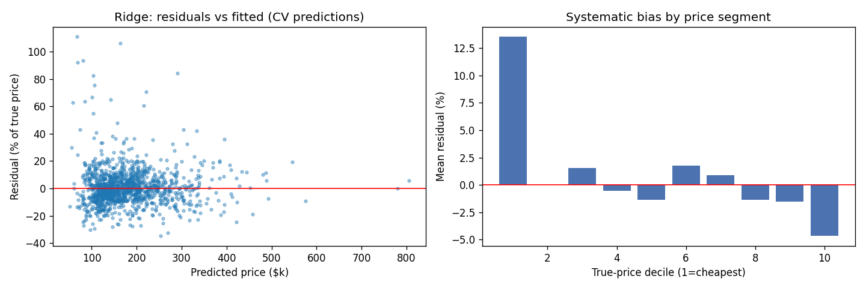
Figure 8 — CV residuals vs fitted values (left) and mean residual by true-price decile (right) for the best point model.

6.4 Model selection: accuracy is not the deliverable
We deploy the quantile LightGBM system — three models sharing one regularized configuration (1,500 trees, learning rate 0.03, 8 leaves, feature and row subsampling, L2 = 1.0), trained at $α=0.10,0.50,0.90$, with the median model serving as the point estimate. The reasoning, stated openly:
- The business question demands a per-home confidence range. Quantile regression yields feature-dependent intervals natively — wide where the model is genuinely uncertain, narrow where it is not.
- One coherent model family avoids stitching a Ridge point onto intervals from a different model — mismatched point/band and two failure modes instead of one.
- The point-accuracy cost (9.78% vs 8.99% MAPE) is immaterial against the negotiation-margin KPI, and the comparison above is reported rather than hidden.

7 Calibrated confidence intervals

7.1 Quantile regression
Each quantile model minimizes the pinball loss
$$L_{α}(y,\hat{y}) = max\left(α (y−\hat{y}), (α−1) (y−\hat{y})\right), α∈\{0.10, 0.50, 0.90\},$$
whose minimizer is the conditional $α$-quantile [2]. The p10–p90 band therefore claims 80% coverage by construction.

7.2 The naive band lies — and how we caught it
On a 20% calibration split (257 sales) never used in training, the raw band contained the true price only 59.1% of the time. This is a known failure mode: quantile estimates on finite samples are themselves noisy and systematically too narrow. Shipping this band would have violated the honesty KPI while looking perfectly rigorous.

7.3 Conformalized quantile regression
CQR [3] measures the shortfall on the calibration set through the conformity score
$$E_{i} = max\left({\hat{q}}_{0.10}(x_{i})−y_{i}, y_{i}−{\hat{q}}_{0.90}(x_{i})\right)$$
— positive where the band missed, negative where it had slack — and widens the band by the empirical $(1−α)$-quantile of the scores:
$$\hat{C}(x) = \left[{\hat{q}}_{0.10}(x)−Q_{1−α}(E), {\hat{q}}_{0.90}(x)+Q_{1−α}(E)\right], 1−α=0.80.$$
The method carries a finite-sample coverage guarantee under exchangeability, and crucially preserves the shape of the quantile band — wide for unusual homes, narrow for common ones — while fixing its level. (Scores are computed in log space, so the correction is multiplicative in dollars.)
Verified coverage after calibration: 80.5% against the 80% target. Interval width by predicted-price tercile: ≈$35k (typical), ≈$41k (mid), ≈$78k (high-value) — monotonically increasing, as an honest uncertainty estimate must be, since a fixed percentage error compounds on a larger base and high-value homes are rarer in the data.

7.4 Uncertainty as a product feature
The interval is not a statistical garnish; it drives the user experience. The deployed tool translates relative width into advice: a tight range (<25% of the estimate) is labeled a common home profile; a wide range (>40%) explicitly recommends a professional appraisal before pricing. The width thereby routes low-confidence cases to the expensive-but-reliable channel — which is exactly how a platform should consume model uncertainty.

8 Deployment: the working product

8.1 Architecture
Two consumer surfaces share one serving layer (ValuationService), so they can never disagree:
- Valuation tool (primary, live). A Streamlit application on Streamlit Community Cloud with the model loaded in-process. The live demo therefore depends on exactly one running service; a second service failing cannot take it down. Users enter eight primary characteristics (plus optional details); unspecified fields fall back to training-median defaults — a "typical home" prior.
- Prediction API. A FastAPI service exposing POST /predict and GET /health with OpenAPI documentation. All fields are optional and validated (unknown neighborhood values return an explicit 422 with the valid list, never a silent wrong answer); the response echoes which defaults were applied.
POST /predict
{"Neighborhood": "NAmes", "GrLivArea": 1500, "OverallQual": 5, "property_age": 30}
→ {"estimate_usd": 165900, "range_low_usd": 135800, "range_high_usd": 178600,
"coverage": 0.8, "relative_width_pct": 25.8, "defaults_applied": ["TotalBsmtSF", …]}

8.2 De-risking, and a real vendor shock
Free-tier deployment is the most binary deliverable — it runs or it does not — so the pipeline was proven in week one with a placeholder model, before any real modeling. The insurance paid out almost immediately: the original target (Hugging Face Spaces) moved all compute apps behind a paid plan mid-project. Because deployment was already a solved, tested path, pivoting to Streamlit Community Cloud (free, approved by the brief, deploying straight from the public GitHub repository) cost hours, not weeks, and required zero application changes.

8.3 Reproducibility
Python 3.11 everywhere; every dependency pinned; a lean deployment requirement set kept separate from the development environment so monitoring and EDA libraries never ship to production; one fixed seed governs data generation, splits, and model training. Appendix B lists the complete command sequence that rebuilds every artifact in this report from the raw Kaggle files. A test suite (data invariants, service sanity, API contract, and a render test that executes the Streamlit app script) runs on every change.

9 Post-deployment monitoring

9.1 Design
The 175 held-out sales of 2010 are replayed month by month through Evidently [4], exactly as a production system would meet new sales. Each month is evaluated on a rolling three-month window: single months carry only 6–48 sales, too few for stable statistics — we verified that a 10-row window flags every feature as drifted, which is noise, not signal. Drift tests additionally require at least 40 rows; the calendar month field is excluded from drift testing since the calendar always "moves". Four retraining triggers were fixed before the stream was examined — committing to thresholds up front prevents tuning alerts until they fire:
Trigger | Definition | Rationale
T1 — Data drift | >30% of input features drift (per-column statistical tests) | The world the model sees has changed
T2 — Performance | Rolling RMSE > 1.25 × training baseline ($24.4k) | Errors have materially grown
T3 — Systematic bias | |rolling mean error| > 5% of window median price | Consistent one-directional mispricing distorts the platform even at acceptable RMSE
T4 — Interval health | Observed coverage of the 80% range < 65% | The confidence promise itself is breaking

9.2 Results on the 2010 stream
Month | Window n | RMSE | Bias | Drift share | Coverage | Verdict
2010-01 | 10 | $16,180 | +2.2% | n/a (<40) | 80% | —
2010-02 | 25 | $15,484 | −0.4% | n/a (<40) | 80% | —
2010-03 | 46 | $31,957 | −4.0% | 76% | 72% | Retrain: T1 + T2
2010-04 | 75 | $27,507 | −5.2% | 67% | 69% | Retrain: T1 + T3
2010-05 | 108 | $25,913 | −6.5% | 48% | 74% | Retrain: T1 + T3
2010-06 | 123 | $25,427 | −7.4% | 38% | 73% | Retrain: T1 + T3
2010-07 | 90 | $27,676 | −7.9% | 57% | 76% | Retrain: T1 + T3
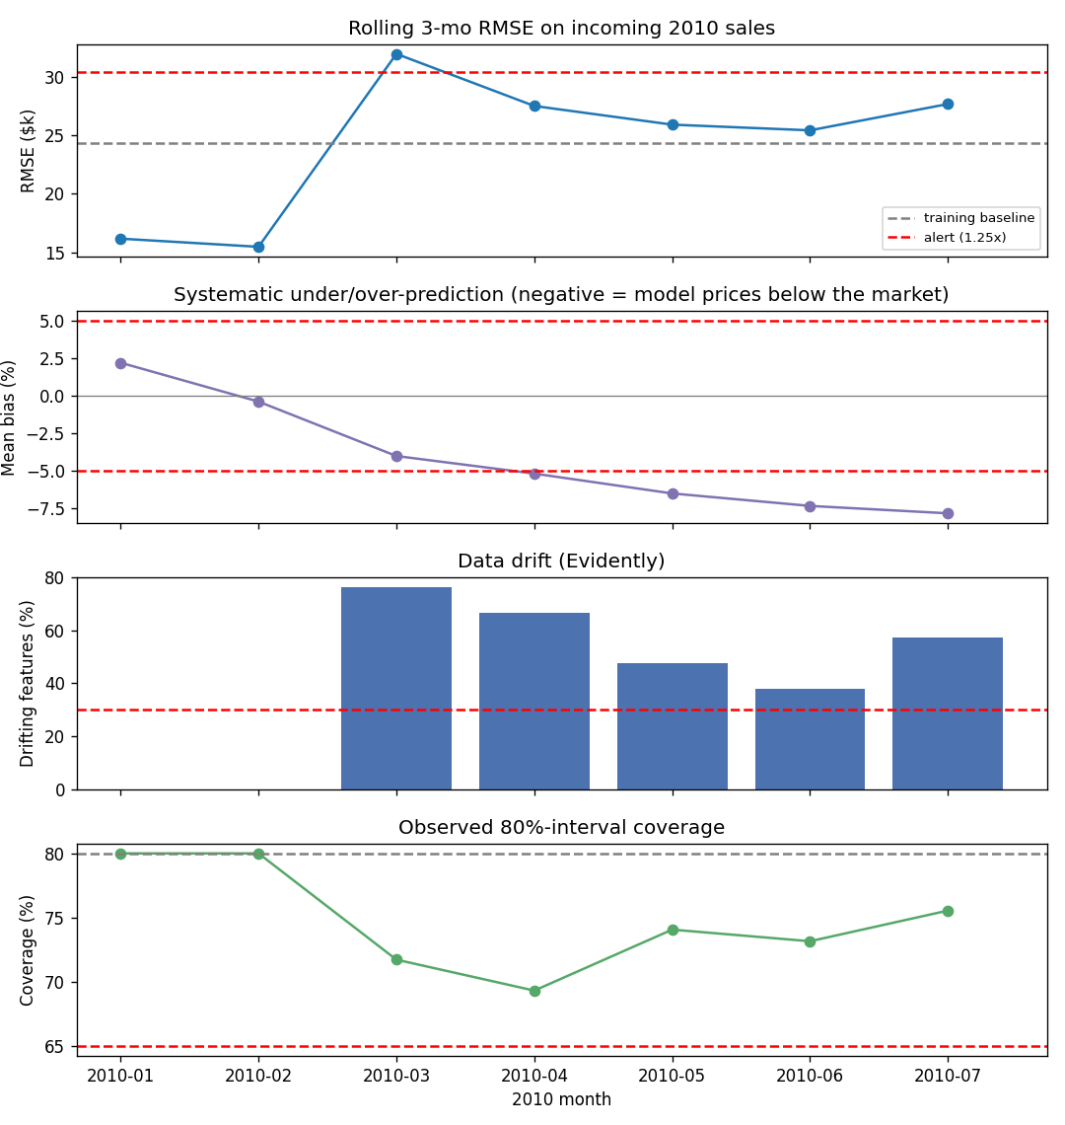
Figure 9 — Rolling RMSE, systematic bias, feature-drift share, and observed interval coverage across the 2010 stream. Dashed red lines mark the alert thresholds.

9.3 Reading the dashboard
The story unfolds in three acts. January–February look healthy: errors below baseline, coverage on target. March breaks first — an RMSE spike coincides with drift crossing its threshold, driven by an interest-rate regime the training window never contained (drift score 1.9 versus the 0.1 test threshold) plus a genuine post-crisis shift in the mix of homes coming to market. From April, the signature of the designed rebound takes over: RMSE settles back near baseline, but systematic bias marches from −0.4% to −7.9% — the model prices every home below a recovering market — while interval coverage sags from 80% to ~73%, approaching but not breaching its floor.
Operational verdict: retrain from March 2010. The deeper lesson: input-drift detection (T1) shows that conditions changed; only error and bias monitoring (T2/T3) show it matters. A platform that watches only feature distributions would know something happened but not whether to care; one that watches only RMSE would have missed the bias creep until customers complained about consistently low valuations. Monitoring predictions and their errors — not just inputs — is the design conclusion this project demonstrates end-to-end.

10 Business recommendations
- Price on quality and location first. Overall quality, living area, and neighborhood — the latter largely via school proximity — carry most of the pricing signal; renovation history refines it. Listing forms should make these fields mandatory and validated, since valuation quality depends on them most.
- Show the range, not just the number. A calibrated range converts the tool from a black box into a negotiation aid: sellers see the defensible span, agents see when to escalate to an appraisal (wide range = unusual home). Publishing uncalibrated ranges would be worse than none — ours covered 59% while claiming 80% until calibration fixed it.
- Treat the model as perishable. In a moving market, this model drifted beyond tolerance within ~3 months of deployment. Budget quarterly retraining, gated by the four triggers of Section 9, with systematic bias as the most business-critical alarm.
- Route uncertainty to the expensive channel. Wide-interval homes are precisely where a professional appraisal earns its fee; the platform can sell that hand-off as a premium service rather than hiding model weakness.

11 Limitations and future work
- The contextual layer is synthetic. Assumptions are documented and test-enforced, but real amenity and transaction data would change coefficients; the architecture (and the data dictionary discipline) transfers unchanged.
- Prices are at the 2010 Ames level. Any other market needs local data and recalibration; the tool states its market level in the interface.
- The cheapest decile is over-predicted (~13%). A segment-specific model or monotonicity constraints are natural next steps.
- Retraining is recommended, not automated. The next engineering step is a scheduled retrain–evaluate–promote loop with the same trigger gates.
- Monthly samples are small (6–48 sales), bounding monthly drift-verdict confidence — hence rolling windows and minimum-sample gates, which a higher-volume platform could tighten.

12 Conclusion
The project delivers the full lifecycle the course asked for: a documented and deliberately imperfect synthetic data layer with a real time axis; EDA that turns correlations into business claims; cleaning that proves itself against known ground truth; a cross-validated model comparison with an openly reasoned deployment choice; confidence intervals whose stated 80% is verified rather than asserted; a live tool and API sharing one serving path; and monitoring that catches — for explainable reasons and on pre-committed thresholds — the precise moment the model begins to age. The through-line is a single principle: every claim the system makes about itself is either tested or measured.

References
- Kaggle. House Prices — Advanced Regression Techniques. kaggle.com/competitions/house-prices-advanced-regression-techniques. Based on: De Cock, D. (2011). "Ames, Iowa: Alternative to the Boston Housing Data." Journal of Statistics Education 19(3).
- Koenker, R., & Bassett, G. (1978). "Regression Quantiles." Econometrica 46(1), 33–50.
- Romano, Y., Patterson, E., & Candès, E. (2019). "Conformalized Quantile Regression." Advances in Neural Information Processing Systems 32.
- Evidently AI. Evidently: open-source ML monitoring. github.com/evidentlyai/evidently.
- Ke, G. et al. (2017). "LightGBM: A Highly Efficient Gradient Boosting Decision Tree." Advances in Neural Information Processing Systems 30.
- Pedregosa, F. et al. (2011). "Scikit-learn: Machine Learning in Python." Journal of Machine Learning Research 12, 2825–2830.

Appendix A — Data dictionary (synthetic fields)
Grain: one row per listing, keyed to the Ames data by Id. Macro fields are joined from a monthly series. Full version with file-level details: DATA_DICTIONARY.md in the repository.
Column | Type | Unit | Valid range | Generation logic / business assumption
listing_id | str | — | L- + 6 digits | Platform listing key; injected duplicates use prefix L-9.
listing_date | date | — | 2006-01 … 2010-07 | Real Ames sale month (YrSold/MoSold) + random day 1–27.
dist_school_km | float | km | 0.1 – ~6 | Neighborhood base + lognormal scatter; pricier neighborhoods closer to schools (realized r = −0.60).
dist_hospital_km | float | km | 0.5 – ~14 | Same mechanism, range 1.0–8.0 km.
dist_transit_km | float | km | 0.1 – ~4 | Neighborhood base drawn independently of price (bus lines follow roads, not wealth); r ≈ +0.1.
renovated | str | — | Yes / No | Yes iff Kaggle YearRemodAdd > YearBuilt — consistent with the real remodel column.
renovation_cost_usd | float | USD | ~$15k – $400k; NaN if never renovated | Living area × ($12 + $3.2 × OverallQual)/sq ft × lognormal(σ = 0.30).
days_on_market | int | days | 3 – ~250 | 35 × (price ÷ neighborhood median)^1.8 × market-coldness^6 × lognormal(σ = 0.35).
local_interest_rate_pct | float | % p.a. | 4.7 – 6.7 | Monthly macro series shaped like US 30-yr mortgage rates through the crisis.
market_price_index | float | index, 2006-01 = 100 | ~94 – 106 | Boom–crisis–rebound; +9.5% rebound entirely inside the 2010 monitoring stream (designed drift signal).
sale_price | int | USD | ~$34k – $779k | Modeling target — Kaggle price re-expressed under the index (formula in §2.2).
sale_price_kaggle | int | USD | $34,900 – $755,000 | Original Kaggle SalePrice, preserved unmodified for audit.
Injected data-quality problems and their realized rates are listed in §2.4; all injections are restricted to synthetic fields and to listings before 2010.

Appendix B — Reproducibility guide
Requirements: Python 3.11; the Kaggle files train.csv, test.csv, data_description.txt placed in data/raw/ (download requires a Kaggle account; competition rules forbid redistribution).
python3.11 -m venv .venv && source .venv/bin/activate
pip install -r requirements-dev.txt # full env; requirements.txt = lean deploy set
python -m src.data_generation.generate # synthetic data (byte-identical per seed)
jupyter nbconvert --execute --inplace notebooks/eda_price_drivers.ipynb
python -m src.cleaning.clean_listings # prints the before/after evidence table
python -m src.features.build_model_table
python -m src.modeling.compare_models # 5-fold CV comparison + residual figures
python -m src.modeling.train_final # quantile models + conformal calibration
python -m src.monitoring.run_monitoring # replays 2010, writes Evidently reports
pytest tests/ # data invariants + service/API/app tests
streamlit run app/streamlit_app.py # the valuation tool, locally
uvicorn app.api.main:app # the prediction API → /docs
Every step is seeded (RANDOM_SEED = 42); outputs are reproducible byte-for-byte. Monitoring reports land in monitoring/reports/; report figures in reports/figures/.

