<>

**FPT UNIVERSITY**

--o0o--



**Project Report**

eBilling and Invoice System

Students’ name (code on eProject Guide):

1. Nguyen Van Duc - [Ducnvgc00560@fpt.edu.vn](mailto:Ducnvgc00560@fpt.edu.vn) (Leader)
2. Mai Duc Muoi – [Muoimdgc00568@fpt.edu.vn](mailto:Muoimdgc00568@fpt.edu.vn)
3. Nguyen Gia Quyen – [Quyenng00466@fpt.edu.vn](mailto:Quyenng00466@fpt.edu.vn)

Fanculty: Nguyen Viet Khoa

##### **Ha Noi 5/2014**

Table of contents

Problem definition 3

Customer Requirement Specification (CRS) 6

Requirements Analysis 7

Data Flow Diagram 15

Flow Chart 21

Entity Relationship Diagram 25

|  |  |
| --- | --- |
| Name of the Students  (code on eProject Guide) | Nguyen Van Duc (Leader)  Mai Duc Muoi  Nguyen Gia Quyen |
| Name of the Center | FPT University |
| Name of the Project | Ebilling and invoice System |
| Project Start Date/ End Date | 10-Apr-2014/ 10-May-2014 |
| Form | Problem definition |
| Form code | Form No.1/PD/Ver 1.0 |

This project is to be developed for one of the big decorator services in Mumbai, they supply decorating item to film industry for movie shooting. Presently they issue their client handwritten invoice and they enter details in manual register. And maintain MS Excel file for product rate. They want computerization of their manual invoice and bill generation process.

The client uses MS Excel, and maintains their product list, customer list, and prints the invoice, however it is not possible them to share the data from multiple system in multi user environment, there is lot of duplicate work, and chance of mistake. When the product price are changed they need to update each and every excel file. There is no option to find and print previous saved invoice.

There is no security; any body can access any report and sensitive data, also no reports to find out the sales volume, stock list, and summary report. This eBilling and invoicing system is used to overcome the entire problem which they are facing currently, and making complete atomization of manual billing and invoicing system

1. Types of user:
   * Manager
   * Sales Representative
   * Accountant
   * Seller
2. Name of application: eBilling and Invoice System
3. Main function of the application: managing business activities of a company.

|  |  |
| --- | --- |
| Name of the Students  (code on eProject Guide) | Nguyen Van Duc (Leader)  Mai Duc Muoi  Nguyen Gia Quyen |
| Name of the Center | FPT University |
| Name of the Project | Ebilling and invoice System |
| Project Start Date/End Date | 10-Apr-2014/ 10-May-2014 |
| Form | Customer Requirement Specification (CRS) |
| Form code | Form No.2/CRS/Ver 1.0 |

1. Functions of the application:

### Business Requirements

The business goal for the application is to support an increase the productivity and complete automation of existing manual bill and invoice generation process. Business requirements are discussed in the Scope section, with the following additional detail:

* Sales representatives need a method to store and access sales opportunity data, and when a sale is generated, convert some or all of the information into a sales order without re-entering information.
* Each sales representative should receive customer and sales data pertinent only to them.
* The accountant should be able to enter or update product information in one interface only, with all necessary product information being received by sales staff.
* Manager must receive his or her customer and appointment data plus detailed and rollup information for each sales representative on his or her team.
* The application should support the capability to use multi user environment.
* The MIS Executive should able to generate all type of reports as and when required by the management.

The sales staff wants to improve their current ability to analyze their customers. In particular, they want to focus on identifying their best customers and building long-term relationships within that base. To enable them to accomplish this goal, they want to extract meaningful data that easily answers the following questions:

* What are the early warning signs of problems?
* Who are my best customers across product lines?
* With whom do I focus my efforts for building a long-term relationship?
* What are my customers' issues as groups?
* Geographically, where are my best customers?
* What products are my customers buying and at what rate?

### User Requirements

User requirements are categorized by user type.

Sales Staff (Representatives and Managers)

* View the data in various ways, for example:
  + Customers who are the top buyers of specific items
  + Best customers based on criteria to be determined
  + Best customers based on geographical analysis
  + Drops in a customer's sales
* Store multilingual and multiregional information in the database rather than relying on the sales staff to translate the information
* Identify which product prices have been modified, especially on current orders in progress
* Use opportunity rules, which are statements that help the sales representative convert an opportunity into a sale
* Add third-party data sources and financial evaluation tools
* Identify where promotions and programs would be the most beneficial
* Apply discounts to customer orders:
  + Sales representatives can offer discounts up to 15 percent, or up to 20 percent with authorization.
  + Sales managers can offer discounts up to 20 percent
* Enable capture, analysis, and sharing of data about a customer across the company
* Use forecasts to establish sales goals
* Allow all staff to view all contacts, but allow each contact to be assigned to a sales representative

Accountant

* Update product details, including price, photo, and description
* Add, delete, and update product specifications
* Generate stock reports and check the availability, order the item as and when needed.

MIS Executive

* Generate Reports as per requirement.
* Share the data, and convert reports to different format like Text, CSV.

Sales Automation

* Problem customer identification. Ability to identify top 10 developing problem customers by sales representative.
* Identification of best customers across product lines and regions. All customers can be sorted by the factors (to be determined) that rank them qualitatively. Variable sorts and rankings can be chosen by the sales representative.
* Identification of issues across groups. All customers can be sorted by the issues (to be determined) within group categories that can be updated. Variable sorts and rankings can be chosen by the sales representative or other user.
* Analysis of quantities and rates of products. Products can be sorted by the quantity and dates sold. Variable sorts and rankings can be chosen by the user.

## Manage Orders

### Description

This function will enable sales representative to place orders for eBilling and Invoice System products, track submitted orders, and view completed orders and print the invoice.

### Business Need

This function will enable sales representative to interact with eBilling and Invoice System catalog directly without the intervention of any other employees.

### Priority

High

## Manage Products

### Description

This function allows user of eBilling and Invoice System to create, maintain, and delete information about products in the product database that can then be viewed and ordered by customers, and accessed and updated by the sales staff.

### Business Need

This function will support the sales staff with accurate and relevant information, and will also support the Manage Orders function by ensuring up-to-date product information.

### Priority

High

## Manage Contacts

### Description

This function enables the sales staff to create and manage contacts as well as share contact information with the rest of the company.

### Business Need

This function enables user of eBilling and Invoice System to have accurate and up-to-date contact information when working with customers.

### Priority

Medium

## Analyze Customers

### Description

This function allows management to analyze the customer database and find out information, such as the identities of the best customers, the top buyers, and the most popular products.

### Business Need

This function will allow management to determine the most (and least) profitable customers and product lines, enabling better decision making in the running of the business.

### Priority

Medium

## Forecast Sales

### Description

This function allows management to plan and track production costs, track sales results, and plan sales staffing needs.

### Business Need

This function will allow management to manage the revenue streams of the organizations and control costs.

1. Hardware Requirements:
   * A minimum computer system can help you to access all tools in the course
   * 256Mb Ram or higher
2. Software requirements: Java SE 7.0, NetBeans 7.4, MS SQL Server 2008

|  |  |
| --- | --- |
| Name of the Students  (code on eProject Guide) | Nguyen Van Duc (Leader)  Mai Duc Muoi  Nguyen Gia Quyen |
| Name of the Center | FPT University |
| Name of the Project | Ebilling and invoice System |
| Project Start Date/ End Date | 10-Apr-2014/ 10-May-2014 |
| Form | Requirements Analysis |
| Form code | Form No.3 / RA / Ver 1.0 |



*Two – tier architecture*

|  |  |
| --- | --- |
| *Login* | |
| User type | Manager, accountant, seller, Sales Representative |
| Description | A GUI helps user to log in the application |
| Activate | Fill all of fields and click “login” button |
| Pre-condition |  |
| Pos-process |  |
| Flow chart (step by step) | 1. Enter datainput (user code and password) 2. Click “login” button 3. If data is valid, there is a message to alert that log in successfully 4. If data is invalid, there is a message to alert that user code or password was wrong |
| Exception |  |
| Special request |  |

|  |  |
| --- | --- |
| *Main menu* | |
| User type | Manager, accountant, seller |
| Description | A GUI helps user to choose function |
| Activate | Choose and click buttons |
| Pre-condition |  |
| Pos-process |  |
| Flow chart (step by step) | Choose and click to buttons |
| Exception |  |
| Special request | User must login successfully |

|  |  |
| --- | --- |
| *Product management* | |
| User type | Manager |
| Description | A GUI helps manager to manage drugs normally |
| Activate | Fill all of fields and click buttons |
| Pre-condition | User must be manager |
| Pos-process |  |
| Flow chart (step by step) | * Add Product:  1. Click add button, a new form will appear 2. Enter new data to fields 3. Click save button to save data    * If data is invalid, there is a message to alert that the transaction stopped    * If data is valid, there is a message to alert that add successfully  * Delete Product:  1. Choose data rows and click delete button 2. A alert will appear to confirm:    * If you choose “yes”, all data of drug will be deleted    * If you choose “no” or “cancel”, nothing will be done  * Update Product:  1. Click update button, a new form will appear 2. Edit fields in that form to update your product 3. Click save button to save data 4. There is a message to confirm  * If you choose “yes”: * If data is invalid, there is a message to alert that the transaction stopped * If data is valid, there is a message to alert that add successfully * If you choose “no” or “cancel”, nothing will be done * Search:  1. Click search button, a new form will appear 2. Enter data into fields to search  * If there is a result, these informations will appear. You can use buttons to do something with these drugs * If there is nothing, an alert will appear * Clear store:   + - 1. Click clear button       2. A message will be appear to confirm * If you choose “yes”, all data will be deleted * If you choose “no” or “cancel”, nothing will be done * Back to main menu: * Click back button, you will be brought to main menu |
| Exception |  |
| Special request | User must be manager |

|  |  |
| --- | --- |
| *Ebill management* | |
| User type | Manager, seller |
| Description | A GUI helps user can enter Order from customer |
| Activate | Fill all of fields and click buttons |
| Pre-condition |  |
| Pos-process |  |
| Flow chart (step by step) | 1. Press “Select Guess” to choose a customer exited in Guess list or “New Guest” to enter new customer. 2. Choose “Add” button to add some product into right table.  * A new window will be appeared. * You choose a product from Product list * Enter quantity of that Product. * Click “Ok” button to add that Product into product table.  1. Choose “Edit” button to edit quantity of a Product. 2. Choose “Remove” button to remove a product from right table. 3. Press “Calculate” to calculate total money of all Product. 4. Press “Save” to save this Ebill or “Cancel” to exit this windows. |
| Exception |  |
| Special request | User must be manager, seller |

|  |  |
| --- | --- |
| *Bill Managerment* | |
| User type | Manager, accountant |
| Description | A GUI helps user can enter Bill |
| Activate | Fill all of fields and click buttons |
| Pre-condition |  |
| Pos-process |  |
| Flow chart (step by step) | 1. Choose Bill type is Import or Export. 2. If bill type is Import, press Select Order to choose a Order enterd, If bill type is Export, press New Bill.  * If press “New Bill”, a new window will be appear, you enter all information about that Manufactory. * Press “Ok” button to accept and return New Bill windows, or “Cancel” to reject.  1. Choose “Add” button to add some medicines into right table.  * A new window will be appeared. * You choose a medicine from medicines list * Enter quantity and measure of that medicine. * Click “Ok” button to add that medicine into Medicines table.  1. Choose “Edit” button to edit quantity, measure of a medicine. 2. Choose “Remove” button to remove a medicine from right table. 3. Press “Calculate” to calculate total money of all medicines. 4. enter expired Date. 5. Press “Save” to save this Bill or “Cancel” to exit this windows. |
| Exception |  |
| Special request | User must be manager, accountant |

|  |  |
| --- | --- |
| *User management* | |
| User type | Manager |
| Description | A GUI helps manager to manage users who log in the system and use functions |
| Activate | Fill all of fields and click buttons |
| Pre-condition | User must be manager |
| Pos-process |  |
| Flow chart (step by step) | * Add User:  1. Click add button, a new form will appear 2. Enter new data to fields 3. Click save button to save data    * If data is invalid, there is a message to alert that the transaction stopped    * If data is valid, there is a message to alert that add successfully  * Delete User:  1. Choose data rows and click delete button 2. A alert will appear to confirm:    * If you choose “yes”, all data will be deleted    * If you choose “no” or “cancel”, nothing will be done  * Update User:  1. Click update button, a new form will appear 2. Edit fields in that form to update your drug 3. Click save button to save data 4. There is a message to confirm  * If you choose “yes”: * If data is invalid, there is a message to alert that the transaction stopped * If data is valid, there is a message to alert that add successfully * If you choose “no” or “cancel”, nothing will be done * Search:  1. Click search button, a new form will appear 2. Enter data into fields to search  * If there is a result, these informations will appear. You can use buttons to do something with these drugs * If there is nothing, an alert will appear * done * Back to main menu: * Click back button, you will be brought to main menu |
| Exception |  |
| Special request | User must be manager |

|  |  |
| --- | --- |
| *Guest management* | |
| User type | All users |
| Description | A GUI helps user to guests |
| Activate | Fill all of fields and click buttons |
| Pre-condition | User must log in before |
| Pos-process |  |
| Flow chart (step by step) | * Add guest:  1. Click add button, a new form will appear 2. Enter new data to fields 3. Click save button to save data    * If data is invalid, there is a message to alert that the transaction stopped    * If data is valid, there is a message to alert that add successfully  * Delete guest:  1. Choose data rows and click delete button 2. A alert will appear to confirm:    * If you choose “yes”, all data will be deleted    * If you choose “no” or “cancel”, nothing will be done  * Update guest:  1. Click update button, a new form will appear 2. Edit fields in that form to update your drug 3. Click save button to save data 4. There is a message to confirm  * If you choose “yes”: * If data is invalid, there is a message to alert that the transaction stopped * If data is valid, there is a message to alert that add successfully * If you choose “no” or “cancel”, nothing will be done * Search:  1. Click search button, a new form will appear 2. Enter data into fields to search  * If there is a result, these informations will appear. You can use buttons to do something with these drugs * If there is nothing, an alert will appear * done * Back to main menu: * Click back button, you will be brought to main menu |
| Exception |  |
| Special request | User must login |

|  |  |
| --- | --- |
| Name of the Students  (code on eProject Guide) | Nguyen Van Duc (Leader)  Mai Duc Muoi  Nguyen Gia Quyen |
| Name of the Center | FPT University |
| Name of the Project | Ebilling and invoice System |
| Project Start Date/ End Date | 10-Apr-2014/ 10-May-2014 |
| Form | Data Flow Diagram |
| Form code | Form No.4/DFD/Ver 1.0 |

1. Hierarchy Function Diagram

Ebillling and Invoice System

Customer Manager

Ebilling Manager

User Manager

Product Manager

Update

Delete

Product Manager

Add

Update

Delete

Update

Update

Update

Update

Update

Delete

Update

Update

Delete

View

Product Manager

Product Manager

|  |  |
| --- | --- |
| Name of the Students  (code on eProject Guide) | Nguyen Van Duc (Leader)  Mai Duc Muoi  Nguyen Gia Quyen |
| Name of the Center | FPT University |
| Name of the Project | Ebilling and invoice System |
| Project Start Date/ End Date | 10-Apr-2014/ 10-May-2014 |
| Form | Flow Chart |
| Form code | Form No.5/FC/Ver 1.0 |

Flow Chart

1. Login



2. Add Records



3. Update Records



4. Delete Records



5. Search and View Records



|  |  |
| --- | --- |
| Name of the Students  (code on eProject Guide) | Nguyen Van Duc (Leader)  Mai Duc Muoi  Nguyen Gia Quyen |
| Name of the Center | FPT University |
| Name of the Project | Ebilling and invoice System |
| Project Start Date/ End Date | 10-Apr-2014/ 10-May-2014 |
| Form | Entity Relationship Diagram |
| Form code | Form No.6/ERD/Ver 1.0 |

2. Entity Relationship Diagram

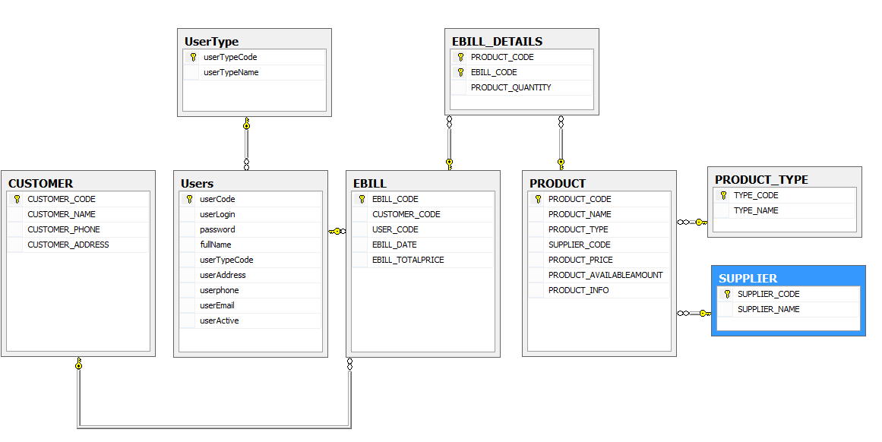

|  |  |
| --- | --- |
| Name of the Students  (code on eProject Guide) | Nguyen Van Duc (Leader)  Mai Duc Muoi  Nguyen Gia Quyen |
| Name of the Center | FPT University |
| Name of the Project | Ebilling and invoice System |
| Project Start Date/ End Date | 10-Apr-2014/ 10-May-2014 |
| Form | Table Design |
| Form code | Form No.7/ERD/Ver 1.0 |

|  |  |  |  |
| --- | --- | --- | --- |
| *productType* | | | |
| Field name | Data type | Constraint | Description |
| productTypeCode  productType | Varchar(10) | Primary key | Types of product |

|  |  |  |  |
| --- | --- | --- | --- |
| *Supplier* | | | |
| Field name | Data type | Constraint | Description |
| supplierCode | Int | Primary key, Identity (1, 1) | Code of each supplier |
| supplierName | Varchar(20) |  | Name of supplier |

|  |  |  |  |
| --- | --- | --- | --- |
| *Product* | | | |
| Field name | Data type | Constraint | Description |
| ProductCode | Int | Primary key, Identity (1, 1) | Code of each Product |
| ProductName | Varchar(50) |  | Name of each Product |
| ProductType | Int | Foreign key references PRODUCT_TYPE(TYPE_CODE) | Type of Product |
| SupplierCode | int | Foreign key references PRODUCT_TYPE(TYPE_CODE) | Supplier of Product |
| Product Price | Float |  |  |
| Product AvailableAmount | int |  |  |
| Product Information | Varchar(50) |  |  |

|  |  |  |  |
| --- | --- | --- | --- |
| *Customer* | | | |
| Field name | Data type | Constraint | Description |
| customerCode | Int | Primary key, Identity (1, 1) | Code of each guest |
| customerName | Varchar(100) |  | Name of each guest |
| customerAddress | Varchar(100) |  | Address of each guest |
| customerPhone | Varchar(15) |  | Phone number of each guest |

|  |  |  |  |
| --- | --- | --- | --- |
| *Bills* | | | |
| Field name | Data type | Constraint | Description |
| billCode | Int | Primary key, Identity (1, 1) | Code of each bill |
| userCode | int | Foreign key references users(userCode) | Code of user |
| CustomerCode | int | Foreign key references Customer(customerCode) | Code of Customer |
| EbillDate | Datetime |  | When create the bill |
| Price | Float |  | Total price of bill |

|  |  |  |  |
| --- | --- | --- | --- |
| *Bill Details* | | | |
| Field name | Data type | Constraint | Description |
| ProductCode | int | Primary key  Foreign key references product(productCode) | Code of each Product |
| billCode | int | Primary key  Foreign key references ebill(billCode) | Code if each bill |
| Quantity | Int |  | Quantity of each Product when you create a bill |

|  |  |  |  |
| --- | --- | --- | --- |
| *Users* | | | |
| Field name | Data type | Constraint | Description |
| userCode | int | Primary key Identity (1, 1) | Code of each user. They use their code like username to login |
| userLogin | Varchar(30) |  | Name of each user |
| Password | Varchar(10) |  | Password of each user. They use it to login |
| fullName | Varchar(20) |  | Full name user |
| userTypeCode | int | Foreign key references userType(userTypeCode) | Type of each user: manager, accountant, seller |
| userAddress | Varchar(50) |  |  |
| userPhone | int |  |  |
| userEmail | Varchar(50) |  |  |
| userActive | int |  |  |

|  |  |
| --- | --- |
| Name of the Students  (code on eProject Guide) | Nguyen Van Duc (Leader)  Mai Duc Muoi  Nguyen Gia Quyen |
| Name of the Center | FPT University |
| Name of the Project | Ebilling and invoice System |
| Project Start Date/ End Date | Nguyen Van Duc (Leader)  Mai Duc Muoi  Nguyen Gia Quyen |
| Form | GUI |
| Form code | Form No.8/GUI/Ver 1.0 |

Login:

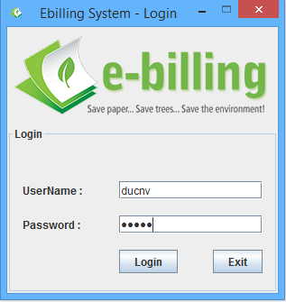

System Main :

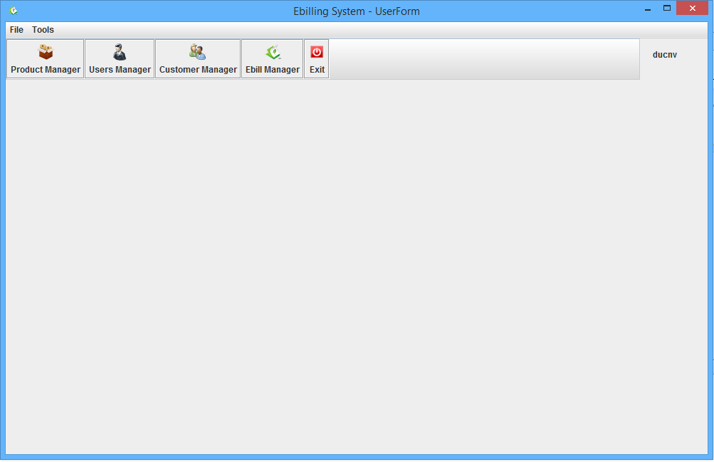

Product Manage :

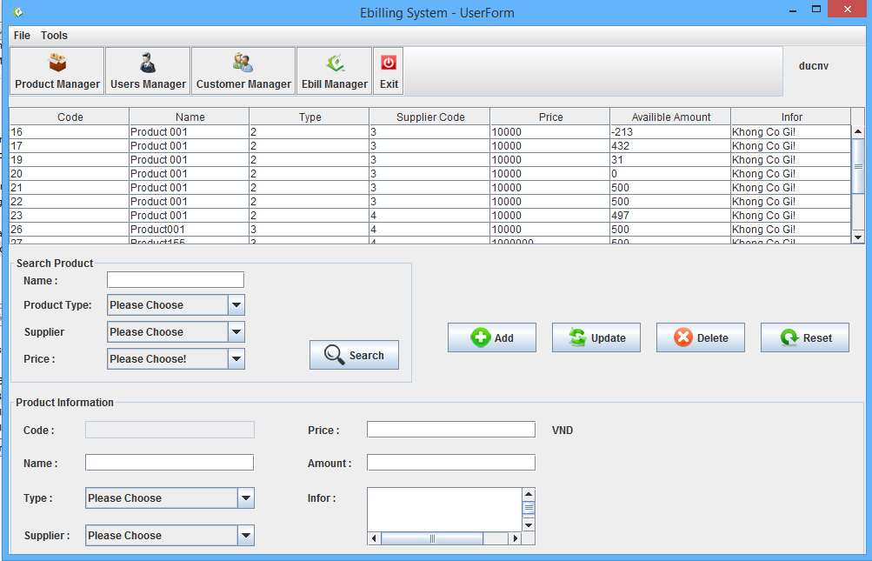

Users Manage:

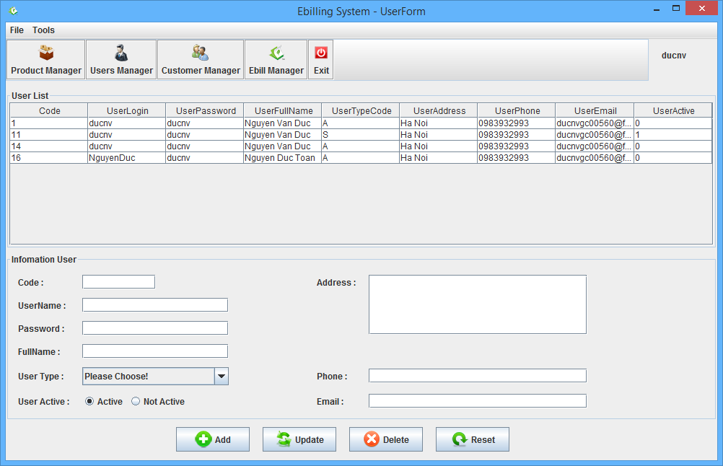

Customer Manager:

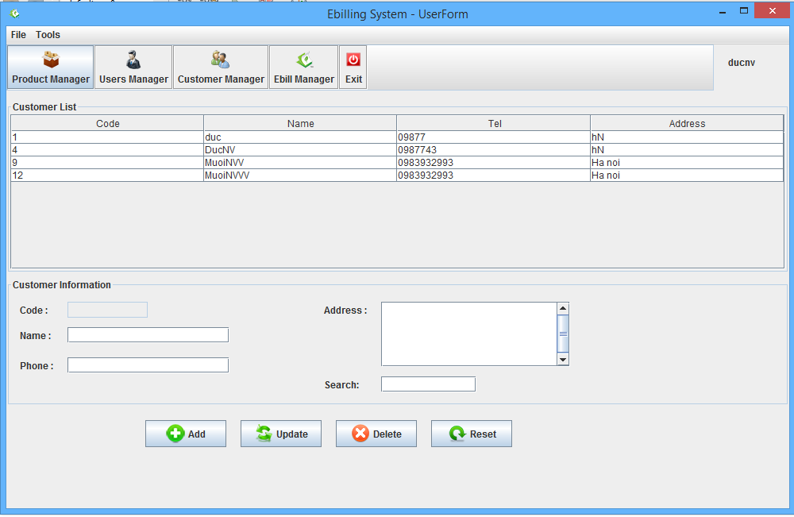

Ebill Manage: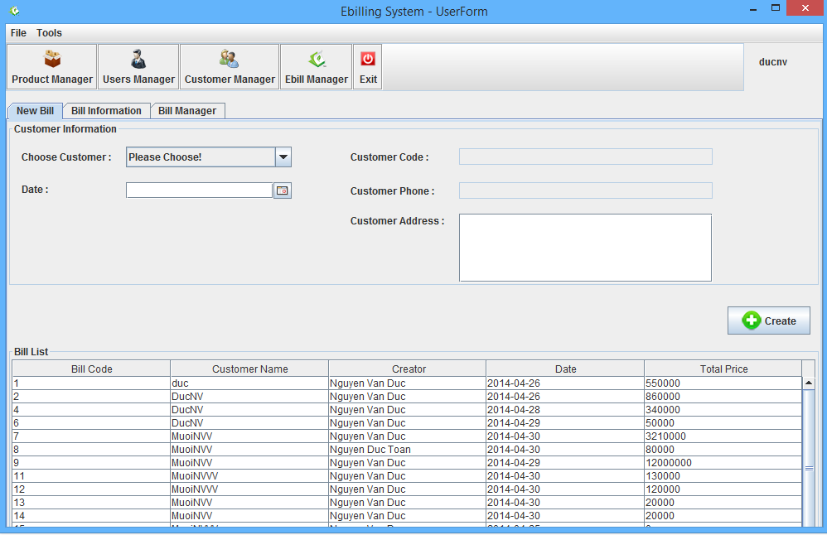

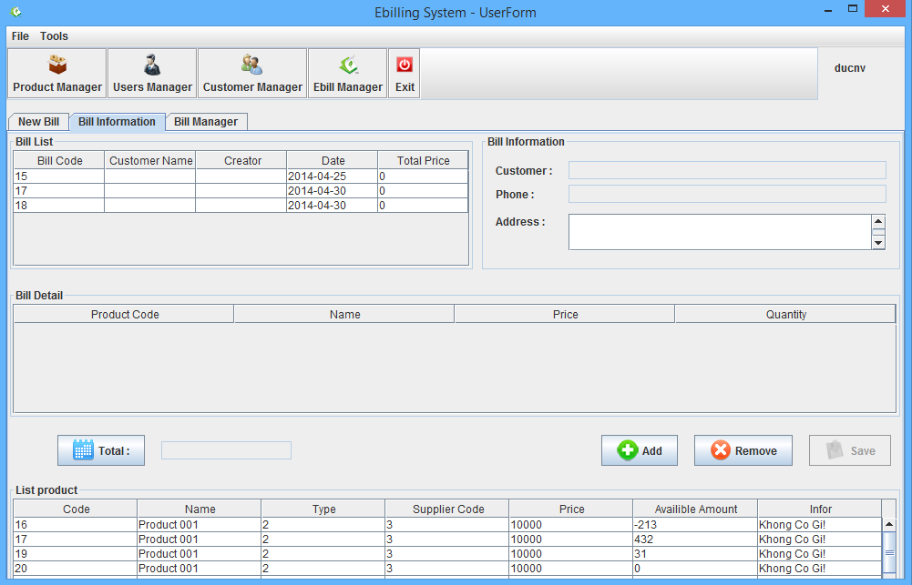

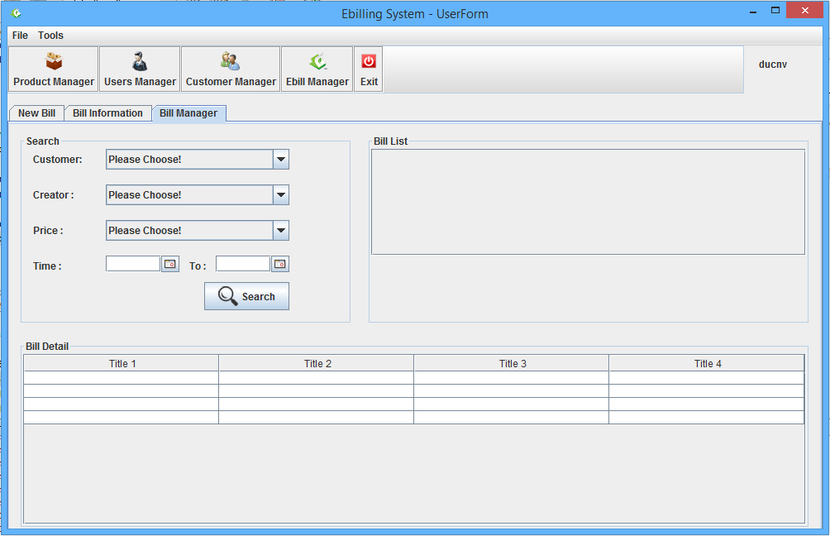

|  |  |
| --- | --- |
| Name of the Students  (code on eProject Guide) | Nguyen Van Duc (Leader)  Mai Duc Muoi  Nguyen Gia Quyen |
| Name of the Center | FPT University |
| Name of the Project | Ebilling and invoice System |
| Project Start Date/ End Date | Nguyen Van Duc (Leader)  Mai Duc Muoi  Nguyen Gia Quyen |
| Form | Task sheet |
| Form code | Form No.9/TS/Ver 1.0 |

|  |  |  |  |  |  |  |  |
| --- | --- | --- | --- | --- | --- | --- | --- |
| Project Ref. No.: | | Project title | Activity plan prepared by | Date of preparation of activity plan | | | |
| Sr.No. | Task | Actual start date | Actual days | Team member names | Status |
| 3 | Application development | User management |  | 15/04/14 |  | Nguyen Gia Quyen | Completed |
| 4 | Application development | Medicine management |  | 15/04/14 |  | Nguyen Van Duc | Completed |
| 5 | Application development | Customer management |  | 16/04/14 |  | Mai Duc Muoi | Completed |
| 6 | Application development | Supplier management |  | 20/04/14 |  | Nguyen Gia Quyen | Completed |
| 8 | Application development | Bill management |  | 20/04/14 |  | Nguyen Van Duc | Completed |
| 9 | Application development | Search |  | 20/04/14 |  | Mai Duc Muoi | Completed |
| 10 | Application development | Report |  | 30/04/14 |  | Nguyen Van Duc | Completed |