1. Config SQL server 2008 system :

Step 1: Open SQL server configuaration manager

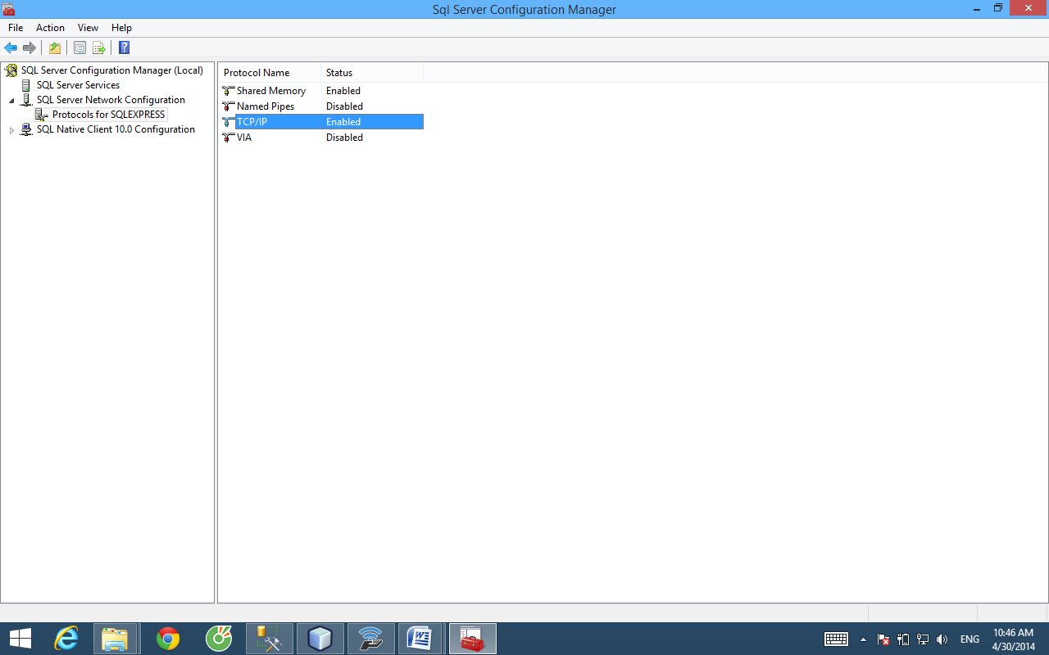

set Enable = Yes

TCP Dynamic Ports : 1433

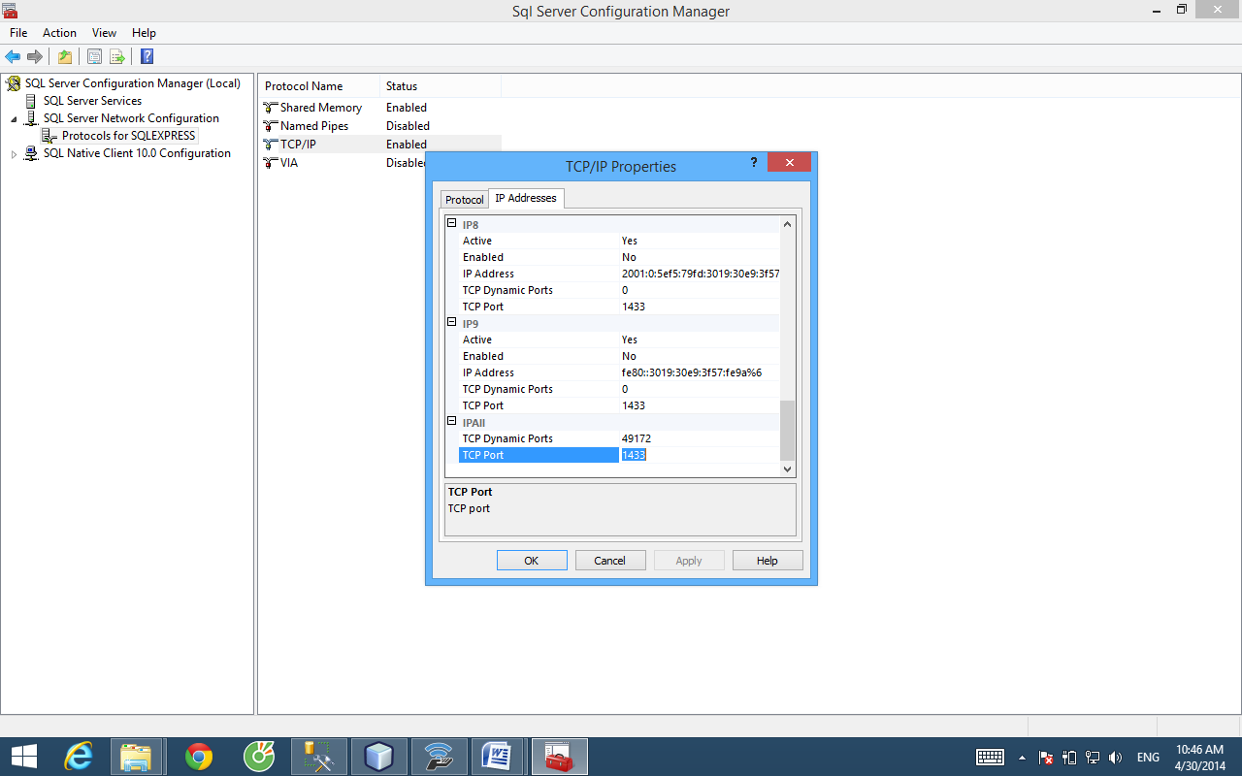

Config Server Properties

Select : Security ---> Choice SQL server and window Authentication mode

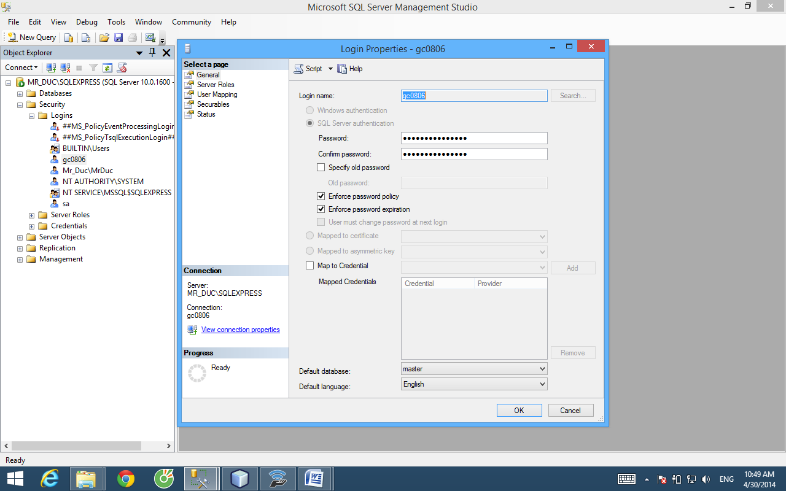

Set Login Properties - sa (defautl)

password : 123456

Confirm : 123456

step 5 :

Connect to server

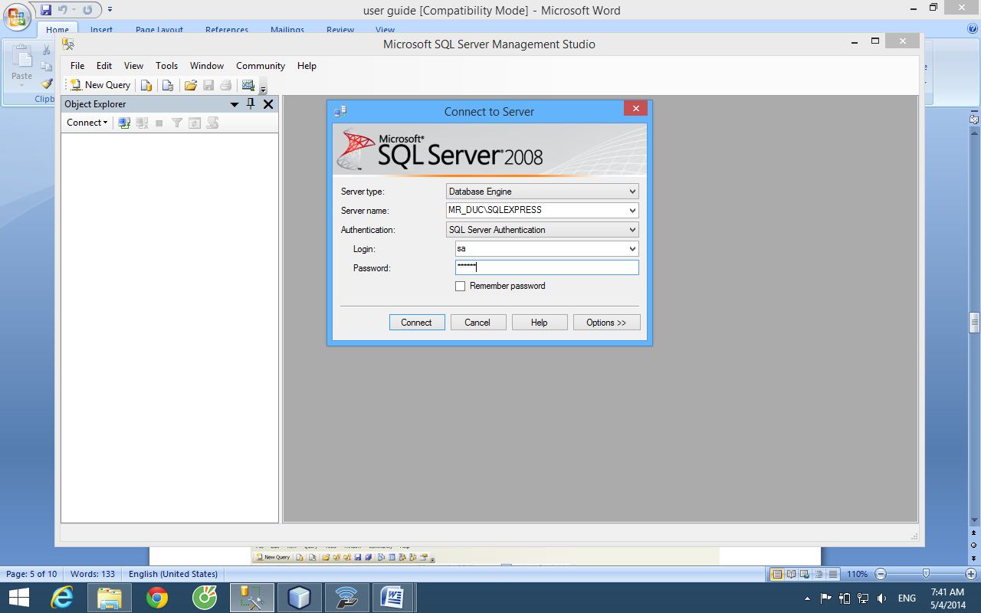

Login : sa

Passsword : 123456

Select file Database_Ebill.sql

Open with SQL server 2005 --> Execute

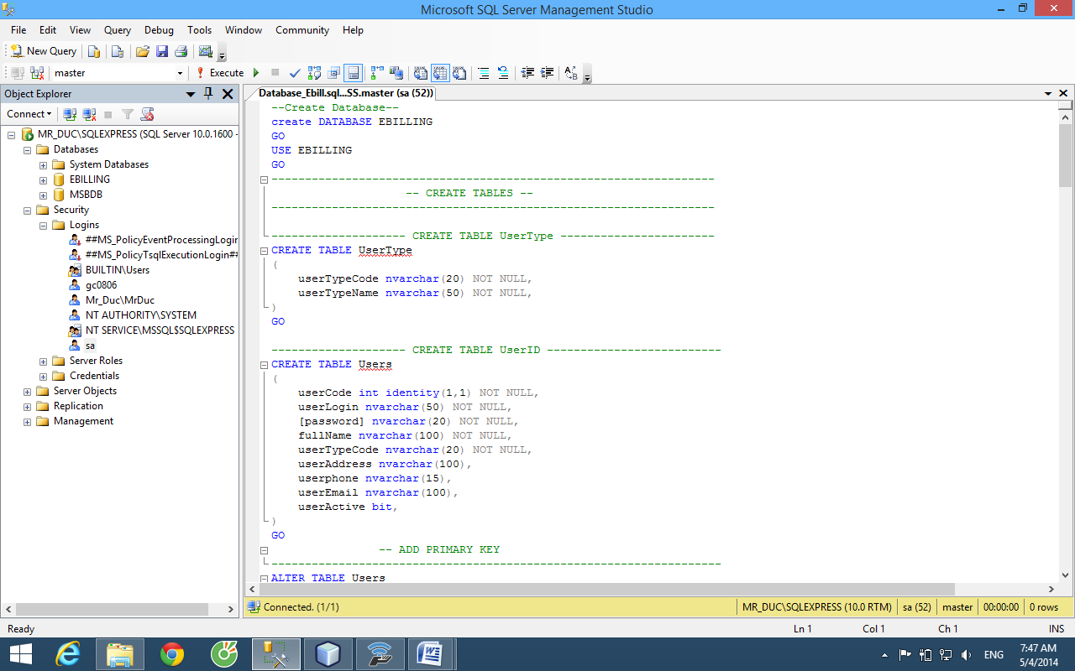

Step 6 :Run Ebilling and Invoice System

Step 6.1: Config Application

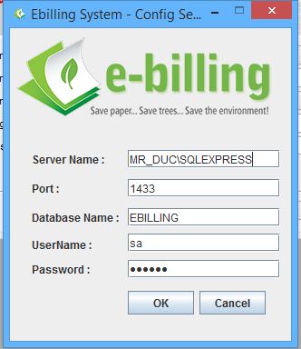

Step 6.2: Login:

UserName: ducnv

Password : ducnv

