Question 1:

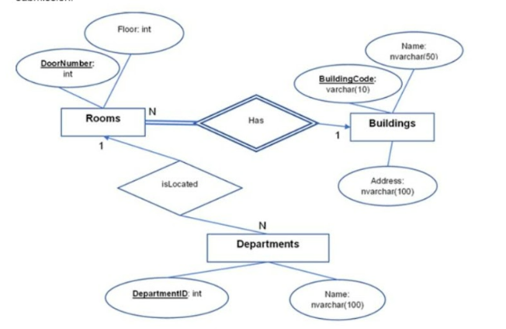

Question 2: Retrieve all cars with the color "Red" from the "Cars" table.

Question 3: Retrieve a list of customer names and their mobile phone numbers in "California" and sort them by their names.

Question 4: Display the rentals that occurred between January 1, 2023, and December 31, 2023.

Question 5: Retrieve a list of all customers (Customers) and the number of rentals (Rentals) each customer has made, along with the total amount (Amount) each customer has paid.

Question 6: Retrieve information about cars with the minimum and maximum number of rentals.

Question 7: Retrieve information about the customer (Customers) with the most rentals and the car (Cars) they have rented the most times.

Question 8: Create a stored procedure to calculate the total number of rentals for a specific car type, with the input being the @ID of the car.

Question 9: Create a trigger named 'car_up_trig' on the Car table to display the elements that have been changed after an update.

Question 10: Delete data from the "Cars" table with the condition 'economy.'