

To diplay only the welds with a > 5 do the following:

|  |  |
| --- | --- |
| Set Undeformed |  |
| Set Graphics  this forces colors in result to actually be on the scale |  |
| Set scale like this:  or any way you want to divide the weld throats. |  |
| Probe all welds 14 and above. They will all be red in the plot, this way you can still distinguish them. |  |
| Select Capped Iso Surfaces |  |
| Show everything above 5.1 (don’t forget the /x) |  |
| Show Undeformed Wireframe. This one is up to personal taste. Try them all. |  |
| Profit! |  |

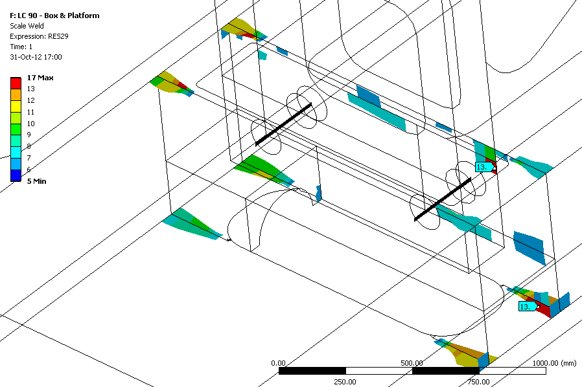

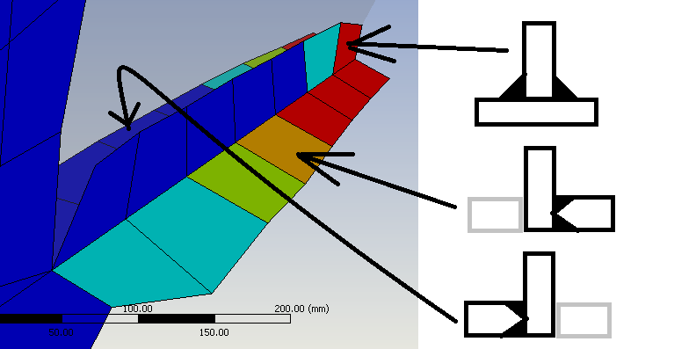

Make high ress images with:

C:\Program Files\ANSYS Inc\v140\aisol\DesignSpace\DSPages\macros\HighResolutionImageToFile.js