**APTECH COMPUTER**

**EDUCATION**



**Vinegar Food**

**Documentation**

|  |  |
| --- | --- |
| **Authors** | **C1808G2 – Group** |
| **DUC PHAM TRUNG**  **HIEU HOANG DUC   TRUONG NGUYEN VAN**  **NGOC DO MINH** |
| **Date** | **18-Mar-2019** |
| **Instructor** | **DIEP TRAN VAN** |

Hanoi, Mar 18, 2018

**APTECH COMPUTER**

**EDUCATION**



**Vinegar Food**

**Documentation**

|  |  |
| --- | --- |
| **Authors** | **C1808G2 – Group** |
| **DUC PHAM TRUNG**  **HIEU HOANG DUC   TRUONG NGUYEN VAN**  **NGOC DO MINH** |
| **Date** | **18-Mar-2019** |
| **Instructor** | **DIEP TRAN VAN** |

Hanoi, Mar 18, 2018

Index

***1.*** ***Problem Definition*** 3

***1.1*** ***Problem Abstraction*** 3

***1.2*** ***The Current System*** 4

***1.3*** ***The Proposed System*** 5

***1.3.1*** ***Customer activity*** 5

***1.3.2*** ***Admin activity*** 6

***1.3.3*** ***Boundaries of the System*** 7

***1.3.4*** ***Hardware and Software Requirements*** 7

***2.*** ***Customer Requirements Specification*** 9

***2.1*** ***Users of the System*** 9

***2.1*** ***System functions*** 10

***3.*** ***System Designs*** 12

***3.1*** ***Entity Relationship Diagram*** 12

***3.2*** ***Database Design*** 13

***3.3*** ***Sitemap*** 18

***3.4*** ***System functions design*** 19

Register & Logout flowchart 19

Login, Logout, Register Function 20

Management Function 21

Count views function 22

Searching function 23

Statistics customer & product manager function 24

Invoice Management function 24

Display function is suitable on all screens 24

Function to edit registered information 24

Storage function and selection of delivery address 24

***4.*** ***Task sheet*** 25

**5.** **Validation Checklists** 26

1. ***Problem Definition***
   1. ***Problem Abstraction***

Nowadays, advanced technologies are developing more and more and are applied more and more in the fields of economy, production as well as everyday life of people. A typical example of developing such technologies is the application of information technology to most activities. Thanks to that, the work was don’t quickly, accurately and achieved much higher results.

As the society grows, people's living standard is improved, especially the eating needs of each family and each individual. People have many choices for their meals.

Life is getting busier and people have less time for their meals. They cannot go to the store to choose the food they like because it takes time and effort. With increasing demand, and to save time for each individual, our team has built a website to introduce and sell products online that will help customers more convenient for their eating needs. To choose their favorite food, they need an internet-connected device that can buy what they want. Therefore the topic "Building a website to sell food" has been selected. The goal of this report is to analyze and design an online food website.

The design of Vinegarfood.com focuses on website's ease of use and navigation. Website visitors can easily find their interested information. For example, the "formula of the month" page will display information about the categories of each month, year, recipes, and notes when choosing dishes, where to share experiences from chefs popular. If users have any question, they can go to contact page and fill in the contact form. The contact page uses Googlemap, a Geo-location API, to give users better information about the address of Vinegarfood.

This site will be developed for Windows and mobile platforms using HTML5, CSS3, Javascript, PHP and API GeoLocation, framework Boostrap, Jquery. The site will be tested on latest and popular browsers such as Safari,

Microsoft Edge, Mozilla Firefox, IE, Opera and Chrome. The hardware requirements include Intel Pentium 4 or higher processor, 1GB or higher RAM, and an HTML5 compatible browser to view the Website.

* 1. ***The Current System***

In today’s busy life, we humans often have less time to care for ourselves and our families especially in eating. Sometimes having to buy and process food makes us spend a lot of time on work, making us eat inadequately, adversely affecting the health of ourselves and those around us. Not only that currently dirty food is spreading in the market, the vegetables and fruits contaminated by food and rotten food still reach consumers while we ourselves are not aware of it. It is not easy to choose to buy clean and safe products for health without spending a lot of time researching. That's why Vinegar Food was born. Vinegar Food will help you solve all these problems. You just need to be at home, at work or anywhere, with a phone call to be delivered to your place. Delight to choose food with hundreds of different dishes extremely delicious and special quality assurance. Vinegar Food selects materials from reputable processing facilities to pass food management department inspections on food safety and hygiene. The processing of closed and hygienic dishes with the best chefs in the country promises to bring you a perfect meal.

Finally, Vinegar Food was created for the health of the community.

* 1. ***The Proposed System***
* Before building a Website we need:

- Who is the target customer?

- What is the purpose of the website?

- What are the main functions of the Website?

- Identify the main information blocks that the Website will provide.

* Customer

This website is designed for everyone, especially those with eating and drinking preferences.

* Purpose of Website

The purpose of the website is to introduce and sell online dishes. They will freely choose their favorite dishes. Food options are arranged according to specific categories. Easily search on the "search" function at the top of the web page.

Can read information about delicious dishes, cooking instructions from experts from the monthly recipe function.

Easily select dishes into cart, pay for selected products.

View purchased orders, order details and products. Order history, order status, item statistics via "order history" function.

Feedback on the item, comment the order through the "comment" function under the order details. Or send comments on the store via "Contact & Feedback" page.

Save the list of addresses in the order history. Easy shopping for the next time via the "address book" function.

In addition, the website has the purpose of introducing too many interested customers, knowing more about the website, narrowing the distance, solving the problem of road, in order to increase revenue

* + 1. ***Customer activity***

When customer decides to visit a Website and engage in viewing or purchasing of a Website product, the customer is provided with a shopping cart. Customers are free to view information and choose their favorite products in their shopping cart.

The website is designed to help customers quickly find the type of product that you want to buy quickly.

**n1** - Upon entering the website, they can choose to register for an account. An account will enable them to manage orders placed quickly, comment on products, and add more delivery addresses they want.

**n2** - When entering the list of dishes, customers can select the list of dishes they need, arrange it by name, price, highlight or can search the name and list of dishes that you like right on the box search.

**n3** - Once they have selected the products they need, they can order and the food will be transferred to their cart

**n4** - When the options are completed, the customer can go to the payment page, enter the shipping address or select previously saved history.

**n5** - After successful order, customers can easily manage all their orders through the management page or they can use the "Bill code" provided to search on the search bar.

**n6** - Customers can leave a comment right below the product. Or go to the contact page and fill in the feedback form.

* + 1. ***Admin activity***

Provide and update products regularly so that customers feel excited and happy when buying products.

Tracking customers: After the customer presses the payment button, the order will be summarized immediately and delivered to the customer.

In order to attract regular customers to access the Web, Admin needs to take measures to promote the publication of promotions, discounts during the festive season to entice customers, Have preferential invoices in invoices.

Administrators are provided with the necessary functions such as adding, editing, hiding products, categories, images, news, order statistics, management permissions …

* + 1. ***Boundaries of the System***
* Customer
* Payment process for customers is simple (Cash only)
  + 1. ***Hardware and Software Requirements***

***Display is suitable for all devices with different screen sizes***

* Hardware Requirements:

- The device has an internet connection.

* Intel Pentium 4 or higher
* 1 GB ram or higher
* 80GB hard disk
* Software Requirements: A webserver.
* Operating system support for the program to run.
* HTML5 and Javascript support browsers such as Mozilla Firefox, Chrome, …
* Boostrap3 libraries, Jquery plugins.
* The database is MySQL.
* Web page requirements
* The system consists of two functions:

**User:**

* Those who have the need to purchase. They will view the necessary products from the system and order the products that fit them. Therefore the Website must meet the following requirements:

1. Display a list of store products so customers can view and select
2. Once the customer has finished viewing and selecting the product they wish to purchase, the system must display the order in order for the customer to enter the necessary information for payment.
3. Display a list of products, a search box for customers to view and select.
4. Product comment function, direct connection with people. Feedback, add products and advice for everyone in need.
5. Customers can choose to log in to the system to facilitate purchase, order management, address book. Shopping for the next time will be easy and convenient.

**Admin:**

* The master of the application has control over the operation of the system. This user needs to provide a username and password to login and the system performs its functions. If the login process is successful then Admin must have the following functions:

1. Update management functions (Add, edit, delete) products on the Web, this is not easy, it must be exact.
2. Access and check customer orders.
3. Statistics of products sold, remaining, revenue statistics.
4. In addition to the functions mentioned above, the Website must be designed to be easy to understand, interface is easy to use, and nice to make customers feel happy, satisfied when viewing the product. Provide the same information.
5. The most important thing in the web is to ensure absolute safety of the information of customers. At the same time, the website must be easy to upgrade, maintain, repair when needed to add, update the new features
6. ***Customer Requirements Specification***
   * 1. ***Users of the System***

Users of the system are registered user, non-registered user and admin.

* Registered users should be able to do the followings:
* Add a list of delivery addresses
* Select the shipping address
* Order quickly
* Free shipping service
* View order history
* Comment on the product, feedback on orders.
* See news about the recipes of the restaurant
* Non-registered users should be able to do the followings:
* Add products to the basket
* Submit shipping address any payment information.
* Order management with bill of lading has been provided.
* Comment on products, feedback on orders.
* See news about the recipes of the restaurant
* Admin should be able to do the followings:
* Create, update, delete contents of product, category product, blogs, category blog, image, …
* Update news product discount, hot products and blogs
* Manage customer enquiries
* Manage the recipe chart (recipe of the month)
  + 1. ***System functions***
* Input/ Output provided by system admin
* Input food contents to the database
* Process the food input data in the database
* Process user's input data from review, comment, contact and registration form
* Display lists of food, albums, genres, recipe of the month
* Display order history
* Display product comments
* Input/ Output provided by customers
* Contact account
* Shipping address
* Comment on food
* Feedback on the restaurant
* Email receiving promotion from the restaurant
* Function: Import product
  + Product and Blog Update: Update the correct information in the Product, Blog table.
  + Update the invoice: Update the product information in the database, and update the invoice
  + Update the views count on the blog.
  + Update the quantity: Update the number of products, see the number of products is going to end up to complementing.
  + Input: Metrics from the SQL side tables
* Function: Business management
  + View blog information: Customers who want to view recipe of the month
  + Increase views and display news sites
  + View product information: Customers who want to view product want to view product information, click on any product to read the product information to know and select the item to buy.
  + Add to Cart: When customers want to buy certain products, the website will provide you with a button added to your shopping cart to freely choose the product you want to buy.
  + Payment: Customers purchase the product through the invoice Web system will send a message to customers.
  + Add/ Update products, blog: As the function of Admin, Admin will add new product or update product or update the product is out of stock, blog views.
* Function: Statistic
* Statistics of news views
* Invoice Statistic: Admin will bill the invoice based on the invoice number that the customer pays.
* Revenue statistics: Admin will total the amount collected through the bill.
* Product statistics: Admin will count the number of products to display, left to inventory.
* Function: User
  + Customers can choose to log into the system
  + Logged in successfully:
  + Customers can edit information.
  + Add shipping address
  + Manage order history
  + Statistics of order history, purchase data, favorite products
* Do not log in:
  + Order management through bill of lading codes issued upon delivery
* Comment on products or news
* View products: Customers visiting the Website can view the entire Website and food products. If a customer wants to view a product detail, just click on the product image. Can search for favorite food on the search bar
* Buy the product: Customers after viewing the fished to buy products right below the product image.
* Payment: After you click the purchase button, the system website will appear invoices, you need to fill out the information that the invoice required to make payment.
* Send feedback: If you have any comments about products as well as Website can go to the contact us to write your comments and presses send to the Admin.

1. ***System Designs***
   1. ***Entity Relationship Diagram***

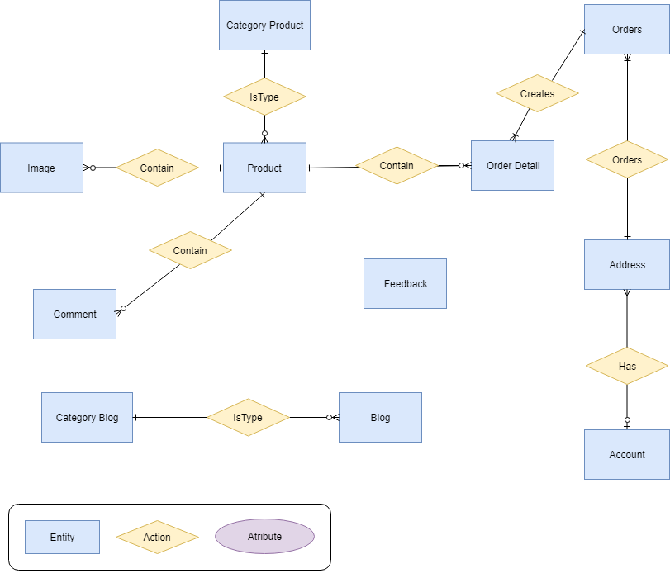

* 1. ***Database Design***

|  |  |  |
| --- | --- | --- |
| **TABLE Product** | | |
| **Name** | **Type** | **Attribute** |
| ProductID | INT | Primary Key |
| CategoryID | INT | Foreign Key |
| ProductName | VARCHAR(80) |  |
| Thumbnail | TEXT |  |
| Ingredients | VARCHAR(255) |  |
| NetWeight | INT |  |
| Quantity | INT |  |
| UserManual | VARCHAR(50) |  |
| ExpirationDate | VARCHAR(50) |  |
| Price | DECIMAL(18) |  |
| PriceDiscount | DECIMAL(18) |  |
| ModifiedDate | DATETIME |  |
| Status | BIT |  |

|  |  |  |
| --- | --- | --- |
| **TABLE CategoryProduct** | | |
| **Name** | **Type** | **Attribute** |
| CategoryID | INT | Primary Key |
| CategoryParent | INT | Foreign Key |
| CategoryName | VARCHAR(80) |  |
| Thumbnail | TEXT |  |
| Picture | TEXT |  |
| Status | BIT |  |

|  |  |  |
| --- | --- | --- |
| **TABLE Image** | | |
| **Name** | **Type** | **Attribute** |
| ImageID | INT | Primary Key |
| ProductID | INT | Foreign Key |
| ImageURL | TEXT |  |

|  |  |  |
| --- | --- | --- |
| **TABLE Feedback** | | |
| **Name** | **Type** | **Attribute** |
| FeedbackID | INT | Primary Key |
| FirstName | VARCHAR(30) |  |
| LastName | VARCHAR(30) |  |
| Title | VARCHAR(80) |  |
| Content | VARCHAR(255) |  |
| Status | BIT |  |

|  |  |  |
| --- | --- | --- |
| **TABLE Comment** | | |
| **Name** | **Type** | **Attribute** |
| CommentID | INT | Primary Key |
| ProductID | INT | Foreign Key |
| Email | VARCHAR(50) |  |
| FirstName | VARCHAR(30) |  |
| LastName | VARCHAR(30) |  |
| Content | VARCHAR(255) |  |
| CreateDate | DATETIME |  |

|  |  |  |
| --- | --- | --- |
| **TABLE Orders** | | |
| **Name** | **Type** | **Attribute** |
| OrderID | INT | Primary Key |
| AddressID | INT | Foreign Key |
| BillCode | VARCHAR(15) |  |
| TransportFee | DECIMAL(18) |  |
| RequireDate | DATETIME |  |
| ShippedDate | DATETIME |  |
| Note | VARCHAR(255) |  |
| OrderFeedback | VARCHAR(255) |  |
| DeliveryStatus | TINYINT |  |

|  |  |  |
| --- | --- | --- |
| **TABLE OrderDetail** | | |
| **Name** | **Type** | **Attribute** |
| OrderDetail | INT | Primary Key |
| ProductID | INT | Foreign Key |
| OrderID | INT | Foreign Key |
| TotalMoney | DECIMAL(18) |  |
| Quantity | INT |  |

|  |  |  |
| --- | --- | --- |
| **TABLE CategoryBlog** | | |
| **Name** | **Type** | **Attribute** |
| CategoryBlogID | INT | Primary Key |
| Title | VARCHAR(80) |  |

|  |  |  |
| --- | --- | --- |
| **TABLE Blog** | | |
| **Name** | **Type** | **Attribute** |
| BlogID | INT | Primary Key |
| CategoryBlogID | INT | Foreign Key |
| Title | VARCHAR(80) |  |
| Thumbnail | TEXT |  |
| Content | TEXT |  |
| Author | VARCHAR(80) |  |
| CreateDate | DATETIME |  |
| ViewCounts | INT |  |

|  |  |  |
| --- | --- | --- |
| **TABLE Address** | | |
| **Name** | **Type** | **Attribute** |
| AddressID | INT | Primary Key |
| AccountID | INT | Foreign Key |
| FirstName | VARCHAR(30) |  |
| LastName | VARCHAR(30) |  |
| Address | VARCHAR(255) |  |
| PhoneNumber | VARCHAR(12) |  |
| Status | BIT |  |

|  |  |  |
| --- | --- | --- |
| **TABLE Account** | | |
| **Name** | **Type** | **Attribute** |
| AccountID | INT | Primary Key |
| Email | VARCHAR(50) |  |
| PhoneNumber | VARCHAR(12) |  |
| UserName | VARCHAR(30) |  |
| Password | VARCHAR(16) |  |
| FirstName | VARCHAR(30) |  |
| LastName | VARCHAR(30) |  |
| Gender | VARCHAR(15) |  |
| Planlevel | TINYINT |  |
| Status | BIT |  |

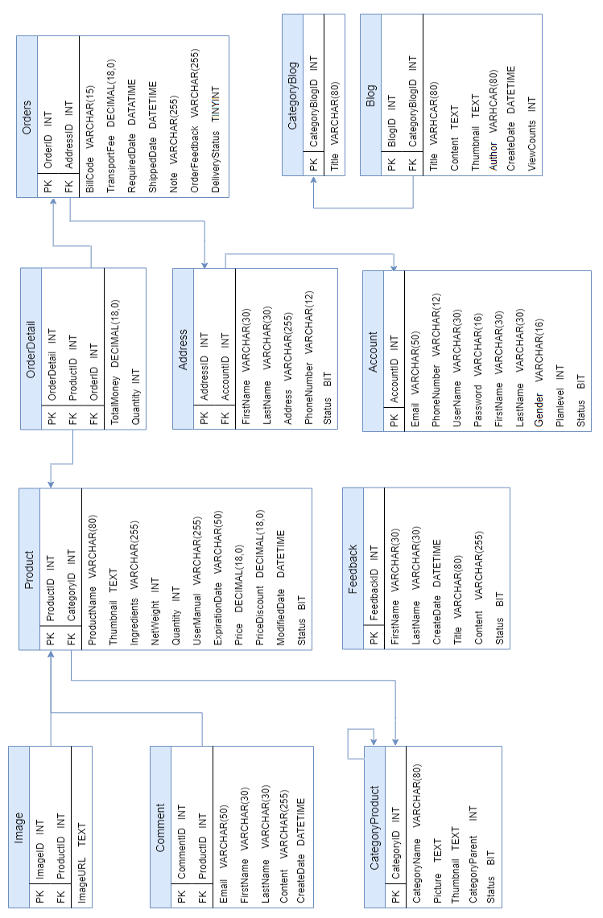

* 1. ***Sitemap***

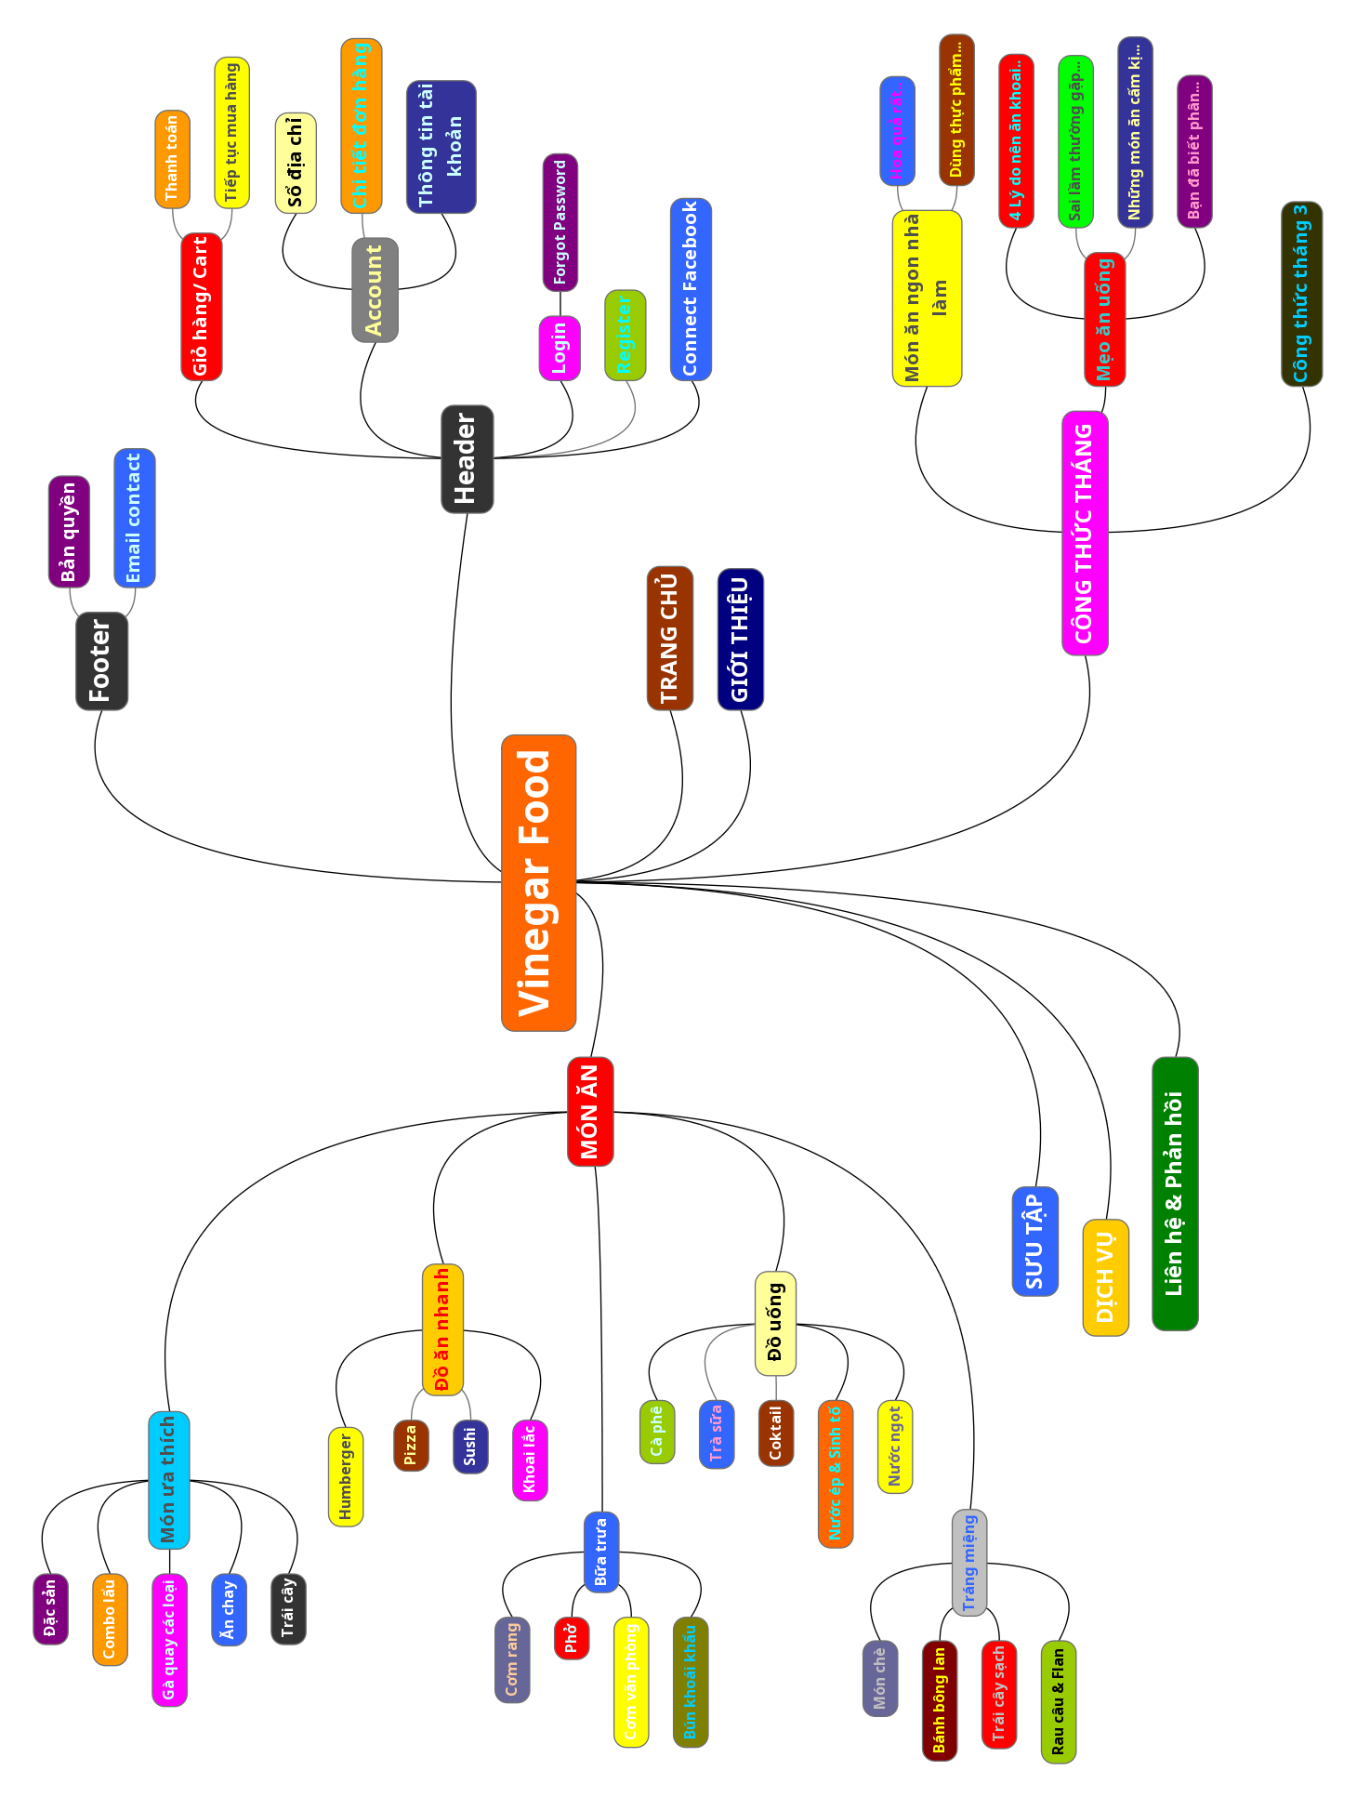

* 1. ***System functions design***

**General Function**

**Login:**

* + - **Input: Username and password**
    - **Process: Validate data input. Check user’s account in users table in database**
    - **Output: If user and password is correct, login and redirect user to home page. If it’s incorrect, input again & error message is displayed.**

**Register:**

* + - **Input: Input username, password, email, …**
    - **Process: validate the input data password, user match check. Check if account exits in database. If account already exist, notify user that account exist and ask them to reenter data.**
    - **Output: If registration successful, redirect user to home page.**

**Logout:**

* **Input: Logout require**
* **Process: Destroy all of the data associated with the current session.**
* 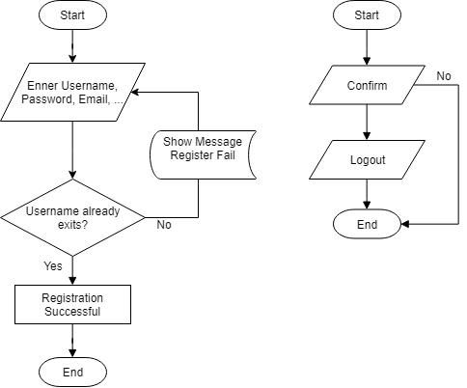**Output: Redirect user to home page.**

**Register & Logout flowchart**

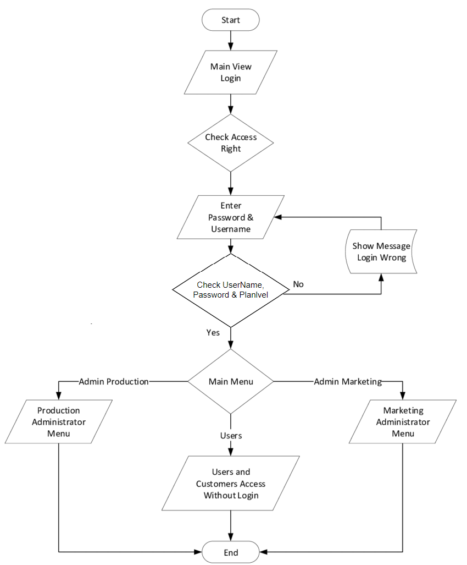

### Login flowchart

### Management Function

**Insert/Update**

* **Input: Enter data**
* **Process: Add/Update data into database**
* **Output: Display data list**

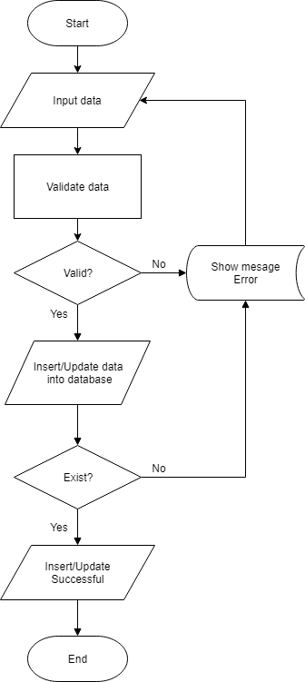

**Insert/Update flowchart**

### Count views function

* **Input: When go to the blog detail page**
* **Process: Update view on blog detail**
* **Output: Show views**

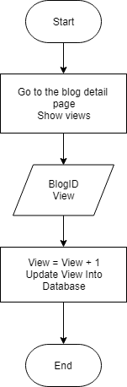

**Count views flowchart**

### Searching function

* **Input: Enter keyword**
* **Process: Find keyword like product .name, order = keyword**
* **Output: Display products or order**

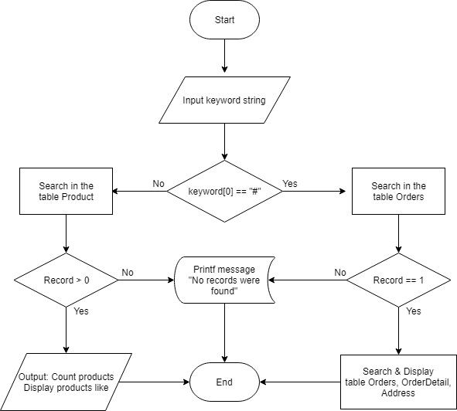

**Searching flowchart**

### Statistics customer & product manager function

* **Input: Data in the Database**
* **Process: Statistics based on data**
* **Output: Show statistics**

### Invoice Management function

### Display function is suitable on all screens

### Function to edit registered information

### Storage function and selection of delivery address

1. ***Task sheet***

|  |  |  |  |  |  |  |
| --- | --- | --- | --- | --- | --- | --- |
| **Project Ref. No** | **Project Title: Vinegar Food** | **Activity Plan Prepared By:** | | **Date of Preparation of Activity Plan:** | | |
| **Task Sub division** | **Description** | **Start Date** | **Deadline** | **Actual Days** | **Team Member** | **Complete** |
| **1. Frontend Design** | **Website layout and website sitemap** | **20 Feb. 2019** | **21 Feb. 2019** | **2** | **Duc Pham Trung** | **✔** |
| **2. Database design** | **Design the tables, column, data types** | **21 Feb. 2019** | **22 Feb. 2019** | **2** | **Duc Pham Trung**  **Truong Nguyen Van** | **✔** |
| **3. Website Header & Footer** | **Design frontend** | **22 Feb. 2019** | **23 Feb. 2019** | **2** | **Duc Pham Trung** | **✔** |
| **4. Home page** | **Design frontend** | **23 Feb. 2019** | **03 Mar. 2019** | **9** | **Hieu Hoang Duc** | **✔** |
| **5. Feedback page**  **Introduce page**  **Album page**  **Account page** | **Design frontend** | **23 Feb. 2019** | **03 Mar. 2019** | **9** | **Truong Nguyen Van** | **✔** |
| **6. Meals page**  **Meal Detail**  **Orders management**  **Order detail page**  **Address list page**  **Information customer**  **Cart page**  **Payment page** | **Design frontend** | **23 Feb. 2019** | **02 Mar. 2019** | **8** | **Duc Pham Trung** | **✔** |
| **7. Blogs page**  **Blog Detail**  **Service page** | **Design frontend** | **23 Feb. 2019** | **02 Feb. 2019** | **8** | **Ngoc Do Minh** | **✔** |
| **8. Design Administration Management** | **Design frontend** | **02 Mar. 2019** | **04 Mar. 2019** | **3** | **Duc Pham Trung** | **✔** |
| **9. Review, update frontend Website** | **Edit the interface** | **02 Mar. 2019** | **05 Mar. 2019** | **4** | **Ngoc Do Minh**  **Hieu Hoang Duc** | **✔** |
| **11.**  **Responsive** | **Check and modify all pages displayed on any screen size** | **04 Mar. 2019** | **06 Mar. 2019** | **3** | **Duc Pham Trung** | **✔** |
| **12. Functionality**  **to mobile devices** | **Design** | **06 Mar. 2019** | **08 Mar. 2019** | **3** | **Duc Pham Trung** | **✔** |
| **13. Management page & Website** | **Backend** | **08 Mar. 2019** | **13 Mar. 2019** | **6** | **Duc Pham Trung**  **Truong Nguyen Van** | **✔** |
| **14. Input real data to replace test data** | **Input real data** | **05 Mar. 2019** | **09 Mar. 2019** | **5** | **Hieu Hoang Duc**  **Ngoc Do Minh** | **✔** |
| **15. Review, update functions** | **Design, edit functions** | **13 Mar. 2019** | **14 Mar. 2019** | **3** | **Duc Pham Trung**  **Truong Nguyen Van** | **✔** |
| **16.**  **Project documents** | **Project report, user and developer guide** | **14 Mar. 2019** | **16 Mar. 2019** | **3** | **Duc Pham Trung** | **✔** |
| **17. Final check and submit** | **Fix website problems related to frontend and backend** | **16 Mar. 2019** | **17 Mar. 2019** | **2** | **All team members** |  |

1. **Validation Checklists**

|  |  |  |
| --- | --- | --- |
| **S. No.** | **Aspect tested** | **Suggestions/ Remarks** |
| 1. | Have all the modules been properly integrated and are they completely functional | Yes |
| 2. | Dose each unit meet its objective and purpose?  Are all the validations happening as specified in Process | Yes |
| 3. | Have all Design and Coding standards been followed and implemented? | Yes |
| 4. | Is the GUI design consistent all over? | Yes |
| 5. | Are the codes working as per the specification? | Yes |
| 6. | Does the application's functionality resolve the client problem, and satisfy his needs completely? | Yes |
| 7. | Have the hardware and software been correctly chosen? | Yes |
| 8. | Additional features and utilities that give value addition to the entire project? | Yes |