Location Management

## Objective

* Building a very simple restful API system to allow users can create/update/delete locations

## Outcomes

* Simple Restful API system.
* System has support the address location tree

## Scope

* 1. Must have
* Build with NodeJS (NestJS)
* Validation request
* Handle exceptions.
* Implement Logging.
* Clean code and documentation for your project.
* support the address location tree (PostgreSQL)
  1. Nice to have
* Frontend (not require)

## Implementation

### API documentation

| **APIs** | **Description** |
| --- | --- |
| Get all locations | Get all location data |
| Create location | Create and retrieve a location |
| Update location | Update and retrieve selected location with new data |
| Delete location | Delete and retrieve deleted location |

### API detail documentation

#### Get all locations:

* + Endpoint: <http://localhost:8004/v1/locations>
  + Http Method: GET

#### Create location

* + Endpoint: <http://localhost:8004/v1/locations>
  + Http Method: POST
  + Body:
* **Building**: required, string
* **Name**: required, string
* **Area**: required, string
* **Code**: required, string
* **ParentId**: optional, string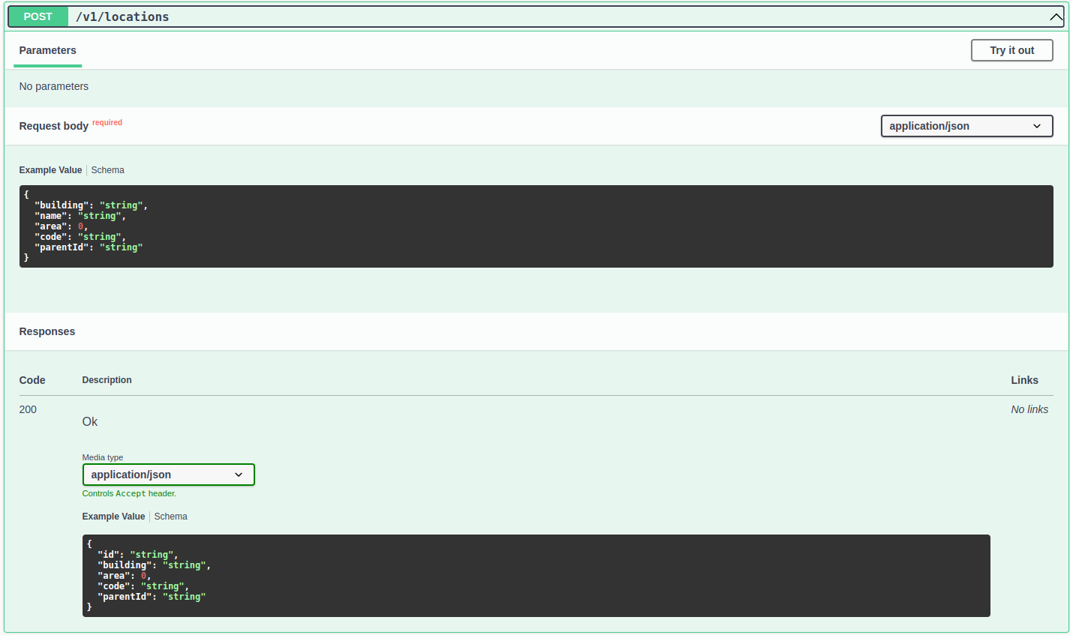

#### Update location

* + Endpoint: <http://localhost:8004/v1/locations>/:id
  + Http Method: PATCH
  + Body:
* **Building**: required if exist, string
* **Name**: required if exist, string
* **Area**: required if exist, string
* **Code**: required if exist, string
* **ParentId**: optional, string

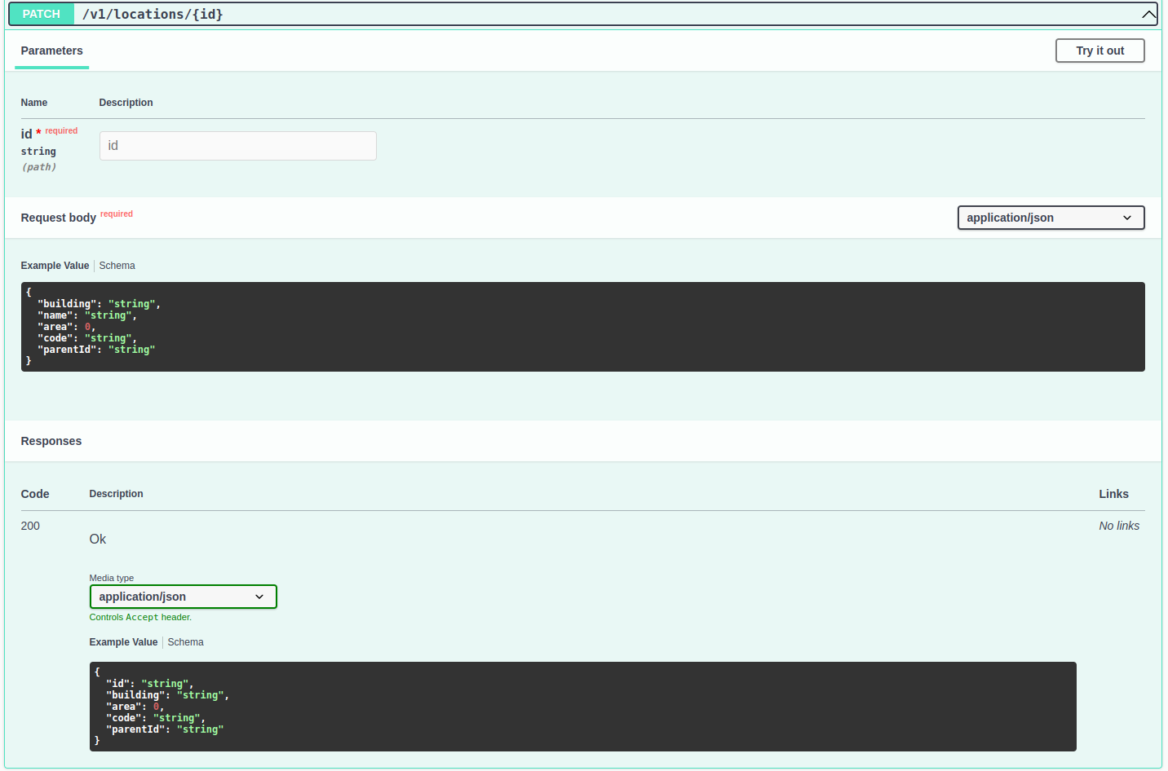

#### 

#### Delete location

* + Endpoint: <http://localhost:8004/v1/locations>/:id
  + Http Method: DELETE

## 

## Conclusion

* This is a simple Restful API system that can allow user manage the location (create. Update, delete).
* System support the address location tree approach