ECEC-t580

Computing and Control

ECEC-t580 Final Project – Application of Kalman Filters

Spring 2020

Professor: Dr. Thomas Chmielewski

Date: 6/6/2020

Team

Jon Palko ([jpp75@drexel.edu](mailto:jpp75@drexel.edu)):

BS Mechanical Engineering, MS Electrical Engineering

Tai Nguyen ([tdn47@drexel.edu](mailto:tdn47@drexel.edu)):

BSMS Computer Engineering

Contents

Section I: Introduction/Background 2

Section II: Alpha Filter 4

II.1 Objective and Summary 4

II.2 Data gathering summary 4

III. Data analysis 7

Section III: Alpha-Beta Filter 7

III.1 Objective 7

III.2 Statistics and Alpha-Beta Filter’s Parameters 8

III.3 Data analysis and graph presentation 9

III.3.1 Set #1 Figures 9

III.3.2 Set #2 Figures 12

III.3.3 Analysis 14

Section IV: Summary and Conclusions 16

Section V: Appendix 16

# Section I: Introduction/Background

The application of the Alpha based Kalman filter with the given ultrasonic sensors was largely successful with variations mostly staying within the expected error range. As the sensors went further away the data became more varied causing some data points exceeding the expected range towards the end of collection. Due to this phenomenon, the Alpha-Beta filter performed well at low/medium range and reasonable at high range.

The objective of the project was to simulate two types of systems. The first being a 1st order system that showed the variations within our sensor itself, while having its position predicted using an alpha based Kalman filter. The second system was meant to represent a 2nd order system with constant velocity for tracking purposes, using an alpha-beta based Kalman filter.

Data was collected using an interrupt service routine (ISR) that triggered every time the sensor received a signal. Using this ISR the time between data collections was measured (microseconds) and used to calculate the actual distance the sensor was from the wall. A total of 100 measurements was taken for over 15 distances between 5 inches and 35 inches. The exact data points used can be seen in Section 2. These distances were measured using the following setup, which had the yard stick perpendicular to the wall and parallel to the sensor.

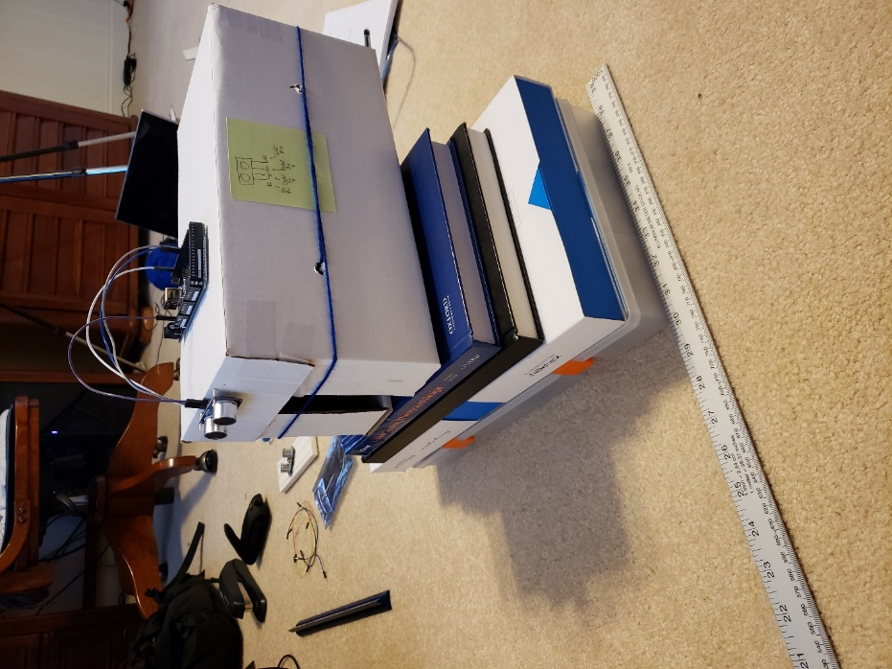

*Figure 1: The Ultrasonic Transducer Setup with the Arduino MEGA 2560*

The following plot shows how close the averages of the ultrasonic transducer measurements were to the ground truth distances measured using the ruler.

*Figure 2: Ultrasonic Sensor Measured Averages Against Ground Truth Values*

As Figure 2 shows, the two sets of measurements are relatively close, and start to separate a little more as the distance increases. This could indicate that the ultrasonic sensor becomes less accurate the further away it is from the target.

# Section II: Alpha Filter

## II.1 Objective and Summary

The purpose of the alpha based Kalman filter is to track a system that doesn’t have any velocity or acceleration, while taking into account noise. In this case that position is where the ultrasonic transducer is with regard to a flat wall. The noise that is being taken into account is unknown maneuver noise and device measurement noise. The maneuver noise was a set assumption for a ¼ inch variation , and the measurement noise was the average sensor variance for over 100 data points at a single distance measured by various sensors 0.0058411. Using the alpha filter equations shown in Table 1 of Kalata’s paper[1], the tracking index (Λ) was calculated using the measurement, maneuver noise, and an update period of T = 1. This tracking index was then used to calculate alpha, which allowed for the state covariance P(k|k) calculation, which is represented by and is calculated by multiplying the measurement noise by alpha. These values are all shown in Table 1 below.

## II.2 Data gathering summary

*Table 1: Alpha Kalman Filter Testing Parameters and Averages*

|  |  |  |  |  |  |  |
| --- | --- | --- | --- | --- | --- | --- |
| Data Point  (inches) | Average value (inches) | Variance by  averaging | Number of points  for average | Kalman filter value +/- 3 std dev  (use last value in run) | Kalman filter  variance P(k|k) | Comments |
| 9 | 8.965555512 | 0.267027625 | 100 | 8.9704 | 0.0038 | α = 0.6474 |
| 10 | 10.00054291 | 0.269853193 | 100 | 9.9959 | 0.0038 | P(k|k) is α* |
| 11.25 | 11.1900252 | 0.257939251 | 100 | 11.1377 | 0.0038 |  |
| 13 | 12.91040039 | 0.28581188 | 100 | 12.9945 | 0.0038 |  |
| 14.75 | 14.55638268 | 0.277670475 | 100 | 14.5034 | 0.0038 |  |
| 16 | 16.31085591 | 0.323404137 | 100 | 16.4038 | 0.0038 |  |
| 17 | 16.82253031 | 0.268952152 | 100 | 16.8363 | 0.0038 |  |
| 18 | 17.7441311 | 0.259739552 | 100 | 17.7411 | 0.0038 |  |
| 19 | 18.73583386 | 0.26409139 | 100 | 18.6667 | 0.0038 |  |
| 20.75 | 20.39396535 | 0.275702015 | 100 | 20.4626 | 0.0038 |  |
| 22 | 21.56748858 | 0.279083175 | 100 | 21.522 | 0.0038 |  |
| 23 | 22.63225315 | 0.273520174 | 100 | 22.5845 | 0.0038 |  |
| 25.25 | 24.86241417 | 0.274481639 | 100 | 24.8228 | 0.0038 |  |
| 27 | 26.6225689 | 0.293960714 | 100 | 26.6499 | 0.0038 |  |
| 28 | 27.35070709 | 0.316129821 | 100 | 27.479 | 0.0038 |  |
| 29 | 28.52098583 | 0.285900167 | 100 | 28.4231 | 0.0038 |  |
| 30 | 29.26996063 | 0.294934008 | 100 | 29.3038 | 0.0038 |  |
| 31.25 | 30.76168701 | 0.324811485 | 100 | 30.7719 | 0.0038 |  |
| 32.75 | 32.1830815 | 0.344504977 | 100 | 32.1264 | 0.0038 |  |
| 35 | 34.61157441 | 0.363009431 | 100 | 34.655 | 0.0038 |  |

These parameters were then used in the following equation to predict the next position using the alpha filter:

[Equation 1]

This computation was done for 20 different data sets, at different distances, resulting in the table of information seen below. The measured values came from the ultrasonic sensor measurement, while the came from the previous calculation where in the new iteration is equal to from the previous iteration. For the initial iteration was set to an initial condition (IC) equal to the average of all 100 data points. These calculated distances were plotted below to show the average values and how the data falls within the error bands of +/- 3.

Due to the high number of data sets tested only a few relevant plots are shown here, but all of them can be viewed in the Appendix.

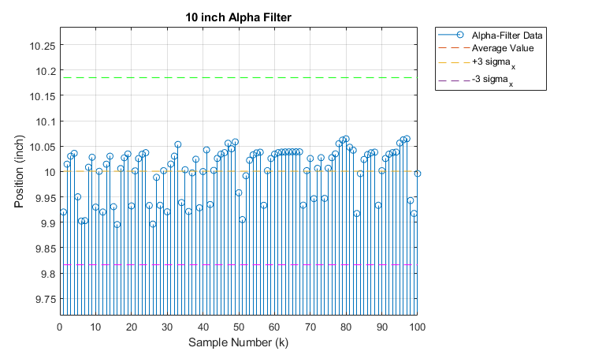

*Figure 3: The 10 Inch Nominal Distance Alpha Filtered Positions*

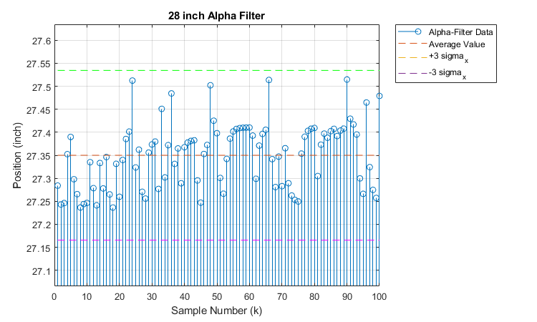

*Figure 4: The 28 Inch Nominal Distance Alpha Filtered Positions*

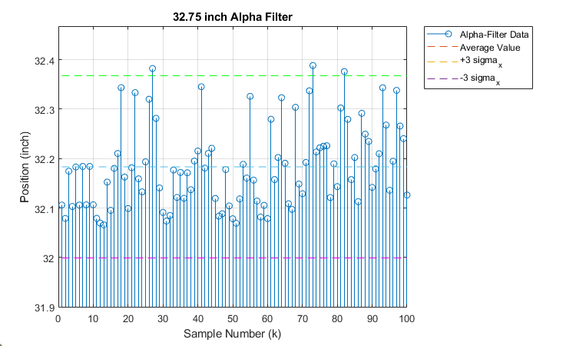

*Figure 5: The 32.75 Inch Nominal Distance Alpha Filtered Positions*

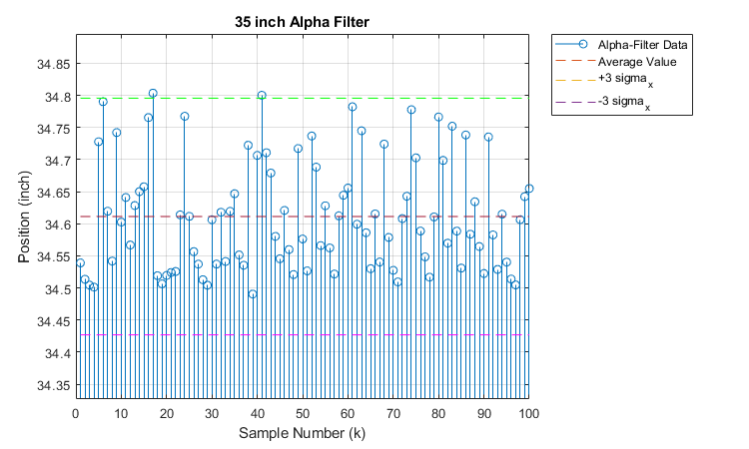

*Figure 6: The 35 Inch Nominal Distance Alpha Filtered Positions*

## III. Data analysis

As the sensor got further from the wall the variation in the data seemed to increase. This could be due to more space allowed for greater opportunity for fluctuations in the air affecting measurements for the ultrasonic transducer. This is also notable in some of the later graphs such as 32.75” and 35”, where there are a few data points outside of the error bands indicating a need to account for greater variance. In order to account for this kind of affect as the distance increases the maneuver noise should also be increased, allowing for a larger error range to capture all the filtered data.

---------------------------------------------------------------------------------------------------------------------

# Section III: Alpha-Beta Filter

## III.1 Objective

This section features the implementation of the Alpha-Beta filter (ABF), a related cousin to the Kalman filter (KF), and its application on an object-tracking model described below.

An Alpha-Beta filter assumes that a system can be approximated with 2 internal states, one state is an integral of the other (i.e. position and velocity). This filter works by calculating a tracking index, T, which is used to calculate the value of alpha and beta. These 2 values are very good estimates of the stead-state Kalman gain, K. It is shown by Kalata[1] that the covariance matrix resulted from the Alpha-Beta filter converges to the one from Kalman filter. The principal advantage of ABF is that alpha and beta can be calculated a head of time with limited knowledge about the applied system:

where T is the time period in between each measurement, is the process noise, and is the measurement noise.

The object-tracking model demonstrated in this paper is similar to the train-on-track model, where a moving train is tracked knowing the distribution of the initial conditions and its position-velocity constraints. While the train is running on the track, an onboard radio signal is communicated to a faraway station every T second about the current position of the train. Assume that the train is traveling with a constant velocity, , with some unknown acceleration. Hence, the train’s velocity is described by a Gaussian distribution with mean = , and standard deviation = . Using the Alpha-Beta filter, the objective is to predict the train movement and evaluate the prediction based on ground-truth.

## III.2 Statistics and Alpha-Beta Filter’s Parameters

The process noise is chosen to be , which assumes a displacement variation of inch. The measurement noise is taken from the class’s variance, and is set to be 0.0764. The average velocity for the “train” is 1.11 inches per second over a distance of 30 inches, yielding a time period T of 1.7850 seconds.

Hence, using the equations in the above section, the value for alpha and beta are:

Hence, the ABF gain K is:

We initialized P(k|k) to be .

After running our filter, P(k|k) is:

Our results are summarized in the table below:

|  |  |  |  |  |  |  |
| --- | --- | --- | --- | --- | --- | --- |
| (class variance) | T  (second) | Alpha | Beta | Steady state error covariance   Matrix | IC  x(0|0) | IC  P(0|0) |
| **0.0058411** | **1.7850** | **0.9642** | **1.3147** |  |  |  |

## III.3 Data analysis and graph presentation

In this section, we present our analysis on the result and performance of the filter on our dataset.

### III.3.1 Set #1 Figures

First, here are the figures for set #1:

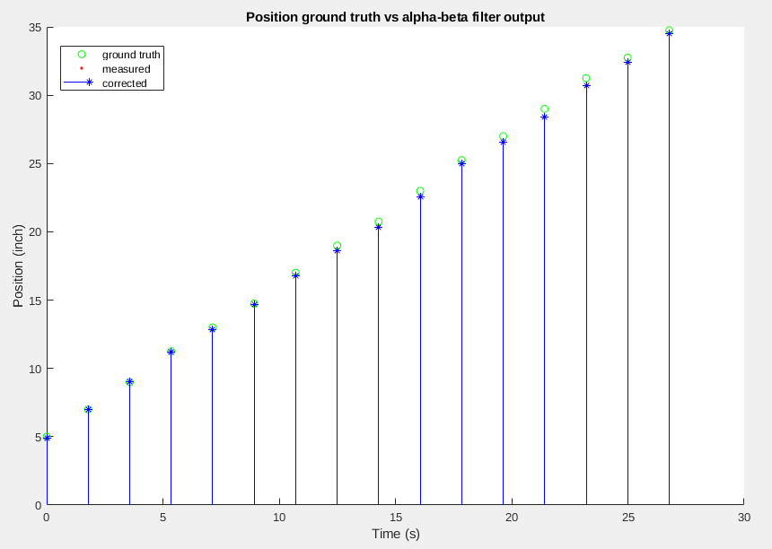

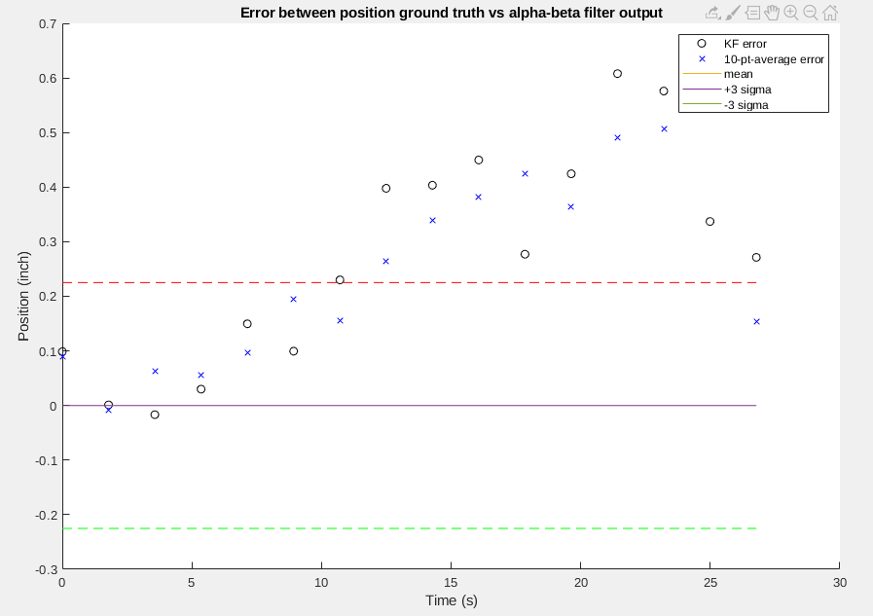

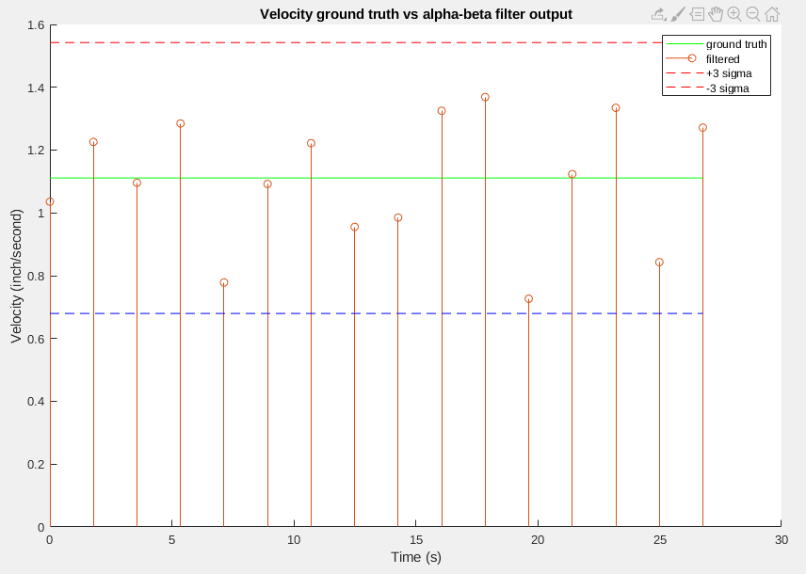

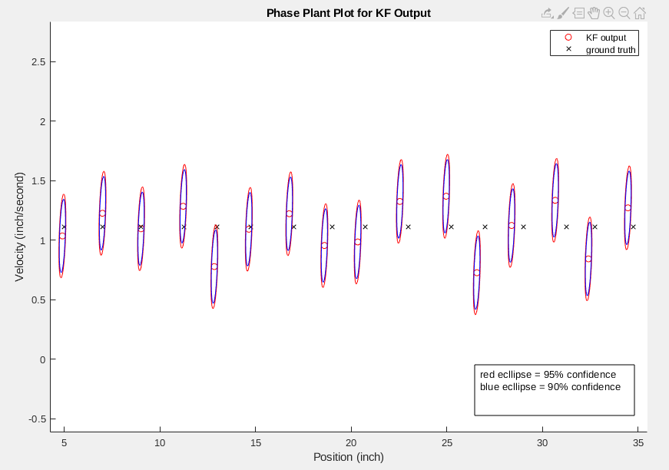

### III.3.2 Set #2 Figures

And below are the figures for set #2:

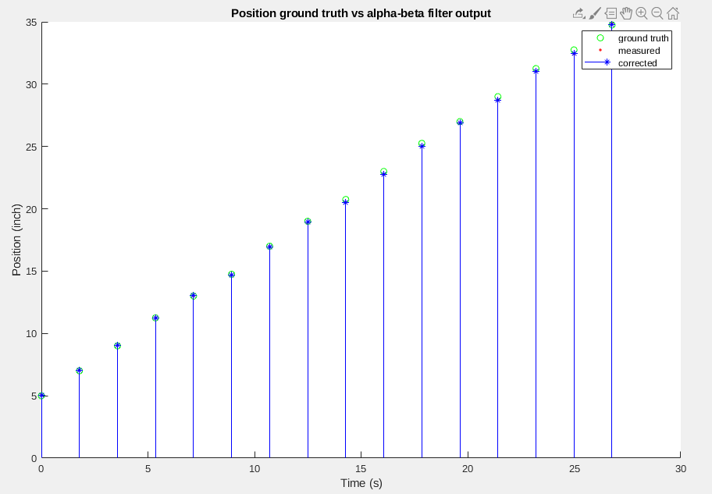

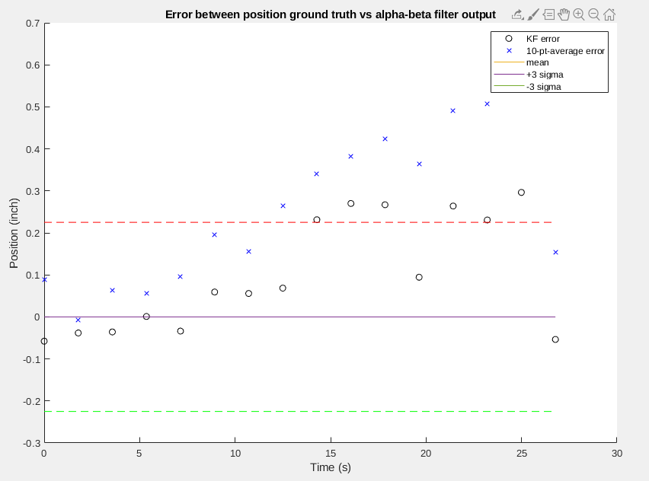

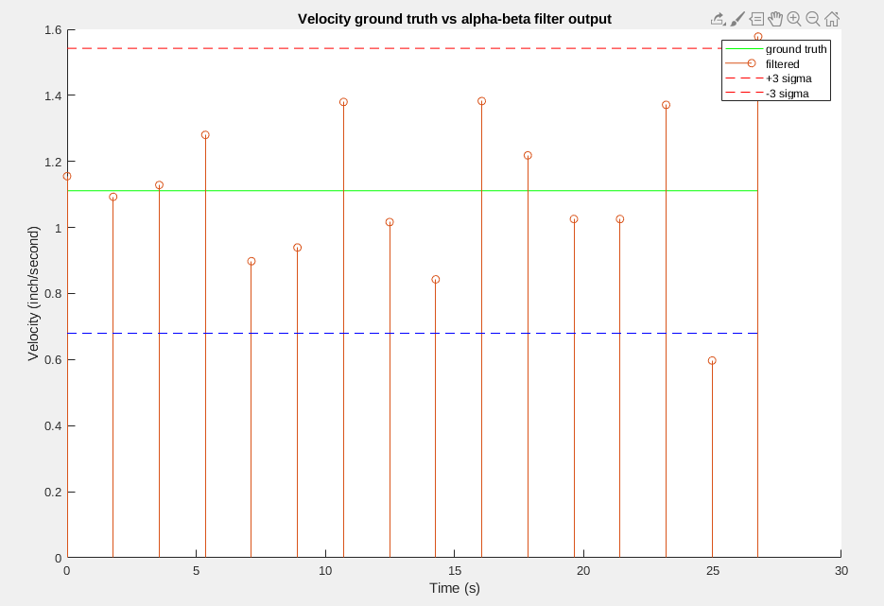

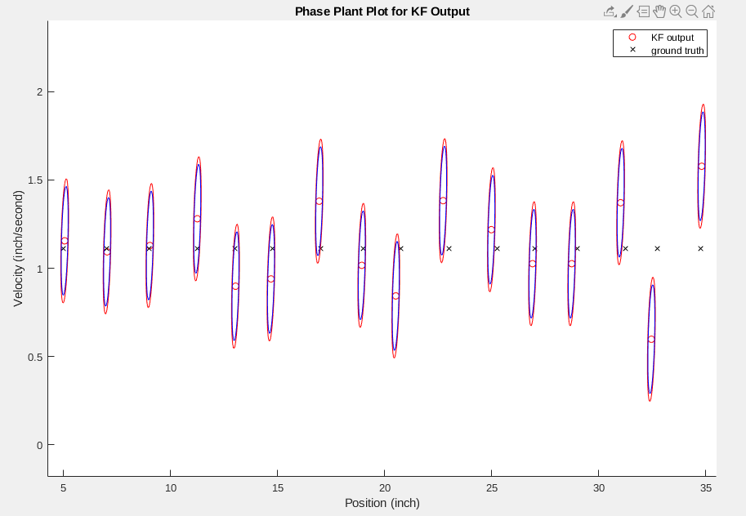

### III.3.3 Analysis

The ABF results obtained from both datasets are reasonable given the quality of the sensor. Since the sensor has small drifts at distances > 15 inches and significant drifts at distances > 21 inches, the performance of the Alpha-Beta filter is shown to decreases over time (error between position ground truth vs filter output figures). The filter’s output can be improved significantly by increasing the measurement noise from 0.0764 (class number) to 0.15. This is shown in 2 figures below for Set #1:

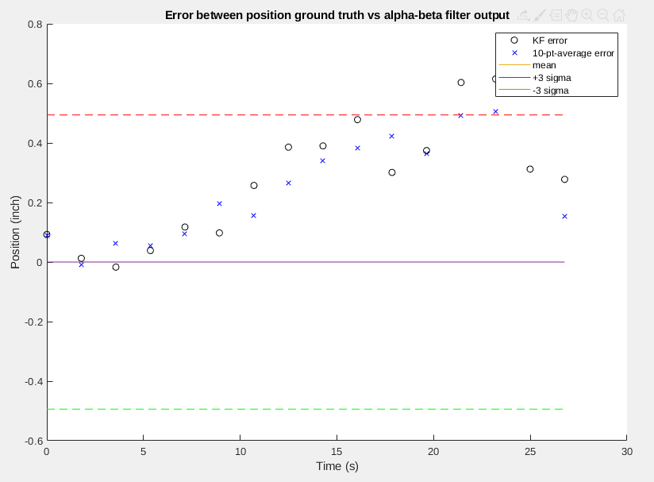

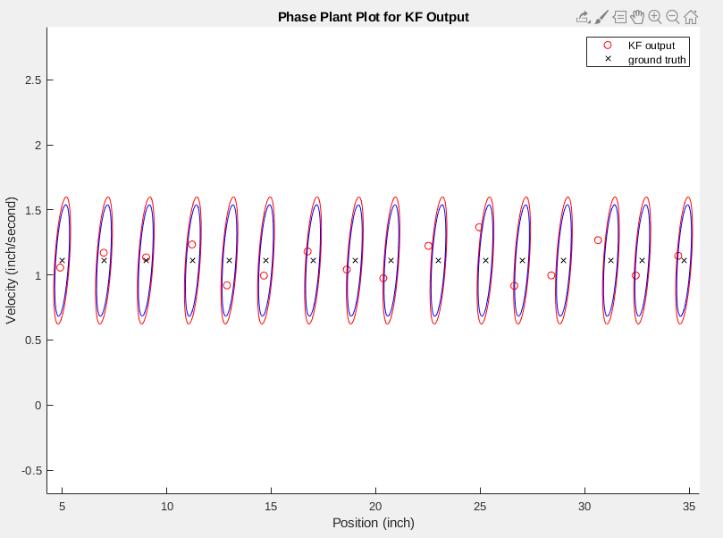

However, even when the measurement noise is increased, the filter’s positional outputs are not as good as averaging samples across all 10 data sets. However, the positional performance of the ABF in set #2 is better than the 10-pt-average. The contrast between the 2 datasets indicates that the sensor is not reliable at large range: some of the time, the measurement is good and other time, the measurement is not so good. This phenomenon is likely due to the fact that the experimental setup was not completely controlled. Measurements for faraway distances have a greater variance (shown as increased error in both sets) due to a higher chance for reflected signals from complex surfaces to interfere.

In addition, the figures for the phase plant graphs showed that a lot of points (from both sets) are outside the ellipse. This is a result of the phenomenon described above: the velocity error stays within the +/- 3 sigma boundaries but the position error does not. Also shown above, increasing the measurement noise to accommodate to high distance measurement variance brings many points inside the ellipses by extending their x-axis.

Finally, the covariance matrix, P(k|k), converges to the one predicted in the Kalata paper using the calculated alpha and beta values.

# Section IV: Summary and Conclusions

We have successfully demonstrated the use of the Alpha and the Alpha-Beta filter on the train-on-track model. Both filters yield reasonable results given the quality of the sensors and the experimental setup. In order to improve the results in both filters, the measurement noise estimate has to be increased because of the significant drifts at high range. The Alpha filter has good results (in between +/- 3 sigma) at low/medium range and reasonable results (points are on the edge, with some, outside +/- 3 sigma) at high range. The Alpha-Beta filter yields expected results, with high distances resulting in prediction with high error and low/medium distances resulting in prediction with tight error. And the covariance matrix P(k|k) in both filters converges to the one predicted by Kalata in his paper.

# Section V: Appendix

Kalata, Paul R. “The Tracking Index: A Generalized Parameter for α-β and α-β-γ Target Trackers.” *The 22nd IEEE Conference on Decision and Control*, Mar. 1983, pp. 174–182., doi:10.1109/cdc.1983.269580.

Additional Alpha-Filter Plots:

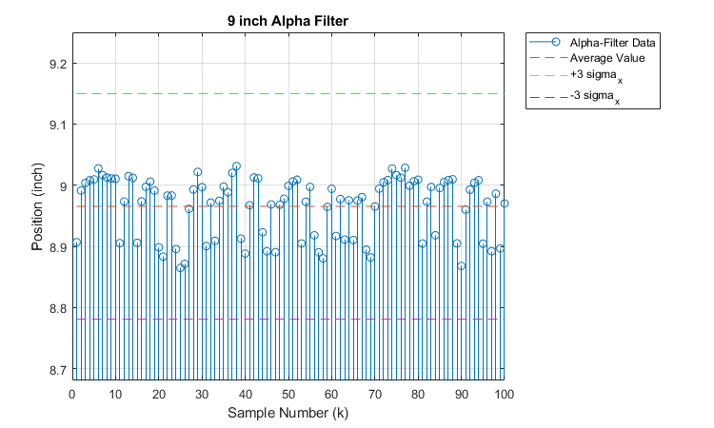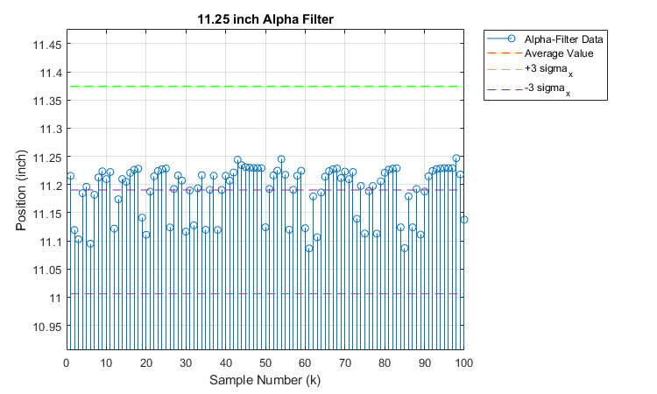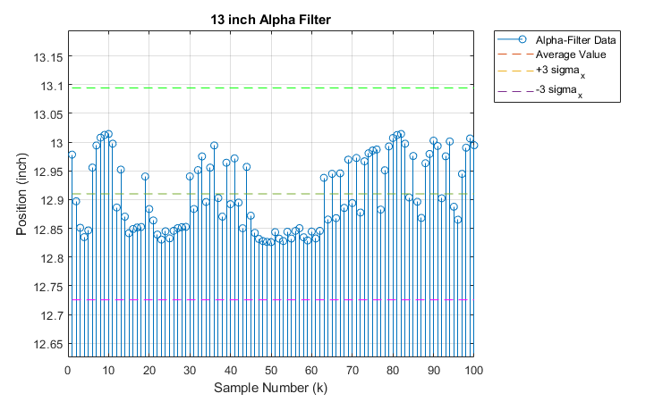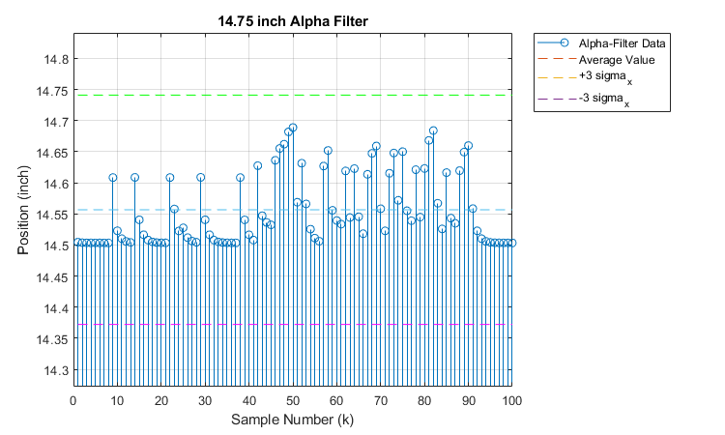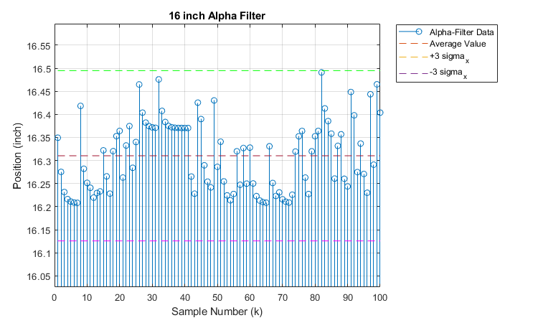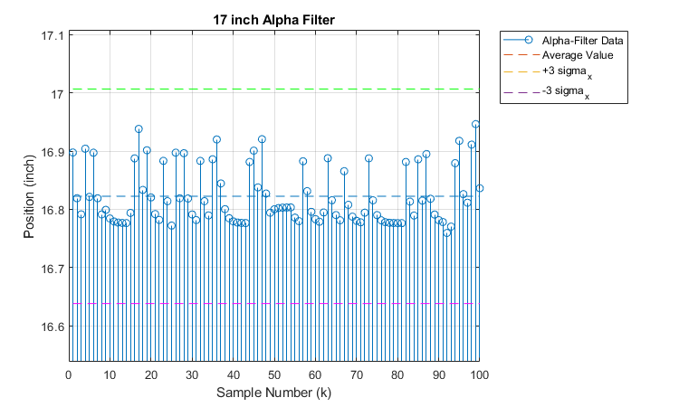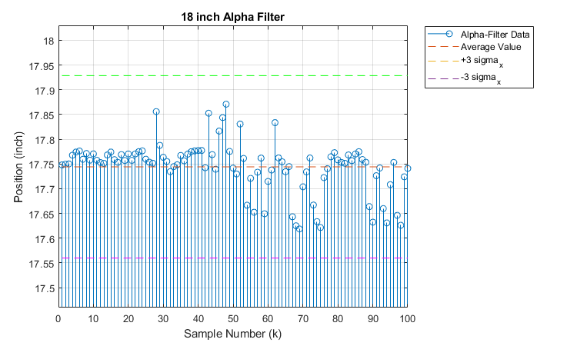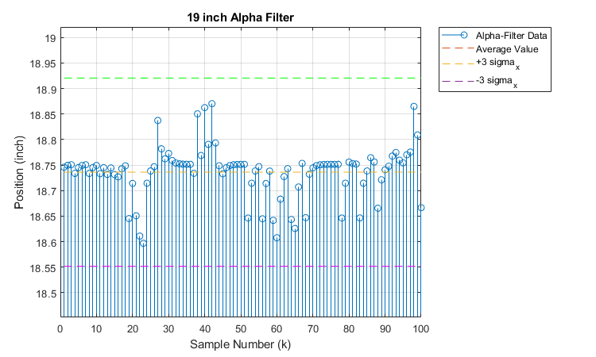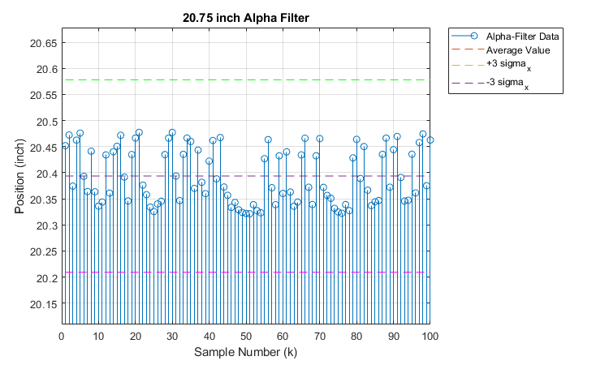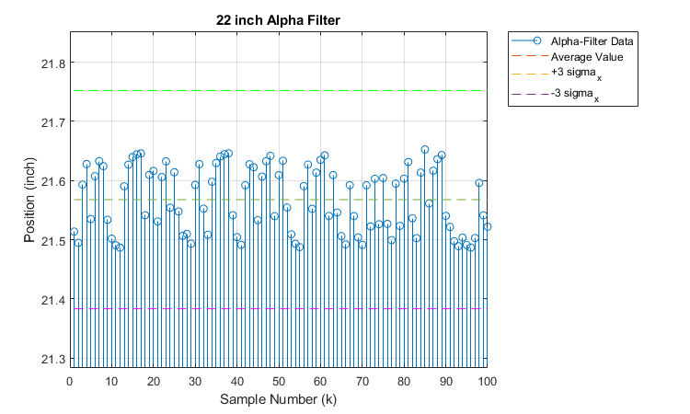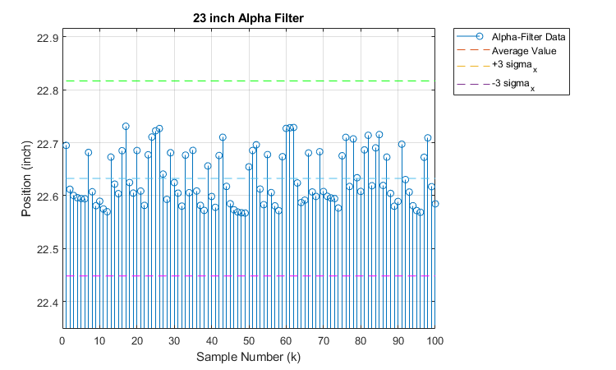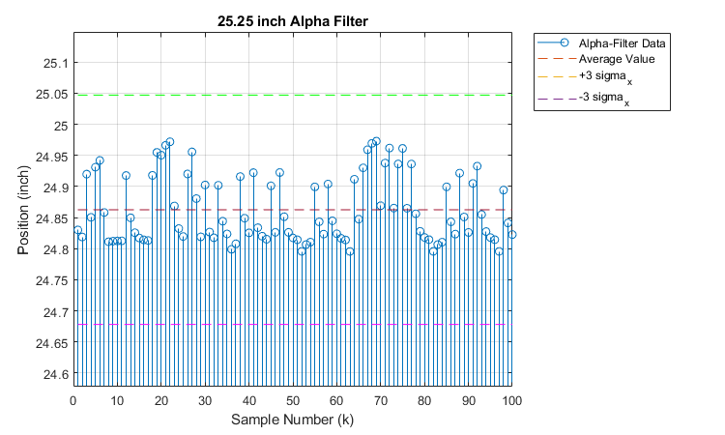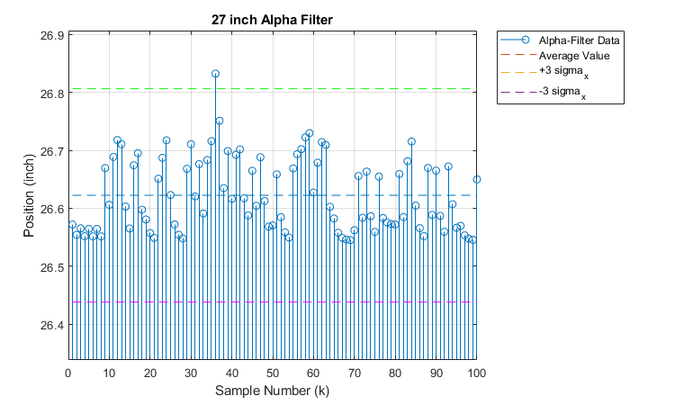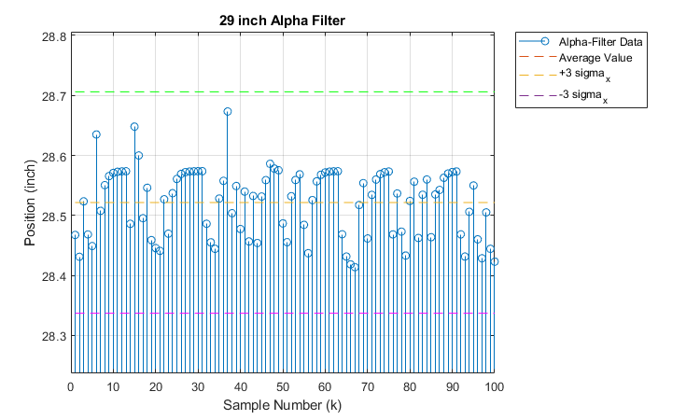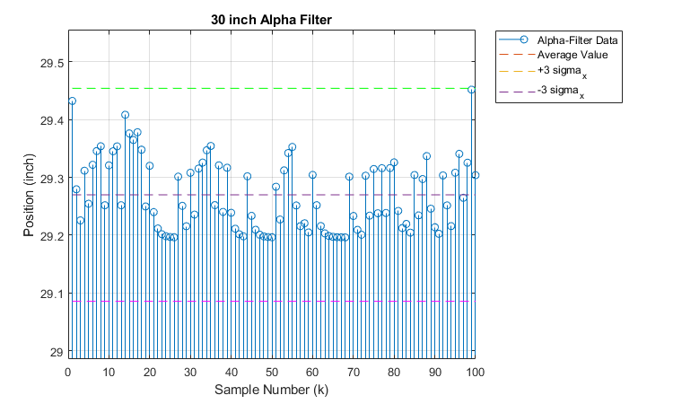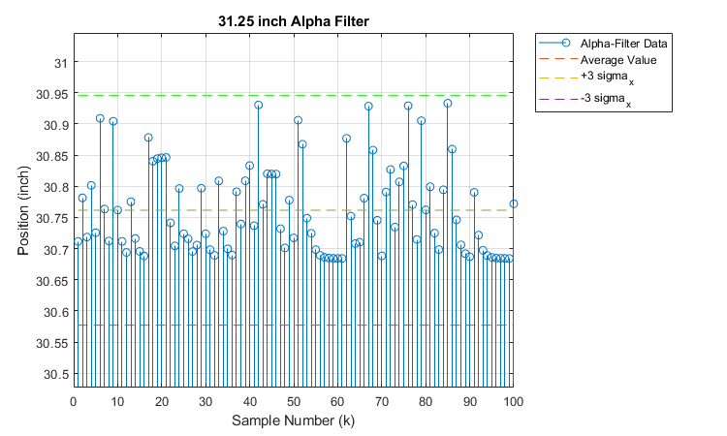

1. Kalata, Paul R. “The Tracking Index: A Generalized Parameter for α-β and α-β-γ Target Trackers.” *The 22nd IEEE Conference on Decision and Control*, Mar. 1983, pp. 174–182., doi:10.1109/cdc.1983.269580.