**Group number (use same as on spreadsheet for noise measurements)___10___**

**Group members:**

* **Jonathan Palko**
* **Tai Nguyen**

See the file UT_KF_Tracking_Spr19-20 remember to use $σ_{w}^{2}=\left(\frac{1}{36}\right)$

**Alpha Filter** - Using the nominal 10’ distance take a large number (>100) of points (don’t move sensor between points). This should be the same as what you used to get mean and covariance in our prior exercise. Run the alpha filter and plot position vs. update number. You can make T = 1 for this exercise. To start the filter, use the mean value of you data as IC of your position data and a “large”value for the position error covariance say about 5x what is predicted by Kalata paper.

Work in inches. You should get a “flat”plot, show +/- 3 $σ_{x}$ around the data. You will see startup anomalies, if they are off scale adjust the scale so you can see the variation when the filter is running

|  |  |  |  |  |  |  |
| --- | --- | --- | --- | --- | --- | --- |
| Sensor distance to wall (inches) | # samples | $$σ_{n}^{2}$$ | Alpha (T=1) $$α$$ | Steady state eror covariance | IC | IC |
| **10** | **116** | **0.0058411** | **0.6474** | **0.0038** | **10.0007** | **N/A** |

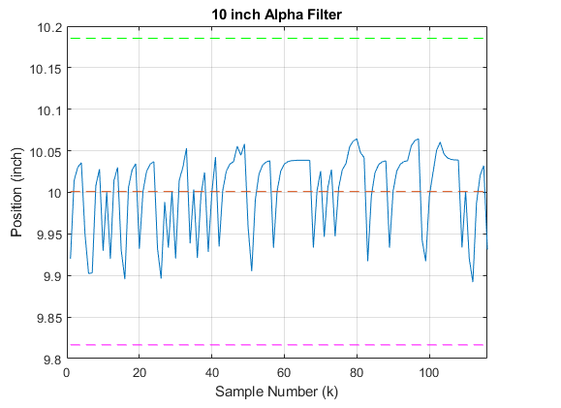

Comments: The calculated values stayed within the acceptable ranges of +/- 3 $σ_{x}$. The plot itself does not appear flat, but when zoomed out to slightly larger axis values it appears to be flat.

**Alph-Beta a Filter**. Use data evenly spaced from about 5 inches to 35 inches (the more data points the better I would pick dR 2 inches apart and take 2 readings at each point but you can use what you have if the graphs look okay ). In this example you can position the sensor to /- ¼ inch of the actual/ruler value. Run the alpha beta filter for your data. Select T (which defines apha and beta) so that the average velocity is is reasonable say 1 mile per hour (you can choose anything you want). To start the filter use $[5, nominal velocity]$ as IC of your state data and a “large”value for the position error covariance MATRIX say about 5x what is predicted by Kalata paper.

Work in inches. For position you should get a ramp and for velocity a “flat”curve , show +/- 3 $σ_{\tilde{v}}^{2}$ around the velocity data. You will see startup anomalies; you may want to adjust the ICs and initial covariance matrix to mimimise these. If startup data is off scale adjust the scale so you can see the variation when the filter is running.

|  |  |  |  |  |  |  |
| --- | --- | --- | --- | --- | --- | --- |
| $$σ_{n}^{2}$$ | T  (second) | Alpha $$α$$ | Beta $$B$$ | Steady state eror covariance   Matrix | IC | IC |
| **0.0058411** | **1.7850** | **0.9642** | **1.3147** | **0.0056 0.0043**  **0.0043 0.0207** | **5.0000**  **1.1111** | **10000 0**  **0 10000** |

Provide two runs each showing position and velocity vs time. Remember stem plots.

**RUN 1**

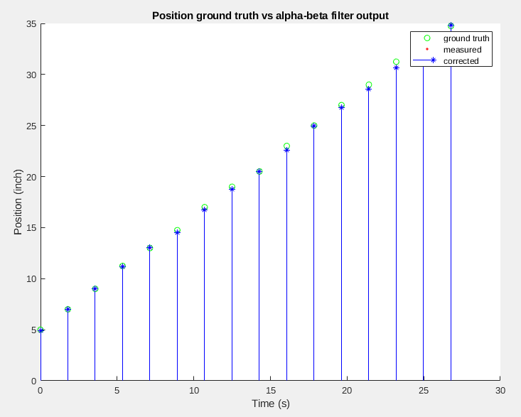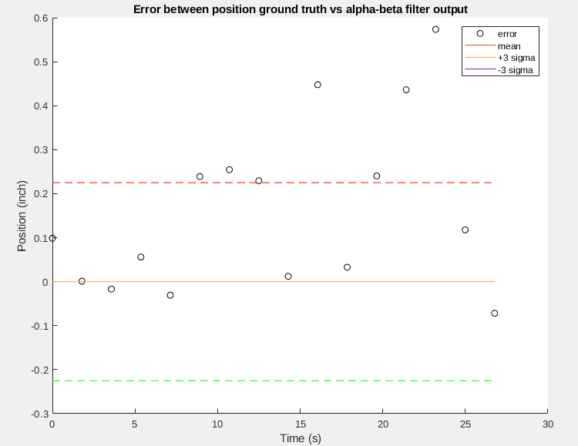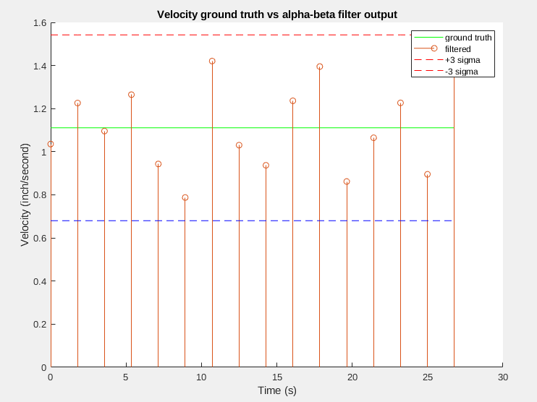

**RUN 2**

