Applications of Kalman Filters Report

Group members: Tai Nguyen (Computer Engineering), Johnathan Palko (Mechanical Engineering)

Professor: Thomas Chmielewski

ECEC-T580

Drexel University, College of Engineering

June 06, 2020

Table of Content

Section I: Introduction/Background

1. Management summary
2. Objective
3. Data gathering summary

Section II: Alpha Filter

1. Objective
2. Statistics and KF parameters
3. Data analysis and presentation

Section III: Alpha-Beta Filter

1. Objective
2. Statistics and KF parameters
3. Data analysis and presentation

Section IV: Summary and Conclusions

Section V: Appendix

Section III: Alpha-Beta Filter

1. Objective

This section features the implementation of the Alpha-Beta filter (ABF), a related cousin to the Kalman filter (KF), and its application on an object-tracking model described below.

An Alpha-Beta filter assumes that a system can be approximated with 2 internal states, one state is an integral of the other (i.e. position and velocity). This filter works by calculating a tracking index, T, which is used to calculate the value of alpha and beta. These 2 values are very good estimates of the stead-state Kalman gain, K. It is shown by Kalata[1] that the covariance matrix resulted from the Alpha-Beta filter converges to the one from Kalman filter. The principal advantage of ABF is that alpha and beta can be calculated a head of time with limited knowledge about the applied system:

$$λ= \frac{T^{2}×σ_{w}}{σ_{n}}$$



$$α = 1 - r^{2}$$



where T is the time period in between each measurement, $σ_{w}$ is the process noise, and $σ_{n}$ is the measurement noise.

The object-tracking model demonstrated in this paper is similar to the train-on-track model, where a moving train is tracked knowing the distribution of the initial conditions and its position-velocity constraints. While the train is running on the track, an onboard radio signal is communicated to a far away station every T seconds about the current position of the train. Assume that the train is traveling with a constant velocity, $v_{avg}$, with some unknown acceleration. Hence, the train’s velocity is described by a Gaussian distribution with mean = $v_{avg}$, and standard deviation = $σ_{w}$. Using the Alpha-Beta filter, the objective is to predict the train movement and evaluate the prediction based on ground-truth.

1. Statistics and KF Parameters

The process noise $σ_{w}$ is chosen to be $\frac{1}{6}$, which assumes a displacement variation of $±\frac{1}{4}$ inch. The measurement noise $σ_{n}$ is taken from the class’s variance, and is set to be 0.0764. The average velocity $v_{avg}$ for the “train” is 1.11 inches per second over a distance of 30 inches, yielding a time period T of 1.7850 seconds.

$$\left\{\begin{aligned}σ_{w}=1/6 \\ σ_{n} = 0.0764 \\ T = 1.7850 \\ v_{avg} = 1.11\end{aligned}\right.$$

Hence, using the equations in the above section, the value for alpha and beta are:

$$α=0.9642$$

$$β= 1.3147$$

Hence, the ABF gain K is:

$$K = \left[\begin{matrix}α \\ β/T\end{matrix}\right]=\left[\begin{matrix}0.9642 \\ 0.7365\end{matrix}\right]$$

We initialized P(k|k) to be $\left[\begin{matrix}1000 & 0 \\ 0 & 1000\end{matrix}\right]$.

After running our filter, P(k|k) is:

$$P(k|k) = \left[\begin{matrix}0.0056 & 0.0043 \\ 0.0043 & 0.0207\end{matrix}\right]$$

Our results are summarized in the table below:

|  |  |  |  |  |  |  |
| --- | --- | --- | --- | --- | --- | --- |
| $$σ_{n}^{2}$$ | T  (second) | Alpha $$α$$ | Beta $$B$$ | Steady state eror covariance   Matrix | IC | IC |
| **0.0058411** | **1.7850** | **0.9642** | **1.3147** | **0.0056 0.0043**  **0.0043 0.0207** | **5.0000**  **1.1111** | **1000 0**  **0 1000** |

1. Data analysis and presentation

In this section, we present our analysis on the result and performance of the filter on our dataset.

First, here are the figures for set #1:

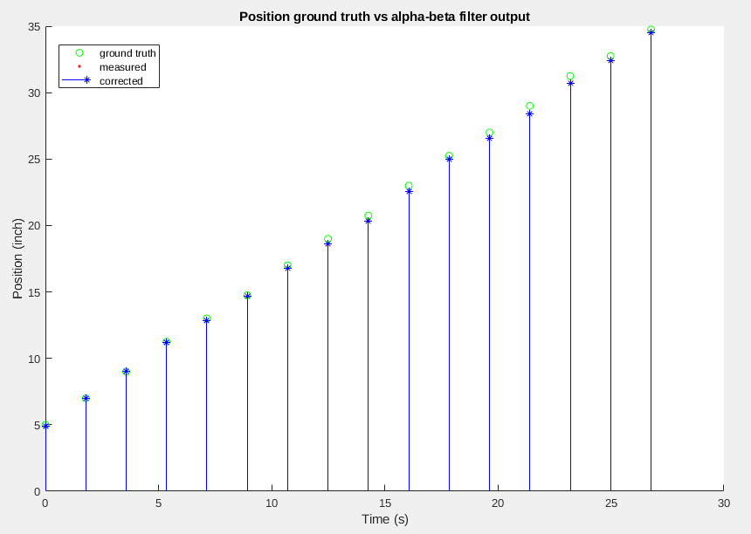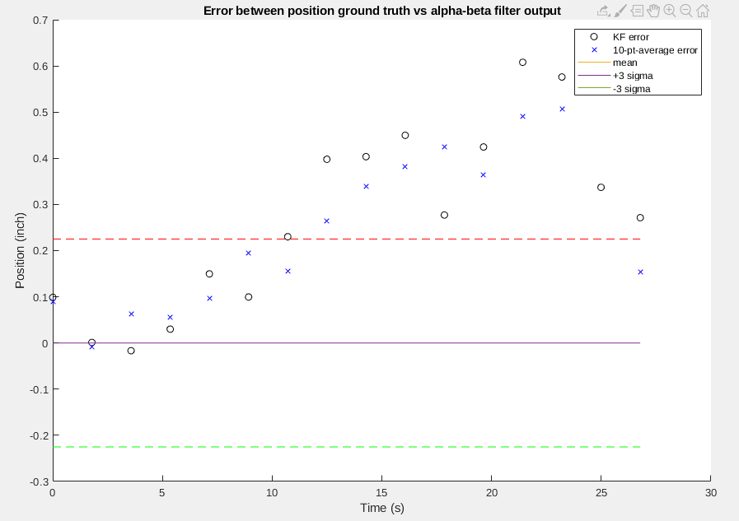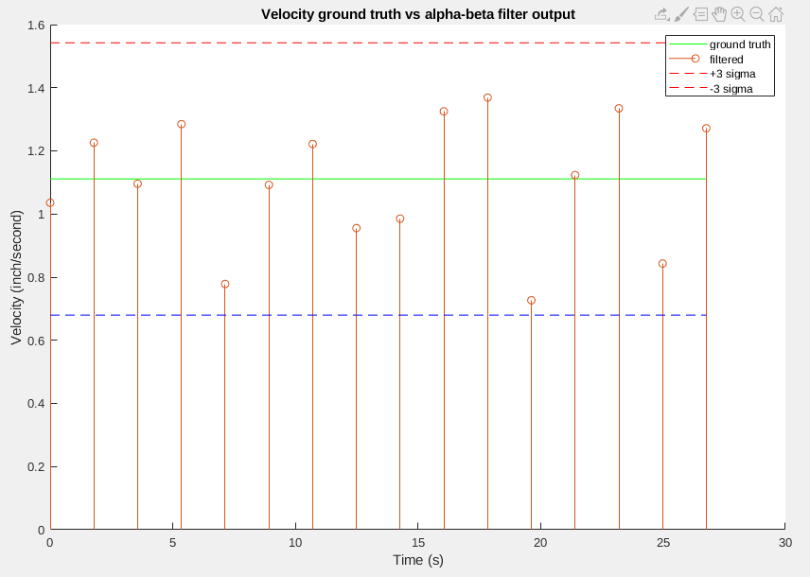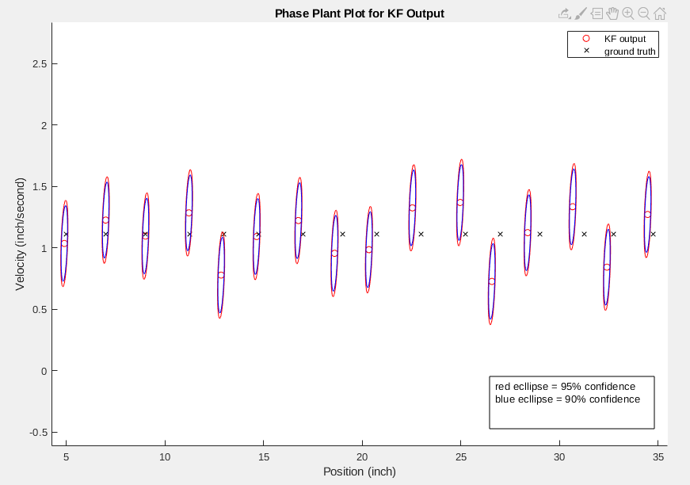

And below are the figures for set #2

