*1) INTRODUCTION*

**1.1) Purpose**

_The purpose of this document is to build an online system can manage car production and customer can choose to buy and sell cars easier and more convenient.

**1.2) Document Convention**

|  |  |
| --- | --- |
| **DB** | **Database** |
| **ERD** | **Entity Relationship Diagram** |

**1.3) Intended Audience and Reading Suggestion**

_This project is prototype for car product management system and it is restricted within the college premises. This project is useful for both user want to buy and sell car

**1.4) Project Scope**

**_**Till now car is one of the most important as a vehicle that can make people life easier. You want to travel place to place? You need to buy car. You want to transport things? Car can help you. Your family want to have a great summer vacation? Well, all you need is a car and a map. But buying a car still a problem to someone. You don’t know what type of car you want to buy. Which producer is better or more suitable for you. Don’t worry we **3StarAuto,** can solve that problem for you.

*2) Diagram:*

**Use case Diagram**

* **User:**

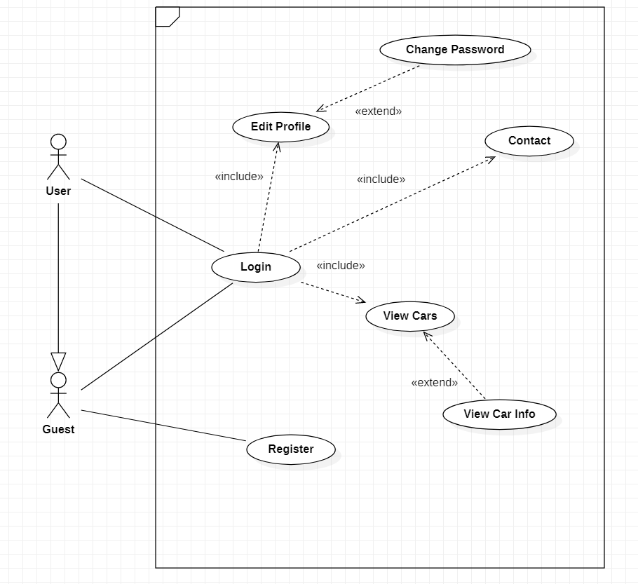

* **Admin:**

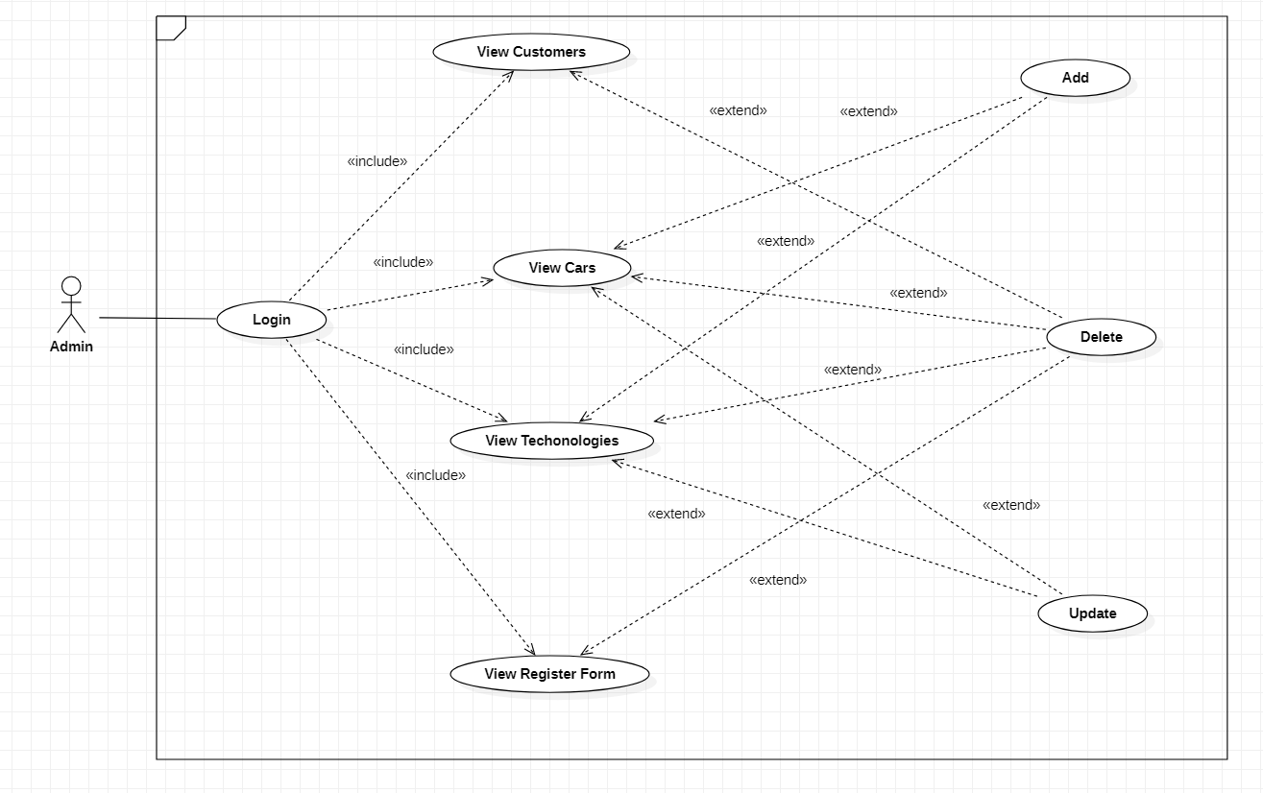

**USE CASE DESCRIPTION**

1. **Actor:**

* **Customers :** include all visitors that use this website. They are guests and members. ***Guest*** is the person that uses this website but doesn’t register. ***Member*** is the person that uses this website and register to become a member of us.
* **Website administrators :** The person(s) that manage and maintain this web site.

1. **Usecase:**

* **Admin:**

|  |  |
| --- | --- |
| **Use case** | Log In |
| **Primary Actor** | Admin |
| **Goal In Context** | Enable admin access to the system |
| **Preconditions** | Admin has a valid username and password and is not already logged in |
| **Trigger** | Admin requires access to the systems to perform their job |
| **Scenario** | 1)The form prompts the admin for their username and password |
| 2)Admin enters their username and password |
| 3)The form enables access to the system according to access control |
| **Exceptions** | Admin enters an invalid username and password |
|  |  |
|  |  |
| **Use case** | View Customers |
| **Primary Actor** | Admin |
| **Goal In Context** | Display a list of customers |
| **Preconditions** | Admin has accessed to the system |
| **Trigger** | Admin views the list of customers |
| **Scenario** | 1) Admin selects ‘View customer’ from the menu navigation |
| 2)The form shows a list of customers |
| **Exceptions** | Admin selects another function |
|  |  |
|  |  |
|  |  |
|  |  |
|  |  |
| **Use case** | Add |
| **Primary Actor** | Admin |
| **Goal In Context** | Enable admin to create the details of each object |
| **Preconditions** | Admin has entered to a section |
| **Trigger** | Admin create for the information about the object |
| **Scenario** | 1) Admin clicks ‘Add’ next to object’s name |
| 2) The form shows the detail of the object to add |
| **Exceptions** | Admin rolls back to the Home page |
|  |  |
|  |  |
|  |  |
| **Use case** | View Techonologies |
| **Primary Actor** | Admin |
| **Goal In Context** | Display a list of techonologies |
| **Preconditions** | Admin has accessed to the system |
| **Trigger** | Admin views the list of techonologies |
| **Scenario** | 1) Admin selects ‘View techonologies’ from the menu navigation |
| 2)The form shows a list of techonologies |
| **Exceptions** | Admin selects another function |
|  |  |
|  |  |
|  |  |
|  |  |
|  |  |
| **Use case** | View Register Form |
| **Primary Actor** | Admin |
| **Goal In Context** | Display a list of Register Form |
| **Preconditions** | Admin has accessed to the system |
| **Trigger** | Admin views the list of Register Form |
| **Scenario** | 1) Admin selects ‘View Register Form’ from the menu navigation |
| 2)The form shows a list of Register Form |
| **Exceptions** | Admin selects another function |
|  |  |
|  |  |
|  |  |
| **Use case** | View Cars |
| **Primary Actor** | Admin |
| **Goal In Context** | Display a list of Cars |
| **Preconditions** | Admin has accessed to the system |
| **Trigger** | Admin views the list of Cars |
| **Scenario** | 1) Admin selects ‘View Cars’ from the menu navigation |
| 2)The form shows a list of Cars |
| **Exceptions** | Admin selects another function |
|  |  |
|  |  |
| **Use case** | Delete |
| **Primary Actor** | Admin |
| **Goal In Context** | Enable admin to delete the details of each object |
| **Preconditions** | Admin has entered to a section |
| **Trigger** | Admin delete for the information about the object |
| **Scenario** | 1) Admin clicks ‘Delete’ next to object’s name |
| 2) The form shows the detail of the object to delete |
| **Exceptions** | Admin rolls back to the Home page |
|  |  |
|  |  |
| **Use case** | Update |
| **Primary Actor** | Admin |
| **Goal In Context** | Enable admin to delete the details of each object |
| **Preconditions** | Admin has entered to a section |
| **Trigger** | Admin update for the information about the object |
| **Scenario** | 1) Admin clicks ‘Update’ next to object’s name |
| 2) The form shows the detail of the object to update |
| **Exceptions** | Admin rolls back to the Home page |

* **User:**

|  |  |
| --- | --- |
| Use Case | Register |
| Primary Actor | Guest |
| Goal in Context | Enable guest have an account to access more functionality of the system |
| Precondition | Guest access to system on window |
| Trigger | Guest require to create an account |
| Scenarios | 1.Guest access to the system on the window 2.Guest click on the "Register" button 3.A window show up and require guest fill his/her information to register form 4.After guest fullfill register form, new message box inform that he/she has created an account and can access to system's limited function. 5.Return to login screen |
| Exception | 1.Guest enter wrong format of username, password, email, phonenumber 2.Guest's username,email or Identity Card's number has been registered |
|  |  |
| Use Case | Login |
| Primary Actor | User/Guest |
| Goal in Context | User or Guest just created an account can access to limited function of the System |
| Precondition | User/Guest had an account on system |
| Trigger | User/Guest require login on system |
| Scenarios | 1.User/Guest access to the system on the window 2.User/Guest click on the "Login" button or want to access to limited function  3.A window shows up and requires users/guests enter username and password 4.After user/guest login to account, a messagebox show welcome message and allow he/she to access system. |
| Exception | User/Guest enter invalid user name and password |
|  |  |
|  |  |
| Use Case | Edit profile |
| Primary Actor | User |
| Goal in Context | Change account information |
| Precondition | User login to the system |
| Trigger | User want to change information |
| Scenarios | 1.User access to the system on the window and login by account 2.User click on "Account Profile" button 3.A window pop-up show every information of user. 4.User make a change on a pop-up window 5.User save the change, close the window and new change has been saved to database |
| Exception | User enter invalid or duplicated username, wrong format of password, email phone number… |
|  |  |
| Use Case | View cars |
| Primary Actor | User/Guest |
| Goal in Context | View all the products on the system |
| Precondition | User/Guest access to the system |
| Trigger | User/guest view product before decide buy it |
| Scenarios | 1.User or guest access to the system on the window 2.User go to "Cars" section 3.List of car will show up for user |
| Exception | Internet error |
|  |  |
| Use Case | Contact |
| Primary Actor | User/Guest |
| Goal in Context | user or guest can contact to admin for any problem of system |
| Precondition | User/Guest access to the system |
| Trigger | User/guest have any problem while access to the system |
| Scenarios | 1.User or guest access to the system on the window 2.User go to "Contact" section 3.contact info of responsible admin show up to user/guest |
| Exception | No admin online. |
|  |  |
|  |  |
|  |  |
| Use Case | Change Password |
| Primary Actor | User |
| Goal in Context | Change password account customer |
| Precondition | User login to the system |
| Trigger | User want to change password |
| Scenarios | 1.User access to the system on the window and login by account 2.User click on "Account Profile" button 3.A window pop-up show every information of user. 4.User make a change on a pop-up window 5.User save the change, close the window and new change has been saved to database |
| Exception | Internet error |
|  |  |
|  |  |
|  |  |
| Use Case | View Car Infor |
| Primary Actor | User |
| Goal in Context | View all the information of the products on the system |
| Precondition | User access to the system |
| Trigger | User view information of the product before decide buy it |
| Scenarios | 1.User or guest access to the system on the window 2.User go to "Cars" section  3. User click view 4.List of car will show up for user |
| Exception | Internet error |

**CLASS DIAGRAM**

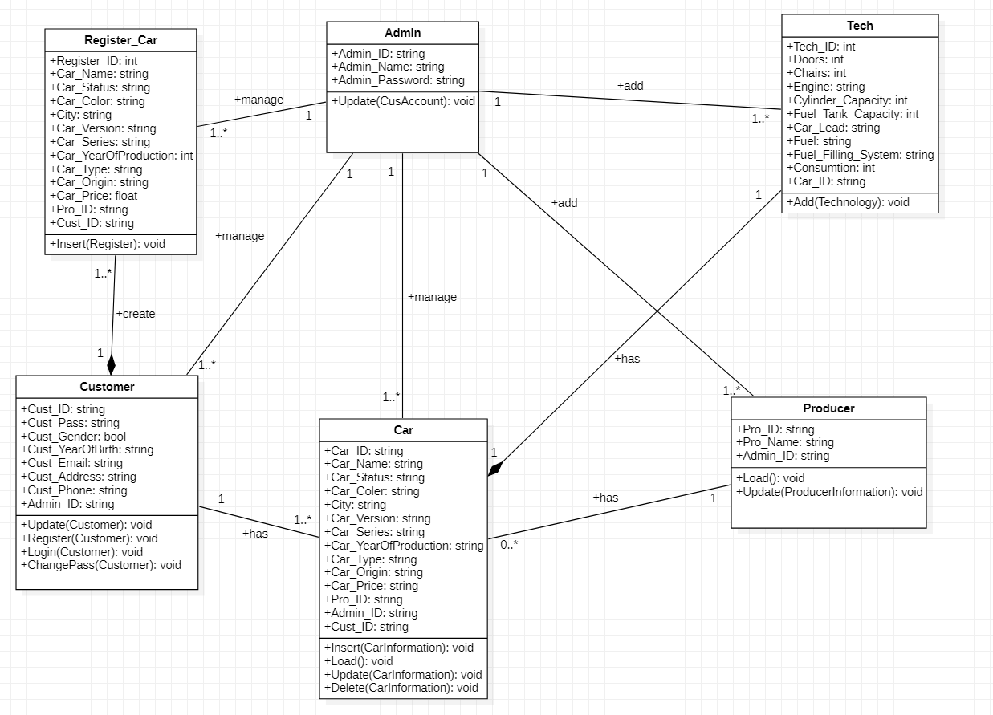

**ENTITY RELATIONSHIP DIAGRAM (ERD)**

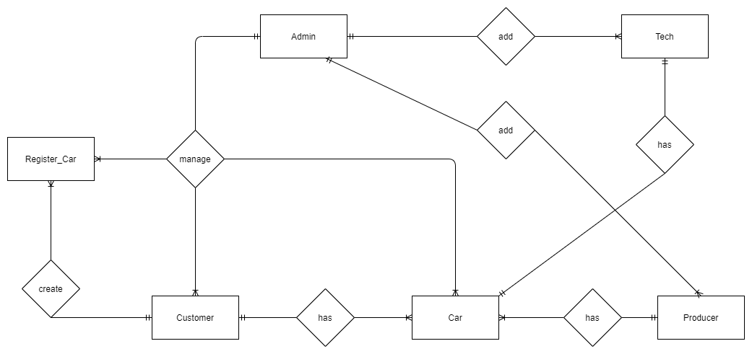

**ENTITY DESCRIPTION**

**1.Producer:**

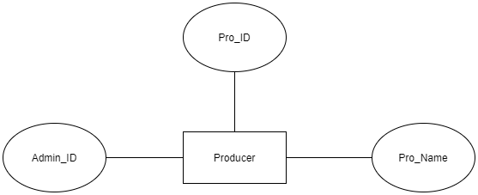

**2.Admin:**

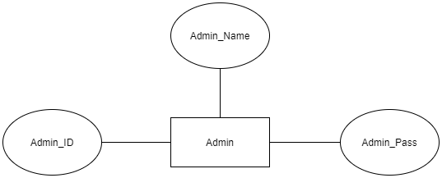

**3.Customer:**

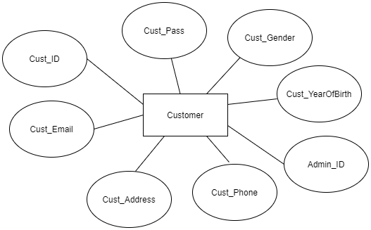

**4.Tech:**

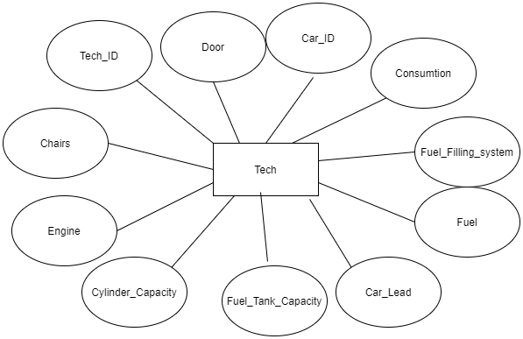

**5. Car:**

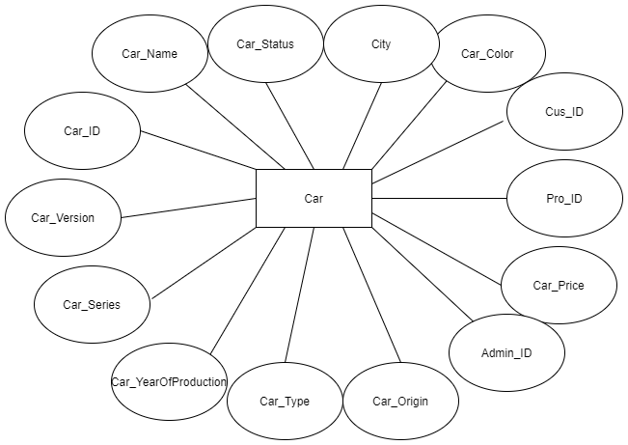

**6.Register_Car:**

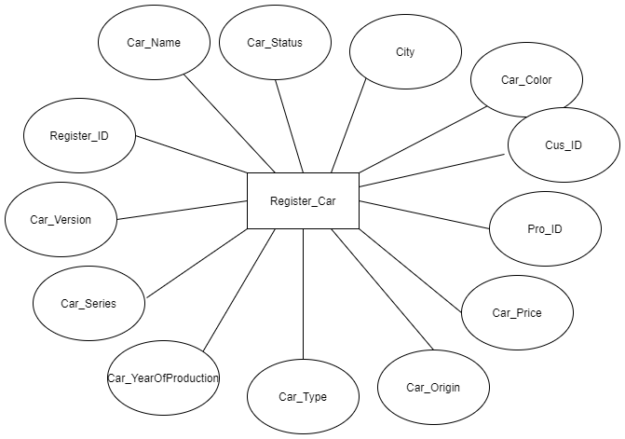

**TABLE DESIGN**

**1. Customer**

|  |  |  |  |  |  |
| --- | --- | --- | --- | --- | --- |
|  |  |  |  |  |  |
| **No** | **Column Name** | **Data Type** | **Size** | **Check** | **Description** |
| 1 | **Cust_ID** | String | 10 | Not Null | Account Customer ID |
| 3 | Cust_Password | String | 10 | Not Null | Account Customer Password |
| 4 | Cust_Gender | Bit |  | Null | Customer Gender |
| 2 | Cust_YearOfBirth | String | 4 | Null | Customer year of birth |
| 3 | Cust_Email | string | 30 | Null | Customer Email |
| 5 | CusInfo_Address | String | 50 | Null | Customer Address |
| 6 | CusInfo_Phone | string | 10 | Null | Customer Phone |
| 8 | **Admin_ID** | String | 10 | Not Null | Account Customer ID |
|  |  |  |  |  |  |
|  |  |  |  |  |  |
|  |  |  |  |  |  |
| **2. Car** |  |  |  |  |  |
| **No** | **Column Name** | **Data Type** | **Size** | **Check** | **Description** |
| 1 | **Car_ID** | String | 10 | Not Null | Car ID |
| 2 | Car_Name | String | 50 | Null | Car Name |
| 3 | Car_Status | String | 20 | Null | Car Status |
| 4 | Car_Color | string | 10 | Null | Car Color |
| 5 | City | String | 30 | Null | City |
| 6 | Car_Version | String | 10 | Not Null | Car version |
| 7 | Car_Series | string | 10 | Null | Car series |
| 8 | Car_YearOfProduction | int |  | Not Null | Car YearOfProduction |
| 9 | Car_Type | String | 10 | Not Null | Car type |
| 10 | Car_Origin | string | 10 | null | Car Origin |
| 11 | Car_Price | float |  | null | Car Price |
| 12 | Pro_ID | string | 10 | null | Production ID |
| 13 | Admin_ID | string | 10 | null | Admin ID |
| 14 | Cust_ID | string | 10 | null | CustomerID |
|  |  |  |  |  |  |
| **3. Admin** |  |  |  |  |  |
| **No** | **Column Name** | **Data Type** | **Size** | **Check** | **Description** |
| 1 | **Admin_ID** | String | 10 | Not Null | Account Admin ID |
| 2 | Admin_Name | String | 50 | Null | Account Admin Name |
| 4 | Admin_Pass | String | 10 | Not Null | Account Admin Password |
|  |  |  |  |  |  |
| **4.Register_Car** |  |  |  |  |  |
| **No** | **Column Name** | **Data Type** | **Size** | **Check** | **Description** |
| 1 | **Register_ID** | int | 10 | Not Null | Car ID |
| 2 | Car_Name | String | 50 | Null | Car Name |
| 3 | Car_Status | String | 20 | Null | Car Status |
| 4 | Car_Color | string | 10 | Null | Car Color |
| 5 | City | String | 10 | Null | City |
| 6 | Car_Version | String | 10 | Not Null | Car version |
| 7 | Car_Series | string | 10 | Null | Car series |
| 8 | Car_YearOfProduction | int |  | Not Null | Car YearOfProduction |
| 9 | Car_Type | String | 10 | Not Null | Car type |
| 10 | Car_Origin | string | 10 | null | Car Origin |
| 11 | Car_Price | float |  | null | Car Price |
| 12 | Pro_ID | string | 10 | null | Production ID |
| 13 | Cust_ID | string | 10 | null | CustomerID |
|  |  |  |  |  |  |
| **5.Tech** |  |  |  |  |  |
| **No** | **Column Name** | **Data Type** | **Size** | **Check** | **Description** |
| 1 | Tech_ID | int |  | not null | Technology ID |
| 2 | Doors | int |  | null | Doors car |
| 3 | Chairs | int |  | null | Chair car |
| 4 | Engine | string | 20 | null | Engine car |
| 5 | Cylinder_Capacity | int |  | null | Cylinder capacity |
| 6 | Fuel_Tank_Capacity | int |  | null | Fuel Tank Capacity |
| 7 | Car_Lead | string | 20 | null | Lead car |
| 8 | Fuel | string | 20 | null | Fuel |
| 9 | Fuel_Filling_System | string | 50 | null | Fuel Filling System |
| 10 | Consumtion | int |  | null | Consumtion |
| 11 | Car_ID | string | 10 | null | Car ID |
|  |  |  |  |  |  |
| **6.Producer:** |  |  |  |  |  |
| **No** | **Column Name** | **Data Type** | **Size** | **Check** | **Description** |
| 1 | Pro_ID | string | 10 | not null | Producer ID |
| 2 | Pro_Name | string | 50 | not null | Producer name |
| 3 | Admin_ID | string | 10 | not null | Admin ID |

**TABLE RELATIONSHIP DIAGRAM**

