**Introduction to cascading style sheets**

**Objectives**

* Style Sheets
* Style Sheets Elements
* Text and Font Properties
* Div tags

**Exercise 1** **(5 marks)**

* Develop website display Latop Dell as follows

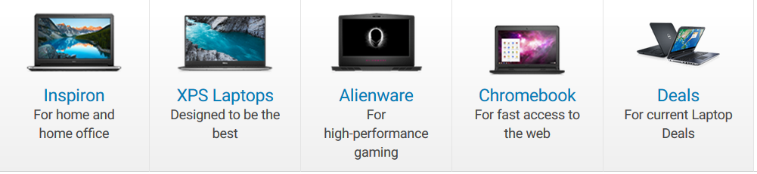

Guide:

Using tags : div, img, h2, p

CSS for div : float : left

**Exercise 2 (5 marks)**

* Develop website display samsung J7 Pro as follows

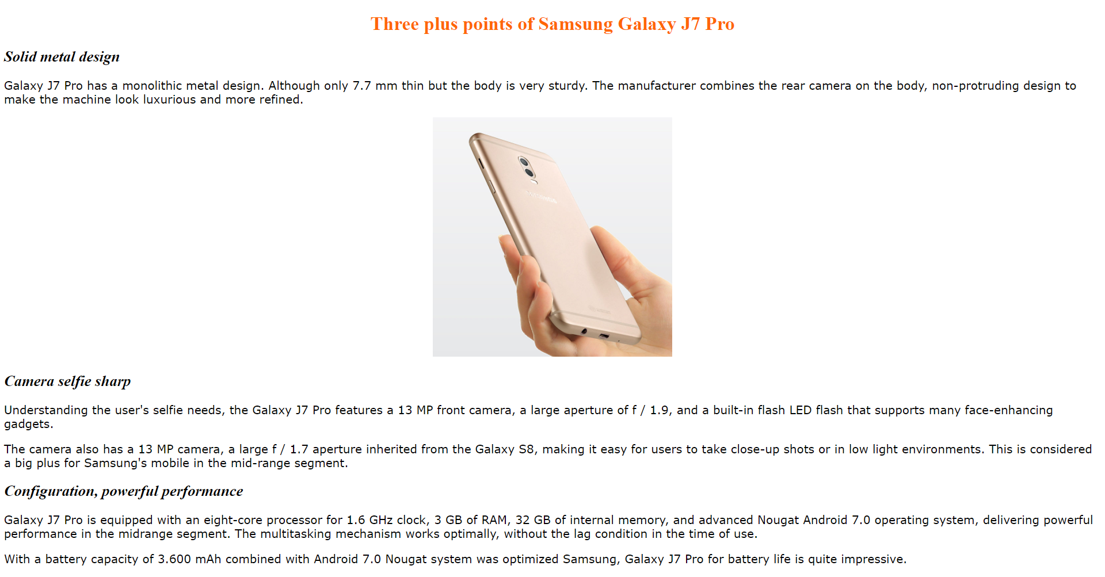

Guide:

