Gold Miner

A game by Thien Duong

2. Game Overview

2.1 Game Concept: The game is designed to entertain young gamer and adults. Player will control a gold mining cart with the objectives to collect as much gold and destroy the bombs that look like gold

2.2 Genre: Survival, Arcade

2.3 Target Audience: Children who are learning first interactions with computers, adults who are learning first interactions with computers, adventurous game players.

2.4 Game Flow Summary: Player starts the game with 3 pieces of gold to collect and 3 bombs to destroy within 30 seconds. If the golds are collected and the bombs are destroyed on time, a victory display will show up with player score, or else a display letting player know he/she lost will pop up and encourage the game to try again

2.5 Look and Feel: The basic look of the game is 2D, sprites of bullet shot out of the gold cart are visible as well as sprites of gold cart movement. The game’s light characteristics make it very easy to handle and less buggy.

3. Gameplay and Mechanics

         3.1 Gameplay

3.1.1. Game Progression: The game starts with the creation of a gold cart and player have 30 seconds to destroy the 3 newly created bombs while collecting the gold pieces to win the game

3.1.2. Mission/challenge Structure:

Mission:

The mission of the play is to gather all the gold and destroy all the bomb pieces

Challenge:

It’s challenging for the player to not hit the bomb pieces because he’ll lose the game and also, the player needs to collect all the gold pieces AND destroy all the bomb pieces with the given amount of ammunition and time. There’s also a catch, the bomb pieces can be confused with the gold pieces. Destroying bomb pieces will gain your score while destroying gold pieces will lose the game. The gold pieces only have 20 health points (easier to destroy), while the bomb pieces have 100 health points.

3.1.3. Puzzle Structure:

A timer is set up to limit the player’s time to complete the gold gathering and destroying tasks. Each time a bomb is destroyed, three seconds is added to the timer.

3.1.4. Objectives – What are the objectives of the game?

To destroy all the bomb pieces and gather all the gold pieces.

3.1.5. Play Flow – How does the game flow for the game player

The same amount of gold and bomb pieces are initialized. The gold cart is given a gun that can shoot bullets. The gold cart can shoot and collect the pieces of gold and bombs.

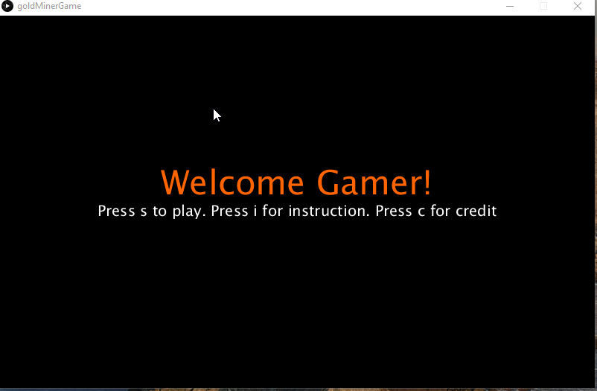

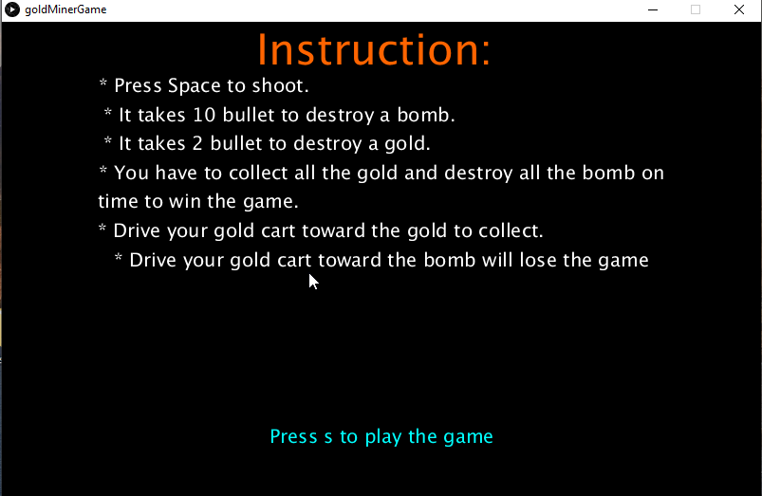

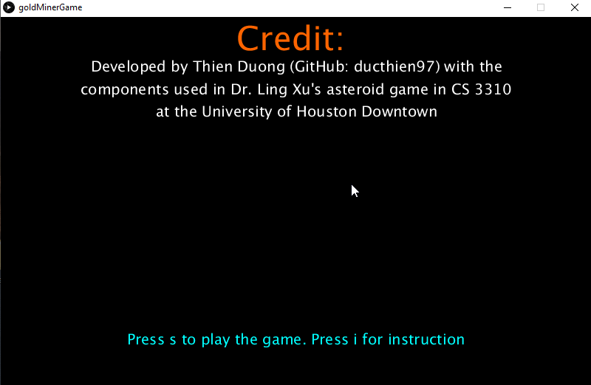

3.2. Mechanics

3.2.1. Physics – The physics of the game is very basic. The gold cart can move within the 2D background created. The bullets shot out of the cart at the top of the cart and in straight motion.

3.2.2. Movement in the game: The gold cart can move in straight motion and can change the direction it’s moving. The bullet can move at the same direction of the top of the gold cart

3.2.3. Objects– collectable objects include: Gold pieces and bomb pieces. However, one type will explode your cart

3.2.4. Actions- S-button to start the game, C-button to show credit of the game, I-button to show the brief instruction of the game, P-button to pause/un-pause the game.

3.2.5. Combat – Player’s goal is to destroy the bombs with its gun and avoid getting hit by the bombs.

3.2.6. Economy

Player’s given a certain amount of ammunition, each of the bomb pieces destroyed will give the player more ammunition to continue. This encourages the player not to misfire in order to save ammo.

Each of the gold pieces have 20 point strength, each of the bomb pieces have 100 point strength.

3.2.7. Screen Flow

First screen is the intro,

If player select play => the play screen pops up =>

If player pause => pause

If player win => congratulate screen pops up

If player lost => “you lost” screen pops up

If player select credit => credit screen pops up

If the player selects instruction -> instruction pops up.

The player can always enter playing mode when the “S” button is pushed.

3.3. Game Options – The player has option to play/view credit/pause/unpause/view instruction

3.4. Replaying and Saving - After each game regardless of winning or losing, the player always has the option to replay a new game.

4. Interface

4.1. Visual System - The game is developed on basic 2D level of graphics

4.2. Control System – Player can control the game mainly from the keyboard

4.3. Audio, music, sound effects - Sound effects are embedded when player gathers gold, destroy bombs or get hit by bomb

4.4. Help System - The player can always look for instructions to play the game using the button “i”.

5. Technical

5.1. Target Hardware - The game does not require heavy computer specification

5.2. Development hardware and software, including Game Engine - Development hardware: PC/Windows, Game Engine: Processing/Java

5.3. Network requirements - The game is completely offline, not network connection required

Reference

The game is developed with components based on core Asteroid Game from Dr. Ling Xu at the University of Houston-Downtown.

Sound components are download from <https://freesound.org/>

Gold Cart Image: <https://www.pngwave.com/png-clip-art-nhvtk>

Gold/Bomb Piece: <https://officialpsds.com/gold-rock-psd-7n8mk8>

Demonstration video: https://drive.google.com/file/d/1v8TYOjU_WX5yfsR1byyKf_AukroUs56o/view?usp=sharing